***APCHE NIFI Diagram***

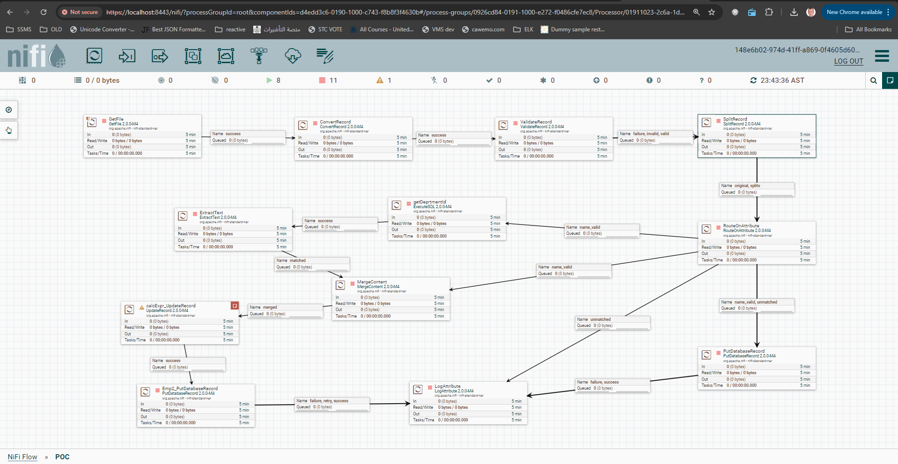

This is a demo for the apache NIFI which is integration framework used in more that use case :

In my case I read from a csv file of records and validate this record and datatypes and then insert the success one into postgress database

And log the failed records into another file

Attached the “NIFI POC.json” you can import it as a project into your nifi canvas

