Secret-Key Encryption Project

Student name: Alshaimaa Alamer
Student ID: 444111008

Task 2: Encryption Using Different Ciphers And Modes
- Using AEC-128-CBC
- Create Text File: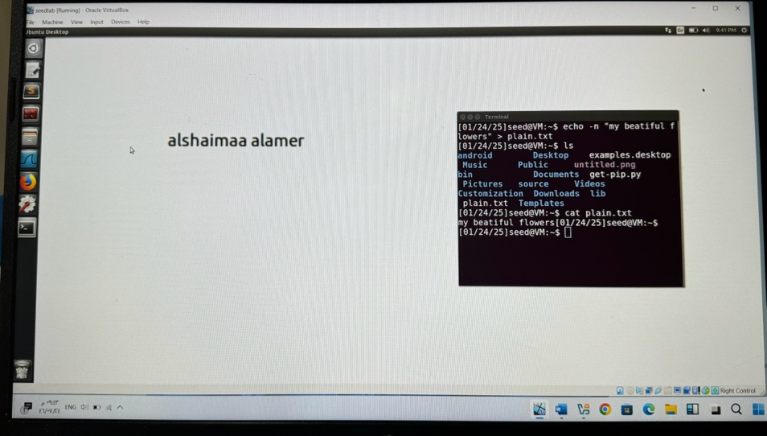
- Use The ghex Command to print The hex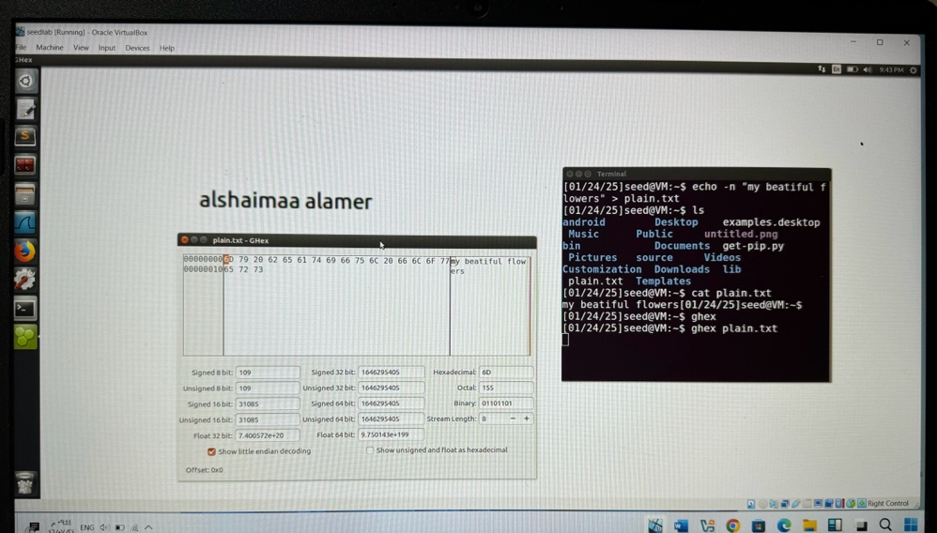

- Encryption+ Use The ghex Command to print the hex
Plain text :my beautiful flowers
Key:123cpjk
Iv:122334455667788
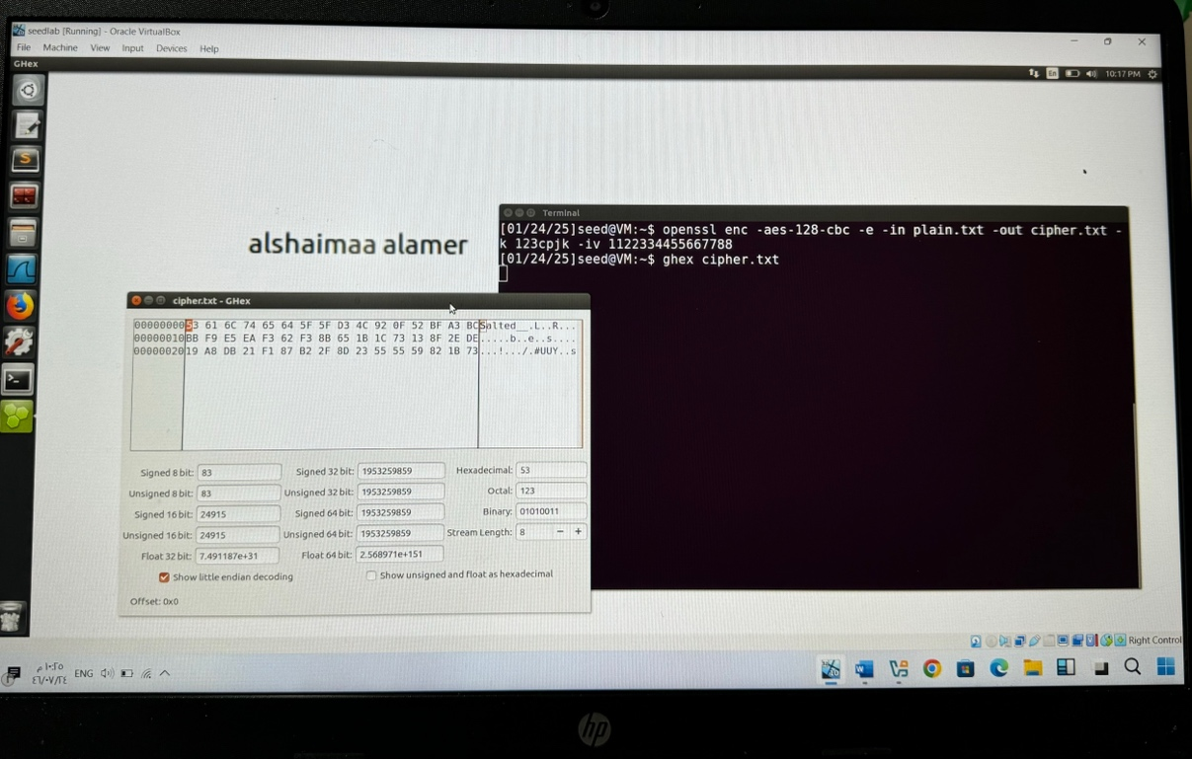

Observation: Verify that the initialisation vector (IV) and key are used to properly encrypt the plaintext.Use the ghex command to inspect the encrypted data and confirm that the output is what you intended.

- Decryption + Use The ghex Command to print the hex
Key: 123cpjk
Iv: 122334455667788
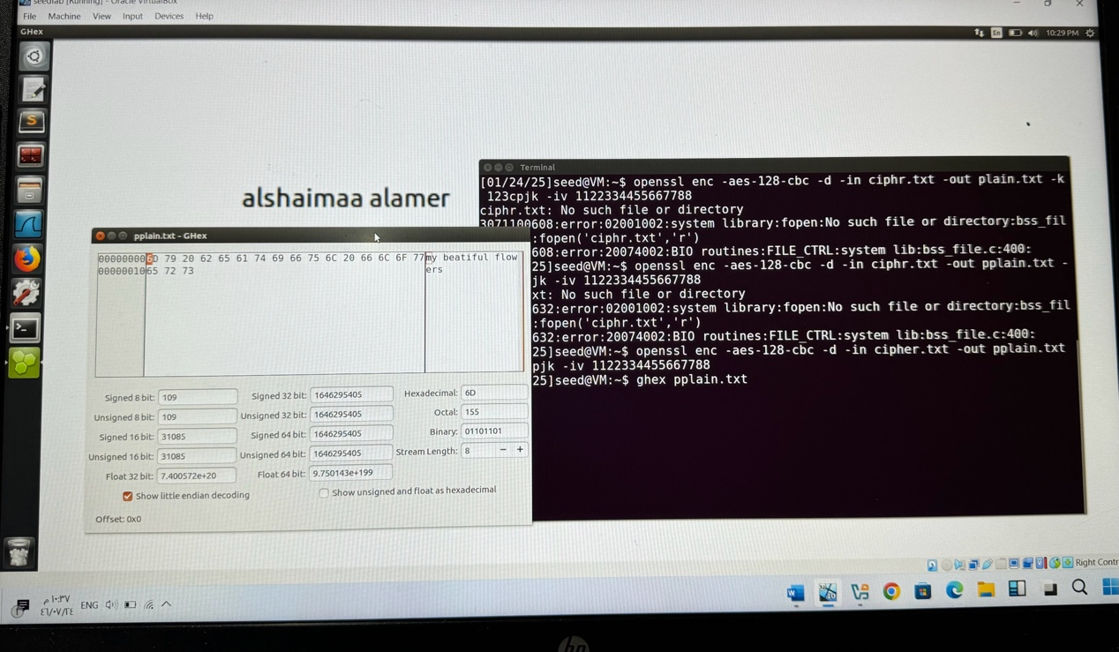
- Using AEC-128-CFB

- Create Text File:
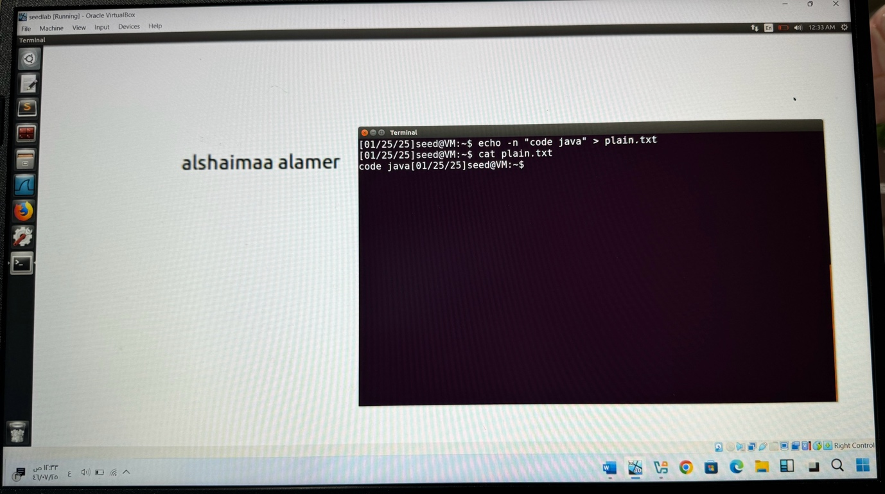

- Encryption
Plain text :code java
Key:123cpjk
Iv:1122334455667788
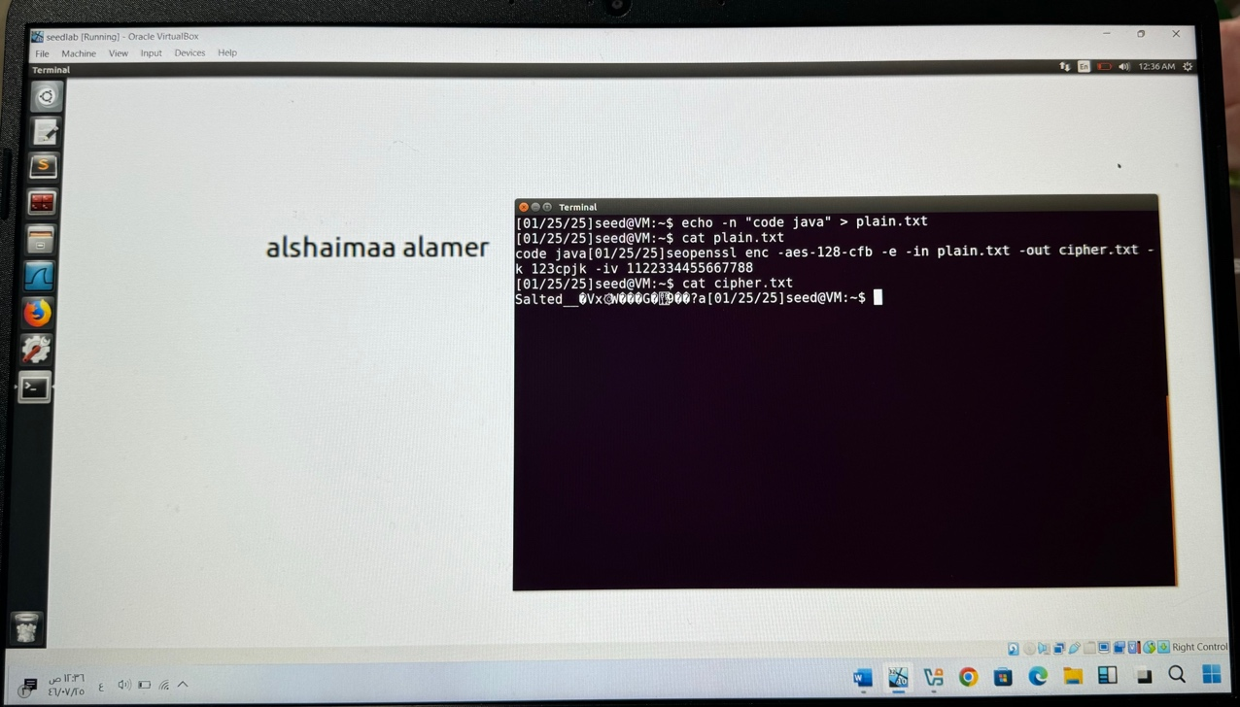
- Use The ghex Command to print the hex after the Encryption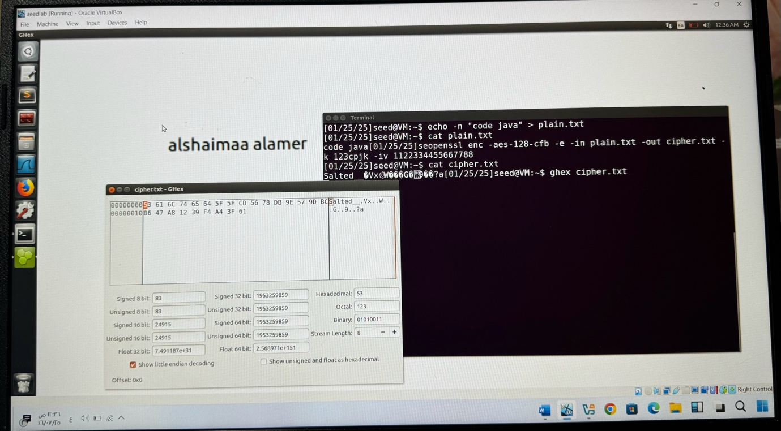

Observation: Verify that while using the CFB mode to encrypt, the text behaves as intended.
Examine how altering the IV or key affects the encrypted output.

- Decryption
Key:123cpjk
Iv:1122334455667788
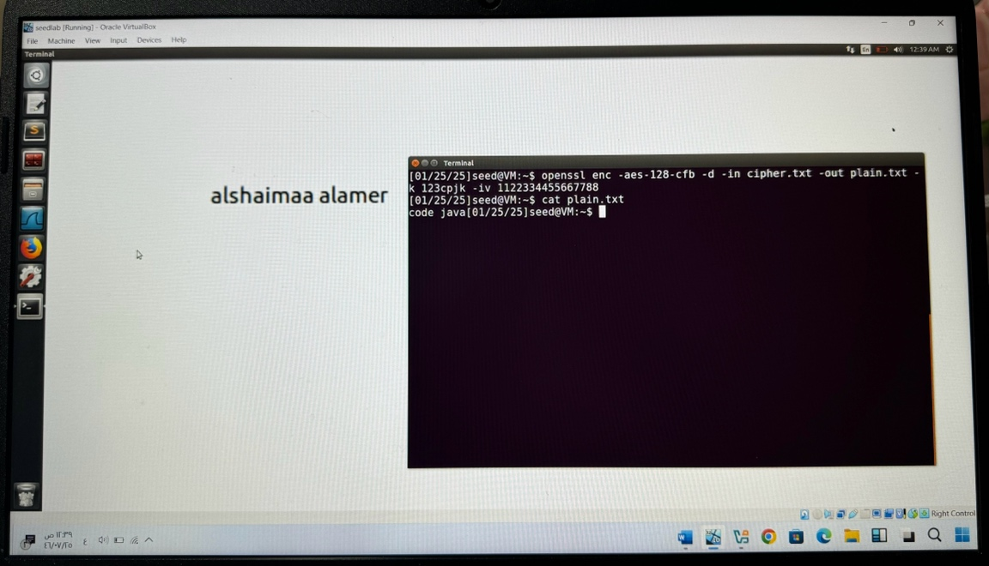

- Use The ghex Command to print the hex after the Decryption
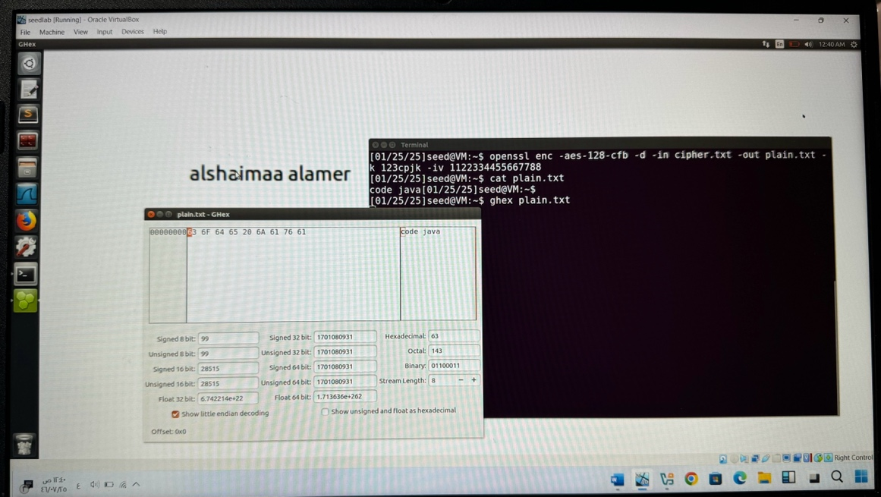

- Using AEC-128-OFB
- Create Text File:
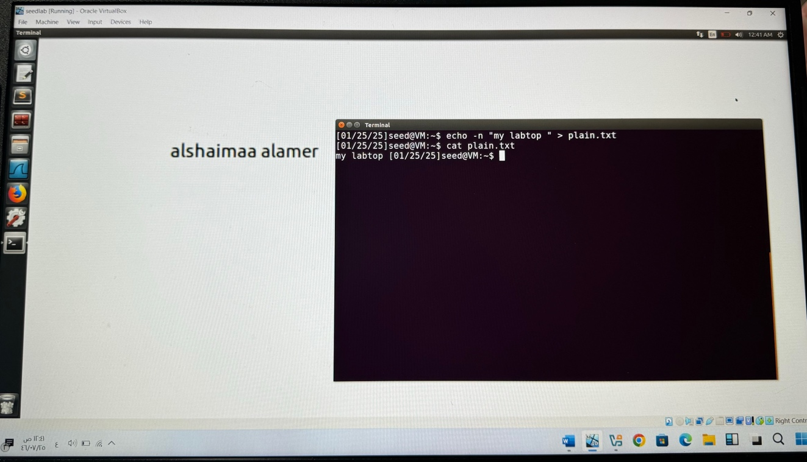

- Use The ghex Command to print the hex
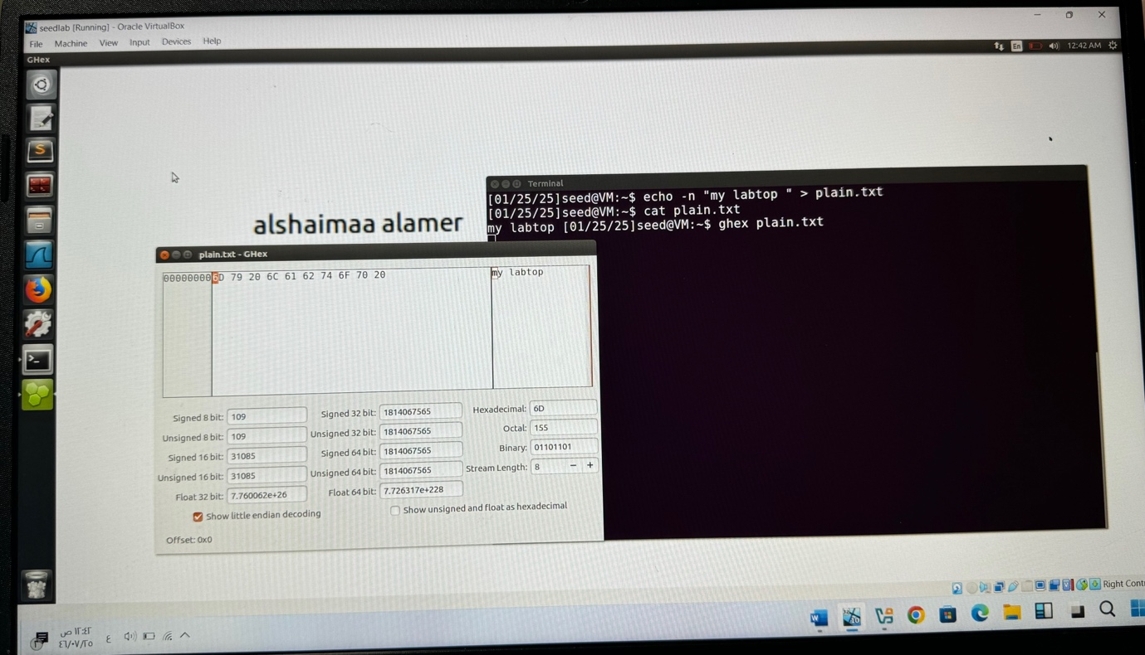
- Encryption
Plain text :my labtop
Key:123cpjk
Iv:1122334455667788
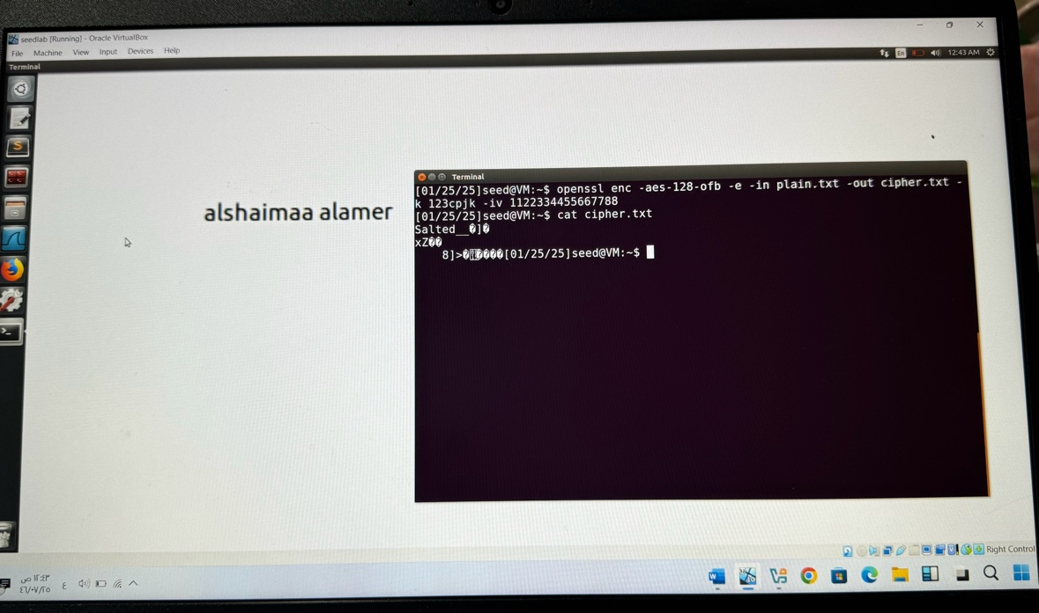

- Use The ghex Command to print the hex after the
Encryption
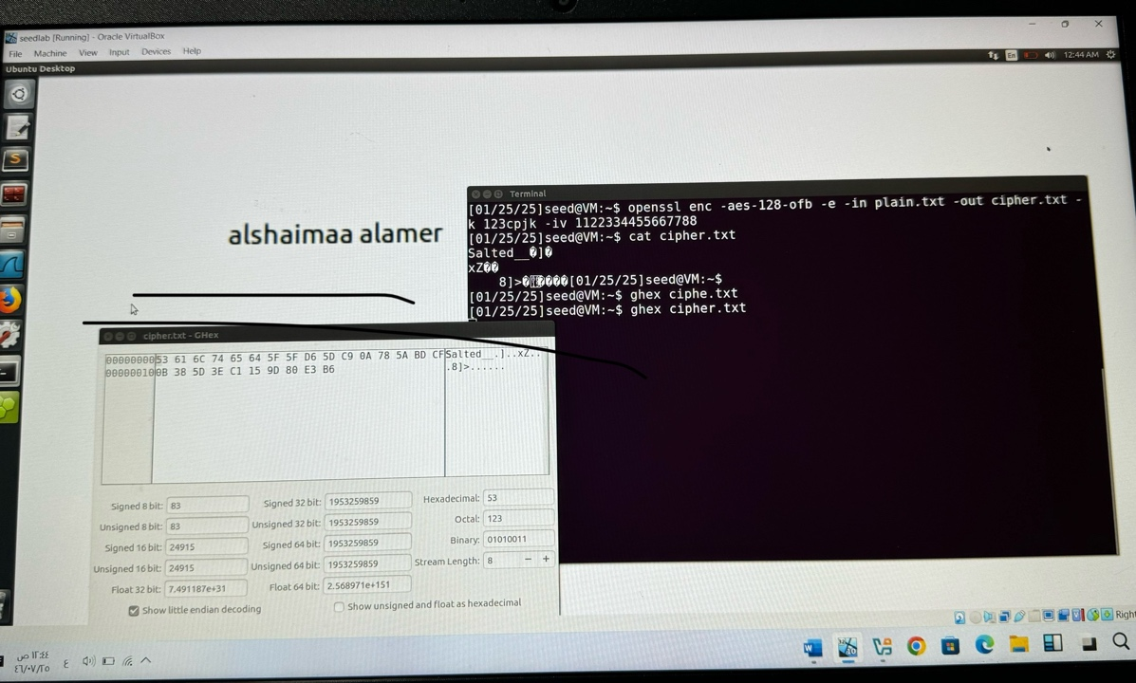

Observation: Make sure the result matches the expected output and that the OFB mode maintains a consistent encrypted stream.
Use the ghex command to see how the encrypted text appears, and use the same parameters to see if the decryption process is successful.

- Decryption
Key:123cpjk
Iv:1122334455667788
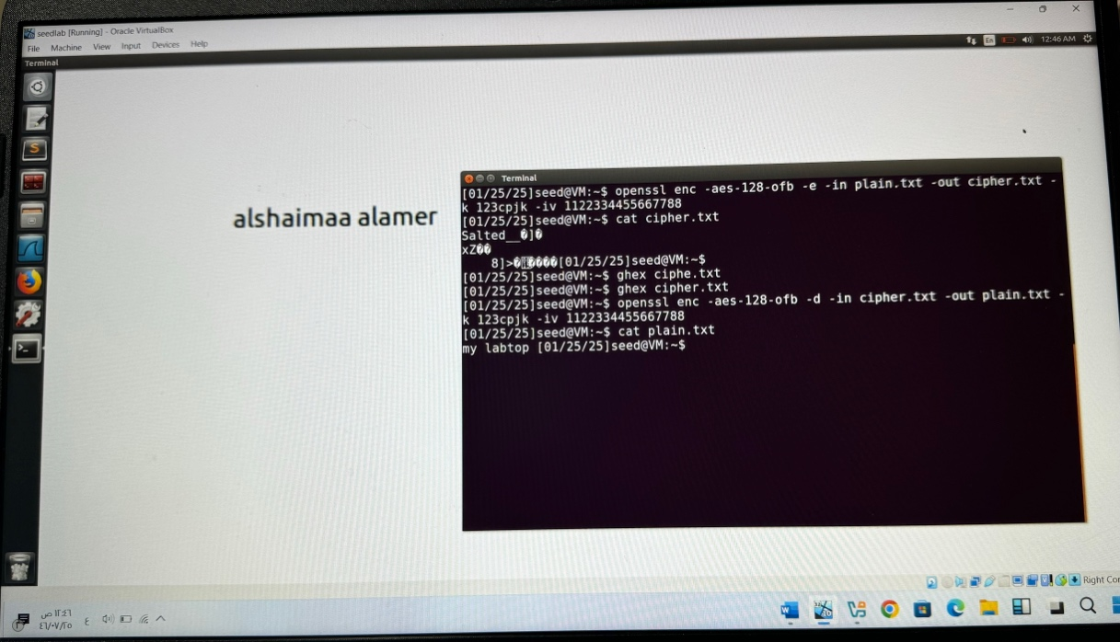
- Use The ghex Command to print the hex after the Decryption 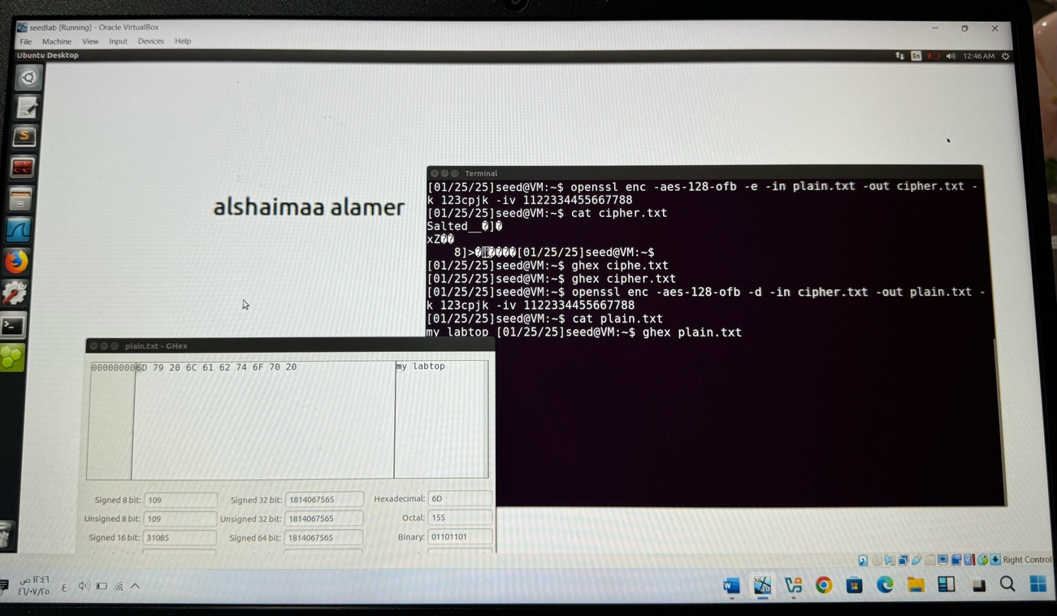
Task 3: Encryption Mode- ECB vs. CBC
- Use The ghex Command to print the hex for the original image
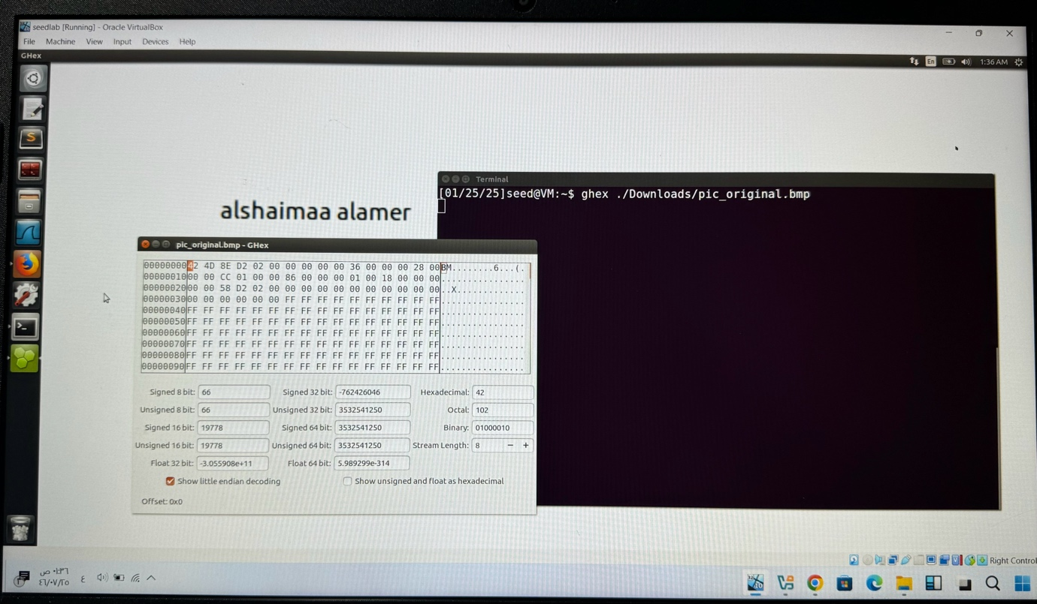
- View the image eog
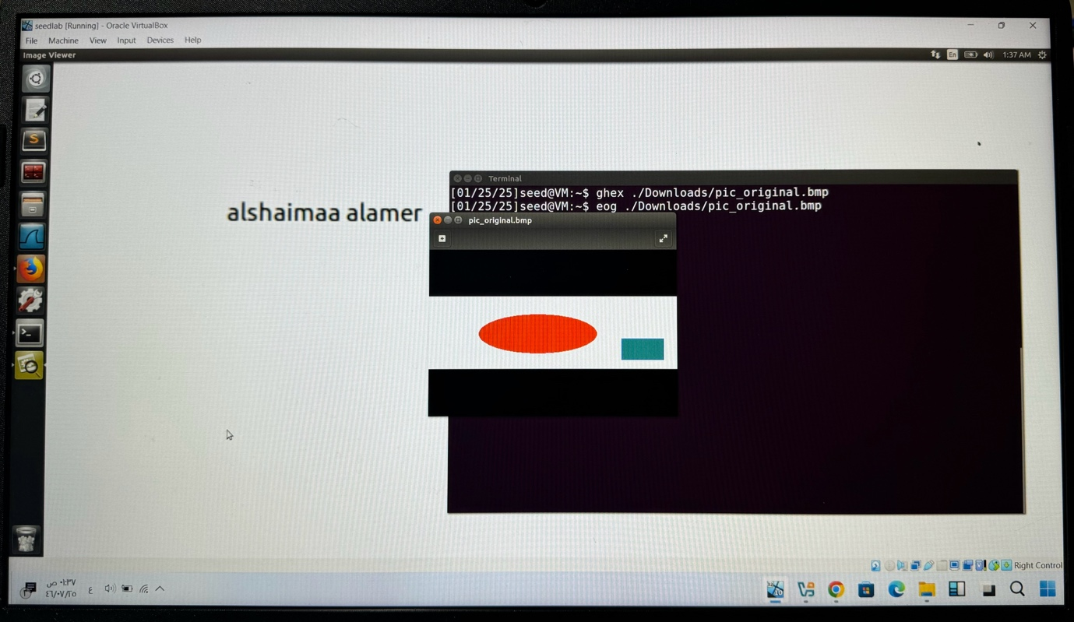

- Encryption Using AES-128-CBC+Adding The Header and Tail To Encryption Image+ View the image eog ‏
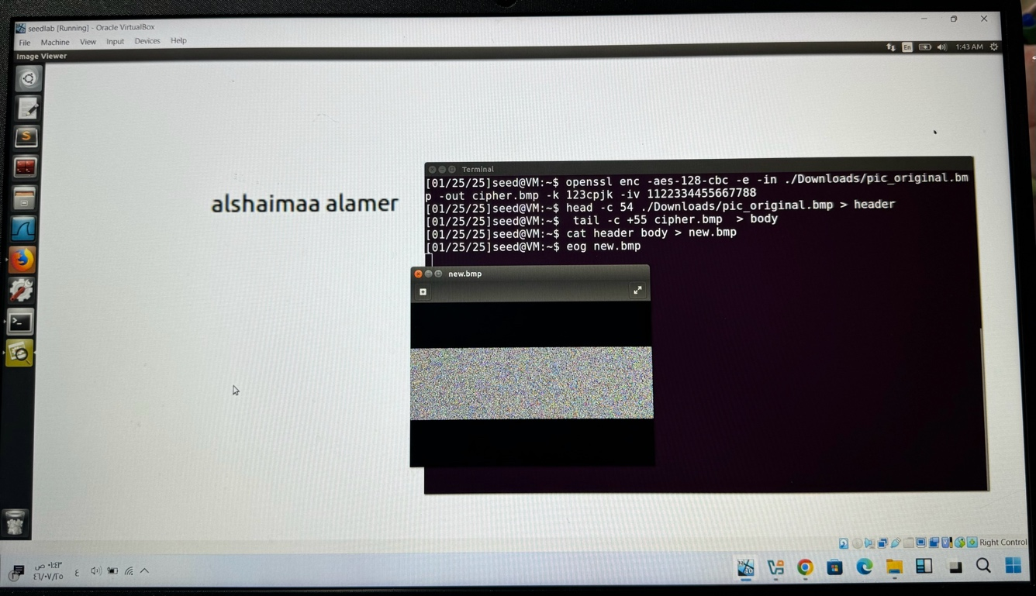
- Use The ghex Command to print the hex after the Encryption 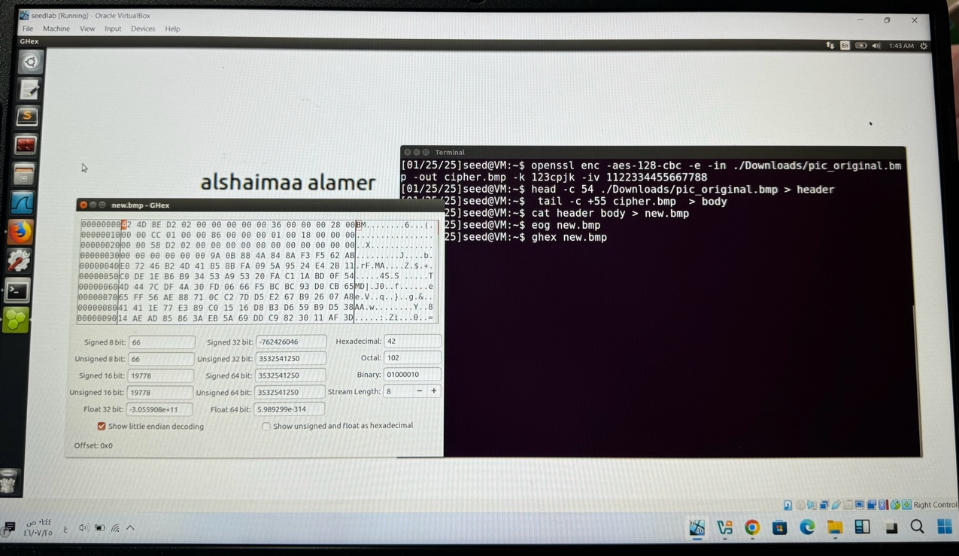

- Encryption Using AES-128-ECB Use The ghex Command to print the hex
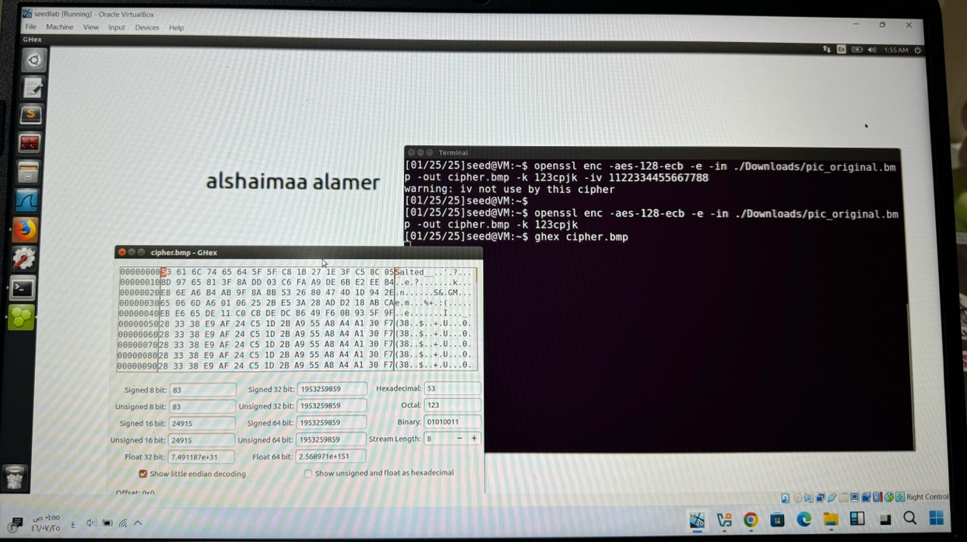
- Adding The Header and Tail To Encryption Image+ View the image eog ‏
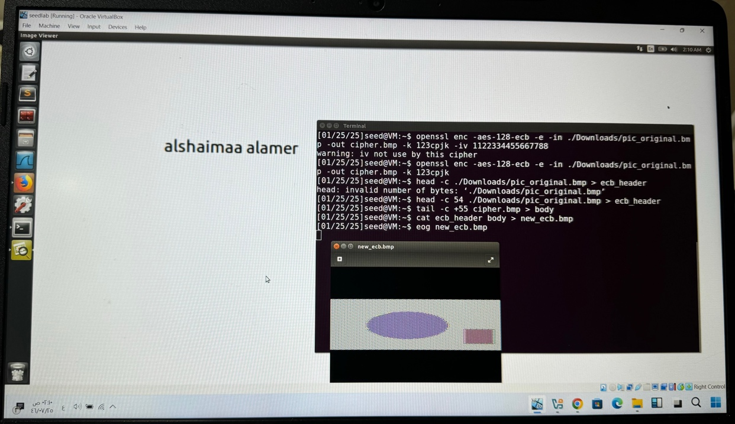

- Use The ghex Command to print the hex after the Encryption
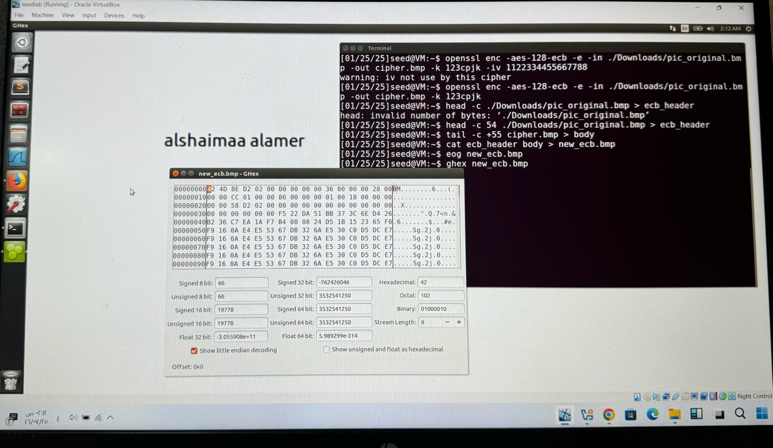

Observation: When comparing ECB with CBC, keep in mind that because there is less randomness in the ECB mode, patterns can be seen in the encrypted images.
Note how the encrypted images change when viewed with eog and emphasise how CBC is more secure than ECB.

Repeat the processes to another picture
A)CBC
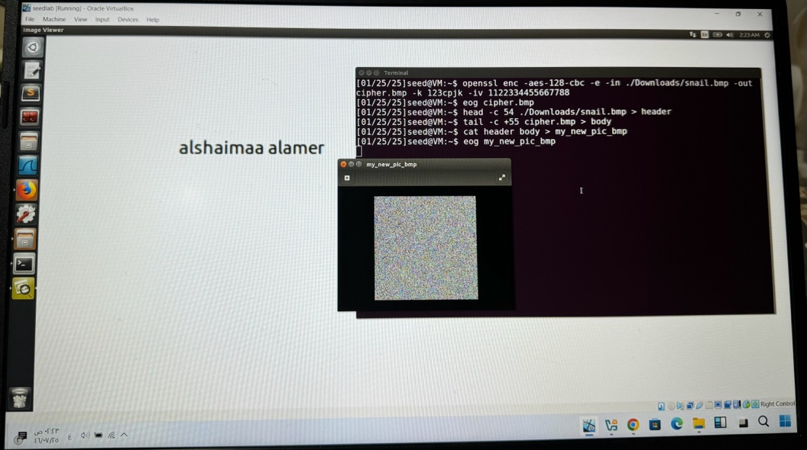

B)ECB
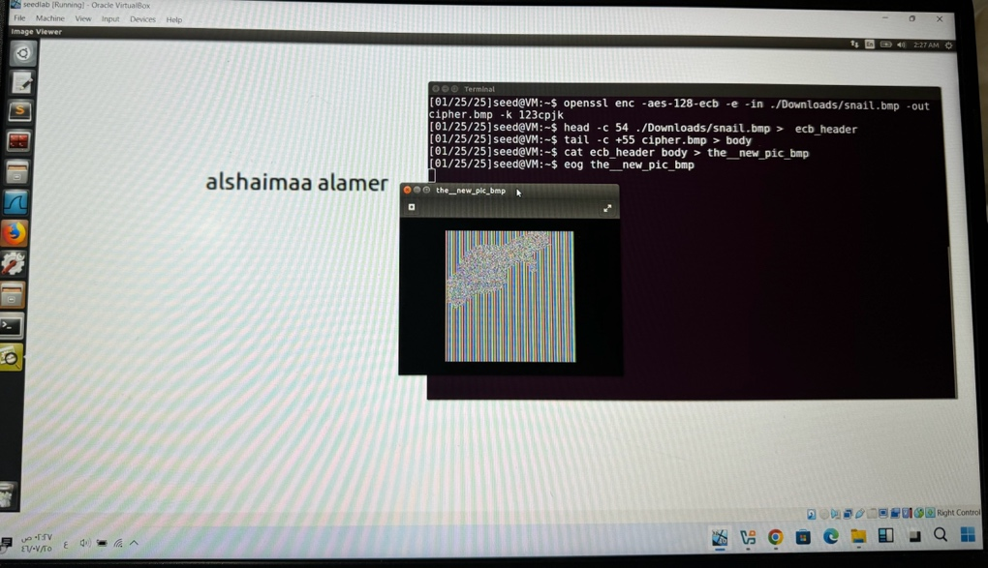

Task 7: Programming Using The Crypto Library
Plain text: This is a top secret
Key:
ASCII Syracuse########
HEX 53797261637573652323232323232323
Iv: aabbccddeeff00998877665544332211
Ciphertext:764AA26B55A4DA654DF6B19E4BCE00F4ED05E09346FB0E762583CB7DA2AC93A2
Vc output
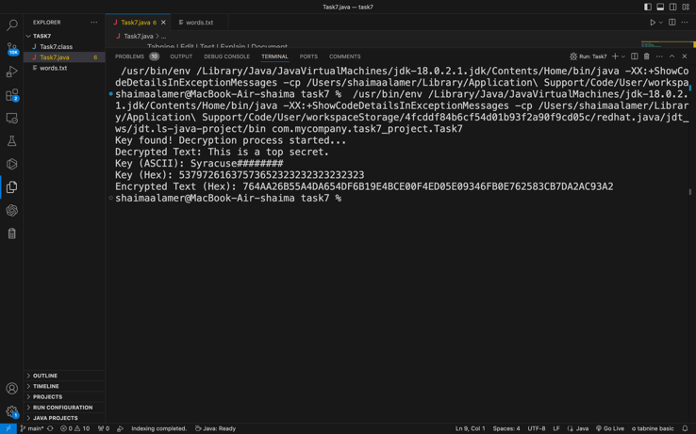
Vm :
-Javac command
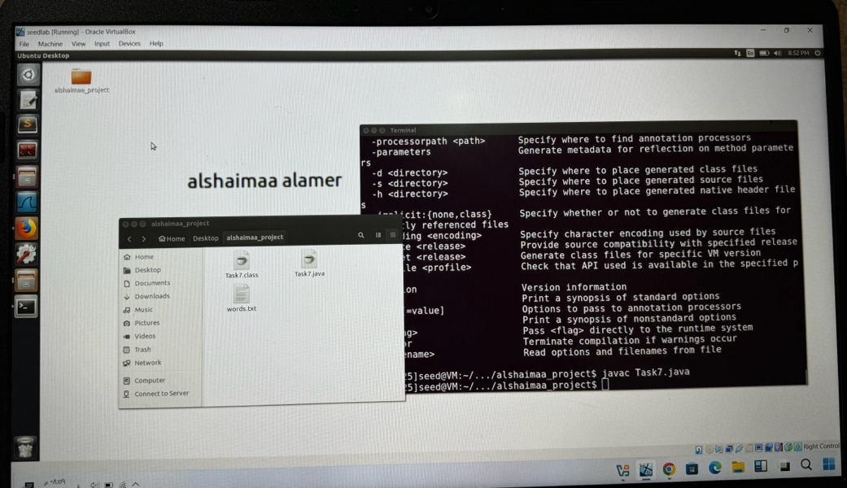

- Vm output
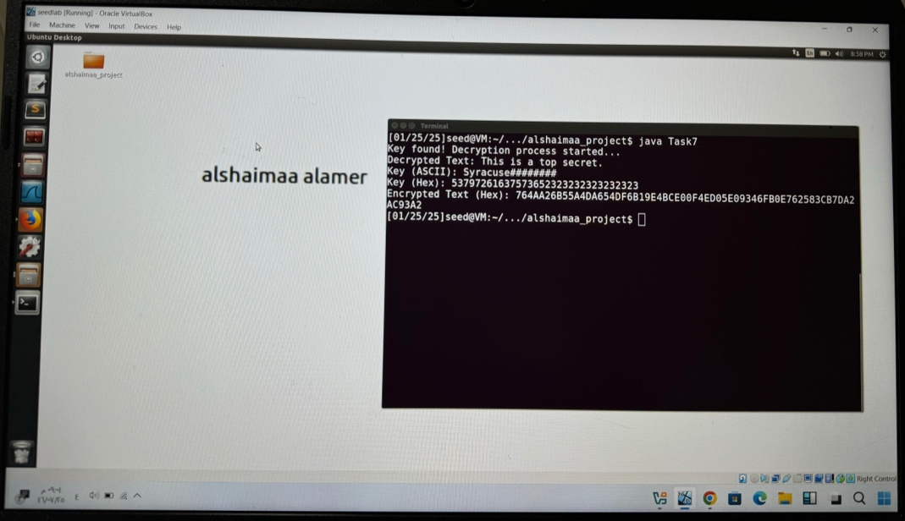

Observation: Using the key and IV, evaluate the accuracy of the ciphertext produced when the plaintext ("This is a top secret") was encrypted.
Compare the encryption and decryption outputs to make sure the application is operating correctly.
Using the Crypto library, I observe any differences that occur during the encryption and decryption procedures.

