 | 

Al Imam Mohammad Ibn Saud Islamic University
College of Computer and Information Sciences
Computer Science Department

Course Title: | Software Security
Course Code: | CS442
Semester: | First Semester 2025-2026
Assignment | Assignment Return to libc
Student Name: | Alshaimaa Alamer | Student ID: | 444000118

Task One: Find address of system
First, we turn oof the randomization so that addresses remain stable then we compiled and gave permissions, create the file badfile and launched GDB

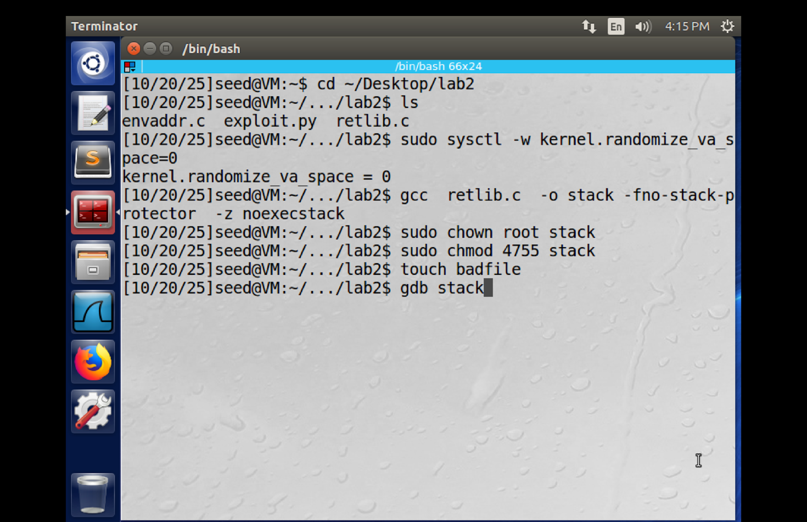

Run the GDB

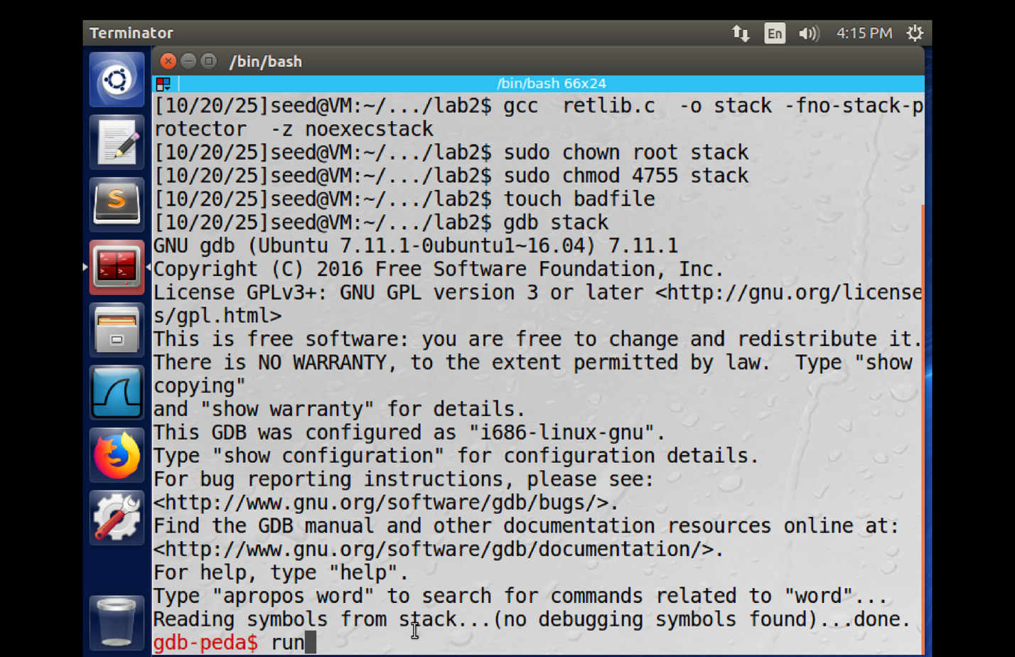

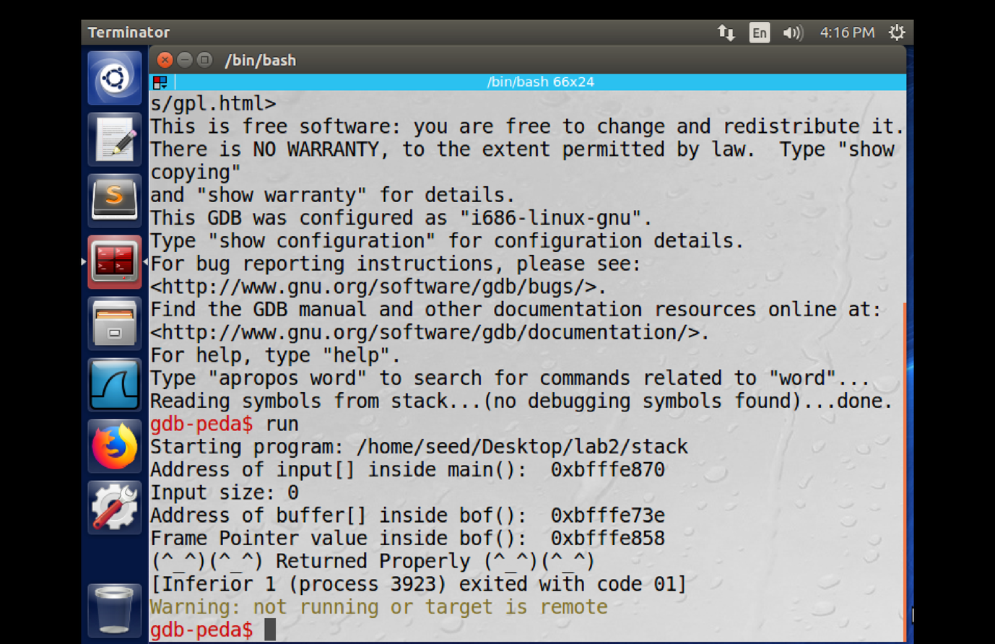

I printed the value of system and exit
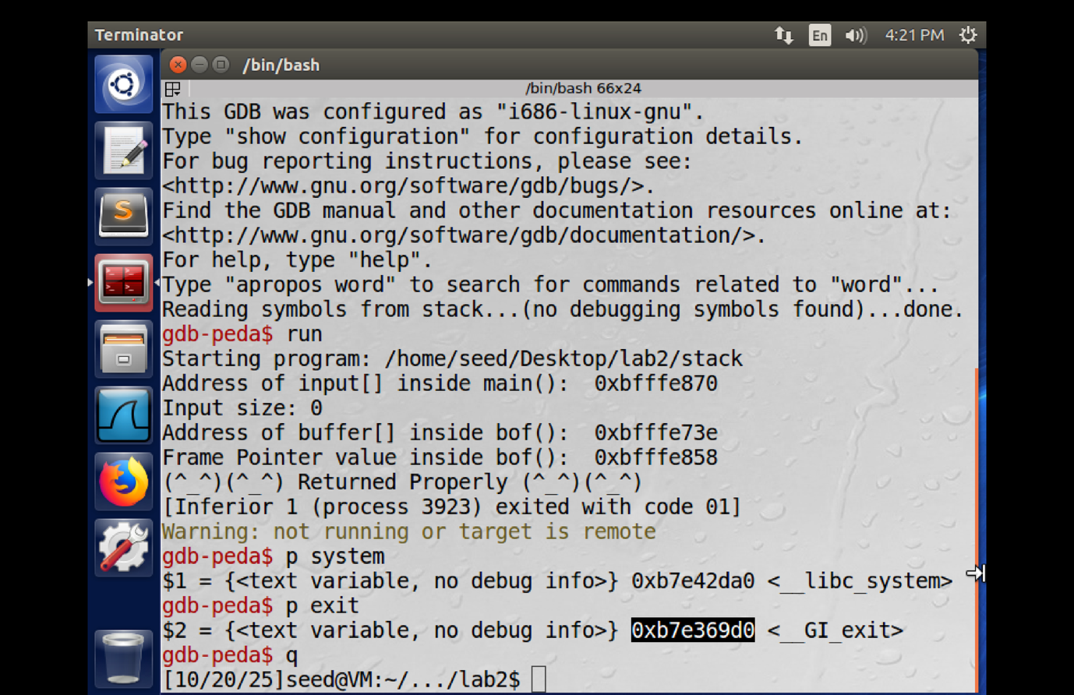

Task Two: Find the address of "/bin/sh" string
Compile the envaddr so I can get the address of the shell
Export the variable "MYSHELL" with value "/bin/sh" then we run env55
Then compiled with -g and gave permissions, launched GDB

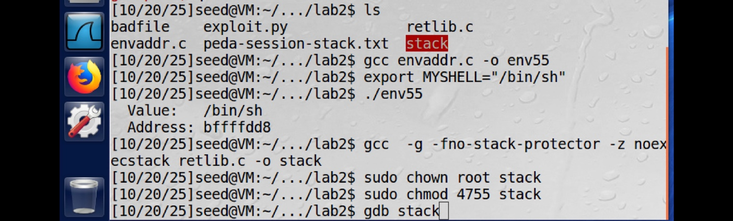
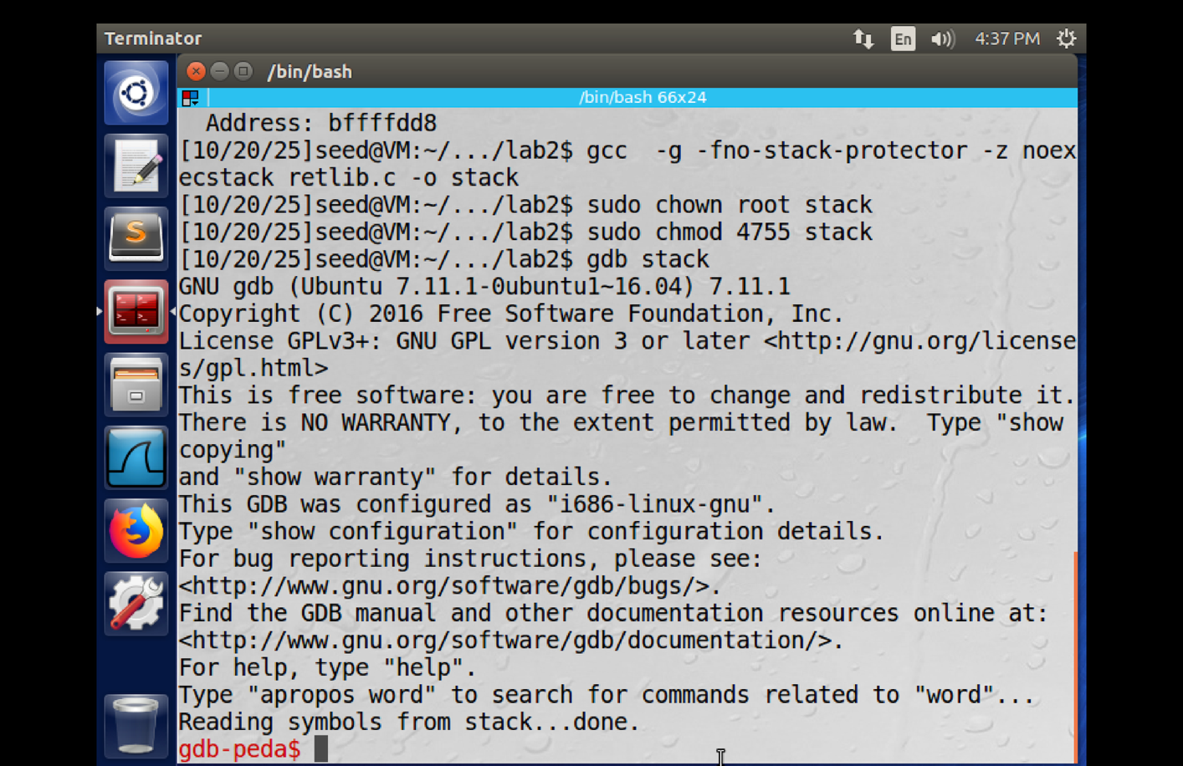

See the functions on retlib.c

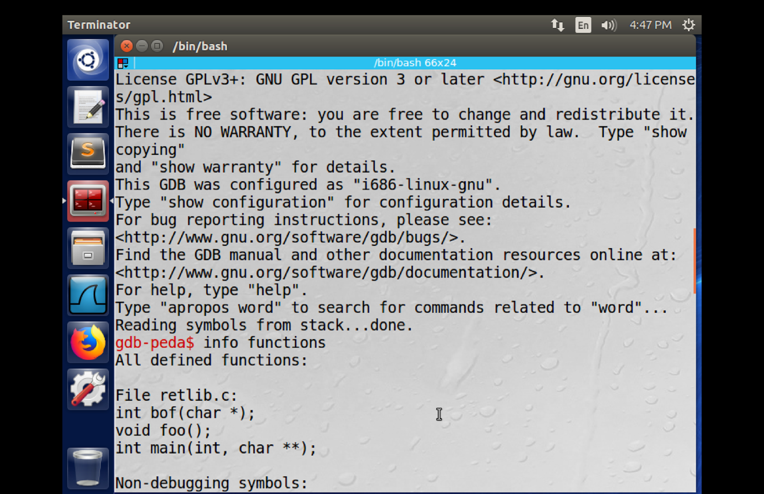
Task Three: find the distance
Print the value of bof to set the breakpoint
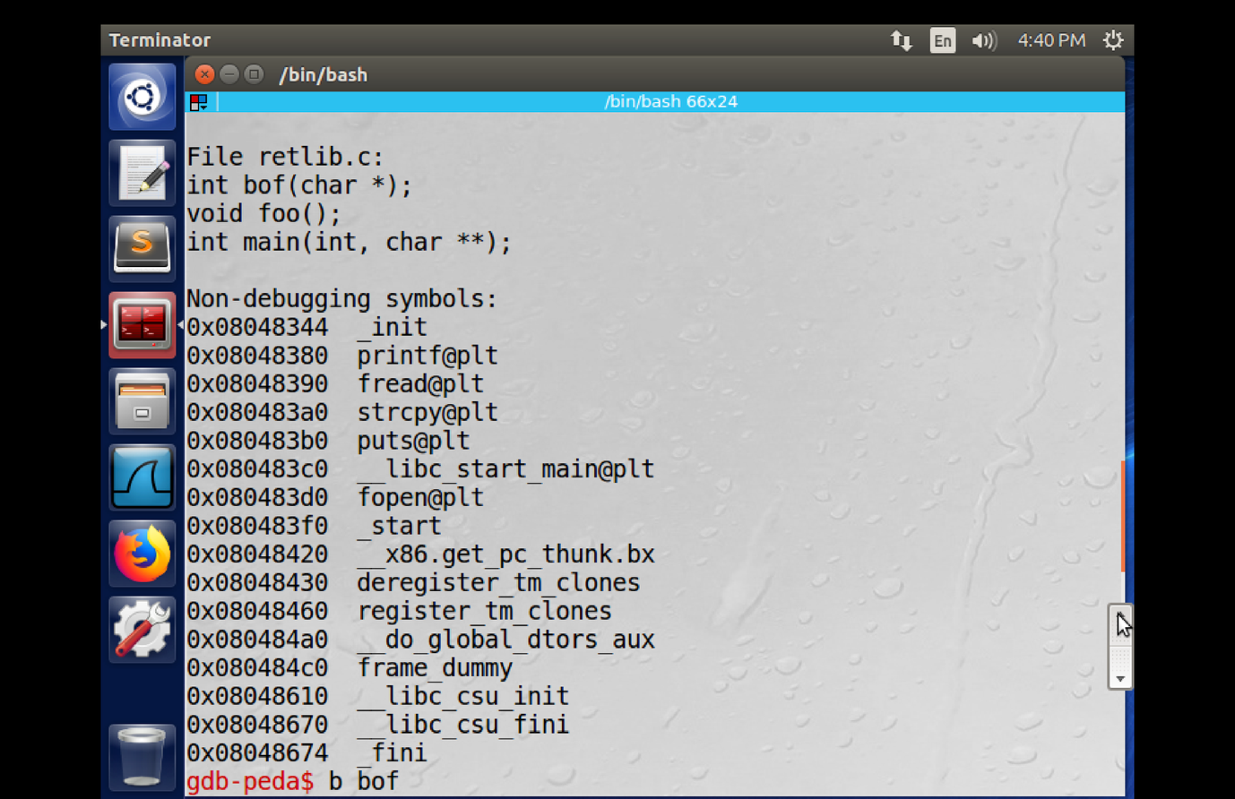

Run it
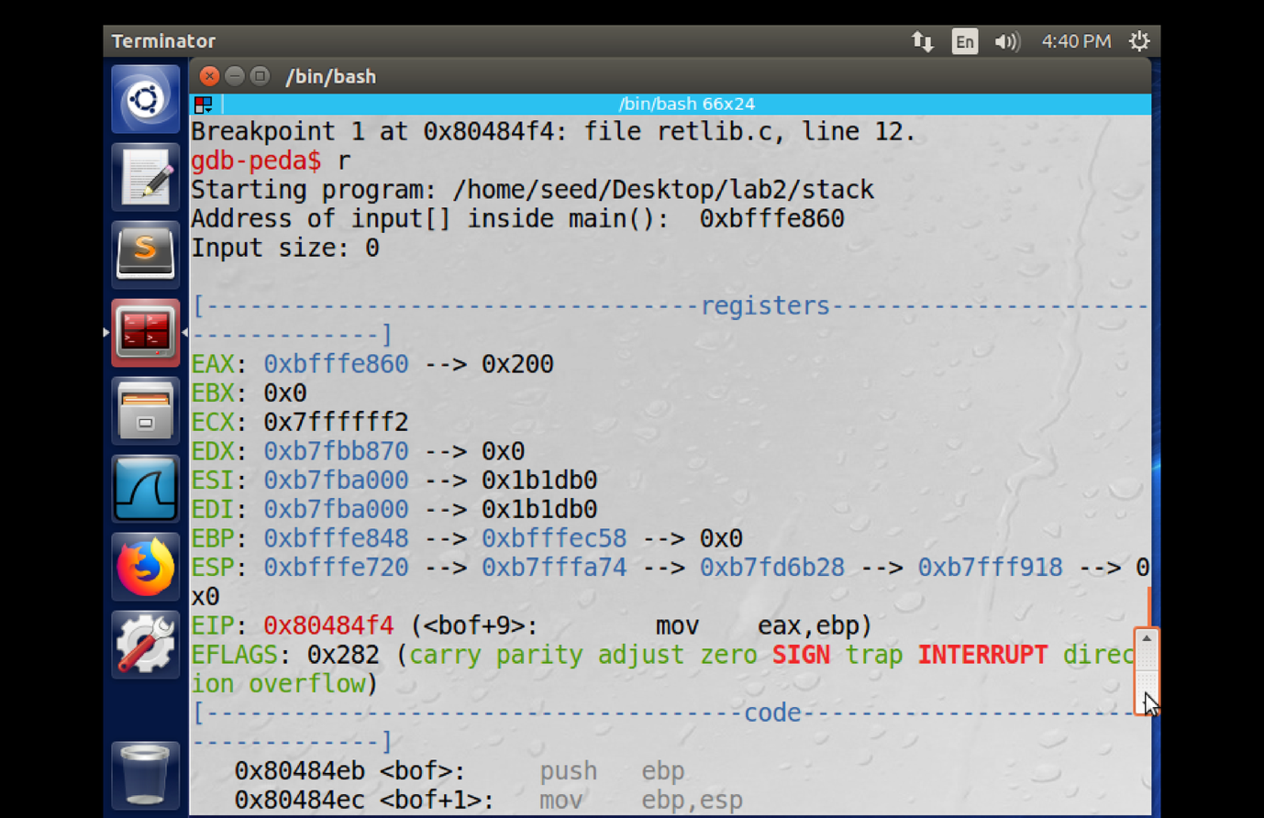
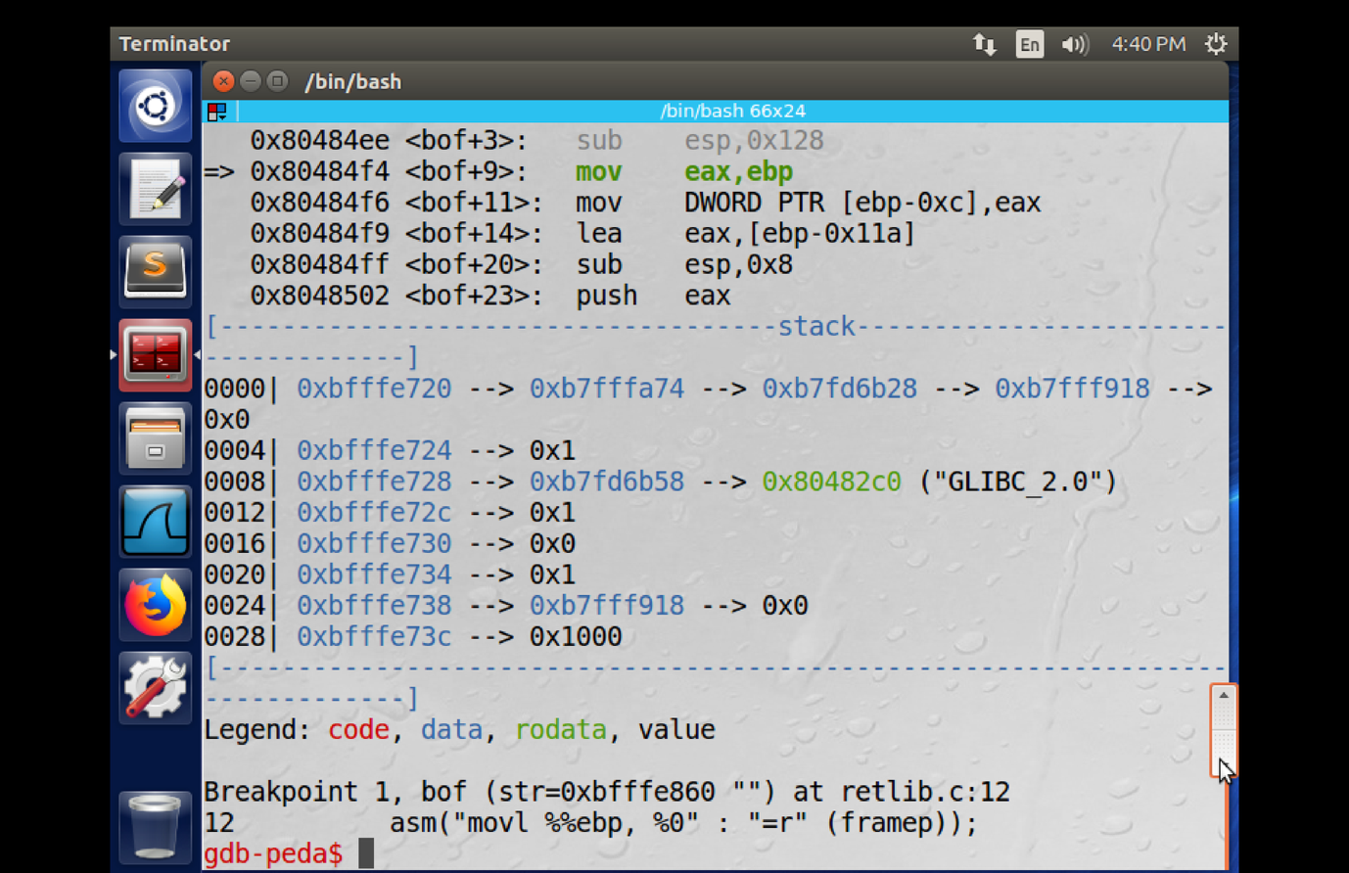

I printed the value of $ebp and &buffer then calculated the distance between them ( 282 bytes)

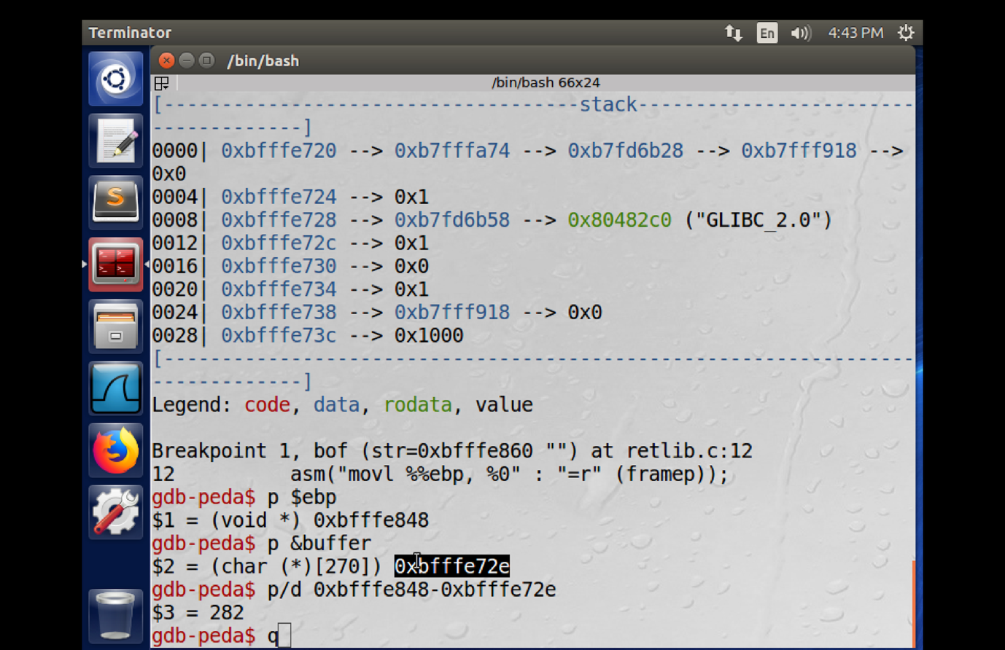

i compiled and gave permissions then I subled the exploit.py
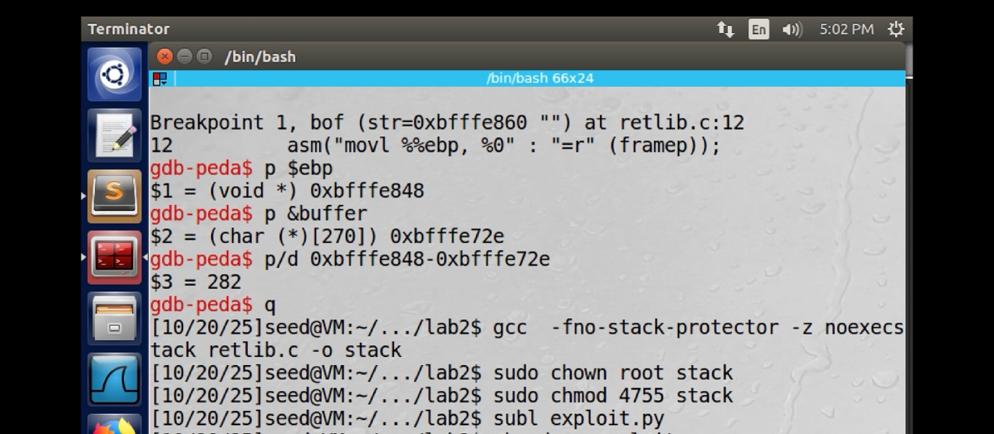

Set the range to 1000
give the sh_addr the value 0xbffffdd8 and give the range 294-298
give the system_addr the value 0xb7e42da0 and give the range 286-290
give the exit_addr the value 0xb7e369d0 and give the range 290-294

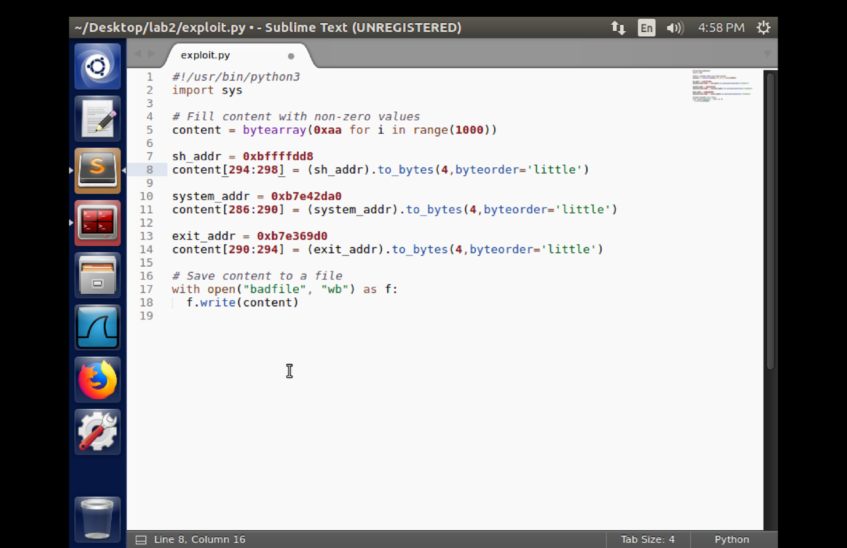
Launch the attack.
give permissions, remove the dummy badfile, and run the exploit and the stack