

Complete Sender JSON Integration Package
  - ALSHUMOOKH API-to-API Settlement Receiver | Full Technical Instructions
Document Control
Production Base URL | https://alshumookh.finance
Document Purpose | Complete sender package for JSON/API payload submission and blockchain settlement verification.
Environment | Production-ready technical deployment while formal certifications are being completed.
Generated Date | 2026-05-10

Executive Technical Summary
The ALSHUMOOKH system can receive external JSON/API payloads, normalize transaction data, store raw audit records, verify blockchain transactions through Alchemy/RPC, reconcile against approved master wallets, and display settlement status in the internal admin dashboard.

1. Information to Give the Sender
Sender-Facing System Details
Production Domain | https://alshumookh.finance
Schema Endpoint | GET https://alshumookh.finance/api/v1/payloads/schema
Ingestion Endpoint | POST https://alshumookh.finance/api/v1/payloads/ingest
Health Endpoint | GET https://alshumookh.finance/health
Blockchain Verification | Alchemy/RPC is used internally by ALSHUMOOKH. No Alchemy key is shared.
Receiver Ethereum Wallet | 0xBD682cfD8382a90adfDd6745780D3D7959c4d939
Supported Networks | Ethereum ERC-20, Base ERC-20, TRON prepared for later RPC activation.
Primary Asset | USDC or other ERC-20 token contract confirmed in writing before settlement.

2. Professional Workflow Diagram
The sender should follow this end-to-end workflow. Small technical tests must be completed before any high-value settlement.
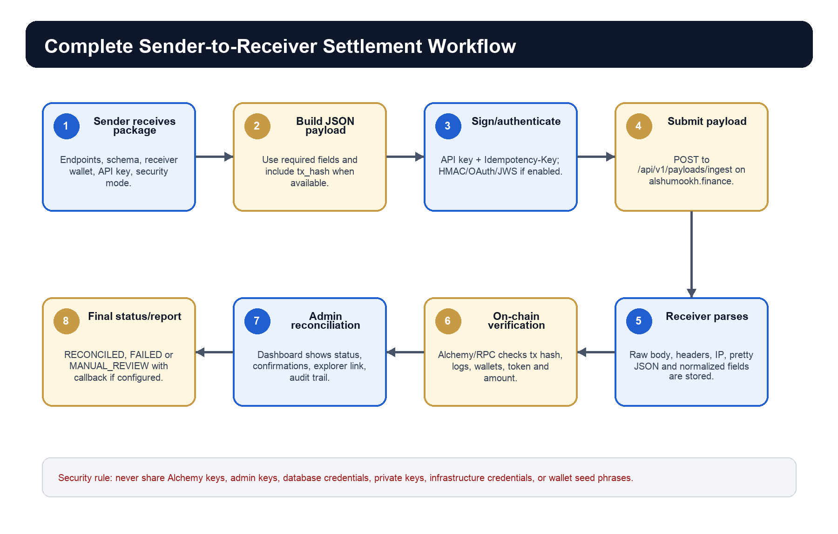

3. Full JSON Payload Format
The receiver accepts unknown/custom fields, but the sender should use the following full JSON structure for automatic parsing, verification, and reconciliation.
{
"transaction_reference": "W2W-2026-000001",
"transaction_id": "optional-external-transaction-id",
"tx_hash": "0xBLOCKCHAIN_TRANSACTION_HASH",
"sender_wallet": "0xSenderWalletAddress",
"receiver_wallet": "0xBD682cfD8382a90adfDd6745780D3D7959c4d939",
"amount": "100.00",
"asset": "USDC",
"network": "ethereum",
"token_contract": "0xA0b86991c6218b36c1d19D4a2e9Eb0cE3606eB48",
"timestamp": "2026-05-10T17:00:00Z",
"sender": {
"name": "Sender Legal Entity",
"technician": "Sender Technical Operator",
"email": "technical@example.com"
},
"receiver": {
"name": "ALSHUMOOKH GLOBAL BANKING FINANCE & CREDIT",
"wallet": "0xBD682cfD8382a90adfDd6745780D3D7959c4d939"
},
"authorization_code": "optional-release-or-operation-code",
"settlement_type": "wallet_to_wallet",
"callback_url": "https://sender.example/settlement/callback",
"signature": "optional-sender-side-signature",
"metadata": {
"agreement_reference": "optional-agreement-reference",
"purpose": "technical settlement test",
"notes": "custom fields are accepted and stored"
}
}

4. Minimum Required Fields
Field | Required | Purpose
transaction_reference | Yes | Unique external settlement reference.
sender_wallet | Yes | Declared wallet sending the funds.
receiver_wallet | Yes | Must match ALSHUMOOKH approved receiver wallet.
amount | Yes | Exact amount to verify/reconcile.
asset | Yes | Token symbol such as USDC.
network | Yes | ethereum, base, or tron-placeholder.
token_contract | Recommended | Required for strong ERC-20 verification.
tx_hash | Required for on-chain verification | If missing, payload status becomes AWAITING_TX_HASH.
timestamp | Recommended | Used for audit and replay protection.
callback_url | Optional | Used if sender requires callback status notification.

5. Accepted Field Aliases
Normalized Field | Accepted Aliases | Notes
transaction_reference | transaction_id, txRef, reference, ref, transactionCode | All map to transaction_reference.
tx_hash | transaction_hash, hash, blockchain_hash, txid | Used for Alchemy/RPC verification.
sender_wallet | from_wallet, from, source_wallet, origin_wallet | Declared source wallet.
receiver_wallet | to_wallet, to, destination_wallet, beneficiary_wallet | Must match receiver master wallet.
amount | value, token_amount, transfer_amount, settlement_amount | Exact payment amount.
asset | currency, token, symbol, crypto_currency | Token symbol.
network | chain, blockchain, protocol | Blockchain network.

6. Required Headers and Security Options
Header | Required | Use
Content-Type: application/json | Yes | JSON request body.
X-API-Key | Yes unless OAuth2 enabled | Dedicated sender API key issued by ALSHUMOOKH.
Idempotency-Key | Yes | Unique key to avoid duplicate processing.
X-Timestamp | Recommended / HMAC required | Replay protection and HMAC base string.
X-Signature | If HMAC enabled | sha256=<hex HMAC digest>.
Authorization: Bearer | If OAuth2 enabled | OAuth2 client credentials token.
X-JWS-Signature | If JWS enabled | Asymmetric signature over payload hash.
X-Client-Cert-Fingerprint | If mTLS-ready enabled | Client certificate fingerprint forwarded by gateway.

7. HMAC Signature Method
If HMAC is enabled for the sender, the sender must sign the exact raw request body.
Signature base string:
X-Timestamp + "." + exact raw JSON body
Algorithm:
HMAC-SHA256 using the sender hmac_secret
Header:
X-Signature: sha256=<hex-digest>

8. Technical Process the Sender Must Follow
- Confirm the receiver wallet, network, asset, and token contract in writing before settlement.
- Call the schema endpoint and confirm the sender payload structure matches the receiver requirements.
- Generate a unique transaction_reference and Idempotency-Key.
- Prepare the JSON payload using the full format in this document.
- Authenticate using the dedicated sender API key, or OAuth2 if enabled.
- Sign the request with HMAC/JWS if that security mode is enabled.
- Submit the payload to POST /api/v1/payloads/ingest.
- Receive payload_id and verification_status from ALSHUMOOKH.
- Broadcast the blockchain transfer and provide tx_hash if it was not included initially.
- Wait for ALSHUMOOKH to verify tx_hash through Alchemy/RPC and reconcile the settlement.
- Respond to any FAILED or MANUAL_REVIEW status with corrected data or supporting evidence.

9. Blockchain Verification Scope
- Transaction hash exists on Ethereum or Base RPC.
- Transaction receipt is successful.
- ERC-20 Transfer logs are parsed.
- Receiver wallet matches ALSHUMOOKH approved master wallet.
- Sender wallet matches declared sender wallet when provided.
- Token contract matches declared asset.
- Amount received matches declared amount.
- Block number, confirmations, and explorer URL are stored.

10. Alchemy Disclosure Policy
Important Security Rule
Do not provide Alchemy keys, Alchemy RPC URLs containing keys, webhook signing secrets, admin keys, database URLs, private keys, seed phrases, Render credentials, GitHub tokens, or MoonPay secrets to the sender.

Alchemy Information Policy
Allowed to disclose | We use Alchemy/RPC internally for Ethereum/Base transaction verification.
Allowed to disclose | Webhook receiver: https://alshumookh.finance/api/v1/webhooks/alchemy
Allowed to disclose | Required sender data: tx_hash, sender_wallet, receiver_wallet, amount, asset, network, token_contract.
Not allowed | ALCHEMY_AUTH_TOKEN, ALCHEMY_ETHEREUM_RPC_URL, ALCHEMY_BASE_RPC_URL, ALCHEMY_WEBHOOK_SIGNING_KEY.

11. Expected API Responses
Successful payload:
{
"status": "payload_received",
"payload_id": "...",
"transaction_reference": "W2W-2026-000001",
"parsed": true,
"verification_status": "AWAITING_TX_HASH"
}
Unparsed payload:
{
"status": "payload_received_unparsed",
"payload_id": "...",
"parsed": false,
"message": "Payload stored but requires manual review"
}

12. Status Flow
Status | Meaning | Sender Action
RECEIVED | Payload received by API. | Store payload_id.
PARSED | Fields normalized. | No action.
AWAITING_TX_HASH | No tx_hash provided. | Provide tx_hash after broadcast.
ALCHEMY_PENDING | Verification started. | Wait.
ALCHEMY_VERIFIED | Blockchain verification succeeded. | Proceed to reconciliation.
ON_CHAIN_CONFIRMED | Transaction confirmed on-chain. | Confirm business side.
RECONCILED | Payload matched with settlement. | Close operation.
FAILED | Verification failed. | Correct payload or investigate tx.
MANUAL_REVIEW | Operator review required. | Provide evidence.

13. Curl Test Example
curl -X POST https://alshumookh.finance/api/v1/payloads/ingest \
-H "Content-Type: application/json" \
-H "X-API-Key: <SENDER_DEDICATED_API_KEY>" \
-H "Idempotency-Key: sender-test-0001" \
-d '{
"transaction_reference": "W2W-TEST-0001",
"sender_wallet": "0xSenderWallet",
"receiver_wallet": "0xBD682cfD8382a90adfDd6745780D3D7959c4d939",
"amount": "100.00",
"asset": "USDC",
"network": "ethereum",
"token_contract": "0xA0b86991c6218b36c1d19D4a2e9Eb0cE3606eB48"
}'

14. Operational Evidence That the System Is Working
The following evidence can be provided to the sender as proof that the receiver environment is active and operational. These items do not expose internal secrets.
Operational Proof Points
Production Domain | https://alshumookh.finance is active over HTTPS.
Health Check | GET https://alshumookh.finance/health returns HTTP 200 OK.
Root Security Behavior | GET / redirects to the login page and does not expose internal API status details.
Admin Dashboard | The internal dashboard is accessible only after admin login/session.
Payload Schema | GET /api/v1/payloads/schema is deployed for sender integration review.
Payload Ingestion | POST /api/v1/payloads/ingest is deployed for sender JSON/API submissions.
OAuth2 Endpoint | POST /api/v1/oauth/token is deployed for client-credentials mode when enabled.
Alchemy Webhook Receiver | POST /api/v1/webhooks/alchemy is deployed for internal blockchain event matching.
Audit Trail | Raw payloads, headers, IP, user agent, parsed fields, idempotency key, and verification status are stored.
Blockchain Verification | ERC-20 Ethereum/Base verification is available through internal Alchemy/RPC configuration.
Latest Confirmed Deployment | Service startup completed successfully and Render reported the service live on https://alshumookh.finance .

Proof Handling
If the sender requires additional evidence, provide screenshots of the live domain, /health response, schema endpoint response, and dashboard settlement payload page. Do not provide admin keys, Alchemy keys, database credentials, or infrastructure secrets.

15. Sender Pre-Live Checklist
- Dedicated sender API key received.
- Idempotency-Key generation implemented.
- Security mode confirmed: API key only, HMAC, OAuth2, JWS, JWE, or mTLS-ready.
- Receiver wallet confirmed.
- Network and token contract confirmed.
- Small test payload without tx_hash completed.
- Small test payload with tx_hash completed.
- Admin dashboard confirms payload and verification result.
- No high-value transfer before small technical test success.

16. Ready-to-Send Message to Sender
Dear Team,
Please find attached the complete ALSHUMOOKH Sender JSON Integration Package.
Production domain:
https://alshumookh.finance
Schema endpoint:
GET https://alshumookh.finance/api/v1/payloads/schema
Payload ingestion endpoint:
POST https://alshumookh.finance/api/v1/payloads/ingest
Please use the JSON format, headers, authentication method, and step-by-step process described in the attached package. ALSHUMOOKH performs Alchemy/RPC verification internally; no Alchemy keys or infrastructure secrets are shared externally.
Please begin with a small technical test payload before any high-value transfer.
Kind regards,
ALSHUMOOKH Technical Team

Certification Notice
The system is technically prepared for controlled API-to-API settlement testing and operational verification. Formal certifications such as ISO 27001, SOC 2, PCI-DSS, PSD2, or eIDAS remain separate audit/compliance deliverables and must be represented only after official issuance.

