

Sender Technical Integration Package
  - ALSHUMOOKH API-to-API Settlement Receiver | Production Integration Guide
Document Control
Production domain | https://alshumookh.finance
Primary purpose | Sender-to-receiver API payload submission, blockchain verification, and reconciliation monitoring.
Document status | Technical operating package for controlled settlement testing while formal certifications are being completed.
Generated date | 2026-05-10

Operational Position
ALSHUMOOKH can receive structured or partially structured JSON settlement payloads, store the full raw audit record, normalize common transaction fields, verify ERC-20 transaction hashes through Alchemy/RPC, reconcile against approved master wallets, and display the result in the admin monitoring dashboard.

1. Information to Provide to the Sender
Sender-Facing Technical Data
Production Base URL | https://alshumookh.finance
Schema Endpoint | GET https://alshumookh.finance/api/v1/payloads/schema
Payload Ingestion Endpoint | POST https://alshumookh.finance/api/v1/payloads/ingest
Health Check | GET https://alshumookh.finance/health
Internal Verification Provider | Alchemy / RPC. This is internal only; no Alchemy secret is shared with sender.
Receiver Master Wallet | 0xBD682cfD8382a90adfDd6745780D3D7959c4d939

2. End-to-End Workflow
The sender must follow the sequence below. The process starts with a small technical test payload before any large-value settlement is attempted.
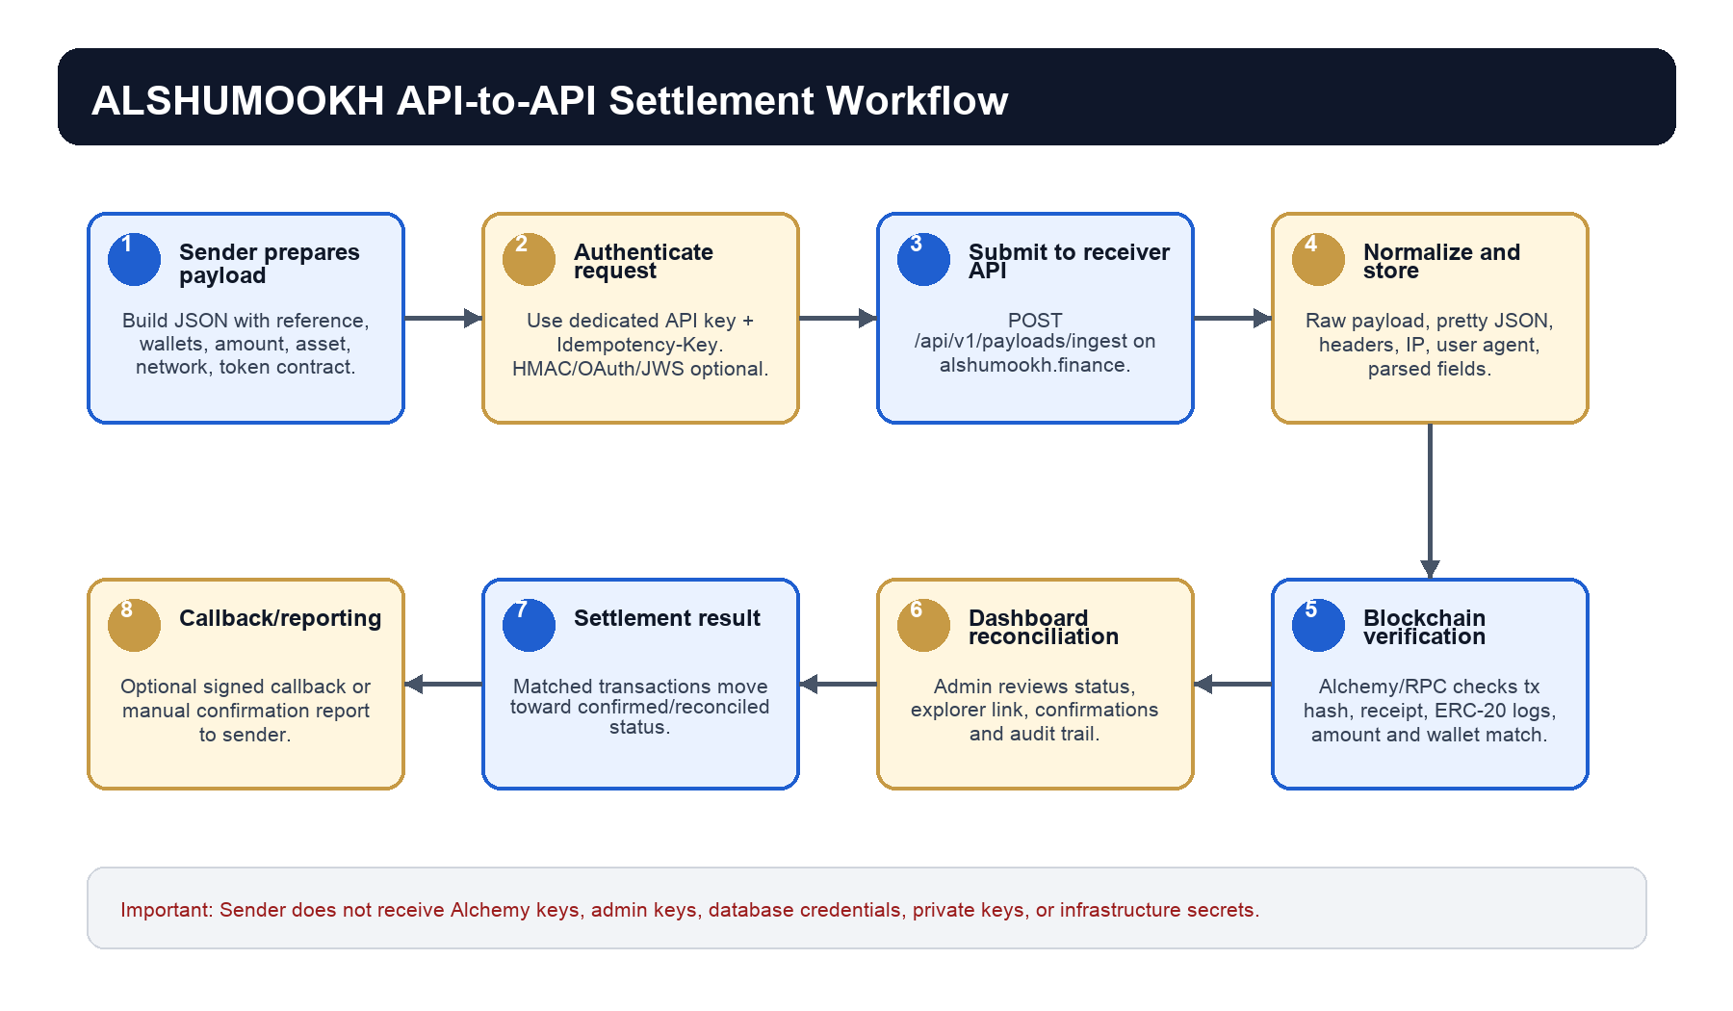

3. Step-by-Step Sender Procedure
- Prepare a structured JSON payload containing transaction_reference, sender_wallet, receiver_wallet, amount, asset, network, and token_contract.
- Generate a unique Idempotency-Key for the request. Do not reuse the same key for a different transaction.
- Authenticate using the dedicated sender API key issued by ALSHUMOOKH. Do not request or use admin credentials.
- If HMAC is enabled, calculate HMAC-SHA256 over X-Timestamp + '.' + exact raw request body.
- Submit the payload to POST https://alshumookh.finance/api/v1/payloads/ingest.
- If a blockchain transaction has already been broadcast, include tx_hash. If not, submit the payload first and send tx_hash later through an updated payload or agreed operational channel.
- Wait for the response containing payload_id, transaction_reference, parsed status, and verification_status.
- After the blockchain broadcast, provide tx_hash and any explorer evidence required for reconciliation.
- ALSHUMOOKH verifies the transaction through Alchemy/RPC and reconciles receiver wallet, amount, asset, token contract, block number, and confirmation count.
- The sender may receive a signed status callback if callback_url and callback security are configured.

4. Required Request Headers
Header | Required | Purpose
Content-Type: application/json | Yes | Declares JSON request body.
X-API-Key | Yes, unless OAuth2 is enabled | Dedicated sender API key.
Idempotency-Key | Yes | Prevents duplicate settlement processing.
X-Timestamp | Recommended / required for HMAC | Replay protection and signature base.
X-Signature | If HMAC enabled | HMAC-SHA256 signature over timestamp and raw body.
Authorization: Bearer | If OAuth2 enabled | OAuth2 client credentials access token.
X-JWS-Signature | If JWS enabled | Asymmetric payload signature.
X-Client-Cert-Fingerprint | If mTLS-ready mode enabled | Client certificate fingerprint forwarded by gateway.

5. Example Payload
{
"transaction_reference": "W2W-TEST-0001",
"tx_hash": "0x...",
"sender_wallet": "0xSenderWallet",
"receiver_wallet": "0xBD682cfD8382a90adfDd6745780D3D7959c4d939",
"amount": "100.00",
"asset": "USDC",
"network": "ethereum",
"token_contract": "0xA0b86991c6218b36c1d19D4a2e9Eb0cE3606eB48",
"timestamp": "2026-05-10T17:00:00Z",
"settlement_type": "wallet_to_wallet",
"callback_url": "https://sender.example/settlement/callback"
}

6. Field Normalization Accepted by Receiver
Normalized Field | Accepted Aliases | Notes
transaction_reference | transaction_id, txRef, reference, ref, transactionCode | Primary settlement reference.
tx_hash | transaction_hash, hash, blockchain_hash, txid | Required for automatic on-chain verification.
sender_wallet | from_wallet, from, source_wallet, origin_wallet | Declared sender wallet.
receiver_wallet | to_wallet, to, destination_wallet, beneficiary_wallet | Must match approved ALSHUMOOKH master wallet.
amount | value, token_amount, transfer_amount, settlement_amount | Exact transfer amount.
asset | currency, token, symbol, crypto_currency | Token symbol, for example USDC.
network | chain, blockchain, protocol | ethereum, base, or tron-placeholder.

7. Blockchain Verification Scope
- Transaction hash exists on the declared network.
- Transaction receipt status is successful.
- ERC-20 Transfer logs are parsed when token transfer data is available.
- Receiver wallet matches the approved ALSHUMOOKH master wallet.
- Sender wallet matches the declared sender wallet when provided.
- Token contract matches the declared asset and agreed token contract.
- Amount received matches the declared amount.
- Block number, confirmation count, and explorer URL are stored for audit.

8. Networks, Assets, and Contracts
Supported Settlement Scope
Ethereum ERC-20 | Supported for Alchemy/RPC verification.
Base ERC-20 | Supported when Base RPC is configured.
TRON | Prepared for later RPC activation; use manual review until activated.
Ethereum USDC contract | 0xA0b86991c6218b36c1d19D4a2e9Eb0cE3606eB48
Other token contracts | Must be confirmed in writing before settlement.

9. Alchemy Information Policy
Do Not Share Alchemy Secrets
The sender does not need, and must not receive, ALCHEMY_AUTH_TOKEN, Alchemy RPC URLs, Alchemy webhook signing key, or any internal provider secret. ALSHUMOOKH performs verification internally.

Provider Disclosure Rules
May disclose | Verification provider: Alchemy/RPC; monitored wallet; supported networks; required tx_hash and token data.
Must not disclose | Alchemy keys, webhook secret, RPC URLs containing keys, admin keys, database URL, private keys, GitHub tokens, Render credentials.
CIS / Technical Sheet wording | Blockchain Verification Provider: Alchemy/RPC. Verification Scope: Ethereum ERC-20 and Base ERC-20 transaction verification. Webhook Receiver: https://alshumookh.finance/api/v1/webhooks/alchemy.

10. Expected API Response
{
"status": "payload_received",
"payload_id": "8e8f...",
"transaction_reference": "W2W-TEST-0001",
"parsed": true,
"verification_status": "AWAITING_TX_HASH"
}

11. Settlement Status Flow
Status | Meaning | Sender Action
RECEIVED | Payload was received by the receiver API. | Keep payload_id for reference.
PARSED | Important fields were normalized successfully. | No action unless correction requested.
AWAITING_TX_HASH | No blockchain transaction hash was provided. | Send tx_hash after broadcast.
ALCHEMY_PENDING | Verification has started. | Wait for confirmation.
ALCHEMY_VERIFIED | Alchemy/RPC verification succeeded. | Proceed with reconciliation steps.
ON_CHAIN_CONFIRMED | Transaction appears confirmed on-chain. | Confirm final business settlement status.
RECONCILED | Receiver has matched payload to blockchain settlement. | Operation can be closed.
FAILED | Verification failed. | Send corrected data or investigate transaction.
MANUAL_REVIEW | Manual operator review required. | Provide supporting evidence.

12. Recommended Test Sequence
- Call GET /api/v1/payloads/schema and confirm sender payload structure.
- Submit a small test payload without tx_hash. Expected result: AWAITING_TX_HASH.
- Submit a small test payload with a real test tx_hash. Expected result: ALCHEMY_PENDING then verified or failed with clear reason.
- Confirm admin dashboard displays the payload, raw JSON, normalized fields, and verification result.
- Only after successful small-value testing should larger settlement operations be discussed.

13. Sender Checklist Before Live Transfer
- Dedicated sender API key received from ALSHUMOOKH.
- Idempotency-Key generation implemented.
- HMAC/OAuth/JWS/JWE/mTLS mode agreed in writing.
- Receiver master wallet confirmed in writing.
- Network and token contract confirmed in writing.
- Small test payload completed successfully.
- Small on-chain test transaction verified successfully.
- Callback URL and callback security agreed if callbacks are required.

14. Message Template to Sender
Dear Team,
Please find attached the ALSHUMOOKH Sender Technical Integration Package.
Our production receiver domain is:
https://alshumookh.finance
Please first review the live schema endpoint:
GET https://alshumookh.finance/api/v1/payloads/schema
Payload ingestion endpoint:
POST https://alshumookh.finance/api/v1/payloads/ingest
For security, we will issue a dedicated sender API key and idempotency requirements. Alchemy verification is performed internally by ALSHUMOOKH; no Alchemy keys or internal infrastructure secrets are shared externally.
Please begin with a small technical test payload before any large-value transaction.
Kind regards,
ALSHUMOOKH Technical Team

Compliance Notice
This package describes the current technical capability of the receiver. Formal third-party certifications such as ISO 27001, SOC 2, PCI-DSS, PSD2, or eIDAS are separate legal/audit deliverables and should be represented only after official issuance.

