DATE: JUNE 10th, 2026
TO: HIPERCAPITAL FINANCE
ALMAJARA 11, 18008, GRANADA, SPAIN.

Transaction:
Sender: HIPERCAPITAL FINANCE PANAMA S.A.
Receiver: AL-SHUMOOKH GROUP
AGREEMENT NO: HIPCF/SHMG/100B/2026
Type of Transfer: API endpoint JSON FILE
Total Amount: €100,000,000,000.00 (One Hundred Billion EURO)
First Tranche: €1,000,000,000.00 (One Billion EURO)
INVESTOR: 35% (OF €1,000,000,000.00) = (€350,000,000.00)
COMMISSION: 5% (OF€1,000,000,000.00) (€50,000,000.00)
TO BE SHARED AMONG ALL THE SENDER SIDE INTERMEDIARIES.

I, MR. AHMED MOHAMMED/ CEO, REPRESENTATIVE OF AL-SHUMOOKH GROUP. HOLDER PASSPORT NO. XXXXXXX ACTING WITH FULL RESPONSIBILITY, HEREBY WITHOUT PROTEST OR NOTIFICATION, WITHOUT, PREJUDICE, RECOURSE, OR DELAY GUARANTEE TO PAY THE FEE ENTITLED TO THE BENEFICIARIES LISTED ON THIS DOCUMENT, VIA USDT, AT THE TIME OF SETTLEMENT OF EACH TRANCHE OF THE TRANSACTION. THIS FEE AGREEMENT IS OUR IRREVOCABLE PAY ORDER TO THE INTERMEDIARIES.
I, MR. AHMED MOHAMMED/ CEO, REPRESENTATIVE OF AL-SHUMOOKH GROUP. HOLDER PASSPORT NO. XXXXXXX ACTING WITH FULL RESPONSIBILITY, HEREBY WITHOUT PROTEST OR NOTIFICATION, WITHOUT PREJUDICE, RECOURSE, OR DELAY GUARANTEE TO TRANSFER THE FULL AMOUNT ACCORDING TO THE TRANCHES SCHEDULED TO THE WALLET ADDRESSES DESIGNATED AS MENTIONED IN THIS AGREEMENT.
I, MR. AHMED MOHAMMED/ CEO, REPRESENTATIVE OF AL-SHUMOOKH GROUP. HOLDER PASSPORT NO. XXXXXXX HEREINAFTER REFERRED TO AS “RECEIVER”/“DEVELOPER” OF THE PRESENT MONETARY RESOURCES, ACTING WITH FULL LEGAL AND CORPORATE RESPONSIBILITY, HEREBY WITHOUT PROTEST OR NOTIFICATION, WITHOUT PREJUDICE, RECOURSE, OR DELAY, GUARANTEE TO PAY, FROM THE PROJECT FUNDING AMOUNT OF
€100,000,000,000.00 (One Hundred Billion EURO) USDT WITH FIRST TRANCHE FUNDING AMOUNT OF €1,000,000,000.00 (One Billion EURO), THE TRANSACTION SETTLEMENT WITH THE INVESTOR, MEANING SIMULTANEOUSLY UPON CLEARANCE OF FUNDS INTO OUR ACCOUNT.
THIS PAYMENT GUARANTEE LETTER HEREINAFTER REFERRED TO AS THE AGREEMENT OR PGL IS OUR PAY ORDER TO THE PROJECT INVESTOR AND INTERMEDIARIES / CONSULTANTS, MENTIONED LATER IN THIS AGREEMENT, IS AND SHALL REMAIN AN INTEGRAL PART
OF THE REFERENCED INVESTMENT COOPERATION AGREEMENT WITH THE AGREEMENT NO.:
HIPCF/SHMG/100B/2026, IF ANY, BETWEEN RECEIVER AND INVESTOR.

PGL: THIS PAY ORDER SHALL REMAIN IN EFFECT UNTIL THIS TRANSACTION, INCLUDING ANY RENEWALS, EXTENSIONS, AND ADDITIONS IS FULLY COMPLETED.

ARBITRATION
ALL DISPUTES AND QUESTIONS WHATSOEVER THAT ARISE BETWEEN THE PARTIES TO THIS AGREEMENT AND TOUCHING ON THIS AGREEMENT ON THE CONSTRUCTION OR APPLICATION THEREOF OR ANY ACCOUNT COST, LIABILITY TO BE MADE HEREUNDER, OR AS TO ANY ACT OR WAY RELATING TO THIS AGREEMENT SHALL BE SETTLED BY ARBITRATION UNDER THE INTERNATIONAL CHAMBER OF COMMERCE (“ICC”) ARBITRATION RULES.
ENTIRE AGREEMENT/ GOVERNING LAW: THIS DOCUMENT CONTAINS THE ENTIRE AGREEMENT AND UNDERSTANDING CONCERNING THE SUBJECT MATTER HEREOF AND SUPERSEDES AND REPLACES ALL PRIOR NEGOTIATIONS AND PROPOSED AGREEMENTS, WRITTEN OR ORAL. NEITHER OF THE PARTIES MAY ALTER, AMEND, OR MODIFY THIS AGREEMENT, EXCEPT BY AN INSTRUMENT IN WRITING SIGNED BY BOTH PARTIES. THIS AGREEMENT WILL BE GOVERNED BY AND CONSTRUED UNDER THE LAWS IN THE PAKISTAN. AND SWISS.
LEGAL ACTION BETWEEN THE PARTIES: IF EITHER PARTY SHALL BE REQUIRED TO BRING ANY LEGAL ACTION AGAINST THE OTHER TO ENFORCE ANY OF THE TERMS OF THIS AGREEMENT THE PREVAILING PARTY SHALL BE ENTITLED TO RECOVER REASONABLE ATTORNEY FEES AND COSTS.
TRANSMISSION BY FACSIMILE/ ELECTRONIC MAIL: A COPY OF THIS DULY SIGNED IMFPA, IF TRANSMITTED BY FACSIMILE, ELECTRONIC MEDIA, OR ELECTRONIC MAIL SHALL BE DEEMED AN ORIGINAL, LEGALLY ENFORCEABLE DOCUMENT.
NON-CIRCUMVENTION & NON-DISCLOSURE: GENERALLY RECOGNIZED INTERNATIONAL STANDARDS OF NON-CIRCUMVENTION AND NON- DISCLOSURE ARE APPLICABLE FOR 5 (FIVE) YEARS FROM THE DATE OF THIS AGREEMENT OR THE LAST DATE OF THE INVESTMENT COOPERATION AGREEMENT, INCLUDING ANY RENEWALS, EXTENSIONS, AND ADDITIONS ARE FULLY COMPLETED AND WE AGREE TO RESPECT THOSE SAID INTERNATIONAL STANDARDS.
NON-SOLICITATION: WE HEREBY DECLARE WE ARE FULLY AWARE THAT THE INFORMATION RECEIVED FROM YOU IS IN DIRECT RESPONSE TO OUR REQUEST AND IS NOT TO BE CONSTRUED OR INTENDED TO BE A SOLICITATION OF FUNDS OF ANY SORT OR ANY TYPE OF OFFERING, AND IS INTENDED FOR OUR GENERAL KNOWLEDGE ONLY. WE HEREBY AFFIRM, UNDER PENALTY OF PERJURY, THAT WE HAVE REQUESTED INFORMATION FROM YOU AND YOUR ORGANIZATION BY OUR CHOICE AND FREE WILL, AND FURTHER THAT YOU HAVE NOT SOLICITED US IN ANY WAY.
PARTIES ARE INDEPENDENT CONTRACTORS: INTERMEDIARIES ARE NOT ADVISORS OF ANY KIND. PARTIES TO THIS AGREEMENT ARE INDEPENDENT CONTRACTORS AND ALL CONTEMPLATED PAYMENTS AND/OR DISBURSEMENTS HEREUNDER ARE OF DIVIDED INTERESTS. NOTHING IN THIS AGREEMENT CONSTRUES OR CREATES A PAYERSHIP OR EMPLOYER/EMPLOYEE RELATIONSHIP BETWEEN OR AMONG THE PARTIES HERETO.
TRANSACTION CODES: ALL AND ANY STATED CODES AND ANY OTHER IDENTIFICATION CODES SHALL REMAIN THE SAME AND SHALL NOT BE CHANGED UNTIL THIS TRANSACTION INCLUDING ANY RENEWALS, EXTENSIONS AND ADDITIONS ARE FULLY COMPLETED, AND WE AGREE TO RESPECT THOSE. THE TRANSACTION CODE, IF ANY, MAY BE AMENDED ONLY BY AGREEMENT BETWEEN ALL PARTIES HERETO.
AUTHORITY TO EXECUTE: I/ WE CONFIRM THAT I/ WE HAVE THE AUTHORITY TO EXECUTE THIS IPGL, AND I/ WE AGREE TO THIS IPGL IN ITS ENTIRETY.
EFFECTIVENESS OF THIS IPGL: THIS IPGL WILL COME INTO EFFECT WITHIN 24 HOURS AFTER BOTH PARTIES HAVE EXECUTED THIS AGREEMENT AND ONLY AFTER THE INVESTOR’S BANK HAS MADE THE FULL MONEY TRANSFER OF INVESTMENT FUNDS TO THE RECEIVER’S BANK COMMON ACCOUNT, AS OF THE INVESTMENT COOPERATION AGREEMENT, BETWEEN RECEIVER AND INVESTOR.
LODGMENT WITH RECEIVER’S BANK: THIS IPGL SHALL BE LODGED IN THE RECEIVER’S BANK AND A COPY FORWARDED TO ALL BENEFICIARIES.
READINESS TO MAKE PAYOUT: WE AS RECEIVER ARE READY TO MAKE THE PAYOUT TO THE INVESTOR AND ALL NOMINEES WITHIN 24 HOURS WITHOUT ANY REASON OR PROBLEMS AND WE ISSUE THIS IPGL WITH ALL BANKING & AGREEMENT DETAILS OF THE INVESTOR & INTERMEDIARIES INVOLVED WITH THIS IPGL ATTACHED, HAND-SIGNED AND SEALED WITH WET BLUE INK ON ALL PAGES, AND FOLLOWING THE PAYOUT TIMES MENTIONED IN THIS IPGL.
CURRENCY AND SPECIAL MESSAGE: ALL SWIFT MT103 WIRE TRANSFERS, IF ANY, TO BE MADE HEREUNDER WILL BE MADE IN EURO CURRENCY AND SHALL HAVE A SPECIAL MESSAGE ATTACHED TO IT AND READ: “URGENT, THE SAME DAY VALUE AND CREDIT”, AS PER THE AGREED TERMS AND CONDITIONS IN THIS IPGL, WHICH BANKING COORDINATES ARE AS PROVIDED IN THE FOLLOWING SCHEDULES.
OFFICIAL NOTICES: ANY OFFICIAL NOTICE(S) EXCHANGED BY THE PARTIES HERETO, SHALL BE SENT TO THE ADDRESSES MENTIONED IN THE EXECUTION SECTION BELOW, AND/OR E-MAIL ADDRESSES PROVIDED THEREIN OR AS MAY BE ATTACHED BY ADDENDA HERETO.
SPECIAL NOTE: BENEFICIARY/PAYMASTER CAN CHANGE ANY TIME HIS PROVIDED BANK ACCOUNT AND/OR CRYPTOCURRENCY (USDT AND BTC) WALLET ADDRESSES ON THIS IPGL BY INFORMING THE RECEIVER BEFORE PAYMENT.
ADVISORS: PARTIES TO THIS AGREEMENT ARE INDEPENDENT CONTRACTORS AND ALL CONTEMPLATED PAYMENTS AND/OR DISBURSEMENTS HEREUNDER ARE DIVIDED INTERESTS. NOTHING IN THIS AGREEMENT CONSTRUES OR CREATES A PAYERSHIP OR EMPLOYER/EMPLOYEE RELATIONSHIP BETWEEN OR AMONG THE PARTIES HERETO. ALL TAXES, FEDERAL, STATE, OR OTHER ARE THE INDEPENDENT RESPONSIBILITY OF EACH OF THE PARTIES HERETO. ALL THE IDENTIFICATION CODES SHALL REMAIN THE SAME AND SHALL NOT BE CHANGED UNTIL THIS TRANSACTION INCLUDING ANY RENEWALS, EXTENSIONS, AND ADDITIONS ARE FULLY COMPLETED AND WE AGREE TO RESPECT THOSE. THE TRANSACTION CODE MAY BE AMENDED ONLY BY AGREEMENT BETWEEN ALL PARTIES HERETO. THIS TRANSMISSION VIA FACSIMILE WILL BE ACCEPTED AS AN ORIGINAL AND WE CONFIRM THAT WE HAVE THE AUTHORITY TO EXECUTE THIS PAY ORDER. THIS IRREVOCABLE PAY ORDER WILL COME INTO EFFECT WITHIN FIVE (5) WORKING DAYS ONLY AFTER EACH TRANSACTION VALUE OF THE AGREEMENT HAPPENS AND ONLY AFTER THE ASSET MANAGER, HAS ALREADY MADE THE TRANSFER RELATED TO THE FIRST AND SUBSEQUENT INVESTMENT TO THE DESIGNATED BANK
ACCOUNT OF THE COMPANY NOMINATED IN THE AMOUNT AGREED BY ALL PARTIES INCLUDING
FEES FOR FACILITATOR’S CONSULTANCY & INTERMEDIARY GROUP BOTH SIDES WILL BE TRANSFERRED. UPON FULL CLEARANCE OF SAID TRANSFERRED FUNDS, THE SERVICE PROVIDER (RECEIVER)'S AUTHORIZED AND INSTRUCTED TRUSTEE DISTRIBUTES AND TRANSFERS CASH FUNDS VIA SWIFT MESSAGE MT103/ TT CASH WITH “URGENT, THE SAME DAY WIRE” OR CONVERTS PAYMENT IN CRYPTO CURRENCY MODE USDT/BTC TO DESIGNATED BANK ACCOUNTS OR WALLETS ADDRESS, AS PER AGREED TERMS AND CONDITIONS IN THIS PGL.
FEES PAID BY THE RECEIVER: THIS PGL IS LEGALLY BINDING ON ALL PARTIES HERETO, THEIR PRINCIPALS, EMPLOYEES, REPRESENTATIVES, AGENTS, AND ASSIGNS IN ALL COUNTRIES OF THE WORLD. I AGREE TO THE ABOVE FEE PROTECTION AGREEMENT IN ITS ENTIRETY. THIS AGREEMENT ONCE EXECUTED BY BOTH PARTIES WILL BECOME EFFECTIVE AS OF THE DATE FIRST WRITTEN ABOVE. ANY OFFICIAL NOTICE(S) EXCHANGED BY THE PARTIES HERETO, SHALL BE SENT TO
THE FIRST MENTIONED ADDRESS(S) HEREIN OR AS MAY BE ATTACHED BY ADDENDA

PLANNING OF THE API endpoint JSON FILE
DESCRIPTION OF API endpoint JSON FILE TRANSFER AND ORDER OF FINANCING:

SENDER’S INSTRUMENT: | API endpoint JSON FILE
TOTAL FACE VALUE: | €100,000,000,000.00 (One Hundred Billion EURO)
FIRST TRANCHE: | €1,000,000,000.00 (One Billion EURO)
DELIVERY: | API endpoint JSON FILE
DURATION OF PAYMENT: | PAYMENT WITHIN FORTY-EIGHT TO SEVENTY-TWO (48-72) HOURS’ AFTER AND BOOKING MT103 IN PAYER’S BANK ACCOUNT
NOTE: | IT'S UNDERSTOOD THAT THE AMOUNT AND TIMING OF TRANCHES  ARE DEFINED IN THE PRESENT AGREEMENT/ PGL WITH BANK ENDORSEMENTS

I, MR. AHMED MOHAMMED/ CEO, REPRESENTATIVE OF AL-SHUMOOKH GROUP. THE UNDERSIGNED PAYOR, HEREBY AGREES TO DISBURSE THE PRESENT FUNDS TO THE UNDER-DESIGNATED BENEFICIARIES' PAYMASTER'S BANK ACCOUNTS OR WALLETS, WHICH PAYMENTS SHALL BE DULY HONORED BY US AND MADE WITHOUT DELAY, WITHIN 24 HOURS UPON RECEIPT TO AND CLEARING OF FUNDS IN FAVOR OF OUR COMPANY.

THIS PAYMENT GUARANTEE LETTER (PGL) SHALL COME INTO FORCE AND SHALL TAKE EFFECT UPON ITS SIGNATURE.

A. LIST BTC /WALLET ADDRESS FOR DISTRIBUTION

I. SENDER’S BENEFICIARIES
A1. PARTY ”A” WALLET (1): TO RECEIVE 9.5% (NINE POINT FIVE PERCENT) OF TOTAL €1,000,000,000.00 (One Billion EURO) = (€95,000,000.00) = (TBA USDT) VALUE INVESTMENT DISBURSEMENT INTO THE FOLLOWING ACCOUNT:

PAYMASTER | FOR HIPERCAPITAL FINANCE
AGREEMENT #: | HIPCF/SHMG/100B/2026 | TO RECEIVE 9.5%
NETWORK | ETHEREUM (ERC20) | QR Code
 |  | 
WALLET ADDRESS | 0x7421cD69f720f209B5CfE5928AFa2936414f4ceF

A2. PARTY ”A” BENEFICIARY WALLET (2): TO RECEIVE 18% (EIGHTEEN PERCENT) OF TOTAL €1,000,000,000.00 (One Billion EURO) = (€180,000,000.00) = (TBA USDT) VALUE INVESTMENT DISBURSEMENT INTO THE FOLLOWING ACCOUNT:

PAYMASTER | FOR HIPERCAPITAL FINANCE
AGREEMENT #: | HIPCF/SHMG/100B/2026 | TO RECEIVE 18%
NETWORK | TRUST WALLET USDT (ERC20) | QR Code
 |  | 
WALLET ADDRESS | 0xDA80529707d6D5E897f359222156986E77aC1baF

A3. SENDER’S FACILITATORS PAYMASTER WALLET (1): TO RECEIVE 1.25% (ONE POINT TWENTY-FIVE PERCENT) OF TOTAL €1,000,000,000.00 (One Billion EURO) = (€12,500,000.00) = (TBA USDT) VALUE INVESTMENT DISBURSEMENT INTO THE FOLLOWING ACCOUNT:

PAYMASTER
AGREEMENT #: | HIPCF/SHMG/100B/2026 | TO RECEIVE 1.25%
NETWORK | TRUST WALLET USDT (ERC20) | QR Code
BENEFICIARIES: | RECEIVER SIDE GROUP (1): 1.25% | 
WALLET ADDRESS | 0xA541E84215634B5082ee39be99B863B09089c397

A4. PARTY ”A” WALLET (3): TO RECEIVE 8.75% (EIGHT POINT SEVENTY FIVE PERCENT) OF TOTAL €1,000,000,000.00 (One Billion EURO) = (€ 87,500,000.00) = (TBA USDT) VALUE INVESTMENT DISBURSEMENT INTO THE FOLLOWING ACCOUNT:
PAYMASTER
AGREEMENT #: | HIPCF/SHMG/100B/2026 | TO RECEIVE 8.75%
NETWORK | TRUST WALLET USDT (ERC20) | QR Code
 |  | 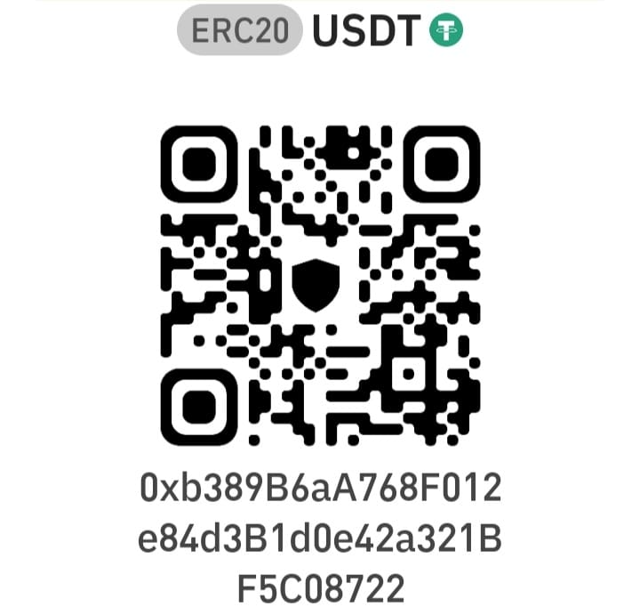
WALLET ADDRESS | 0xb389B6aA768F012e84d3B1d0e42a321BF5C08722

<<<<< THE REST OF THIS PAGE LEFT BLANK INTENTIONALLY >>>>>

B. LIST BTC /WALLET ADDRESS FOR DISTRIBUTION

I. RECEIVER’S BENEFICIARIES
B1. PARTY AB” WALLET (1): TO RECEIVE 2.5% (TWO POINT FIVE PERCENT) OF TOTAL €1,000,000,000.00 (One Billion EURO) = (€25,000,000.00) = (TBA USDT) VALUE INVESTMENT DISBURSEMENT INTO THE FOLLOWING ACCOUNT:

PAYMASTER
AGREEMENT #: | HIPCF/SHMG/100B/2026 | TO RECEIVE 2.5%
NETWORK | TRUST WALLET USDT (ERC20) | QR Code
 |  | 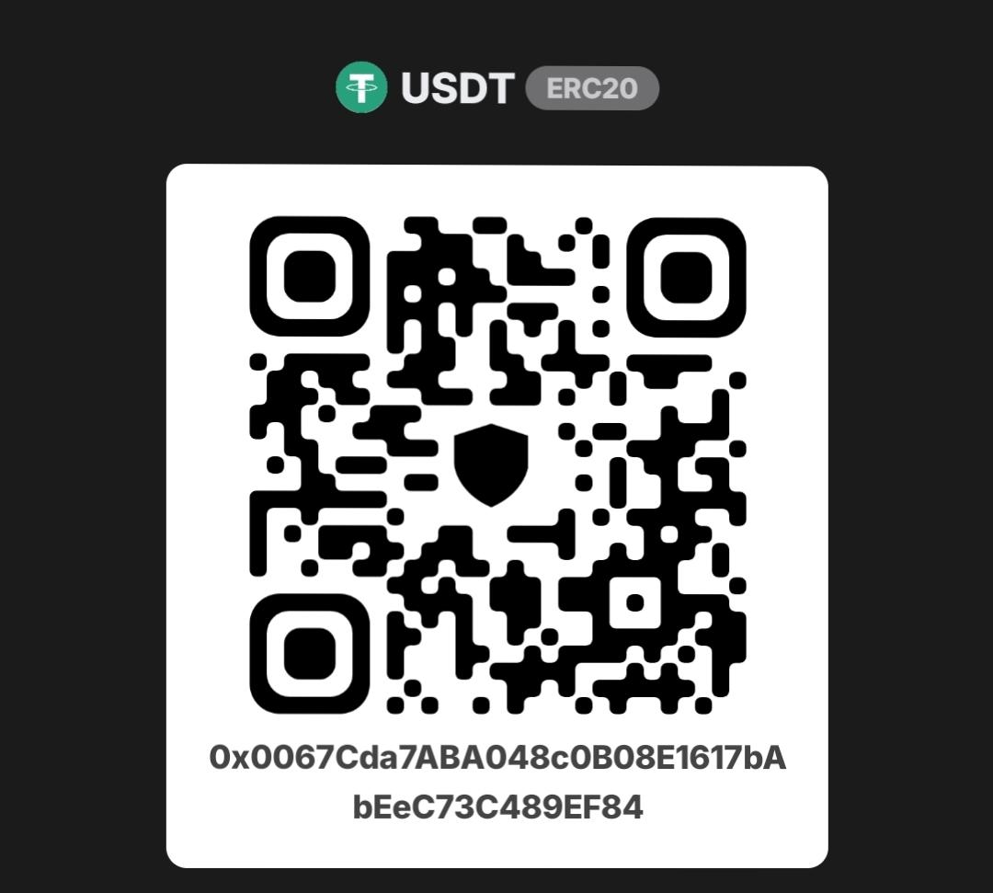
WALLET ADDRESS | 0x0067Cda7ABA048c0B08E1617bAbEeC73C489EF84

B. AGREED AND ACCEPTED FOR AND ON BEHALF OF THE RECEIVER:

IN WITNESS WHEREOF, RECEIVER HAVE HEREUNTO EXECUTED THIS AGREEMENT, HAVING AGREED TO THE PERCENTAGE DISBURSEMENT.
THIS AGREEMENT IS READ, APPROVED AND SIGNED BY RECEIVER IN TWO (2) COPIES, ONE (1) FOR EACH OF THE PARTIES, IN ALL PAGES, ON THIS DATE: JUNE. 10th, 2026
SIGNATURE AND SEAL

………………………………………………………………
COMPANY: | AL-SHUMOOKH GROUP.
REPRESENTED BY: | MR. AHMED MOHAMMED / CEO
PASSPORT NUMBER:
ISSUE / EXPIRY DATE:
COUNTRY OF ISSUE: | UAE

ELECTRONIC SIGNATURE IS VALID AND LEGALLY – BINDING AS AN ORIGINAL IF TRANSMITTED IN SECURE AND CERTIFIED *.PDF FORMAT

PAYER/RECEIVER PASSPORT COPY

PAYER / RECEIVER’S COMPANY CERTIFICATE OF REGISTRATION

ELECTRONIC SIGNATURE IS VALID AND LEGALLY – BINDING AS AN ORIGINAL IF TRANSMITTED IN SECURE AND CERTIFIED *.PDF FORMAT

EDT (ELECTRONIC DOCUMENT TRANSMISSIONS)

EDT (ELECTRONIC DOCUMENT TRANSMISSIONS) SHALL BE DEEMED VALID AND ENFORCEABLEIN RESPECT OF ANY PROVISIONS OF THIS CONTRACT. AS APPLICABLE, THIS AGREEMENT SHALL BE:
- INCORPORATE U.S. PUBLIC LAW 106-229, “ELECTRONIC SIGNATURE IN GLOBAL AND NATIONAL COMMERCE ACT” OR SUCH OTHER APPLICABLE LAW CONFORMING TO THE UNCITRAL MODEL LAW ON ELECTRONIC SIGNATURES (2001) AND;
- ELECTRONIC COMMERCE AGREEMENT (ECE/ TRADE/257, GENEVA, MAY 2000) ADOPTED BY THE
UNITED NATIONS CENTRE FOR TRADE FACILITATION AND ELECTRONIC BUSINESS (UN/CEFACT);
- EDT DOCUMENTS SHALL BE SUBJECT TO EUROPEAN COMMUNITY DIRECTIVE NO. 95/46/EEC, AS
APPLICABLE. EITHER PARTY MAY REQUEST HARD COPY OF ANY DOCUMENT THAT HAS BEEN PREVIOUSLY TRANSMITTED BY ELECTRONIC MEANS PROVIDED HOWEVER, THAT ANY SUCH REQUEST SHALL IN NO MANNER DELAY THE PARTIES FROM PERFORMING THEIR RESPECTIVE OBLIGATIONS AND DUTIES UNDER EDT INSTRUMENTS.

ELECTRONIC TRANSMISSIONS: EACH PARTY IS TO SIGN AND INITIAL THIS AGREEMENT AND SEND COPIES TO THE OTHER PARTY VIA ELECTRONIC MAINLAND SHALL BE CONSIDERED THE SAME AS AN ORIGINAL. WHEN EACH PARTY HAS COMPLETED COPIES OF THIS ELECTRONIC MAIL FROM THE OTHER PARTY, THE AGREEMENT IS CONSIDERED TO BE FINALIZED BY ALL PARTIES. THE PARTIES CONSENT AND AGREE TO BE BOUND CONTRACTUALLY BY ELECTRONIC.

*** END OF AGREEMENT ***

