ALSHUMOOKH GLOBAL BANKING FINANCE & CREDIT
API Integration Details for Sender
Master Wallet to Master Wallet Transfer Workflow
Item | Value / Instruction
Document Purpose | Technical integration instructions for an approved external sender.
Environment | Production
Base URL | https://alshumookh-group-1.onrender.com
Document Date | 2026-05-07
Security Level | Confidential - do not share outside approved technical teams.

1. Purpose
This document explains how an approved sender should integrate with the ALSHUMOOKH payment system to create Master Wallet to Master Wallet transfer requests, receive order references, execute the blockchain transfer, and provide transaction details for confirmation.
Important: This document does not include any Admin API Key. The sender must only receive a dedicated Client API Key created specifically for their account.

2. Required Information From the Sender
Item | Value / Instruction
Company / Sender Name | <SENDER_COMPANY_NAME>
Technical Contact Email | <SENDER_TECH_EMAIL>
Technical Contact Phone | <SENDER_TECH_PHONE>
Server Public IP Address(es) | <SENDER_PUBLIC_IP_1>, <SENDER_PUBLIC_IP_2>
Supported Network(s) | ethereum, base, tron if enabled
Supported Asset(s) | USDC, USDT, ETH, or as approved by ALSHUMOOKH
Callback/Webhook URL | <OPTIONAL_SENDER_CALLBACK_URL>

3. Authentication and Access Control
The sender must authenticate using a dedicated Client API Key. This key is created only for the sender and must be restricted to the sender server public IP address(es).
Item | Value / Instruction
Authentication Header | X-API-Key: <CLIENT_API_KEY>
Content Type | Content-Type: application/json
Idempotency Header | Idempotency-Key: <UNIQUE_REQUEST_ID>
Allowed IPs | The API key should only work from approved sender public IPs.
Admin API Key | Never shared with the sender.
HMAC Secret | Only shared if a signed-request layer is formally enabled.

POST /api/v1/payments/orders HTTP/1.1
Host: alshumookh-group-1.onrender.com
Content-Type: application/json
X-API-Key: <CLIENT_API_KEY>
Idempotency-Key: MW-TRANSFER-10001

4. API Endpoints
Item | Value / Instruction
Create Direct Master Wallet Transfer Request | POST /api/v1/payments/orders
Get Order By Order ID | GET /api/v1/payments/orders/{order_id}
Public Payment Page | GET /pay/direct/{order_id}
Ledger Status Check | GET /api/v1/payments/ledger/status/{order_id}
Coinbase Payment Link Optional | POST /api/v1/transactions

Operational note: If the sender must submit TX Hash directly through API, ALSHUMOOKH should provide a dedicated client-safe endpoint for TX Hash submission. The Admin confirmation endpoint must not be shared externally.

5. Create Direct Master Wallet Transfer Request
Use this endpoint when the sender will transfer crypto from their Master Wallet to the approved ALSHUMOOKH Ledger wallet.
POST https://alshumookh-group-1.onrender.com/api/v1/payments/orders

5.1 Request JSON Example
{
"external_id": "MW-TRANSFER-10001",
"provider": "manual",
"side": "BUY",
"network": "ethereum",
"fiat_currency": "USD",
"crypto_currency": "USDC",
"crypto_amount": "1000.00",
"customer_wallet_address": "0xSenderMasterWalletAddress",
"treasury_wallet_address": "0xBD682cfD8382a90adfDd6745780D3D7959c4d939",
"payer_email": "sender@example.com",
"description": "Master wallet to master wallet transfer"
}

5.2 Required Fields
Field | Type | Required | Description
external_id | string | Yes | Unique sender reference. Must not be reused for another transfer.
provider | string | Yes | Use manual for direct wallet transfer.
side | string | Yes | Use BUY unless otherwise agreed.
network | string | Yes | ethereum, base, or tron if enabled.
crypto_currency | string | Yes | USDC, USDT, ETH, or approved asset.
crypto_amount | decimal | Yes | Amount to be transferred.
customer_wallet_address | string | Recommended | Sender source Master Wallet address.
treasury_wallet_address | string | Optional | If omitted, ALSHUMOOKH configured Ledger wallet is used.
payer_email | string | Optional | Sender notification/contact email.
description | string | Optional | Transfer purpose or internal note.

5.3 Success Response Example
{
"id": "d0ab8af2-ff62-4b2d-b44d-40dfac988e33",
"external_id": "MW-TRANSFER-10001",
"provider": "manual",
"side": "BUY",
"status": "CREATED",
"network": "ethereum",
"fiat_currency": "USD",
"fiat_amount": null,
"crypto_currency": "USDC",
"crypto_amount": "1000.00",
"treasury_wallet_address": "0xBD682cfD8382a90adfDd6745780D3D7959c4d939",
"payment_reference": "MW-TRANSFER-10001",
"checkout_url": null,
"created_at": "2026-05-07T18:00:00Z"
}

6. Execute Blockchain Transfer
After receiving the order response, the sender must execute the transfer from the sender Master Wallet to the approved ALSHUMOOKH Ledger wallet on the same network and using the same asset and amount.
Item | Value / Instruction
Approved Ethereum Ledger Wallet | 0xBD682cfD8382a90adfDd6745780D3D7959c4d939
Network Must Match | The blockchain network in the transfer must match the network in the request.
Asset Must Match | The token/asset transferred must match crypto_currency.
Amount Must Match | The received amount must match crypto_amount.
Reference | The sender should keep external_id and order_id for reconciliation.

7. TX Hash Submission and Confirmation
Once the blockchain transfer is executed, the sender must provide the transaction hash to ALSHUMOOKH for verification. Until a dedicated client-safe TX Hash submission endpoint is enabled, TX Hash should be sent through the approved operational channel or callback process.

7.1 TX Hash JSON Structure
{
"external_id": "MW-TRANSFER-10001",
"order_id": "d0ab8af2-ff62-4b2d-b44d-40dfac988e33",
"network": "ethereum",
"tx_hash": "0xTransactionHashHere"
}

Do not share or expose any Admin confirmation endpoint to the sender. Confirmation remains an ALSHUMOOKH-controlled operation unless a restricted client-safe endpoint is created.

8. Check Order Status
GET https://alshumookh-group-1.onrender.com/api/v1/payments/orders/{order_id}
Headers:
X-API-Key: <CLIENT_API_KEY>

8.1 Status Values
Item | Value / Instruction
CREATED | Order has been created and is awaiting transfer or processing.
PENDING | Transfer is expected or awaiting verification.
PROCESSING | TX Hash or provider confirmation is under review.
COMPLETED | Transfer has been confirmed and documents may be issued.
FAILED | Transfer failed validation or was rejected.
EXPIRED | Order expired if not completed in the agreed time window.

9. Error Response Format
{
"detail": "Invalid API key"
}

Item | Value / Instruction
400 Bad Request | Invalid JSON, missing amount, unsupported network, or invalid amount.
401 Unauthorized | Missing or invalid Client API Key.
403 Forbidden | Client API Key is not allowed from the sender IP address.
404 Not Found | Order does not exist or does not belong to this sender account.
409 Conflict | Duplicate external_id or idempotency conflict if enforced.

10. Security Rules
- Never share the Admin API Key with the sender.
- Create a dedicated Client API Key for this sender only.
- Restrict the Client API Key to the sender server public IP address(es).
- Use Idempotency-Key for every create request to prevent duplicate orders.
- Do not send API keys through public chat. Use a secure channel or password-protected exchange.
- Rotate the Client API Key immediately if compromise is suspected.
- Each sender can only access orders created under their own client account.

11. End-to-End Workflow
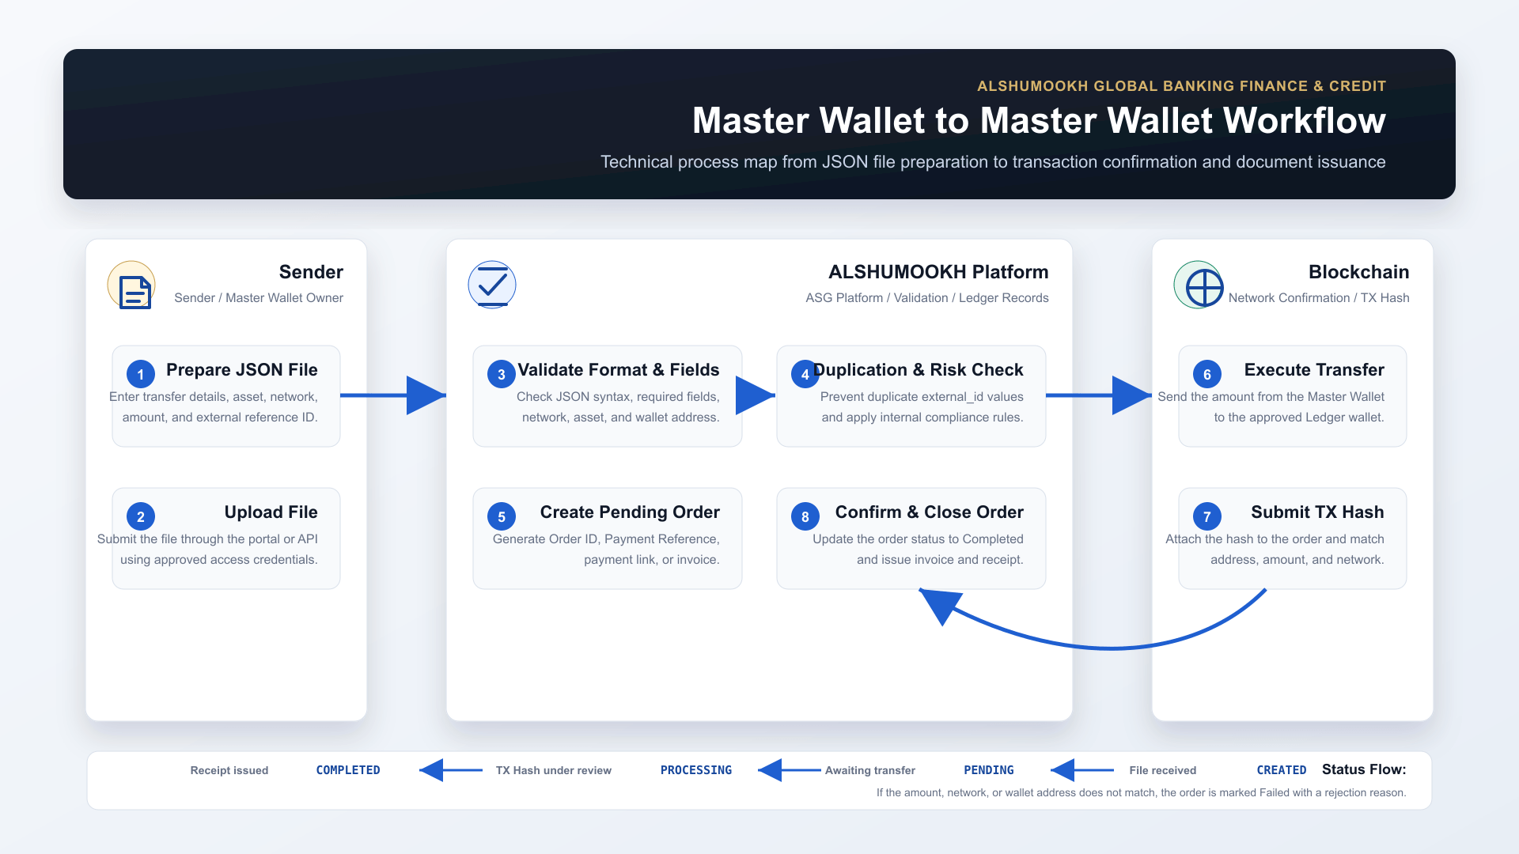

12. Pre-Go-Live Checklist
Checklist Item | Status | Notes
Client API Key created for sender only | Pending
Sender public IPs added to allowed_ips | Pending
Test JSON file received and validated | Pending
Small-value transfer test completed | Pending
Order visible in ALSHUMOOKH dashboard | Pending
Sender cannot access other clients orders | Pending
Operational TX Hash confirmation process agreed | Pending

13. Information to Send Separately
The following sensitive values must be sent separately through a secure channel after the sender public IPs are confirmed:
- Client API Key: <CLIENT_API_KEY>
- Allowed IP confirmation: <APPROVED_SENDER_PUBLIC_IPS>
- Optional callback signing secret only if HMAC/webhook signing is enabled.
Prepared by ALSHUMOOKH GLOBAL BANKING FINANCE & CREDIT. This document is intended for approved technical integration use only.

