ALSHUMOOKH GLOBAL BANKING FINANCE & CREDIT
Master Wallet to Master Wallet Workflow
Technical process map from JSON file preparation to transaction confirmation and document issuance
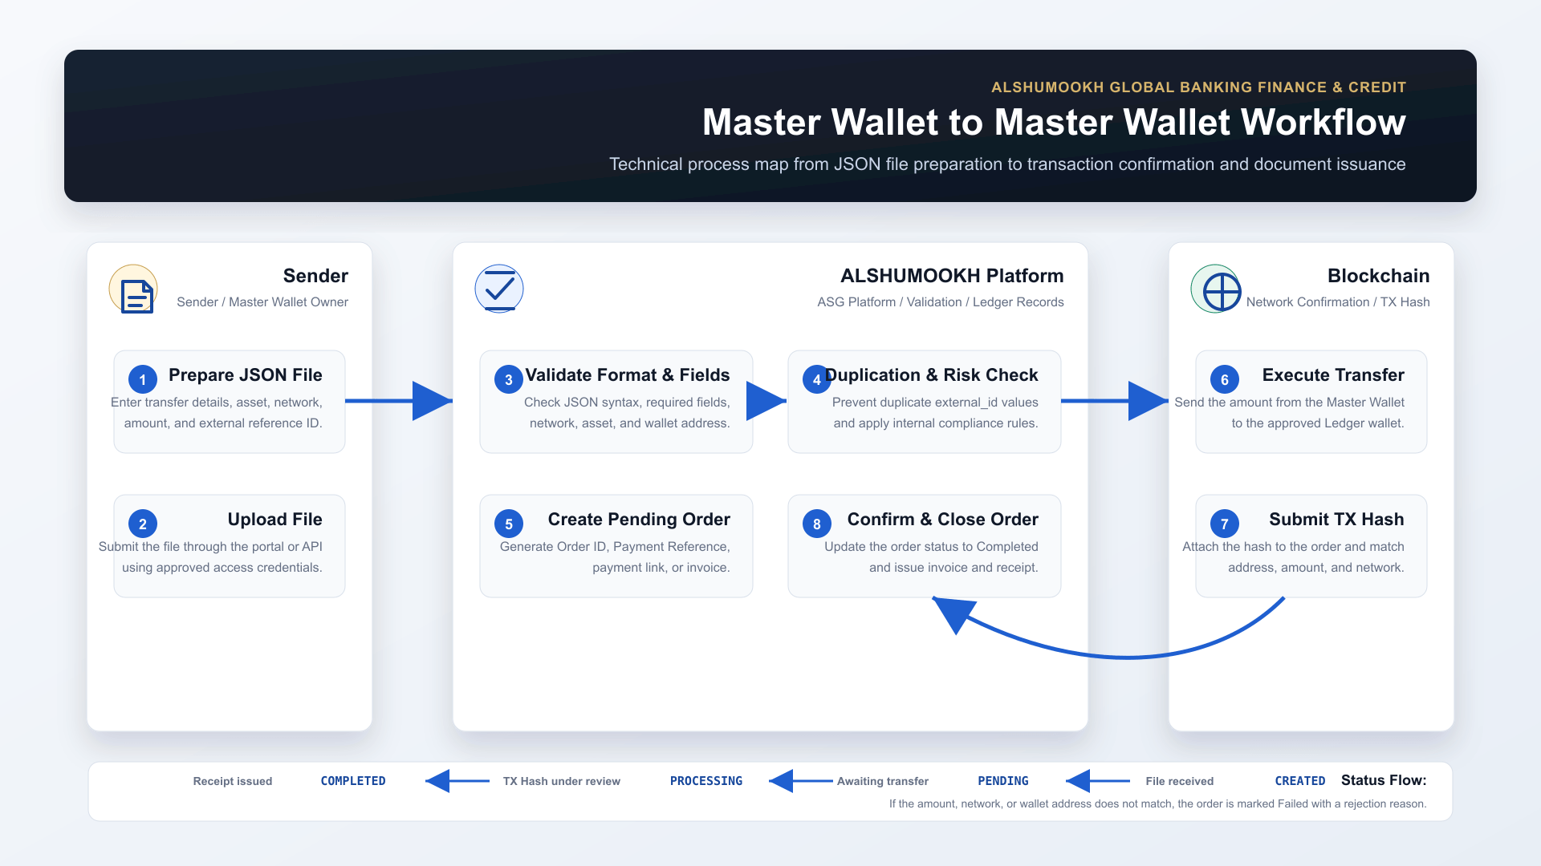
Status Flow: CREATED -> PENDING -> PROCESSING -> COMPLETED / FAILED

