Nabta — Capability Architecture
  - نبتة — المعمارية بالقدرات
Abdulsalam
2026-09-21
Table of Contents

Revision history
Version | Date | Author | Change
0.1 | 2026-09-21 | Abdulsalam | Capability architecture: context, capabilities, module rules, event map, three key flows, data ownership, cross-cutting concerns, decisions log. No product named; products arrive with the Phase 5 ADRs

1 Purpose and scope
This document describes Nabta as a set of capabilities joined by contracts and events, so that the system can be reasoned about, tested and costed before a single technology is chosen. It answers: what are the parts, what does each own, what may cross a boundary, and how do the three flows that define the product actually run. It does not name a language, a framework, a database or a provider. When Phase 5 ends, every open component in PLAN §8.1 has a decision record, and this document’s next major version becomes the software architecture: the same boxes with products inside them and the decisions log filled.
Sources: the charter (vision.md), the pedagogy (pedagogy.md), the requirements (srs.md) — flows below cite requirement IDs — and PLAN §6–§7.
الملخص. تصف هذه الوثيقة نبتة كمجموعة قدرات تربطها عقود وأحداث، لا كمجموعة تقنيات: ما الأجزاء، ماذا يملك كلٌّ منها، ما الذي يجوز أن يعبر الحدود بينها، وكيف تجري التدفّقات الثلاثة التي تعرّف المنتج — الجلسة اليومية، توليد القصة، تقييم القراءة الجهرية. لا تسمّي لغة ولا إطارًا ولا قاعدة بيانات ولا مزوّدًا؛ المنتجات تأتي مع قرارات المرحلة الخامسة، وحينها تصير هذه الوثيقة معمارية البرمجيات بالصناديق نفسها والمنتجات داخلها.

2 Context
Three kinds of people, one system, and external AI providers that the system reaches only through ports it owns.
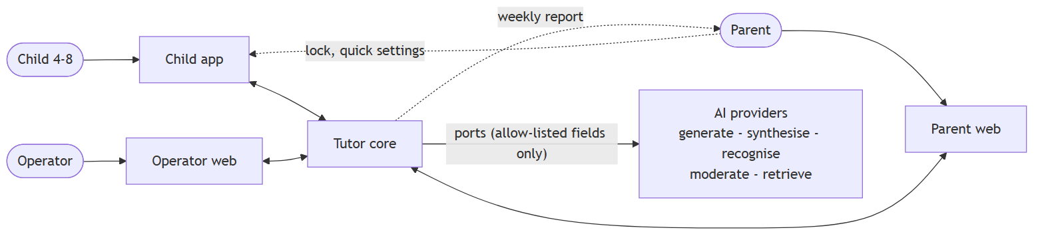
System context
Element | Role | Notes
Child | Learns; touch and voice only | Never an account; never sends free text anywhere (FR-AI-008)
Parent | Consents, configures, reads, asks | The account; the lock and quick settings inside the child app, everything else on the parent web (D-2026-09-21-8, proposed)
Operator | Curates, reviews, watches | One person
Child app | Runs a full session offline from a pack | Stores attempts with client ids until acknowledged (FR-TUT-005/006)
Parent web · Operator web | Read and administer | Network required
Tutor core | Everything else: one deployable with background jobs | P-1
AI providers | Generation, synthesis, recognition, moderation, retrieval | Configuration behind ports; only allow-listed fields cross (FR-AI-001/004)

3 Capabilities
The container view, drawn as capabilities. Each box in the core is a module with its own storage and a contract; the arrows are the only permitted dependencies.
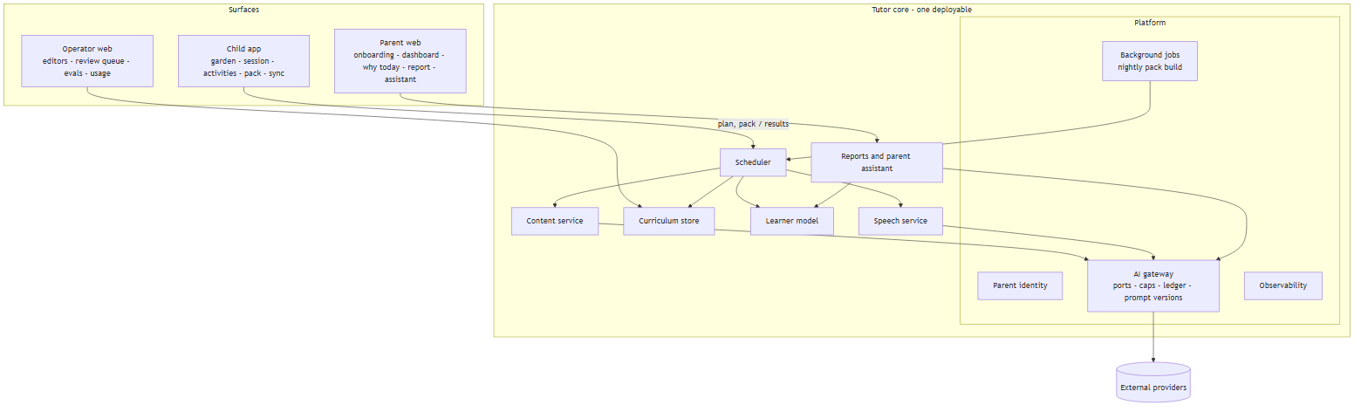
Capabilities
Capability | Owns | Offers (contract) | Emits
Curriculum store | skill graph (versioned), content items, word lists, activity templates, template stories, policy | load and validate a graph; expand nodes; frontier(statuses); content by scope; decompose(text) | CurriculumPublished
Learner model | children (profile, consents), SkillMastery, Attempt, review state | record attempts (idempotent on client id); update statuses by the mastery rule; statuses and evidence for a child; export; delete | AttemptRecorded, MasteryChanged, SkillMastered, ReviewDue, ConfusionDetected, ConsentChanged, ChildDeleted
Scheduler | session plans and their reasons | plan(child, date) → plan with reasons (R1–R14, deterministic) | SessionPlanned
Content service | generated content and its statuses, review items, activity packs | story(brief), wordProblem(brief) → Validated content or fallback; buildPack(plan); review queue | ContentValidated, ContentRejected, ContentFlagged, PackBuilt
Speech service | audio assets (by text hash and voice), recordings (encrypted, TTL), alignment results | synthesise(text, voice) cached; score(audio, target) → per-word evidence; purge | AudioSynthesised, RecordingScored, RecordingPurged
Reports & parent assistant | weekly reports, ParentQuery log, retrieval index over pedagogy / guide / activities | dashboard data (from learner statuses), “why today” (from plan reasons), weekly report, ask(question, child) with sources | WeeklyReportReady
Platform | parent identity, storage, jobs, AI gateway (Usage, Prompt, EvalRun), observability | ports (generate, repair, synthesise, recognise & align, moderate, retrieve); caps; ledger; prompt versions; eval gate; schedules | CapReached, ProviderFailed, EvalRun

4 Module rules
These hold whatever the stack turns out to be (PLAN §6). They are the tests the software architecture will be checked against.
- Explicit boundaries. Curriculum, Learners, Tutor (scheduler), Content, Speech, Reports and the AI gateway are separate modules. A module reaches another only through its contract or by consuming its events; no module reads another’s storage. A query that needs two modules’ data is answered by one module calling the other’s contract, or by a read model fed by events (the dashboard is one).
- AI behind interfaces. Every model, synthesis, recognition, moderation and retrieval call goes through a port owned by the platform (FR-AI-001). Providers are configuration. Every call is logged and capped (FR-AI-002/003). The port enforces the field allow-list (FR-AI-004): nickname, age band, interests, cast first names and relations, non-personal constraints — nothing else, ever.
- Nothing unvalidated reaches a child. Content is cached with a status; a pack contains only Validated or Approved content (FR-CNT-005, NFR-SAF-001); any rejection falls back to a template (FR-CNT-004).
- Children are not accounts. A child is data owned by a parent account, selected by a PIN (FR-LRN-002). No credentials, no surname, no photo, no location — the fields do not exist.
- Offline is a feature. The child app completes a session from a pack; submission is idempotent on client-generated ids (FR-TUT-005/006, NFR-OFF-*).
- Decisions produce reasons. The scheduler emits a reason object with every planned activity at decision time (FR-TUT-003); no module reconstructs a reason afterwards.
- Evidence is typed. An attempt is either evidence or no-evidence at the moment it is recorded (FR-LRN-005/006); nothing downstream reinterprets it.

5 Event map
Events are facts, past tense, with a stable name and a small payload keyed by ids. They are the only way a module learns about another’s changes without calling it. Planned: delivery semantics (in-process vs. queued) are a Phase 5 decision; the contract is at-least-once with idempotent consumers.
Event | Producer | Payload (key fields) | Consumers
SessionPlanned | Scheduler | child, date, plan id, activities with reasons | Content (build pack), Reports (why today)
PackBuilt | Content | child, date, pack id, size, content hashes | Child app sync, Observability
AttemptRecorded | Learner model | attempt id (client), child, skill(s), evidence flag, distractor | Learner model (mastery), Observability
MasteryChanged | Learner model | child, skill, old status, new status, estimate | Scheduler, Reports (dashboard read model), Child app (garden)
SkillMastered | Learner model | child, skill, mastered at | Scheduler (seed, letter-focus story), Reports
ReviewDue | Learner model | child, skill, due date | Scheduler
ConfusionDetected | Learner model | child, letter x, letter y, counts | Scheduler (R9), Reports (knot)
ContentValidated / ContentRejected / ContentFlagged | Content | content id, kind, brief hash, prompt version, validator report, cost | Content (pack), Operator review queue, Observability
AudioSynthesised | Speech | text hash, voice, duration, cost | Content (pack)
RecordingScored | Speech | attempt id, per-word results, floor applied | Learner model
RecordingPurged | Speech | recording id, purged at | Observability, privacy audit
WeeklyReportReady | Reports | child, week, report id | Parent notification
ConsentChanged | Learner model | child, scope, granted/revoked, at | Speech (disable capture), Content (template-only), audit
CapReached | AI gateway | scope (child/global), purpose, at | Content (fallback), Observability
ProviderFailed | AI gateway | port, error class, retries | Content (fallback), Observability
ChildDeleted | Learner model | child id, at | every module: purge; audit (without data)

6 Key flows
Each step cites the requirement it satisfies. Participants are capabilities, never products.

6.1 Daily session
Nightly build, offline session, idempotent sync, next plan.
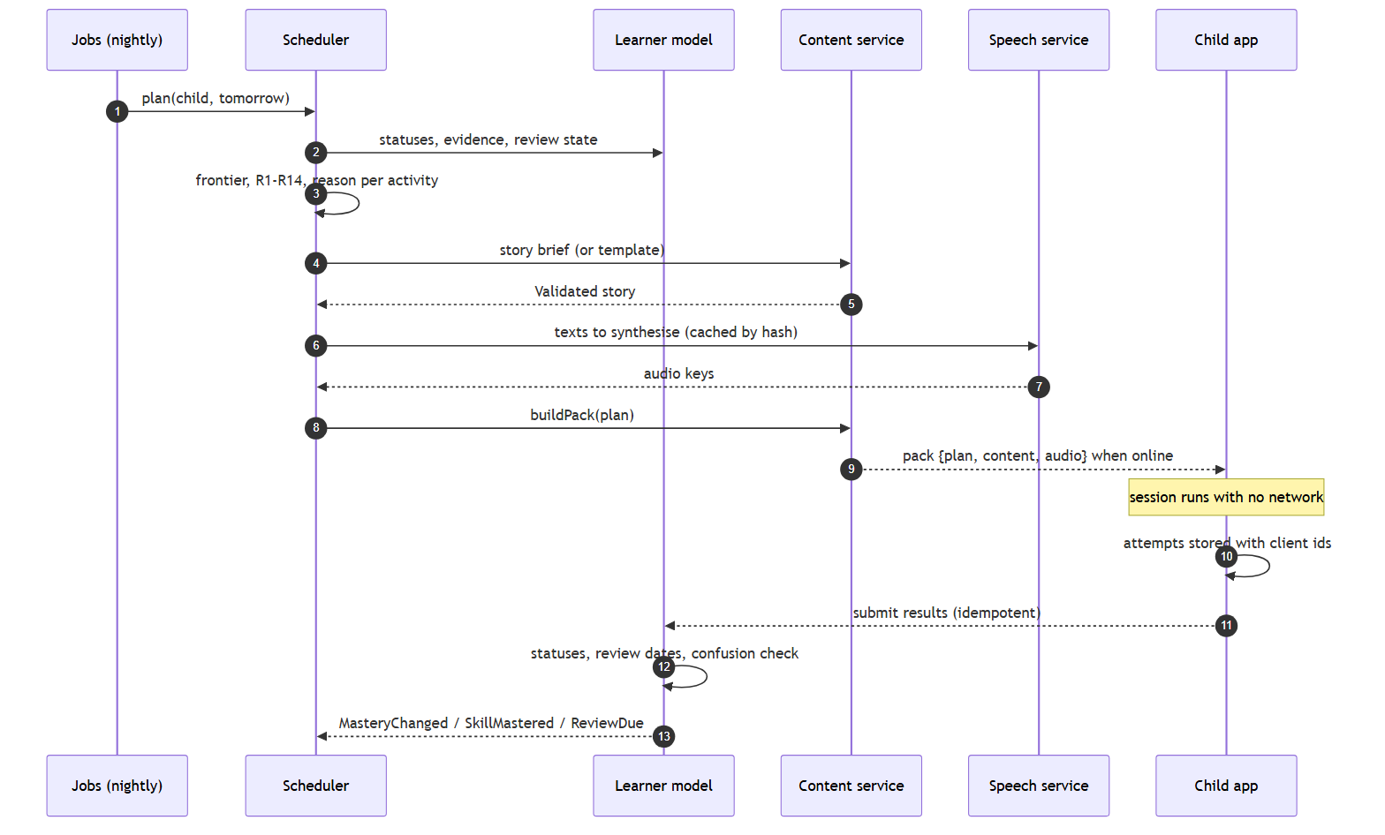
Daily session
# | Step | Requirements
1–3 | The nightly job asks the scheduler for tomorrow’s plan; the scheduler reads the learner state, computes the frontier and applies R1–R14, attaching a reason to every activity | FR-CUR-004, FR-TUT-001…003, FR-CUR-010
4–5 | The story brief is written by the scheduler; the content service returns Validated content or a template story | FR-CNT-001…005, FR-CNT-007
6–7 | Every text in the plan is synthesised once and cached by hash | FR-SPC-001/002, NFR-COST-002
8–9 | The pack is assembled and pulled by the child app when a network exists | FR-TUT-005, NFR-OFF-001/002
10 | The session runs offline; attempts carry client-generated ids | NFR-OFF-001, FR-LRN-005
11–12 | Results are submitted at least once; the learner model applies the mastery rule and the confusion trigger; no-evidence rows never lower an estimate | FR-TUT-006, FR-LRN-006/007, FR-TUT-010, NFR-REL-001
13 | Events feed the next plan, the garden and the dashboard | FR-TUT-011, FR-RPT-001
The staleness question. The plan is built on the statuses of the night before; if the warm-up changes them, a pre-generated story could fall outside the letter set (charter risk R3). The architecture leaves three options for Phase 5 to cost: build one spare story below ability; freeze the story’s letter set to what was mastered before the warm-up (never the session’s new letter); or allow the story to be below ability, never above. All three keep G2.

6.2 Story generation
Brief → gateway → structured output → validators in fixed order → safety → one repair → cache.
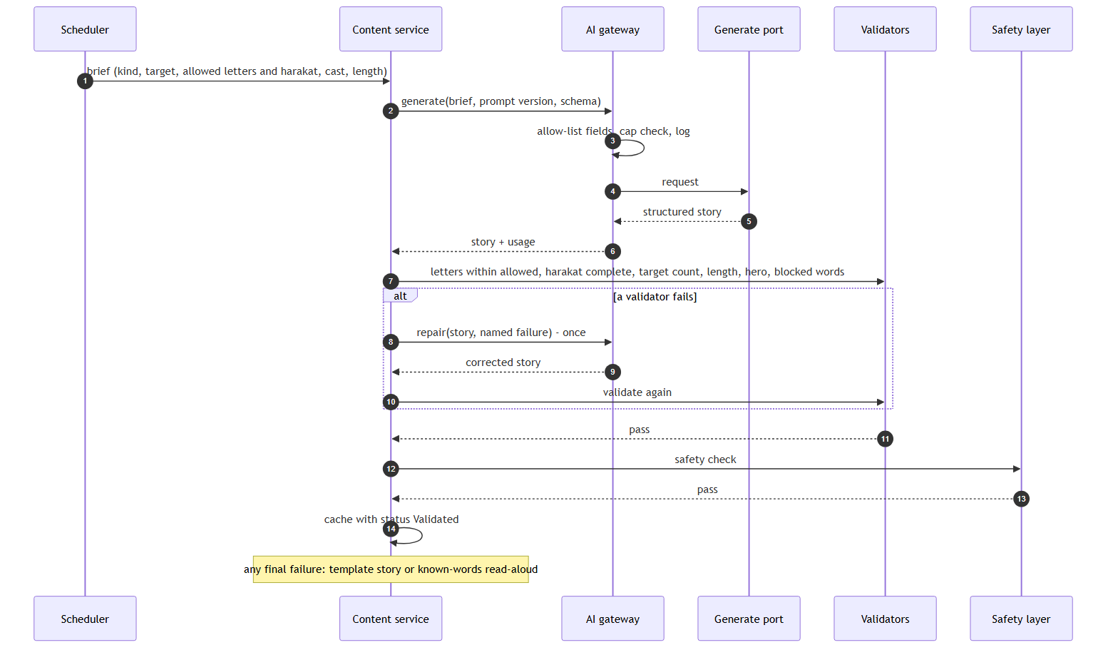
Story generation
# | Step | Requirements
1 | The scheduler writes the brief; the model never chooses its own constraints; no parent free text | FR-CNT-001, FR-AI-008
2–6 | The gateway applies the field allow-list, checks caps, logs, and calls the generate port with a versioned prompt and an output schema | FR-AI-001…004, FR-CNT-002
7 | Validators run in the fixed order; each failure is logged with the prompt version | FR-CNT-003, FR-CUR-006
8–10 | One repair round with the failure named | FR-CNT-004
11–13 | Safety layer, then cache with status Validated; only Validated or Approved content enters a pack | FR-CNT-005, NFR-SAF-001
note | Fallback is a template story or a read-aloud of known words — never a story above ability | FR-CNT-004/007, R10

6.3 Read-aloud scoring
Consent, capture, recognise and align through a port, the confidence floor, purge.
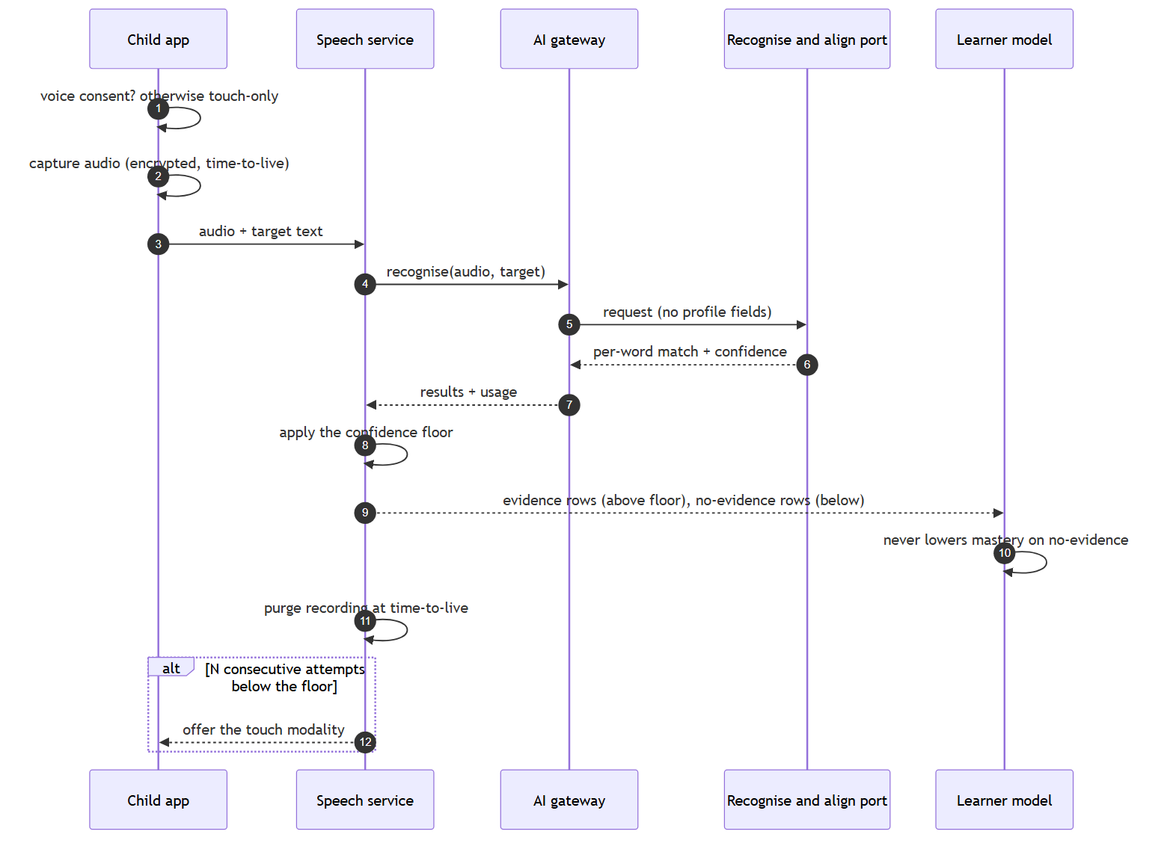
Read-aloud scoring
# | Step | Requirements
1 | No consent → the microphone is never shown | FR-LRN-003, UC-06
2–3 | Audio is encrypted on capture and carries its time-to-live | FR-SPC-006, G13
4–7 | Recognition and alignment go through the port; the request carries no profile fields | FR-SPC-004, FR-AI-004
8–10 | The floor separates evidence from no-evidence; a no-evidence row never lowers an estimate or advances a review | FR-SPC-005, FR-LRN-006, G10
11 | The recording is purged; the evidence row keeps per-word results only | FR-SPC-006
12 | After N below-floor attempts the session offers touch | FR-SPC-007, G6
Where recognition runs — on the device or through a hosted port — is an E3 question; the flow is the same either way, and the child notices only latency.

7 Data ownership
Each module owns its entities; nobody else writes them (PLAN §7).
Module | Entities
Curriculum | Domain, Skill (expanded), SkillPrerequisite, ActivityTemplate, ContentItem, WordList, StoryTemplate, Policy
Learners | Child, Consent, SkillMastery, Attempt
Tutor | Session, SessionActivity (with reason)
Content | GeneratedContent (status, validation report, prompt version, cost), ReviewItem, ActivityPack
Speech | AudioAsset, Recording (encrypted, retain-until), alignment results on the attempt
Reports | WeeklyReport, ParentQuery, the retrieval index (derived, rebuildable)
Platform | parent identity, Usage, Prompt, EvalRun, caps
Read models that span modules — the dashboard, the garden — are built from events, never from joins across module storage.

8 Cross-cutting concerns
Offline and sync. The pack is the unit of delivery; the attempt with a client id is the unit of return. At-least-once delivery, idempotent handling, results kept on the device until acknowledged (FR-TUT-006, NFR-OFF-001, NFR-REL-001).
The AI gateway. Seven ports (generate, repair, synthesise, recognise & align, moderate, retrieve, illustrate-deferred); providers as configuration; per-call logging with prompt version and cost; per-child and global caps with template fallback; bounded retries; the field allow-list; eval suites in CI gating prompt changes (FR-AI-001…008, NFR-SAF-002).
Observability. One weekly view: cost per child-day, cap hits, validator rejection rates, eval scores, share of below-floor attempts (NFR-OBS-001). Every event above is also a metric.
Privacy and security. Consent per scope with an audit trail; recordings and packs encrypted at rest; recordings purged at their time-to-live; export and delete per child; the data-flow map maintained and the allow-list derived from it (NFR-PRV-*).
Deployment shape. One deployable core with background jobs, one child app, one web for parent and operator. Nothing here says how; P-1 says how many.

9 Decisions log

9.1 Taken (product and process)
P-1 … P-7 (PLAN §8.2); D-2026-09-21-1 … 7 (charter § Decisions); D-2026-09-21-8 surface split — proposed (SRS § Product perspective).

9.2 Open — products decided in Phase 5
Component | Candidate classes | Decided in
Language model for content | small local · server open-weights · hosted; ± fine-tuning | A2, A3, A5, E3
Prompting and output control | plain · schema-constrained · constrained decoding · post-validation | A3, A6, E1
Speech synthesis | open neural · hosted neural · on-device | B1, B4
Speech recognition and reading assessment | open ASR · hosted ASR · pronunciation assessment · forced alignment | B2, B3
Handwriting scoring | stroke template matching · small on-device classifier · vision model | C1, C2
Learner model and scheduler | BKT · IRT/Elo · DKT · SM-2/FSRS; engineered vs model-as-tutor | D2–D7
Safety layer | output classifiers · hosted moderation · allow-list validators · review sampling | E1
Retrieval for the parent assistant | none (long context) · hand-built index · hosted file search | A4, E3
Story illustrations (deferred) | none · generated with a house style and a vision check | C3
Nightly pack generation | on demand · provider batch API | E3
Where inference runs | on-device · self-hosted · hosted, per component | E3
Child app platform | native · cross-platform toolkit · web/PWA — scored on NFR-PERF, NFR-OFF, NFR-DEV | E5
Backend, storage, jobs, identity, event delivery | from the requirements the study produced | E5
Parent and operator web | — | E5
ADR-001 (lab runtime) is reserved for step 1.1 and is not a product decision.

10 Open questions for Phase 5
- Pack staleness (charter R3): which of the three options is cheapest while keeping G2?
- Can recognition run on the device at the floor, or is a hosted port required (privacy vs. latency vs. cost)?
- Where does the retrieval index live and how is it rebuilt when the pedagogy changes?
- Event delivery: in-process now, queued later — what does “one deployable” allow?
- Confirm or reverse the surface split (D-2026-09-21-8) before Phase 7 is expanded.

