Wathiq — Software Architecture Document
  - وثيق — وثيقة معمارية البرمجيات
Abdulsalam
2026-08-27
Table of Contents

Document control
Version | Date | Author | Change
0.1 | 2026-08-27 | Abdulsalam | C4 context + container, module map, key flows, decisions D1–D9 (roadmap step 0.5)
Status: Draft · Related: Vision (vision), SRS (srs), Database (database). Diagrams are authored in Mermaid (source kept beside each figure) and rendered to assets/*.png with mermaid-cli. Anything not yet built is marked Planned.

1 Introduction
This document describes the target architecture of Wathiq v1 using the C4 model (context, container, component) and records the decisions that shape it. The system is a modular monolith: one deployable ABP/.NET application whose modules are isolated in code and in the database, plus self-hosted AI on the same server.
Architectural drivers (from the SRS): privacy constraint C1 (personal data never reaches a cloud AI), cost ceiling C2 (≤ USD 20/month), solo operation (NFR-OPS-001), and bilingual RTL UI (NFR-I18N-001).

2 C4 Level 1 — System context
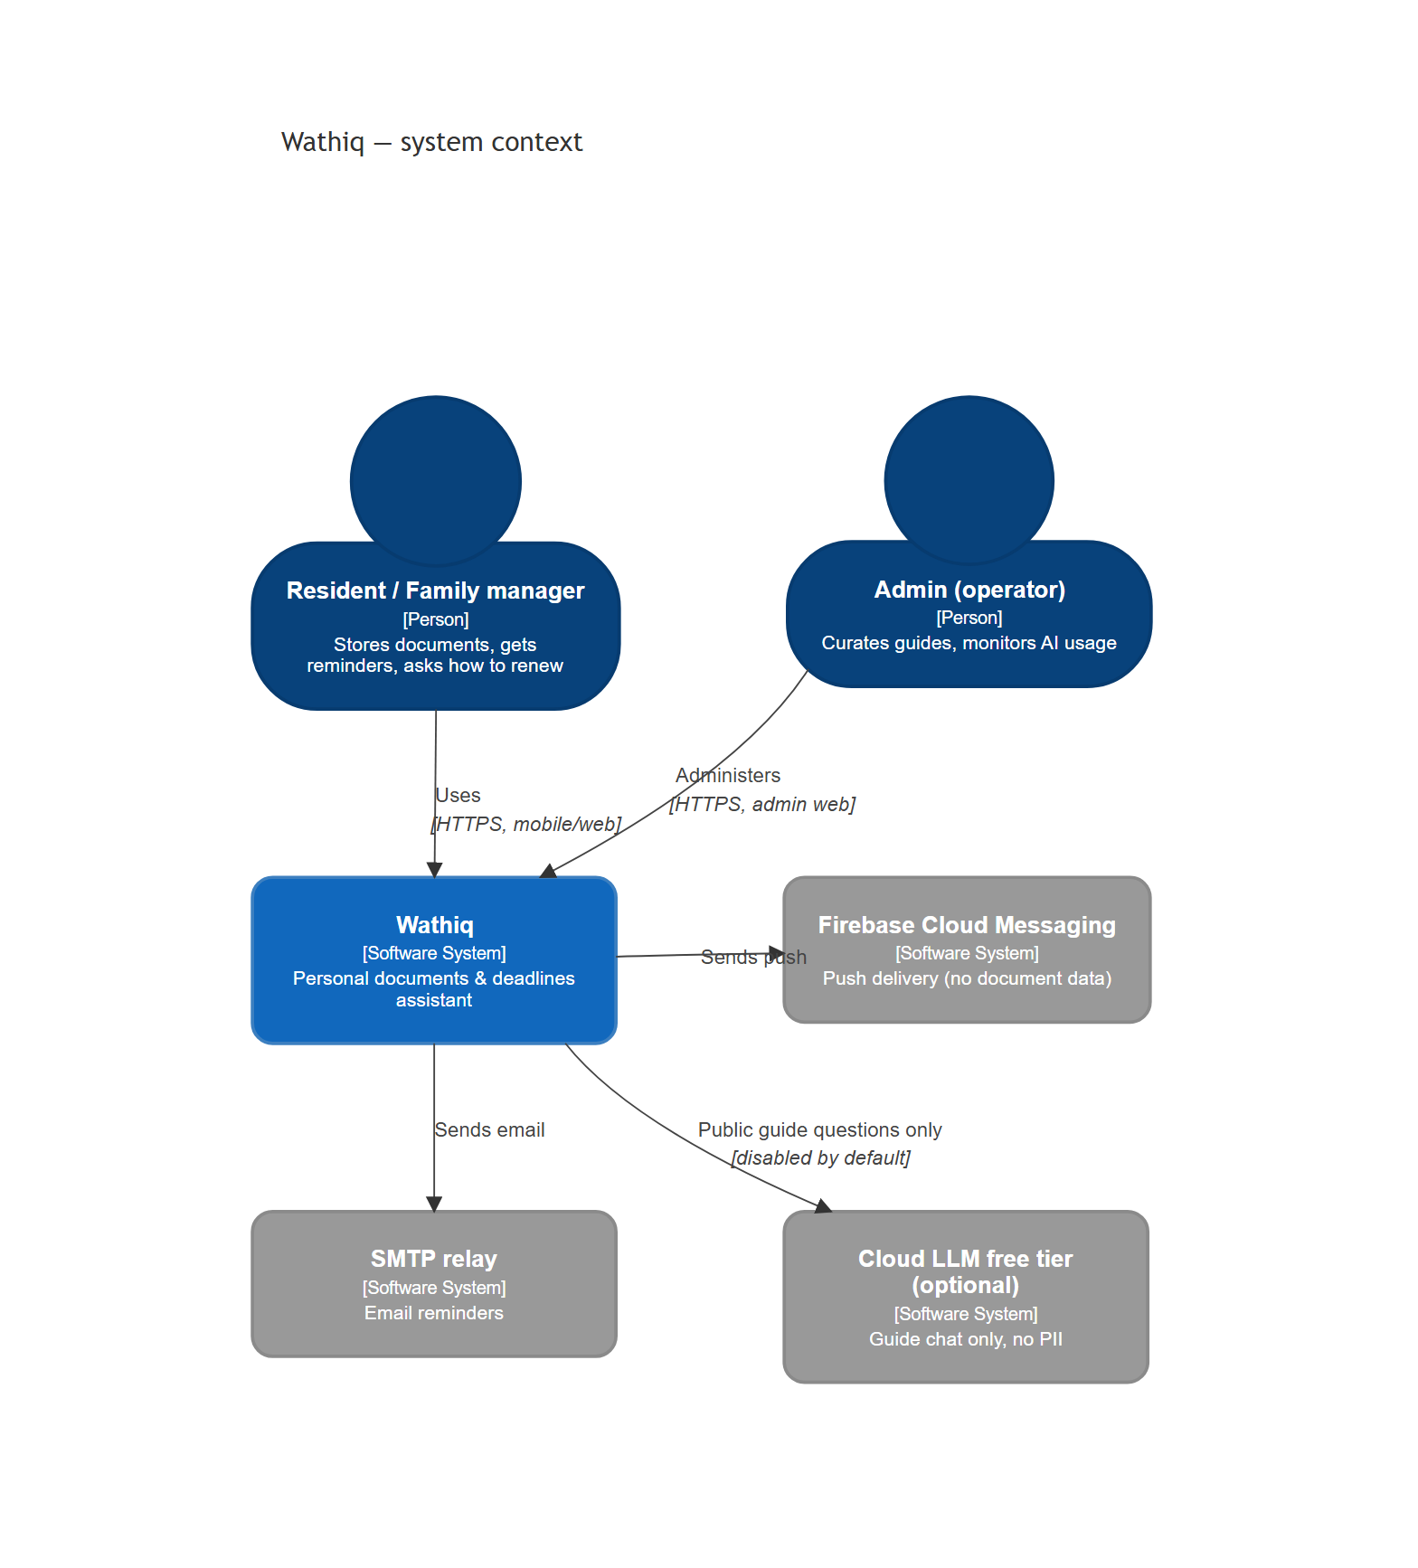
System context
C4Context
title Wathiq — system context
Person(resident, "Resident / Family manager", "Stores documents, gets reminders, asks how to renew")
Person(admin, "Admin (operator)", "Curates guides, monitors AI usage")
System(wathiq, "Wathiq", "Personal documents & deadlines assistant")
System_Ext(fcm, "Firebase Cloud Messaging", "Push delivery (no document data)")
System_Ext(smtp, "SMTP relay", "Email reminders")
System_Ext(cloudllm, "Cloud LLM free tier (optional)", "Guide chat only, no PII")
Rel(resident, wathiq, "Uses", "HTTPS, mobile/web")
Rel(admin, wathiq, "Administers", "HTTPS, admin web")
Rel(wathiq, fcm, "Sends push")
Rel(wathiq, smtp, "Sends email")
Rel(wathiq, cloudllm, "Public guide questions only", "disabled by default")
Element | Responsibility | Trust boundary
Resident / Family manager | Owns personal data; confirms every AI extraction | External person
Admin | Single operator | External person, elevated role
Wathiq | Everything that touches personal data | Our server
FCM, SMTP | Delivery channels; payloads carry titles, never document fields | Third party
Cloud LLM (optional) | Answers public procedure questions when enabled | Third party; PII forbidden (C1)

3 C4 Level 2 — Containers
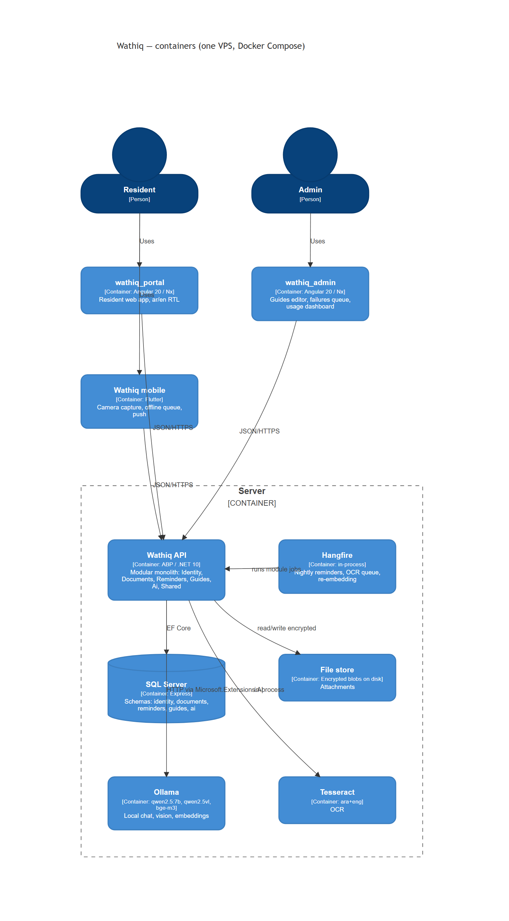
Containers
C4Container
title Wathiq — containers (one VPS, Docker Compose)
Person(resident, "Resident")
Person(admin, "Admin")
Container(portal, "wathiq_portal", "Angular 20 / Nx", "Resident web app, ar/en RTL")
Container(adminapp, "wathiq_admin", "Angular 20 / Nx", "Guides editor, failures queue, usage dashboard")
Container(mobile, "Wathiq mobile", "Flutter", "Camera capture, offline queue, push")
Container_Boundary(server, "Server") {
Container(api, "Wathiq API", "ABP / .NET 10", "Modular monolith: Identity, Documents, Reminders, Guides, Ai, Shared")
Container(jobs, "Hangfire", "in-process", "Nightly reminders, OCR queue, re-embedding")
ContainerDb(sql, "SQL Server", "Express", "Schemas: identity, documents, reminders, guides, ai")
Container(files, "File store", "Encrypted blobs on disk", "Attachments")
Container(ollama, "Ollama", "qwen2.5:7b, qwen2.5vl, bge-m3", "Local chat, vision, embeddings")
Container(tess, "Tesseract", "ara+eng", "OCR")
}
Rel(resident, portal, "Uses")
Rel(resident, mobile, "Uses")
Rel(admin, adminapp, "Uses")
Rel(portal, api, "JSON/HTTPS")
Rel(adminapp, api, "JSON/HTTPS")
Rel(mobile, api, "JSON/HTTPS")
Rel(api, sql, "EF Core")
Rel(api, files, "read/write encrypted")
Rel(api, ollama, "HTTP via Microsoft.Extensions.AI")
Rel(api, tess, "in-process")
Rel(jobs, api, "runs module jobs")
Container | Technology | Notes | Status
Wathiq API | ABP, .NET 10, EF Core, OpenIddict | One process hosts all modules and Hangfire | Planned (P1)
SQL Server | Express (prod) / LocalDB (dev) | One database, one schema per module | Planned (P1)
File store | Local disk, AES-encrypted blobs | Key outside the data volume (NFR-SEC-001); S3-compatible later | Planned (P1, encryption P8)
Ollama | qwen2.5:7b, qwen2.5vl:7b, bge-m3 | Only container allowed to see document data | Planned (P3)
Tesseract | ara+eng | Deterministic OCR before the LLM (D5) | Planned (P3)
wathiq_portal / wathiq_admin | Angular 20, Nx, Tailwind 4 | Two apps, shared Nx libs | Planned (P4, P7)
Wathiq mobile | Flutter, Riverpod, Drift | Offline-first | Planned (P6)

4 C4 Level 3 — Modules (components of the API)
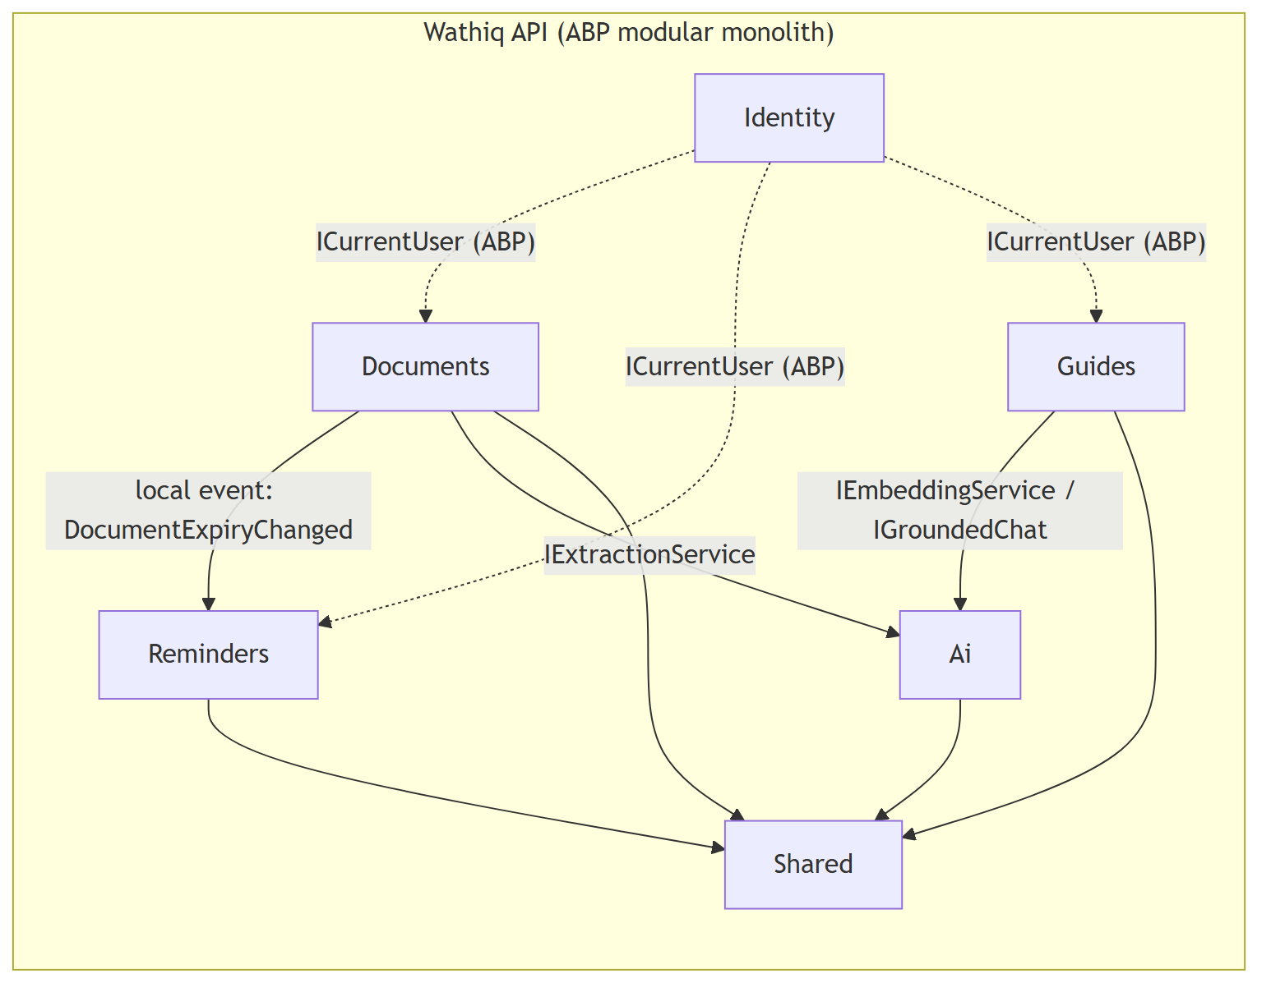
Module map
flowchart LR
subgraph API["Wathiq API (ABP modular monolith)"]
IDM[Identity]
DOC[Documents]
REM[Reminders]
GDE[Guides]
AI[Ai]
SHR[Shared]
end
DOC -- "local event: DocumentExpiryChanged" --> REM
DOC -- "IExtractionService" --> AI
GDE -- "IEmbeddingService / IGroundedChat" --> AI
DOC --> SHR
GDE --> SHR
REM --> SHR
AI --> SHR
IDM -. "ICurrentUser (ABP)" .-> DOC
IDM -. "ICurrentUser (ABP)" .-> REM
IDM -. "ICurrentUser (ABP)" .-> GDE
Each module is four projects — Domain, Application, EntityFrameworkCore, HttpApi — under backend/modules/<Name>/, the same layering as the reference ABP backend.
Module | Owns | Exposes to other modules | Depends on
Identity | Users, roles, family links (ABP Identity) | ICurrentUser, user id | —
Documents | DocumentType, Holder, Document, Attachment, ExtractionResult | IDocumentLookup (id → expiry, holder); event DocumentExpiryChanged | Ai, Shared
Reminders | ReminderRule, Reminder, DeliveryLog; nightly job | — | Documents (events + lookup), Shared
Guides | Guide, GuideVersion, GuideStep, GuideChunk (+embedding), Feedback | IGuideSearch | Ai, Shared
Ai | Provider routing, prompts, Usage, caps, eval samples | IExtractionService, IEmbeddingService, IGroundedChat | Shared
Shared | File storage abstraction, localization, audit, encryption | IFileStore, IEncryptor | —
Module rules
- No cross-module DB joins. Each module has its own DbContext and SQL schema; a module never maps another module’s tables. Where the reference backend uses one shared MoDBenefitTrackDbContext with all DbSets, Wathiq deliberately splits it (see D10).
- Cross-module reads go through an application-service interface in the owning module (IDocumentLookup), returning DTOs — never entities.
- Cross-module reactions go through ABP local events (DocumentExpiryChanged → Reminders).
- Foreign keys across schemas are stored as plain Guid columns without a database constraint; integrity is enforced in the owning module’s application service.
- Only Ai references Microsoft.Extensions.AI; no provider SDK type appears outside it.

5 Key flows

5.1 Add a document with extraction (UC-01)
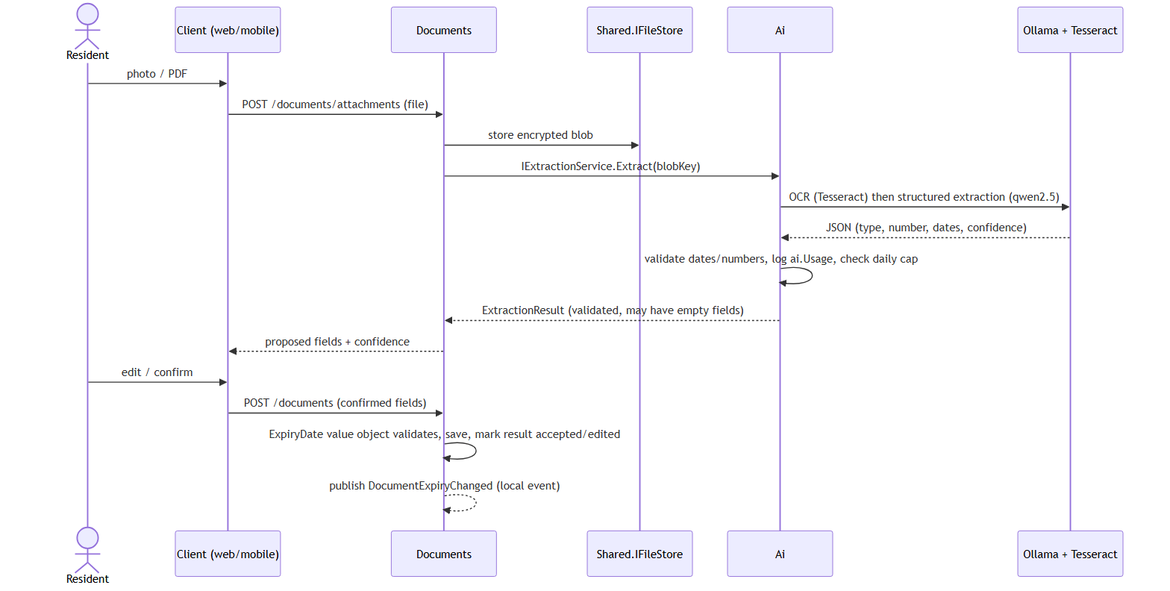
Add document flow
sequenceDiagram
actor U as Resident
participant C as Client (web/mobile)
participant D as Documents
participant S as Shared.IFileStore
participant A as Ai
participant O as Ollama + Tesseract
U->>C: photo / PDF
C->>D: POST /documents/attachments (file)
D->>S: store encrypted blob
D->>A: IExtractionService.Extract(blobKey)
A->>O: OCR (Tesseract) then structured extraction (qwen2.5)
O-->>A: JSON (type, number, dates, confidence)
A->>A: validate dates/numbers, log ai.Usage, check daily cap
A-->>D: ExtractionResult (validated, may have empty fields)
D-->>C: proposed fields + confidence
U->>C: edit / confirm
C->>D: POST /documents (confirmed fields)
D->>D: ExpiryDate value object validates, save, mark result accepted/edited
D-->>D: publish DocumentExpiryChanged (local event)

5.2 Nightly reminder run (UC-02)
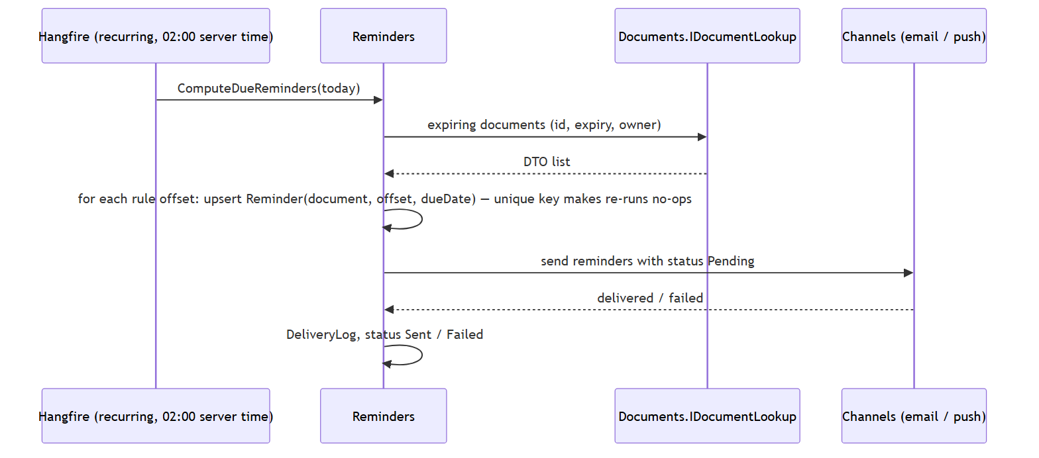
Reminder run
sequenceDiagram
participant H as Hangfire (recurring, 02:00 server time)
participant R as Reminders
participant DL as Documents.IDocumentLookup
participant CH as Channels (email / push)
H->>R: ComputeDueReminders(today)
R->>DL: expiring documents (id, expiry, owner)
DL-->>R: DTO list
R->>R: for each rule offset: upsert Reminder(document, offset, dueDate) — unique key makes re-runs no-ops
R->>CH: send reminders with status Pending
CH-->>R: delivered / failed
R->>R: DeliveryLog, status Sent / Failed
Idempotency: Reminder has a unique index on (DocumentId, OffsetDays); sending is gated by status, so a second run on the same day finds nothing Pending (FR-REM-002).

5.3 Grounded renewal answer (UC-03)
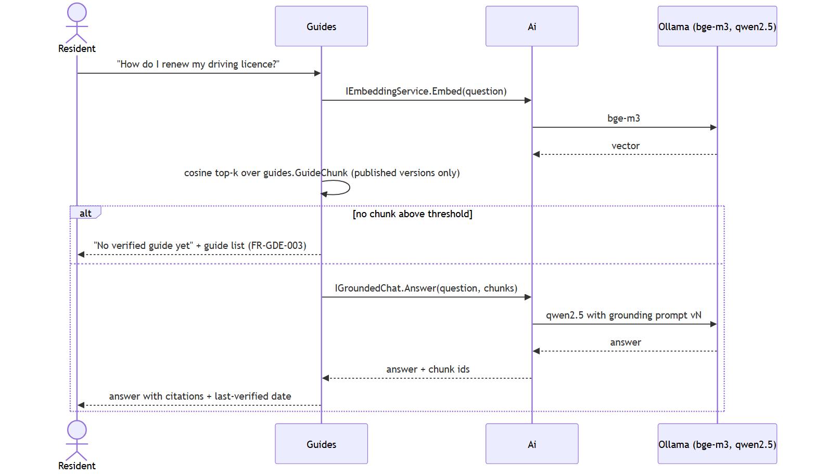
RAG answer
sequenceDiagram
actor U as Resident
participant G as Guides
participant A as Ai
participant O as Ollama (bge-m3, qwen2.5)
U->>G: "How do I renew my driving licence?"
G->>A: IEmbeddingService.Embed(question)
A->>O: bge-m3
O-->>A: vector
G->>G: cosine top-k over guides.GuideChunk (published versions only)
alt no chunk above threshold
G-->>U: "No verified guide yet" + guide list (FR-GDE-003)
else
G->>A: IGroundedChat.Answer(question, chunks)
A->>O: qwen2.5 with grounding prompt vN
O-->>A: answer
A-->>G: answer + chunk ids
G-->>U: answer with citations + last-verified date
end

6 Cross-cutting concerns
Concern | Approach | Status
Authentication | OpenIddict (ABP), OIDC code flow for web, password/refresh for mobile | Planned (P1)
Authorization | ABP permissions per module; data filtered by owner user id | Planned (P1)
Privacy routing | Ai chooses provider per purpose: Extraction → local only; GuideChat → local or cloud by config | Planned (P3)
Usage caps | ai.Usage row per call; per-user daily count checked before each call | Planned (P3)
Localization | ABP localization JSON (ar, en); clients carry their own ar.json/en.json | Planned (P1, P4)
Files | IFileStore abstraction; local encrypted disk now, S3-compatible later | Planned (P1)
Observability | Serilog → Seq; health checks; Hangfire dashboard (admin only) | Planned (P7)
Deployment | Docker Compose: api, sql, ollama; volumes for data/files/models | Planned (P0.6 skeleton, P7)

7 Decisions log
D1–D9 are from docs/PLAN.md §6 and are summarised here; D10 onward are recorded as ADRs in docs/decisions/.
ID | Decision | Consequence
D1 | ABP modular monolith | One deployable; module discipline enforced by convention and separate DbContexts
D2 | SQL Server incl. embeddings | Vectors as VARBINARY, cosine computed in code until the VECTOR type is available
D3 | Microsoft.Extensions.AI first | Provider is configuration; SK optional later
D4 | Ollama + Qwen 2.5 | Fully private; quality risk R1 mitigated by evals
D5 | Tesseract before vision LLM | Cheap deterministic OCR; LLM structures text
D6 | Angular 20 signals, standalone | Modern Angular; contrast with reference repo
D7 | Flutter + Riverpod + go_router + Drift | Offline-first mobile
D8 | Markdown → Pandoc .docx | Regenerable documents (this pipeline)
D9 | Local git until Phase 9 | Publish after privacy features exist
D10 | One DbContext and one SQL schema per module (ADR-001) | Differs from the reference backend’s single shared context; migrations per module

Open points
- Embedding storage: VARBINARY + in-code cosine vs SQL Server 2025 VECTOR — revisit in Phase 5.
- Push provider for iOS without a paid Apple developer account — decide in Phase 6.

