BIGDATA PROJECT DOCUMENT

YUHAN CHEN

- PROJECT INTRUCTION

This project runs in a container and uses MNIST model to recognize handwritten picture. User firstly submit the picture to the web service. The service will be stored at an online database. Then the project will get the picture and use prediction model which created by using tensorflow.build. The result will be delivered to cassandra which is running in another container.

What is bigdata?Big data is a field that treats of ways to analyze, systematically extract information from, or otherwise deal with data sets that are too large or complex to be dealt with by traditional data-processing application software. Data with many cases offer greater statistical power, while data with higher complexity may lead to a higher false discovery rate. Big data challenges include capturing data, data storage, data analysis, search, sharing, transfer, visualization, querying, updating, information privacy and data source. Big data was originally associated with three key concepts: volume, variety, and velocity. Other concepts later attributed with big data are veracity and value.

- TERMINOLOGY EXPLANATION

2.1MNIST
MNIST is a classic demo for deep learning. It is commonly used for training various image processingsystems. It contains 60,000 training images and 10,000 testing images. These images are made of black and white and the size of these images is 28*28.

2.2Tensorflow
Tensorflow is an open-sorce library for dataflow and differentiable programming across a range of tasks. It is a symbolic math library, and is also used for machine learning applications such as neural networks. It is a standard expectation in the industry to have experience in TensorFlow to work in machine learning.

2.3 Flask
Flask is a micro web framework written in Python. It is classified as a microframework because it does not require particular tools or libraries. It has no database abstraction layer, form validation, or any other components where pre-existing third-party libraries provide common functions.

2.4 Docker

Docker is a platform for developers and sysadmins to develop, deploy, and run applications with containers. The use of Linux containers to deploy applications is called containerization. Containers are not new, but their use for easily deploying applications is.
Containerization is increasingly popular because containers are: Flexible, Lightweight, Interchangeable, Portable, Scalable, Stackable.
2.5 Cassandra
Apache Cassandra is an open source distributed database management system designed to handle large amounts of data across many commodity servers, providing high availability with no single point of failure. Cassandra offers robust support for clusters spanning multiple datacenters, with asynchronous masterless replication allowing low latency operations for all clients.

2.6 CQL
Cassandra Query Language or CQL is a simple interface for accessing Cassandra, as an alternative to the traditional Structured Query Language (SQL). CQL adds an abstraction layer that hides implementation details of this structure and provides native syntaxes for collections and other common encodings. Language drivers are available for Java (JDBC), Python (DBAPI2), Node.JS (Helenus), Go (gocql) and C++.

2.7 RESTful API
Representational State Transfer (REST) is a software architectural style that defines a set of constraints to be used for creating Web services. Web service APIs that adhere to the REST architectural constraints are called RESTful APIs. HTTP-based RESTful APIs are defined with the following aspects
1.a base URI, such as http://api.example.com/collection/;
2.standard HTTP methods
3.a media type that defines state transition data elements, The current representation tells the client how to compose requests for transitions to all the next available application states. This could be as simple as a URI or as complex as a Java applet.

3 IMPLEMENTATION

3.1 Export MNIST deep learning model
The model is created by the official code of tensorflow on github. The correct rate of the mode is about 91%. A saver is defined to save the model after training the code. Then we use the function saver.save to save the model to a particular path. The relevant code is as follows:

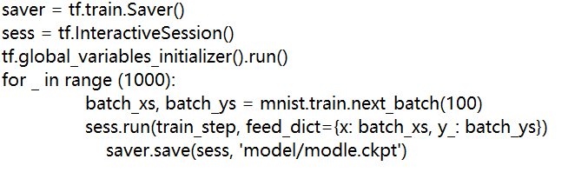

After executing these code, we can find four file at ./model：
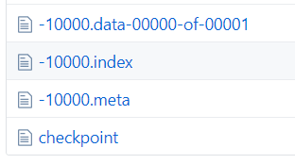
When you use the model to predict the picture, you have to load the model first. The relevant code is as follows:
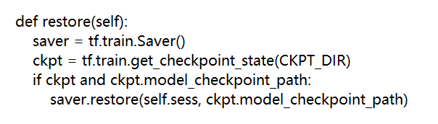

3.2 Build a Cassandra service
Before we connect to Cassandra, we should start Cassandra. First, . we create a Cassandra service called test.Next, we use to run the service created before at the port 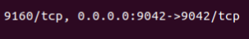 we can now see that the cassandra container is successfully running

Then, we access the cassandra with cqlsh and execute the following code
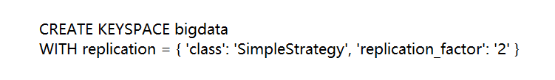
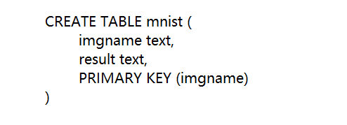
We can see the KEYSPACE called bigdata is created and we use this keyspace to creat a table called mnist. In this table, ‘imgname’ is set as the main key.

3.3 Web deployment using flask
First, we need to create a page to submit our picture. We can use following code to create the page. Then we have to create a folder called /upload. The picture submitted will be store at here. The predicting part of the project will get the picture from this route.
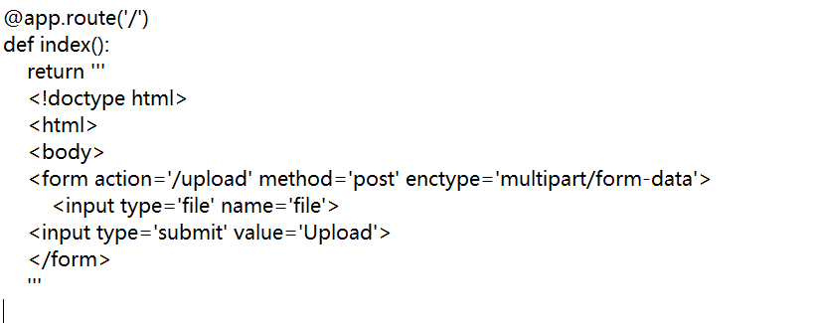
Then we create a link to connect to the table in Cassandra
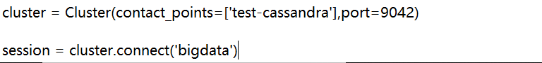
After we upload the picture, we will receive a result form the predicting part. Then we use following code to write the result to the table in Cassandra.
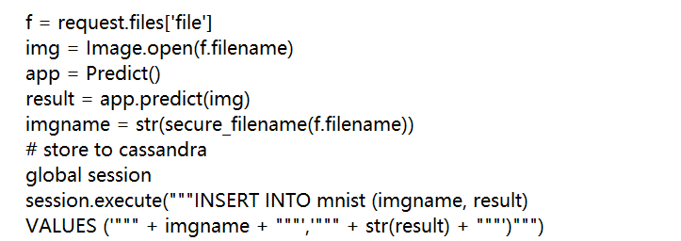

3.4 Build a docker image
To build a docker image, we need python file, requirement.txt and a docker file. The python file is the code we need to run in this project. We name it as app.py. The requirement.txt will tell docker which package we need to install at the new environment. In this project, we need to install the following package.
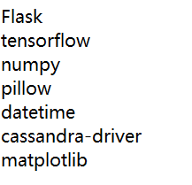

The dockerfile defines what goes on in the environment inside your container. Access to resources like networking interfaces and disk drives is virtualized inside this environment, which is isolated from the rest of your system, so you need to map ports to the outside world, and be specific about what files you want to “copy in” to that environment.
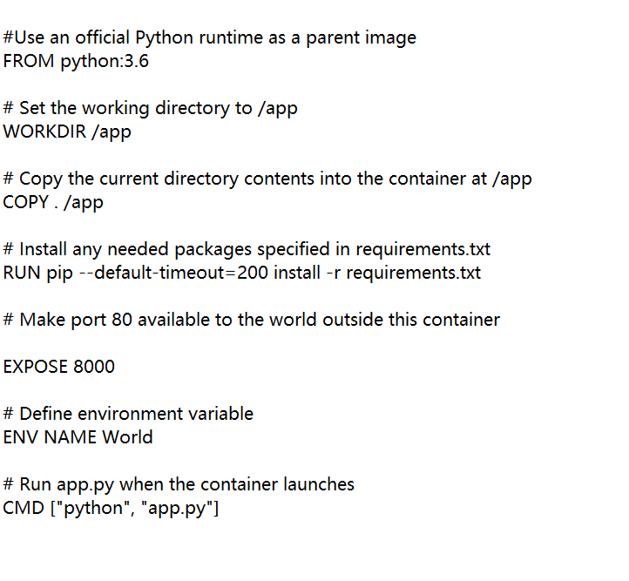
Then we can use the build command to create the image

After we tag the image, use ‘sudo docker image ls’ to see the image we have. We can see the image ‘bigdata’ is successfully tagged.

4 PROJECT DISPALY

First, we start the Cassandra container and run it at the network called ‘test’ so that another container can access this container.
Next, we use cqlsh to create the KEYSPACE named bigdata and create the table named mnist.
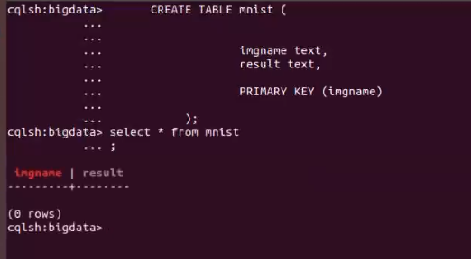
Then, we run the image ‘bigdata’ created before. The app is running at 0.0.0.0:4000.

Click the button 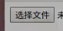 to submit the picture
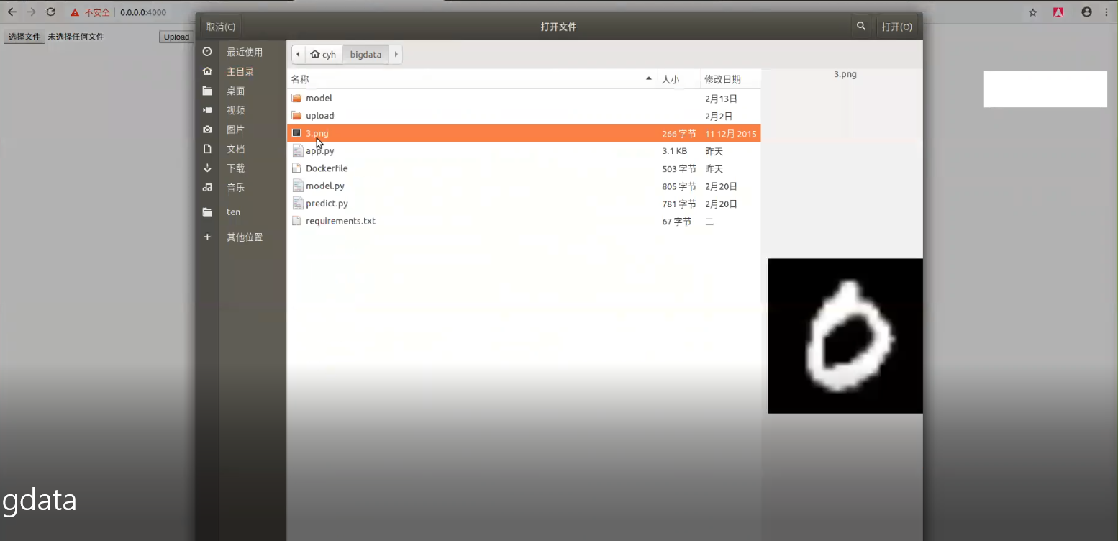
Now, we check our table in Cassandra, we can find the filename and the result has been record successfully.
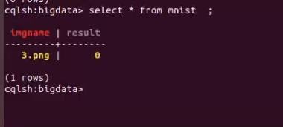

5 CONCLUSION
During this study, I learned what is bigdata and how to analyse these data. I think Docker, Tensorflow and Cassandra are the most important thing in this project. Before I attend this project, I had no idea on deep learning and docker. I think these thing are very fantastic and convenient.

Before Docker was introduced, it is not easy to run the same program at different computers, especially the computers with different OS. One of the way to solve the problem is to run the program in a virtual machine. However, a virtual machine will occupy a lot of resource of the computer, and it will take much time to install a virtual machine. With the docker, people will no longer worry these problem. A Docker image will install all the package which the program needs. If someone wants to run the program at another computer, he just need to copy the image without install any other package or system. What’s more, a container of docker won’t occupy much resource, which means you can run many programs at the same time.
With a steep rise in NoSQL databases, several organizations are making a transition from traditional databases to open-source, distributed and high performance ones like ‘Cassandra’. Cassandra have the following advantage:
1 Open Source
2 Peer to Peer Architecture:
3 Elastic Scalability

4 High Availability and Fault Tolerance:

5 High Performance

6 Column Oriented

7 Tunable Consistency
8 Schema-Free
It is because of the above reasons, Cassandra is in great demand among several companies, where MySQL is getting replaced by NoSQL databases. A database that was initially created to solve the inbox search issues at Facebook, has come a long way to solve Big Data problems. Today, Cassandra is used in diverse applications…whether it is streaming videos or supporting various business units or production applications.

With the advantage of Docker and Cassandra, it will be more and more easy to analyse huge amount of data, because a program can be run at different environment so that we can handle these data with many resource, even the computer far away form us.

REFERENCE

https://en.wikipedia.org/wiki/Flask_(web_framework)
https://docs.docker.com/get-started/
https://hub.docker.com/_/cassandra/
https://en.wikipedia.org/wiki/Representational_state_transfer
https://en.wikipedia.org/wiki/Curl_(programming_language)
https://en.wikipedia.org/wiki/Big_data
https://www.edureka.co/blog/apache-cassandra-advantages/

