CPP Problem Design
Subject: Simple Drawing Program
Contributor: 謝宜杭, 林承達, 廖宣瑋
Main testing concept: 2-Dimension Array
Basics | Functions
□ C++ BASICS  □ FLOW OF CONTROL  □ FUNCTION BASICS  □ PARAMETERS AND OVERLOADING  ■ ARRAYS  □ STRUCTURES AND CLASSES  □ CONSTRUCTORS AND OTHER TOOLS  □ OPERATOR OVERLOADING, FRIENDS,AND REFERENCES  □ STRINGS  □ POINTERS AND DYNAMIC ARRAYS | □ SEPARATE COMPILATION AND NAMESPACES  □ STREAMS AND FILE I/O  □ RECURSION  □ INHERITANCE  □ POLYMORPHISM AND VIRTUAL FUNCTIONS  □ TEMPLATES  □ LINKED DATA STRUCTURES  □ EXCEPTION HANDLING  □ STANDARD TEMPLATE LIBRARY  □ PATTERNS AND UML

Description:
Please design a simple drawing program (fill the background with *) allow users to draw square, isosceles right triangle and lines on the console. (for figures, fill with Upper X)

Input:
In the beginning, allow users to enter two integers separated by space to set the size of the drawing board (m*n). After that, enter the corresponding drawing code. First input the type of the figure, S indicates square, T indicates Isosceles right triangle and L indicates lines. Finally, input the parameter of the figure. Following is the required parameters of each type of figure:
- S <w> <x> <y>
Note that the integer w is the width and two integers (x, y) is the origin of the square. The direction of the square extends from top to bottom, from left to right.
- T <w> <x> <y> <LU/LD/RU/RD>
Integer w is the length of hypotenuse. (x, y) is the origin of the triangle. LU (Left Up), LD (Left Down), RU (Right Up) and RD (Right Down) indicates the side that the triangle faces. Draw an equilateral triangle with side length w from point (x, y) that facing the specified direction.
- L <x1> <y1> <x2> <y2>
Input two pairs of integers separated by space, (x1, y1) and (x2, y2). Draw a line segment with (x1, y1) and (x2, y2) as the endpoints.
- EXIT
Exit the program.
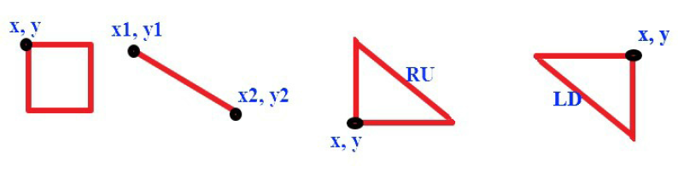
※ The origin point (0, 0) of the drawing board is left up.
※ If the figure to be drawn exceeds the boundary of the drawing board, print "Out of range".
※ For any figure, if the given width is 1, you need to draw the origin point.
※ Output the drawing board after each command and separates each with an empty line.
※ We make sure that all the input data is drawable.

Output:
After drawing a figure or an error message, output a newline.

Sample Input / Output：
Sample Input | Sample Output
5 6  S 2 0 0  S 2 100 100  L 0 4 4 4  T 2 1 3 LU  EXIT | XX***  XX***  *****  *****  *****  *****  Out of range.  XX***  XX***  *****  *****  XXXXX  *****  XX***  XX***  *X***  XX***  XXXXX  *****

□ Eazy,Only basic programming syntax and structure are required.
■ Medium,Multiple programming grammars and structures are required.
□ Hard,Need to use multiple program structures or more complex data types.
Expected solving time:
30 minutes
Other notes:

