CPP Problem Design Example
Subject: Matrix Multiplication
Contributor: 林宇恩,溫勇威,鍾賢廣
Main testing concept: Basic Function and Dynamic Array

Basics | Functions
■ C++ BASICS  ■ FLOW OF CONTROL  ■ FUNCTION BASICS  □ PARAMETERS AND OVERLOADING  □ ARRAYS  □ STRUCTURES AND CLASSES  □ CONSTRUCTORS AND OTHER TOOLS  □ OPERATOR OVERLOADING, FRIENDS,AND REFERENCES  □ STRINGS  ■ POINTERS AND DYNAMIC ARRAYS | □ SEPARATE COMPILATION AND NAMESPACES  □ STREAMS AND FILE I/O  □ RECURSION  □ INHERITANCE  □ POLYMORPHISM AND VIRTUAL FUNCTIONS  □ TEMPLATES  □ LINKED DATA STRUCTURES  □ EXCEPTION HANDLING  □ STANDARD TEMPLATE LIBRARY  □ PATTERNS AND UML

Description:
Please write a program to calculate matrix multiplication.
The multiplication rule of the matrix is as follows, given two matrices A and B：
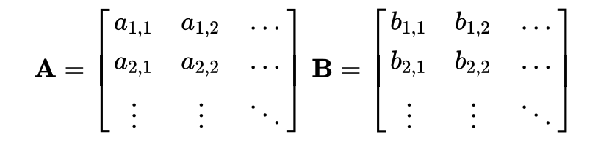
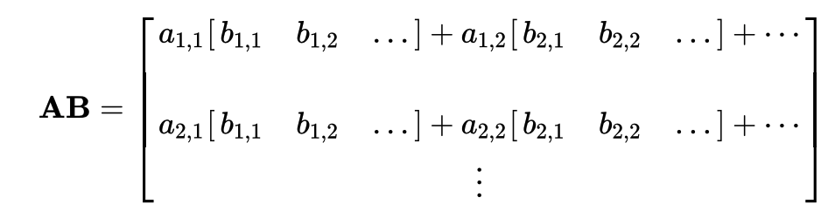
The number of columns of the A matrix must equal to the number of rows of the
B matrix.

Input:
1. The first line is the size of A and B(row major).
2. The second line is the numbers of matrix A.
3. The third line is the numbers of matrix B.

Output:
Output the matrix obtained by multiplying A and B.
If A and B can not be multiplied, please print " Matrix multiplication failed.".

Sample Input / Output：
Sample Input | Sample Output
3 2 2 3  1 2 3 4 5 6  6 5 4 3 2 1 | 12 9 6  30 23 16  48 37 26

■ Easy,Only basic programming syntax and structure are required.
□ Medium,Multiple programming grammars and structures are required.
□ Hard,Need to use multiple program structures or complex data types.
Expected solving time:
20 minutes
Other notes:

