Number of features in the Boston dataset is: 13

Number of samples in the Boston dataset is: 506

Best fitted feature name is: INDUS

Best fitted model score is: 0.20596851298

Value of the loss function for the best fitted model is: 18.5645355697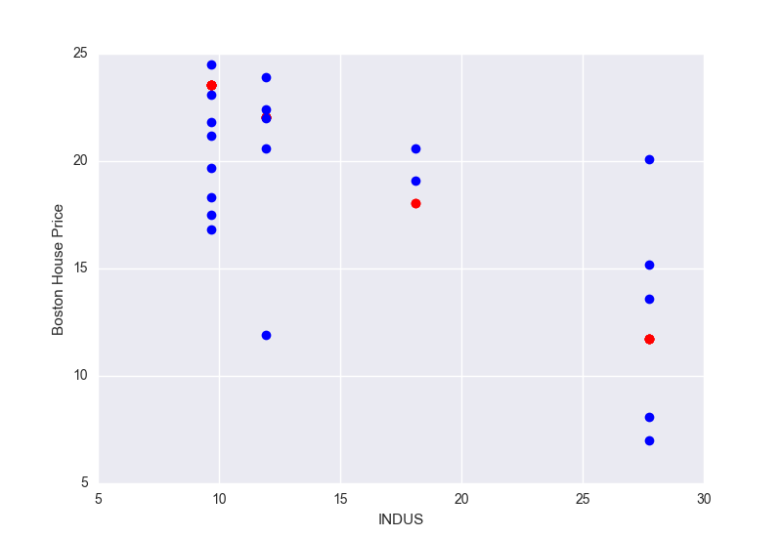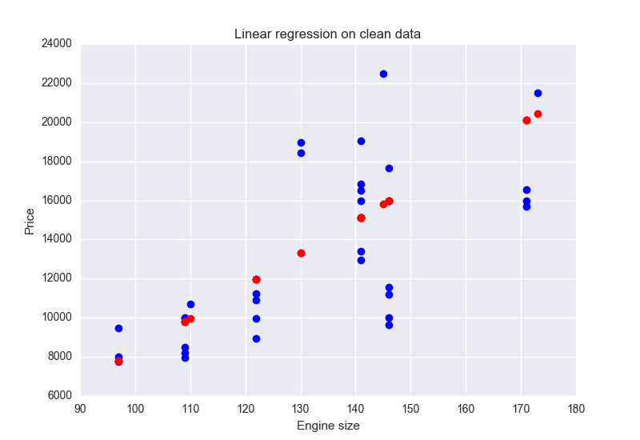

Price prediction for engine size equals to 175 is: 20793.532819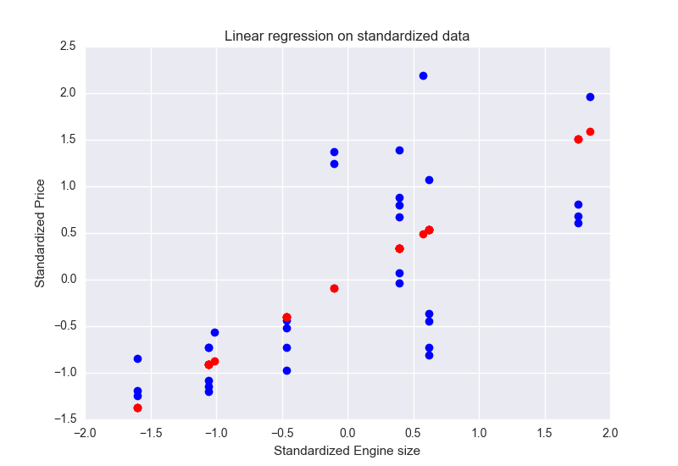

Parameter theta calculated by normal equation: [-3.46944695195e-18, 0.862451815658, 0.0736117227898]

Parameter theta calculated by SGD: [-0.00189133336593, 0.720026835525, -0.00640042505874]

y1= 1.7 + 1.0375x

Linear regression (order 1) model score is: 0.79629076087

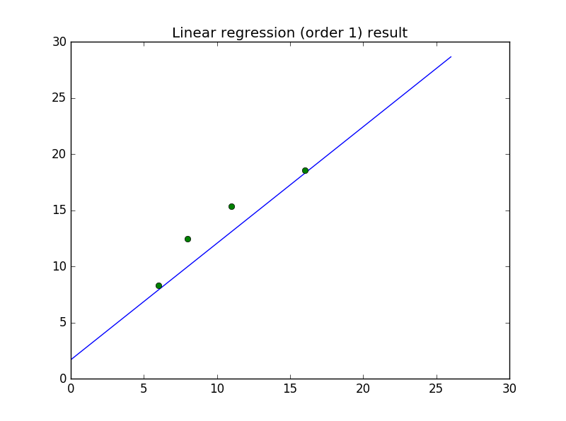

y2= 22.5189365504 + 2.35135613237e-11 x + -0.345575425181 x*x + -1.69531630217 x*x*x + 0.341630494767 x*x*x*x +-0.0228934321526 x*x*x*x*x

Linear regression (order 5) score is: 0.706486295693

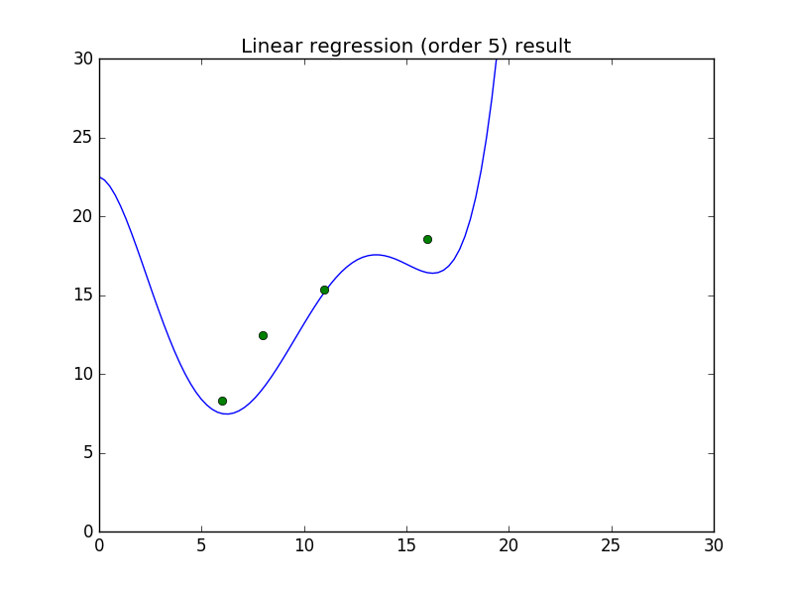

Ridge regression (order 5) score is: 0.820537525488

y2= 8.04799922882 + 0.0 x + -0.0708636459073 x*x + -0.34590785239 x*x*x + 0.0879874697943 x*x*x*x +-0.00615338438865 x*x*x*x*x

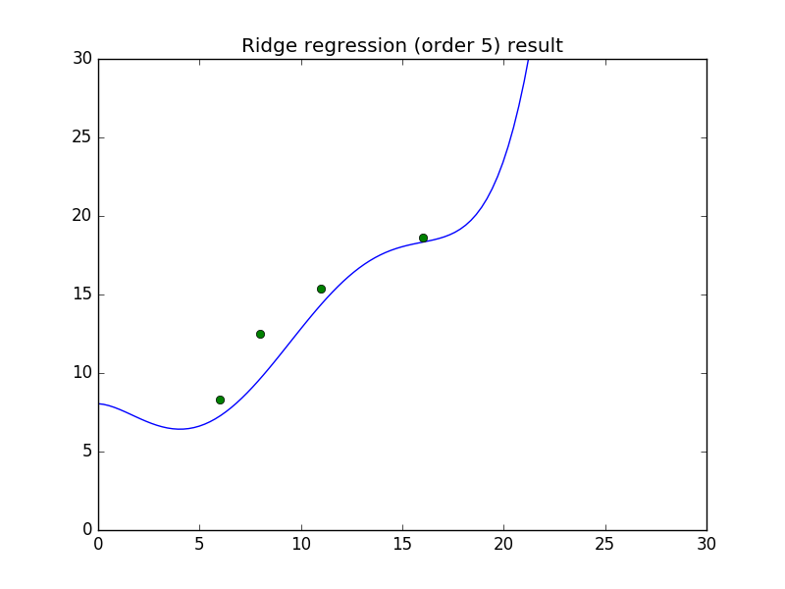

Comparisons  
1. The model with the highest score is: **Ridge model (order 5)**  
2. Ridge model can prevent over-fitting: **yes**3. Ridge model is nearly equivalent to LR model (order 5) if alpha=0: **yes**  
4. A larger alpha results in a larger coefficient for x*x*x*x*x: **no**  
5. Best score is achieved at order: **2**

The predictions only have 0 and 1: **yes**

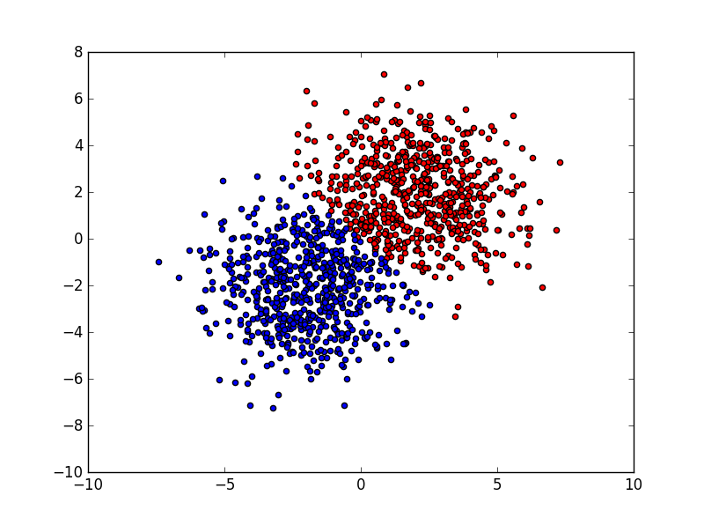

Number of wrong predictions is: 73