

**Predicting Burned Calories**

**on Workout**

T5 Data Science Bootcamp

BY

**Aishah Alanazi**

**Rahaf Almayouf**

**Munira Alshahrani**

**Hussain Al-Sultan**

# Introduction

Calories are a measure of energy. Since calories are, effectively, energy,

any time energy is used or transformed in our body we consume calories

# Study [Methodolog](https://github.dihe.moe/sanjeevai/nyc_subway_data_analysis#p2)y

* **15,000 observations and 9 of features**
* **From Kaggle**
* **Features:**

# Data Description

|  |  |  |  |  |  |  |  |  |
| --- | --- | --- | --- | --- | --- | --- | --- | --- |
| User ID | Gender | Age | Height | Weight | Duration | Heartrate | Body Temp | Calories |

# Tools and Libraries:

* Plotly
* Seaborn
* Skleam
* NumPy
* Pandas
* Matplotlib
* Jupyter
* Trello
* GitHub
* VSCode
* PowerPoint , Word
* Zoom

# EDA

# How can age affect performance time during a workout?

# What are the factors that affect how high or low heart rate during a workout?

# 

# What is the rate of burning calories compared to the time of workout?

# What is the difference between male and female in the duration of workout and burned calories?

# What is the relationship between weight and burned calories?

# What are the oldest ages that achieve high calorie burn?

# What is the difference between male and female in height and weight?

1. **One feature regression**

* Comarison
* Train models

* Test model

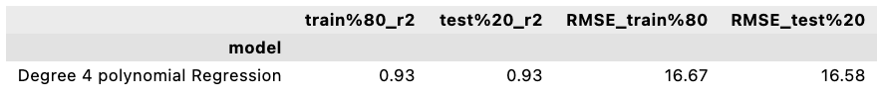

* Three features regression
* Feature selection
* Select Duration and Body_Temp and Heart_Rate features

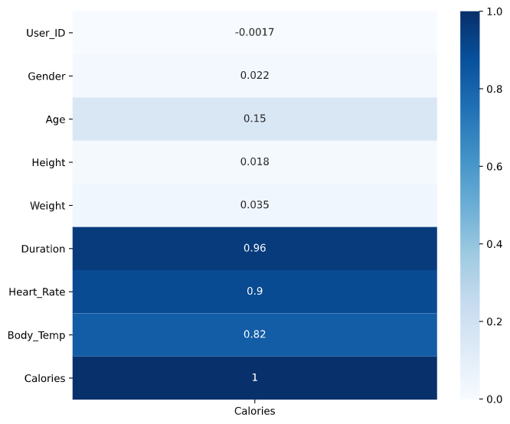

# Conclusion

**Recommendations**

* Age group 20-30 have high potential to join Gym membership, therefore our team conclude that we should give them some offers.

**Future recommendations**

* If we have had more info about the date and time of workout in the dataset that we got, we would have worked on the electrical equipment usage during the 24/7 period that will help in more efficient usage of the electie
* It would decrease the usage of elect 20-30%(caition)

**Reference**

[Predicting Burned Calories on Workout | Kaggle](https://www.kaggle.com/emdemor/predicting-burned-calories-on-workout)