Metadata – Dadant Hive – Series « 2024_06_20_Csv »
Datasets: 2024_06_20_Environment.csv, 2024_06_20_RefHive.csv, 2024_06_20_TestHive.csv
Apiary location: Mas Lafont, 30170 CROS, France
Hive type: Empty wooden Dadant 10 frames (without frames, without bees).
Hive environment: open area
Hives orientation: Bees entrance toward south.

Description:
E
S
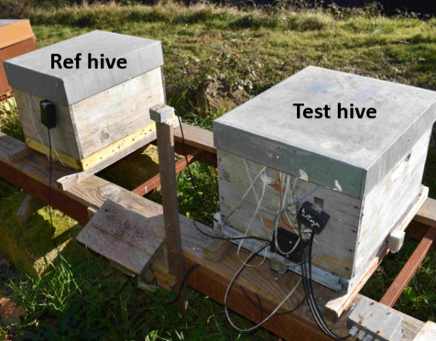
Two wooden Dadant hives are monitored for several days to analyse their thermal behaviour. Usually, the reference hive (Ref hive) remains unmodified during the experiments whereas the test hive undergoes several successive modifications to measure the induced effect on temperature levels. However, in this case, both hives are not modified.
N
W

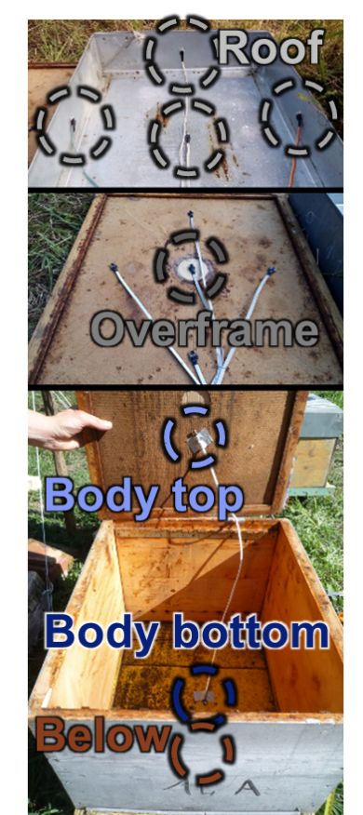
Test Hive:
- 5 sensors installed on hive roof:
north, south, east, west and central position
- 5 sensors installed on the overframe:
north, south, east, west and central position
- 1 sensor in the upper part of the hive body
- 1 sensor in the lower part of the hive body
- 1 sensor below hive

Reference Hive:
- 1 sensor installed on hive roof (central position)
- 1 sensor installed on overframe (central position)
- 1 sensor in the upper part of the hive body
- 1 sensor in the lower part of the hive body
- 1 sensor below hive

Environment:
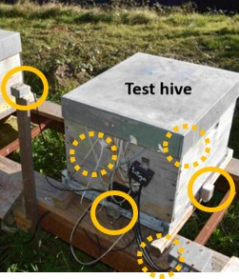
- Luminosity is measured on each of the 6 external sides of the hive (6 sensors).
- Outside air sensor
- Wind speed

Figure 1: Luminosity sensors

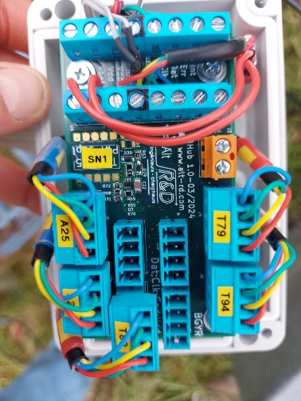
Communications between the acquisition system and the sensors are done via the I2C protocol. If necessary, I2C hubs were inserted to extend the number of sensors that can be connected simultaneously.
The sensors provide an internal analog-to-digital conversion. The sensors were individually calibrated to cancel the bias error between them to allow more precise temperature difference measurements (<0.5°C). Absolute temperature errors are probably around 1°C. The intercalibration were achieved by putting all sensors together in an insulated box.
The acquisition period is set to one minute except for the wind speed data which are acquired every 2 s and averaged over 1 min.
Figure 2: I2C hubs
Data are stored using a csv format in 2 different files:
- 2024_06_20_Environment.csv
- 2024_06_20_RefHive.csv
- 2024_06_20_TestHive.csv
Comment lines are prefixed with hash character ‘#’.

Field name | Description | Unit | Sensor type | Sensor location
Timestamp | Timestamp of measurement  Year/month/ Day/Hour/ min/sec | Local time | PCF8523 (Real-time clock)+  DS3231 (Real-time clock module) | Acquisition system
Epoch [day] | Timestamp of measurement | Day since 1 January 0
Epoch [day] | Timestamp of measurement | Day since 1 January 0 |  |  | 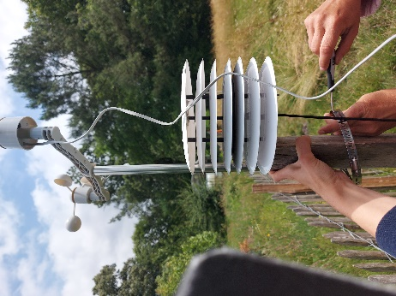
Wind.speed [m/s] | Wind speed | m/s | Sparkfun meteo system | Close to the apiary, 2m high
Ground.T [deg] | Temperature at the ground surface (≈1cm) | °C | NCT75 | On the ground in a shaded area. | 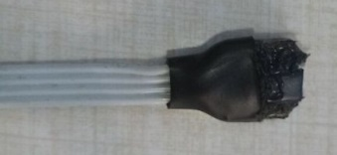
Sky.T [deg] | Equilibrium temperature of a horizontal black steel plane exposed to sunlight and insulated at the rear face | °C | NCT75 | Fixed to the weather station | 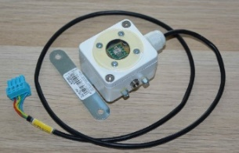  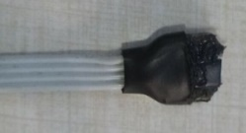      
Test.Luminosity.south.als [lux] | Luminosity south | Lux | VEML7700  (als channel) | South side of the Dadant hive
Test.Luminosity.south.white [lux] | Luminosity south | Lux | VEML7700  (white channel) | South side of the Dadant hive
Test.Luminosity.top.als [lux] | Luminosity top | Lux | VEML7700  (als channel) | Top side of the Dadant hive
Test.Luminosity.top.white [lux] | Luminosity top | Lux | VEML7700  (white channel) | Top side of the Dadant hive
Test.Luminosity.north.als [lux] | Luminosity north | Lux | VEML7700  (als channel) | North side of the Dadant hive
Test.luminosity.north.white [lux] | Luminosity north | Lux | VEML7700  (white channel) | North side of the Dadant hive
Test.Luminosity.west.als [lux] | Luminosity west | Lux | VEML7700  (als channel) | West side of the Dadant hive
Test.Luminosity.west.white [lux] | Luminosity west | Lux | VEML7700  (white channel) | West side of the Dadant hive
Test.Luminosity.below.als [lux] | Luminosity below | Lux | VEML7700  (als channel) | Downward facing below the Dadant hive
Test.Luminosity.below.white [lux] | Luminosity below | Lux | VEML7700  (white channel) | Downward facing below the Dadant hive
Test.Luminosity.east.als [lux] | Luminosity east | Lux | VEML7700  (als channel) | East side of the Dadant hive
Test.Luminosity.east.white [lux] | Luminosity east | Lux | VEML7700  (white channel) | East side of the Dadant hive
Luminosity.horiz.ALS [lux] | Luminosity horizontal plane | Lux | VEML7700  (als channel) | Upward facing fixed on the weather station
Luminosity.horiz.WHITE [lux] | Luminosity horizontal plane | Lux | VEML7700  (white channel) | Upward facing fixed on the weather station
Luminosity.45.CH0 [lux] | Luminosity on a 45-tilted plane (azimuth=south) | Lux | TSL2561 | Fixed on the weather station
Luminosity.45.CH1 [lux] | Luminosity on a 45-tilted plane (azimuth=south) | Lux | TSL2561 | Fixed on the weather station
Luminosity.45.LUX [lux] | Luminosity on a 45-tilted plane (azimuth=south) | Lux | TSL2561 | Fixed on the weather station
Ref.roof [deg] | Temperature measured on Refhive roof | °C | TC74 | Glued under the roof, centered | 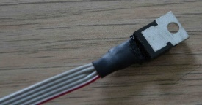
Ref.overframe [deg] | Temperature measured on RefHive overframe | °C | NCT75 | Center of the overframe | 
Ref.body.top.HR [%] | Humidity measured in upper part of RefHive body | % | HIH8100 | Inside hive body (top), in the center | 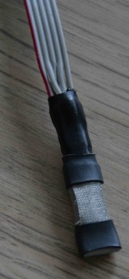
Ref.body.top.T [deg] | Temperature measured in upper part of RefHive body | °C | HIH8100 | Inside hive body (top), in the center
Ref.body.bottom.T [deg] | Temperature measured in lower part of RefHive body | °C | HIH8100 | Inside hive body (bottom), in the center | 
Ref.body.bottom.HR [%] | Humidity measured in lower part of RefHive body | % | HIH8100 | Inside hive body (bottom), in the center | 
Ref.below [deg] | Temperature measured below the RefHive | °C | NCT75 | Centered below the hive floor | 
Test.roof [deg] | Temperature measured on TestHive roof | °C | TC74 | Glued under the roof, centered | 
Test.roof.north [deg] | Temperature measured on the north side of the TestHive roof | °C | TC74 | Hive roof north | 
Test.roof.south [deg] | Temperature measured on the south side of the TestHive roof | °C | TC74 | Hive roof south | 
Test.roof.east [deg] | Temperature measured on the east side of the TestHive roof | °C | TC74 | Hive roof east | 
Test.roof.west [deg] | Temperature measured on the west side of the TestHive roof | °C | TC74 | Hive roof west | 
Test.overframe [deg] | temperature measured on TestHive overframe | °C | NCT75 | Center of the overframe | 
Test.overframe.north [deg] | Temperature measured on the north side of the TestHive overframe | °C | NCT75 | Overframe north | 
Test.overframe.south [deg] | Temperature measured on the south side of the TestHive overframe | °C | NCT75 | Overframe south | 
Test.overframe.west [deg] | Temperature measured on the west side of the TestHive overframe | °C | NCT75 | Overframe west | 
Test.overframe.east [deg] | Temperature measured on the east side of the TestHive overframe | °C | NCT75 | Overframe east | 
Test.body.top.HR [%] | Humidity measured in upper part of TestHive body | % | HIH8100 | Inside hive body (top), in the center | 
Test.body.top.T [deg] | Temperature measured in upper part of TestHive body | °C | HIH8100 | Inside hive body (top), in the center | 
Test.body.bottom.HR [%] | Humidity measured in lower part of TestHive body | % | HIH8100 | Inside hive body (bottom), in the center | 
Test.body.bottom.T [deg] | Temperature measured in lower part of TestHive body | °C | HIH8100 | Inside hive body (bottom), in the center | 
Test.below [deg] | Temperature measured below the TestHive | °C | NCT75 | Centered below the hive floor | 

