Metadata – Dadant Hive – Series « 2024_12_23_Csv »
Datasets : 2024_12_23_Env.csv, 2024_12_23_RefHive.csv, 2024_12_23_TestHive.csv
Apiary location: Beguey, 33130, Saint Symphorien, France
Hive type: Empty wooden Dadant 10 frames (without frames, without bees).
Hive environment: open area
Hives orientation: Bees entrance toward south.

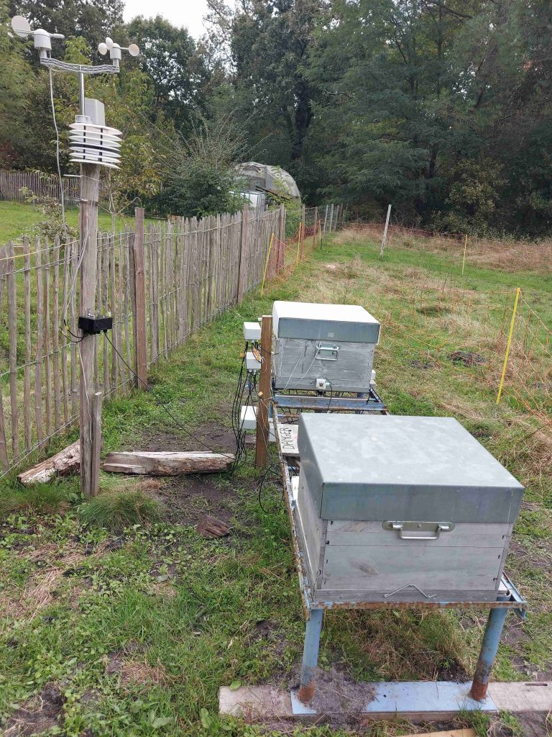
A wooden Dadant hive remains unmodified during the experiments to be used as a reference and is therefore called the reference hive (RefHive). Another Dadant hive, called “TestHive”, underwent several successive modifications. Since all hives are empty in this experiment, results are reproducible.
North
South
West
East
Weather station
TestHive
RefHive

Description:
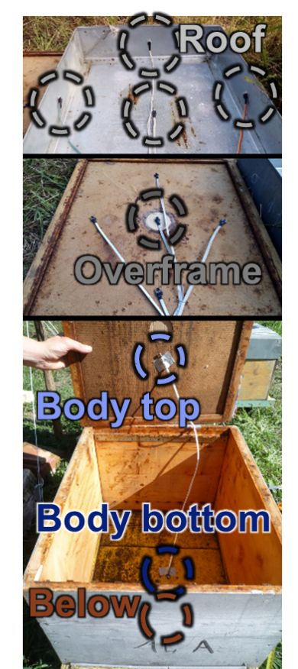
Test Hive:
Figure 1: Temperature sensor locations
- 5 sensors installed on hive roof:
north, south, east, west and central position
- 5 sensors installed on overframe:
north, south, east, west and central position
- 1 sensor in upper hive body
- 1 sensor in lower hive body
- 1 sensor below hive
- 2 infrared cameras
Reference hive:
- 1 sensor installed on hive roof (central position)
- 1 sensor installed on overframe (central position)
- 1 sensor in upper hive body
- 1 sensor in lower hive body
- 1 sensor below hive

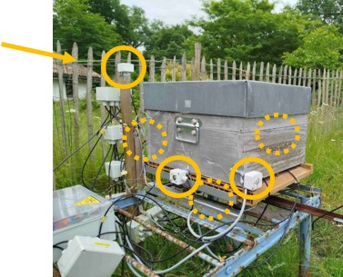
Environment:
Figure 2: Luminosity sensors
- Luminosity is measured on each of the 6 external sides of the hive (6 sensors).
It is not used to measure solar irradiance but rather as a qualitative measurement of luminosity (rough measurement of cloud coverage).
- Outside air sensor
- Wind speed

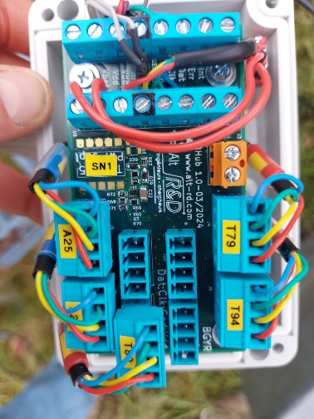
Communications between the acquisition system and the sensors are done via the I2C protocol. If necessary, I2C hubs were inserted to extend the number of sensors that can be connected simultaneously.
Figure 3: I2C hubs
The sensors provide an internal analog-to-digital conversion. The sensors were individually calibrated to cancel the bias error between them to allow more precise temperature difference measurements (<0.5°C). Absolute temperature errors are probably around 1°C. The intercalibration were achieved by putting all sensors together in an insulated box.
The acquisition period is set to one minute except for the wind speed data which are acquired every 2 s and averaged over 1 min.
Data are stored using a csv format in 3 different files:
- 2024_12_23_Env.csv
- 2024_12_23_RefHive.csv
- 2024_12_23_TestHive.csv
Comment lines are prefixed with hash character ‘#’. Column titles are built using comma separated identifier:
identifier1[.identifier2[.identifier3…]].field
For example, the roof temperature of test hive is “test.roof.T”.
List of columns in csv file:
Field name | Description | Unit | Sensor  type | Sensor  location
Timestamp | Timestamp of measurement:  Year/month/ Day/Hour/ min/sec | (local time) | PCF8523 (Real-time clock)+  DS3231 (Real-time clock module) | Acquisition system
Rtc.epoch [day] | Timestamp of measurement | Day since 1 January 0
Air2.T [deg] | Outside air temperature | °C | NCT75 | Close to the apiary, 2m high, in a radiation shield made of 5 plastic plates to limit temperature errors due to radiation heat transfer. | 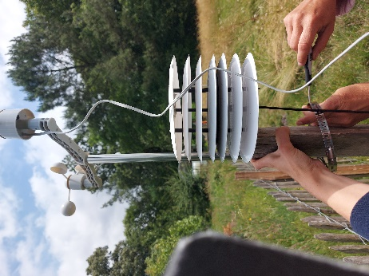
Air1.T [deg] | Outside air temperature | °C | HIH8100
Air1.HR [%] | Outside air humidity | % | HIH8100
Wind.speed [m/s] | Wind speed | m/s | Sparkfun meteo system | Close to the apiary, 2m high
luminosity.north.white [lux] | Luminosity on the north face of the hive | lux | VEML7700  (white channel) | North side of the hive | 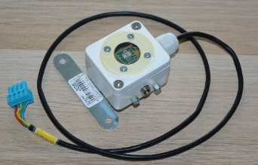
luminosity.south.white [lux] | Luminosity on the south face of the hive | Lux | VEML7700  (white channel) | South side of the hive
luminosity.east.white [lux] | Luminosity on the east face of the hive | Lux | VEML7700  (white channel) | East side of the hive
luminosity.west.white [lux] | Luminosity on the west face of the hive | Lux | VEML7700  (white channel) | West side of the hive
luminosity.top.white [lux] | Luminosity on the top of the hive | Lux | VEML7700  (white channel) | Top of the hive
luminosity.below.white [lux] | Luminosity below the hive | Lux | VEML7700  (white channel) | Below the hive
roof [deg] | Temperature of hive roof | °C | TC74 | Glued under the hive roof, centered | 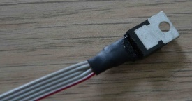
overframe [deg] | Temperature in hive overframe | °C | NCT75 | Center of the overframe | 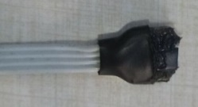
body.top.T [deg]  body.top.HR [%] | Temperature/humidity in hive body | °C | HIH8100 | Inside hive body (top), in the centre | 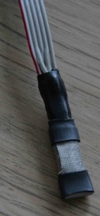
body.bottom.T [deg]  body.bottom.HR [%] | Temperature/humidity in hive body | °C | HIH8100 | Inside hive body (bottom), in the center | 
below [deg] | Temperature below the hive | °C | NCT75 | Centred below the hive floor | 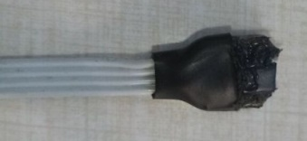
roof.north.T [deg] | Temperature of the north side of the hive roof | °C | TC74 | Hive roof north | 
roof.south.T [deg] | Temperature of the south side of the hiveroof | °C | TC74 | Hive roof south | 
roof.east.T [deg] | Temperature of the east side of the hive roof | °C | TC74 | Hive roof east | 
roof.west.T [deg] | Temperature of the west side of the hive roof | °C | TC74 | Hive roof west | 
overframe.north.T [deg] | Temperature of the north side of the overframe | °C | NCT75 | Overframe north | 
overframe.south.T [deg] | Temperature of the south side of the overframe | °C | NCT75 | Overframe south | 
overframe.east.T [deg] | Temperature of the east side of the overframe | °C | NCT75 | Overframe east | 
overframe.west.T [deg] | Temperature of the west side of the overframe | °C | NCT75 | Overframe west | 
camera.ext.south.PTAT.T [deg] | Temperature of infrared camera sensor | °C | D6T44 | Internal sensor of the D6T | 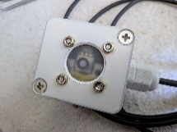
camera.ext.south.T [deg] | Outside surface temperature of south side | °C | D6T44 | 40 cm from the south surface | 
camera.ext.north.PTAT.T [deg] | Temperature of infrared camera sensor | °C | D6T44 | Internal sensor of the D6T | 
camera.ext.north.T [deg] | Outside surface temperature of north side | °C | D6T44 | 40 cm from the south surface | 
For clarity, the hive names “Test” and “Ref” are omitted. As a result, “overframe [deg]” must be read as “Test.overframe [deg]” or “Ref.overframe [deg]”.
D6T44 sensors are inserted in a watertight enclosure. The window is based on a protective film (KUBE PIR Transmissive Window Films (2057, opaque, thickness. 0.14mm, 81% IR transmission) which allows most infrared radiation reaching the sensor.

