Metadata – Ecological Hive – Series « 2024_06_20_Csv »
Datasets : 2024_12_23_ Environment.csv, 2024_12_23_ EcologicalHive.csv
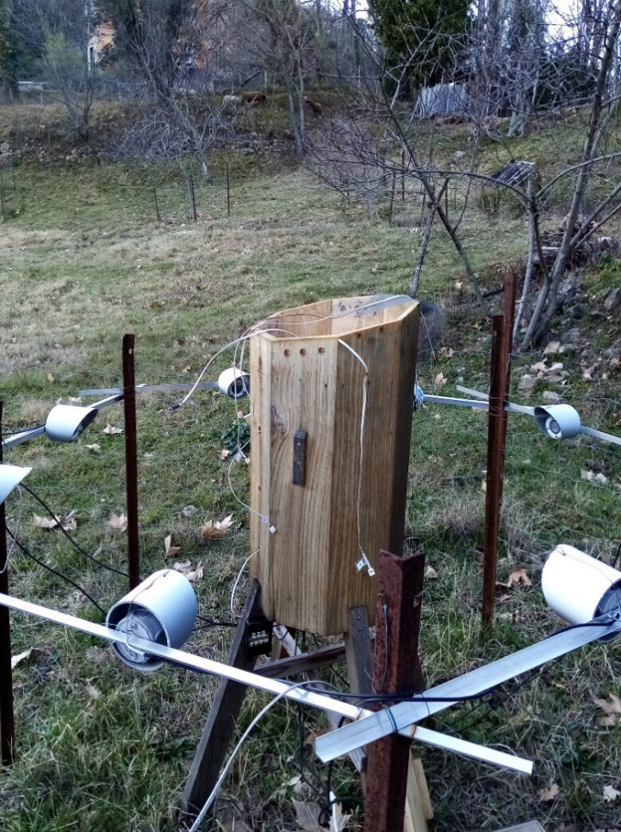
Apiary location: Mas Lafont, 30170 CROS, France
Hive type: Empty wooden Ecological Hive (or Lunar Hive), (without frames, without bees).
Hive environment: open area
Hives orientation: Bees entrance toward south.

Description:

Ecological Hive (also called Lunar Hive):
- 1 sensor installed under hive roof: central position
- 1 sensor installed on the overframe: south position
- 1 sensor in the upper part of the hive body
- 1 sensor in the lower part of the hive body
- 1 sensor below hive
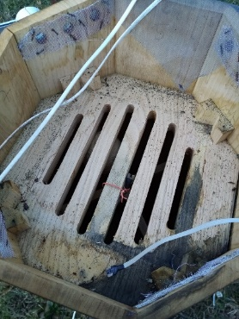
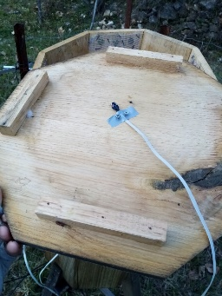
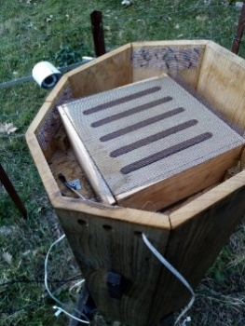
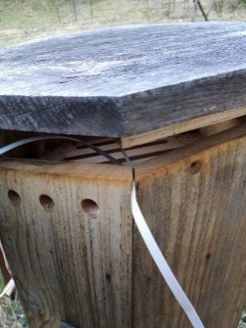

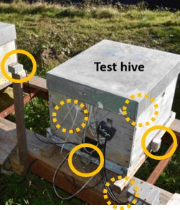
Environment:
- The luminosity (6 sensors) values in each direction (north, south, east, west, top, bottom) is measured on each face of a Dadant close (3m) to the trunk hive.
- Outside air sensor
- Wind speed

Figure 1: Luminosity sensors

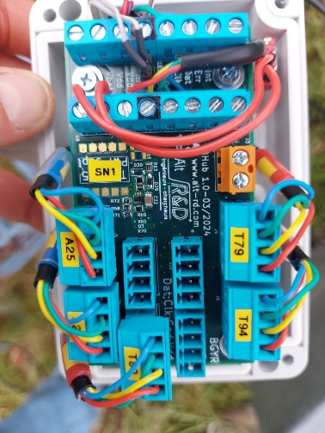
Communications between the acquisition system and the sensors are done via the I2C protocol. If necessary, I2C hubs were inserted to extend the number of sensors that can be connected simultaneously.
The sensors provide an internal analog-to-digital conversion. The sensors were individually calibrated to cancel the bias error between them to allow more precise temperature difference measurements (<0.5°C). Absolute temperature errors are probably around 1°C. The intercalibration were achieved by putting all sensors together in an insulated box.
The acquisition period is set to one minute except for the wind speed data which are acquired every 2 s and averaged over 1 min.
Figure 2: I2C hubs
Data are stored using a csv format in 2 different files:
- 2024_12_23_Environment.csv
- 2024_12_23_EcologicalHive.csv
Comment lines are prefixed with hash character ‘#’.

List of columns in csv file:
Field name | Description | Unit | Sensor  type | Sensor  location
Timestamp | Timestamp of measurement:  Year/month/ Day/Hour/ min/sec | (local time) | PCF8523 (Real-time clock)+  DS3231 (Real-time clock module) | Acquisition system
Epoch [day] | Timestamp of measurement | Day since 1 January 0
Wind.speed [m/s] | Wind speed | m/s | Sparkfun meteo system | Close to the apiary, 2m high | 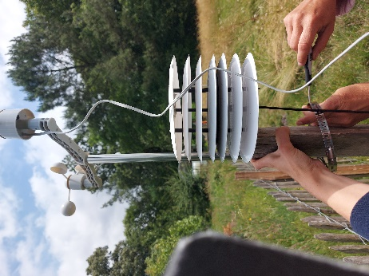
Ground.T [deg] | Temperature at the ground surface (≈1cm) | °C | NCT75 | On the ground in a shaded area.
Sky.T [deg] | Equilibrium temperature of a horizontal black steel plane exposed to sunlight and insulated at the rear face | °C | NCT75 | Fixed to the weather station
Luminosity.south.als [lux] | Luminosity south | Lux | VEML7700  (als channel) | South side of the Dadant hive | 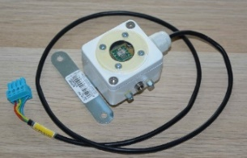
Luminosity.south.white [lux] | Luminosity south | Lux | VEML7700  (white channel) | South side of the Dadant hive
Luminosity.top.als [lux] | Luminosity top | Lux | VEML7700  (als channel) | Top side of the Dadant hive
Luminosity.top.white [lux] | Luminosity top | Lux | VEML7700  (white channel) | Top side of the Dadant hive
Luminosity.north.als [lux] | Luminosity north | Lux | VEML7700  (als channel) | North side of the Dadant hive
luminosity.north.white [lux] | Luminosity north | Lux | VEML7700  (white channel) | North side of the Dadant hive
Luminosity.west.als [lux] | Luminosity west | Lux | VEML7700  (als channel) | West side of the Dadant hive | 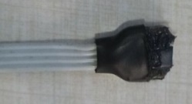
Luminosity.west.white [lux] | Luminosity west | Lux | VEML7700  (white channel) | West side of the Dadant hive | 
Luminosity.below.als [lux] | Luminosity below | Lux | VEML7700  (als channel) | Downward facing below the Dadant hive
Luminosity.below.white [lux] | Luminosity below | Lux | VEML7700  (white channel) | Downward facing below the Dadant hive | 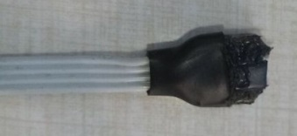
Luminosity.east.als [lux] | Luminosity east | Lux | VEML7700  (als channel) | East side of the Dadant hive | 
Luminosity.east.white [lux] | Luminosity east | Lux | VEML7700  (white channel) | East side of the Dadant hive
Luminosity.horiz.ALS [lux] | Luminosity horizontal plane | Lux | VEML7700  (als channel) | Upward facing fixed on the weather station
Luminosity.horiz.WHITE [lux] | Luminosity horizontal plane | Lux | VEML7700  (white channel) | Upward facing fixed on the weather station
Luminosity.45.CH0 [lux] | Luminosity on a 45-tilted plane (azimuth=south) | Lux | TSL2561 | Fixed on the weather station
Luminosity.45.CH1 [lux] | Luminosity on a 45-tilted plane (azimuth=south) | Lux | TSL2561 | Fixed on the weather station
Luminosity.45.LUX [lux] | Luminosity on a 45-tilted plane (azimuth=south) | Lux | TSL2561 | Fixed on the weather station
Lunar.roof.T [deg] | Temperature of hive roof | °C | NCT75 | Glued under the hive roof, centered | 
Lunar.overframe.south.T [deg] | Temperature in hive overframe | °C | NCT75 | Overframe south | 
Lunar.body.top.T [deg] | Temperature in the upper part of the hive body | °C | NCT75 | Inside the hive body, on the top part
Lunar.body.bot.T [deg] | Temperature in the lower part of the hive body | °C | NCT75 | Inside hive body (bottom), in the center | 
Lunar.below.T [deg] | Temperature below the hive | °C | NCT75 | Centred below the hive floor | 

