Metadata – Trunk Hive – Series « 2024_06_20_Csv »
Datasets: 2024_06_20_Environment.csv, 2024_06_20_LogHive.csv
Apiary location: Mas Lafont, 30170 CROS, France
Hive type: Empty wooden Log Hive.
Hive environment: open area

Description:
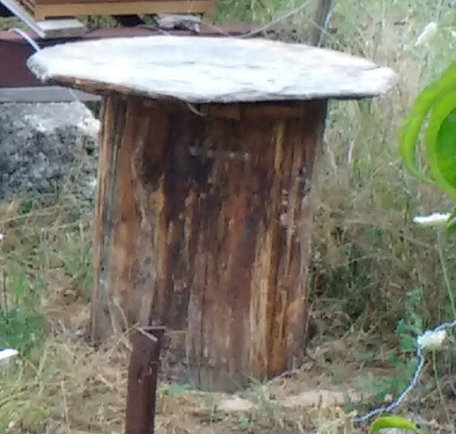
Log Hive, chestnut wood, covered by 2cm thick stone.
Figure 1: Trunk hive

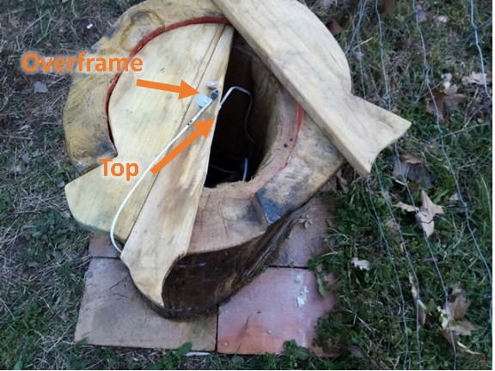
List of sensors:
- 1 sensor installed on the overframe (central position) called “overframe”
- 1 sensor in upper hive body (under the overframe) called “top”
- 1 sensor in lower part of the hive body (at the brick layer surface) called “bot”
- 1 sensor below the hive (between the ground and the brick layer) called “below”
- 1 sensor in below the ground surface at 10cm called “ground10”
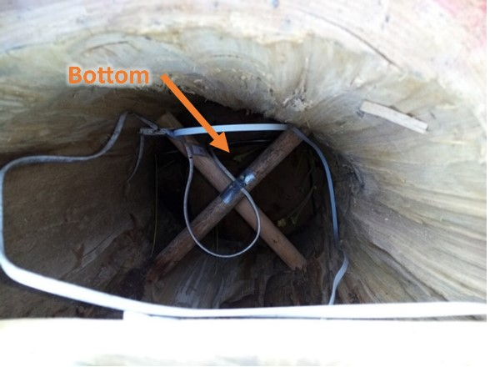
- 1 sensor in below the ground surface at 10cm called “ground20”

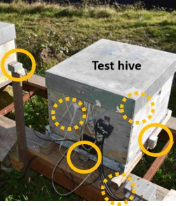
Environment:
- The luminosity (6 sensors) values in each direction (north, south, east, west, top, bottom) is measured on each face of a Dadant close (3m) to the trunk hive.
- Outside air sensor
- Wind speed

Figure 2: Luminosity sensors

Communications between the acquisition system and the sensors are done via the I2C protocol. The sensors provide an internal analog-to-digital conversion. The sensors were individually calibrated to cancel the bias error between them to allow more precise temperature difference measurements (<0.5°C). Absolute temperature errors are probably around 1°C. The intercalibration were achieved by putting all sensors together in an insulated box.
The acquisition period is set to one minute except for the wind speed data which are acquired every 2 s and averaged over 1 min.
Data are stored using a csv format in 2 different files:
- 2024_06_20_Environment.csv
- 2024_06_20_LogHive.csv
Comment lines are prefixed with hash character ‘#’. Column titles are built using comma separated identifier:
identifier1[.identifier2[.identifier3…]].field
For example, the roof temperature of test hive is “trunk.roof.T”.

Field name | Description | Unit | Sensor type | Sensor location
Timestamp | Timestamp of measurement:  Year/month/ Day/Hour/ min/sec | (local time) | PCF8523 (Real-time clock)+  DS3231 (Real-time clock module) | Acquisition system
Epoch | Timestamp of measurement | Day since 1 January 0
Wind.speed [m/s] | Wind speed | m/s | Sparkfun meteo system | Close to the apiary, 2m high | 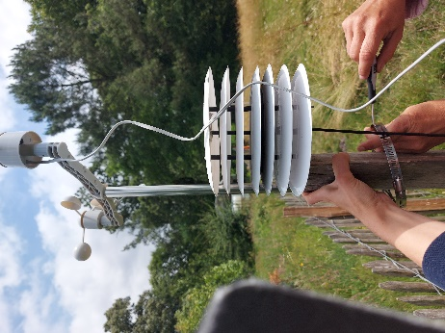
Ground.T [deg] | Temperature at the ground surface (≈1cm) | °C | NCT75 | On the ground in a shaded area. | 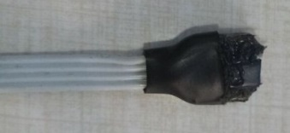
Sky.T [deg] | Equilibrium temperature of a horizontal black steel plane exposed to sunlight and insulated at the rear face | °C | NCT75 | Fixed to the weather station
Luminosity.south.als [lux] | Luminosity south | Lux | VEML7700  (als channel) | South side of the Dadant hive | 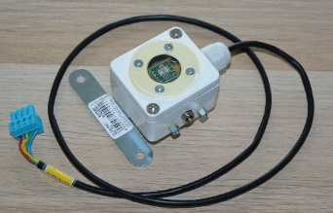
Luminosity.south.white [lux] | Luminosity south | Lux | VEML7700  (white channel) | South side of the Dadant hive
Luminosity.top.als [lux] | Luminosity top | Lux | VEML7700  (als channel) | Top side of the Dadant hive
Luminosity.top.white [lux] | Luminosity top | Lux | VEML7700  (white channel) | Top side of the Dadant hive
Luminosity.north.als [lux] | Luminosity north | Lux | VEML7700  (als channel) | North side of the Dadant hive
Test.luminosity.north.white [lux] | Luminosity north | Lux | VEML7700  (white channel) | North side of the Dadant hive
Luminosity.west.als [lux] | Luminosity west | Lux | VEML7700  (als channel) | West side of the Dadant hive
Luminosity.west.white [lux] | Luminosity west | Lux | VEML7700  (white channel) | West side of the Dadant hive
Luminosity.below.als [lux] | Luminosity below | Lux | VEML7700  (als channel) | Downward facing below the Dadant hive
Luminosity.below.white [lux] | Luminosity below | Lux | VEML7700  (white channel) | Downward facing below the Dadant hive
Luminosity.east.als [lux] | Luminosity east | Lux | VEML7700  (als channel) | East side of the Dadant hive
Luminosity.east.white [lux] | Luminosity east | Lux | VEML7700  (white channel) | East side of the Dadant hive
Luminosity.horiz.ALS [lux] | Luminosity horizontal plane | Lux | VEML7700  (als channel) | Upward facing fixed on the weather station
Luminosity.horiz.WHITE [lux] | Luminosity horizontal plane | Lux | VEML7700  (white channel) | Upward facing fixed on the weather station
Luminosity.45.CH0 [lux] | Luminosity on a 45-tilted plane (azimuth=south) | Lux | TSL2561 | Fixed on the weather station
Luminosity.45.CH1 [lux] | Luminosity on a 45-tilted plane (azimuth=south) | Lux | TSL2561 | Fixed on the weather station
Luminosity.45.LUX [lux] | Luminosity on a 45-tilted plane (azimuth=south) | Lux | TSL2561 | Fixed on the weather station
Log.body.top.HR [%] | Humidity in the upper part of log hive | % | HIH8100 | Inside hive body (top), in the centre | 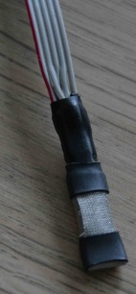
Log.body.top.T [deg] | Temperature in the upper part of log hive | °C | HIH8100 | Inside hive body (top), in the centre
Log.body.bot.T [deg] | Temperature in the lower part of log hive | °C | HIH8100 | Inside hive body (bottom), in the centre | 
Log.body.bot.HR [%] | Humidity in the lower part of log hive | % | HIH8100 | Inside hive body (bottom), in the centre | 
Log.overframe.T [deg] | Temperature in the overframe part | °C | NCT75 | Centre of the overframe | 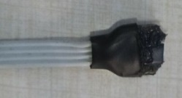
Log.below.T [deg] | Temperature below the log hive | °C | NCT75 | Between the ground and the brick layer | 
Log.ground.10.T [deg] | Ground temperature below the log hive | % | HIH8100 | 10cm under the ground surface under the hive | 
Log.ground.20.T [deg] | Ground temperature below the log hive | % | HIH8100 | 20cm under the ground surface under the hive | 

