|  |
| --- |
|  |
|  |
| Project Documentation of DISM (Semester II) |

**our team members**

* MuHAMMAD ALTAMASH ANSARI student 1099183

**Faculty** = Miss Aatika Liaquat

**Batch Code** = 1803B2

**Curriculum**= 6673

**Semester**= HDSE II



Login Page: -

This is the login page for Dashboard, which you can’t open without signing in.

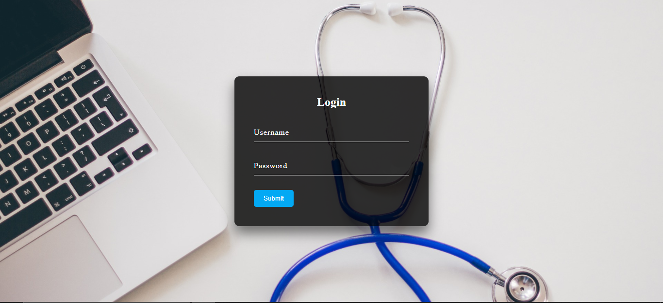

APPOINTMENT:-

This is an appointment form from where Admin can book an appointment for any patient with a doctor.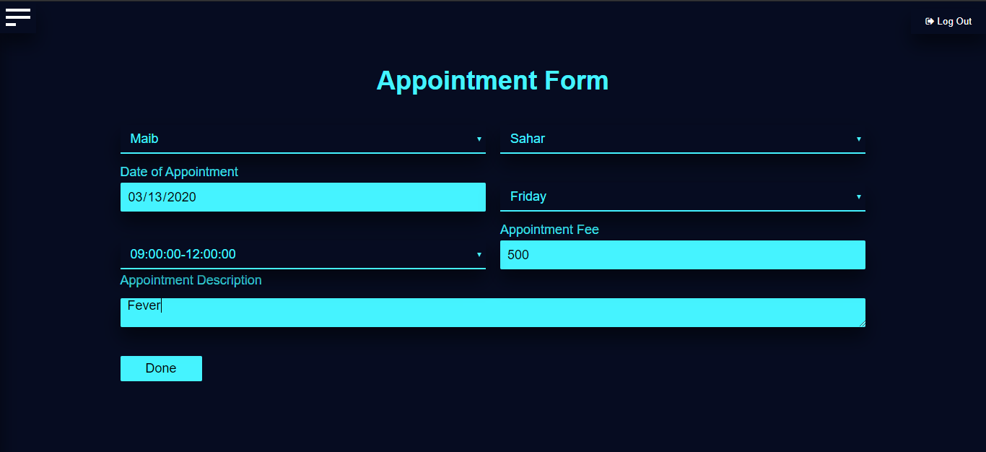

MEDICAL NEWS: -

This is medical news form where admin updates news about medical inventions and viruses.

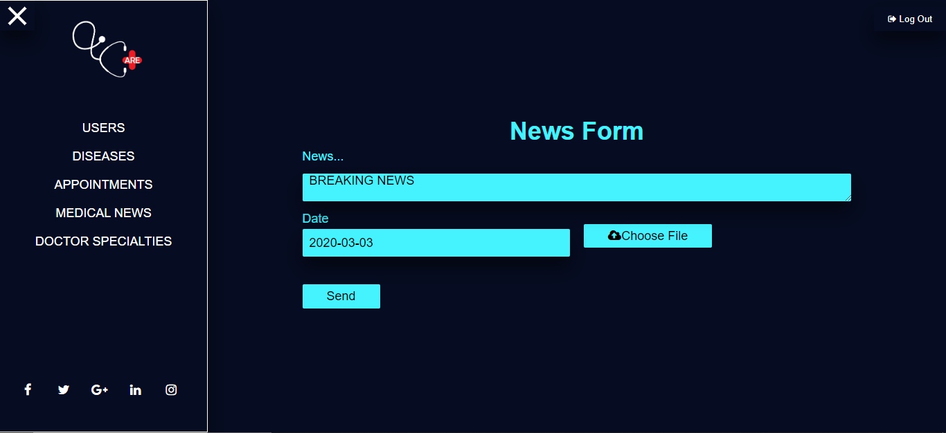

DISEASES: -

Here a user can view all the stock in our care, he or she can search for a particular book using it’s title or writer’s name.

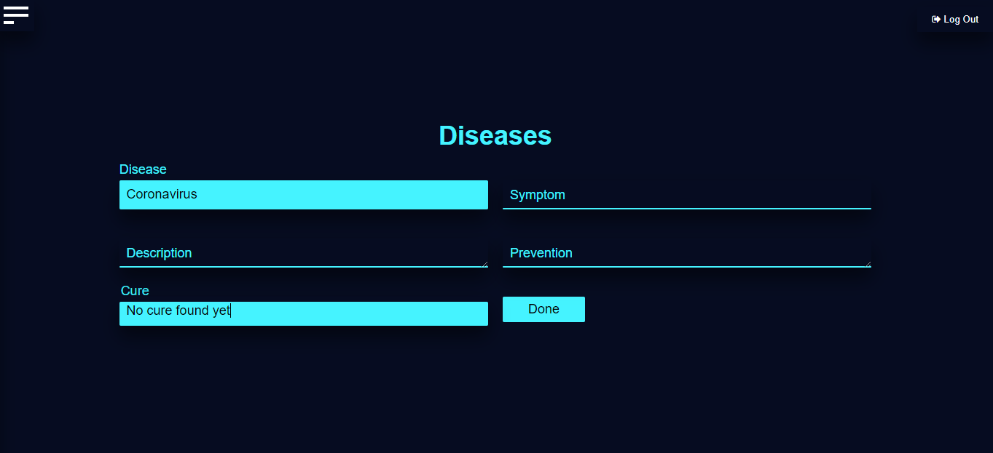

USERS: -

These are three role categories.

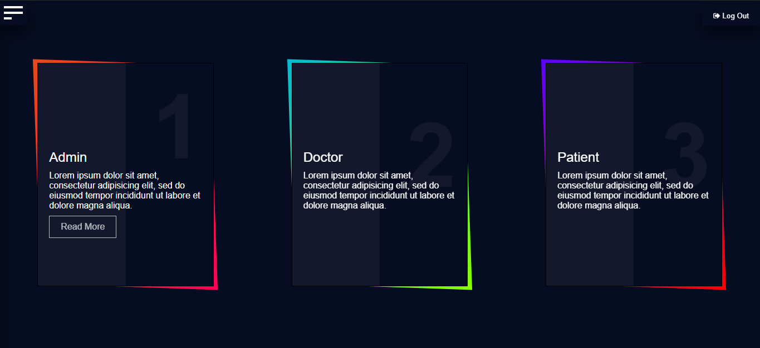

TABLE: -

This is User table in which all the users are visible to admin.

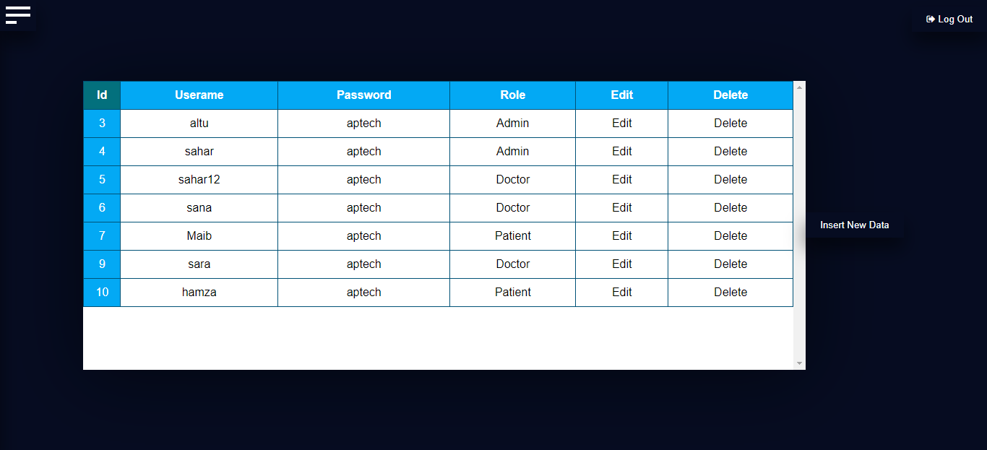



INDEX: -

This is the main and first page of our web application.

 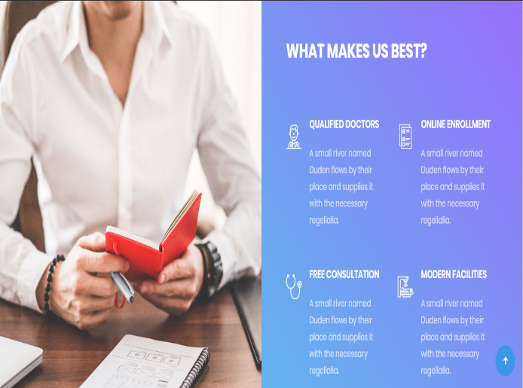

DOCTORS: -

This is how our doctors profile is shown.

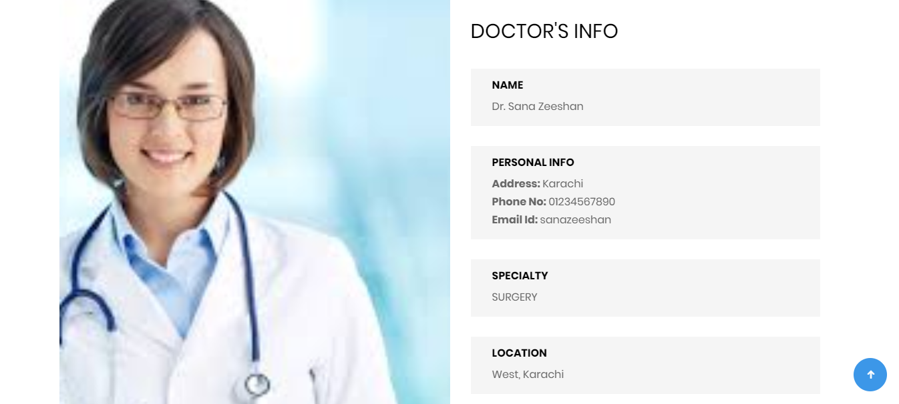

DISEASES: -

Disease updates are shown here.

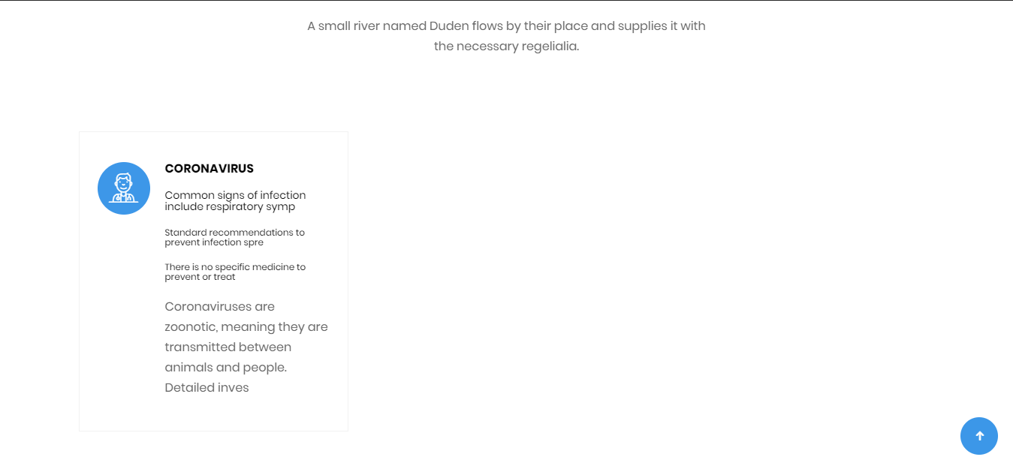

APPOINTMENT: -

This is where a patient can book an appointment with a doctor

