8x8 Telephony Solution with Creovai — AS-IS (HLD)
ArchiMate 3.x · three layers only — Business (yellow), Application (blue), Technology (green)
Status: Draft for TDA review Date: 2026-06-16

1. Diagram
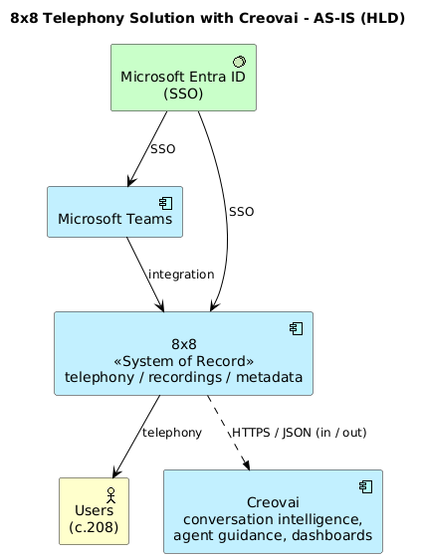

2. What to draw in Archi — element type & colour
Drag each box from the Archi palette using the element type below. In Archi each layer already has its standard fill colour by default; the hex values are given if you need to set them manually (right-click → Fill Color).
Box (label) | ArchiMate element (pick this in palette) | Layer | Colour | Hex
Users (c.208) | Business Actor | Business | Yellow | #FFFFB5
Microsoft Teams | Application Component | Application | Blue | #B5FFFF
8x8 (System of Record) | Application Component | Application | Blue | #B5FFFF
Creovai | Application Component | Application | Blue | #B5FFFF
Microsoft Entra ID | System Software | Technology | Green | #C9E7B8

Note: these are element shapes, not the ArchiMate "Artifact" element. Do NOT use the Technology "Artifact" element here — use the types in the table above.

3. Connections — relationship type & arrow
From → To | Relationship (pick this) | Arrow style | Label
Microsoft Entra ID → 8x8 | Serving | Solid line, open arrowhead | SSO
Microsoft Entra ID → Teams | Serving | Solid line, open arrowhead | SSO
Microsoft Teams → 8x8 | Serving | Solid line, open arrowhead | integration
8x8 → Users | Serving | Solid line, open arrowhead | telephony
8x8 ↔ Creovai | Flow | Dashed line, filled arrowhead | HTTPS / JSON (in / out)

4. Correctness (key points for TDA)
- Creovai integrates only with 8x8 — not Azure. Only 8x8 connects to Azure.
- 8x8 is the single system of record; all downstream data originates from 8x8.
- Microsoft Entra ID governs identity/access for 8x8 and Teams only and does not touch Creovai.

