**INTRODUCTION**

**INTRODUCTION**

TakeDeal.com is the world's leading classifieds platform in growth markets. TakeDeal.com makes it so easy to connect people to buy, sell or exchange used goods and services. It's completely free, and it can be used from a laptop or mobile phone.

In simple word’s

takedeal.com is a platform for users to buy or sell things, or find anything in their community.

It is global online market place where any people can buy and sell any products.

**1.1Project Overview: Objectives**

This project will serve the following objectives: -

1. 100% responsive design.
2. To see all advertisements of other people posted.
3. Message to the next customer to show interest.
4. Post our own advertisements.
5. All information of users are stored.
6. Multiple selections of products.
7. Awareness of the service and brand.
8. Higher Market Share
9. Beating the competitors and remain at top.

**1.2 Existing System:**

We all are knows our community is going on online platforms. Everything we need we found that on online

So, we regularly buy any things from online platforms or from offline going to the shop we buy something but when we get bored of that thing then we sell it through people telling I have one product I want to sell that like wise

and we advertise that product to only few peoples and they don’t want that product and escape from that. So, this project will help user to overcome from all this processes.

**Problems of Existing System:**

1. Time Consuming.
2. Lack of security.
3. Too much of tiredness in search of products.

**1.3 Proposed System:**

This website will help the users to sell their product from anywhere user just need to take some pictures of the products and post the advertisement of that and it will display all the other users who are using this website, if any one likes that product and want to buy that they just talk with you by chat and arrange meeting to buy product.

with this website the products will sell very quickly. anyone can buy or sell from this website. The proposed system of TakeDeal.com.com is a computerized system which performs all the work by installing it.

**CHARACTERISTICS OF THE PROPOSED SYSTEM:**

The use of proposed system will avoid the problems of the existing system and we also get a new system for managing information under the TakeDeal.com The proposed system offers the following Characteristic:

1. Searching of sub-category products which is time consuming it can be reduced.
2. Easy to store data in the database.
3. Administrator can add/remove users.
4. Increase processing speed and Improved security.
5. An easily access environment for users
6. Easy to use real time search facility.
7. No or very few paper work

**1.4 Scope of project:**

1. This project will help user to consume less time.
2. Human efforts can be reduced drastically.
3. Saves Money and resources of organization.
4. In small time we get more services and more choices.
5. Categories like different types of products are available, can be arranged in various categories so it is easy to access and easy to maintain it.

**FEASIBILITY STUDY**

**2.Feasibility Study :**

The basic idea behind feasibility study is to determine whether the project is feasible or not. A feasibility is conducted to identify a best system that meets all the requirements. This includes an identification, description, an evaluation of the proposed systems and selection of the best system for the job. The requirements of the system are specified with a set of constraints such as system objectives and the description of the out puts. It is then duty of the analyst to evaluate the feasibility of the proposed system to generate the above results. Three key factors are to be considered during the feasibility study.

**2.1Project Feasibility**

**1. Operation Feasibility:**

An estimate should be made to determine how much effort and care will go into the developing of the system including the training to be given to the user. Usually, people are reluctant to changes that come in their progression. The computer initialization will certainly affect the turn over, transfer and employee job status. Hence an additional effort is to be made to train and educate the users on the new way of the system**.**

**2.Technical Feasibility:**

The main consideration is to be given to the study of available resources of the organization where the software is to be implemented. Here the system analyst evaluates the technical merits of the system giving emphasis on the performance, reliability, maintainability and productivity.

By taking the consideration before developing the proposed system, the resources availability of the organization was studied. The organization was immense computer facilities equipped with sophisticated machines and the software hence this technically feasible.

**2.2 Hardware Specification:**

1. Operating System: Microsoft Windows 7/windows 8/ windows 8.1/windows 10
2. Processor: Intel Pentium 4 or above.
3. Hard disk: 1GB or above.
4. RAM: 1GB

**2.3 Software Specification:**

1. Databases: SQL Database
2. Development Tool: Visual Studio 2015
3. Languages Used: ASP.net

**SYSTEM DESIGN**

**3.System Design:**

**3.1** DFD (Data Flow Diagram):

* **Context Level DFD:**

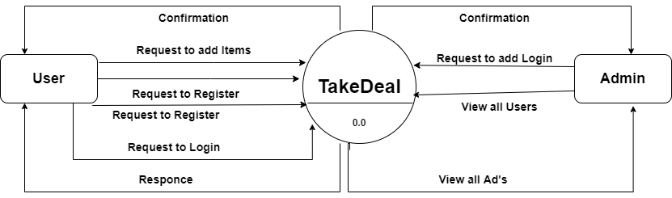

* **First Level DFD for User:**

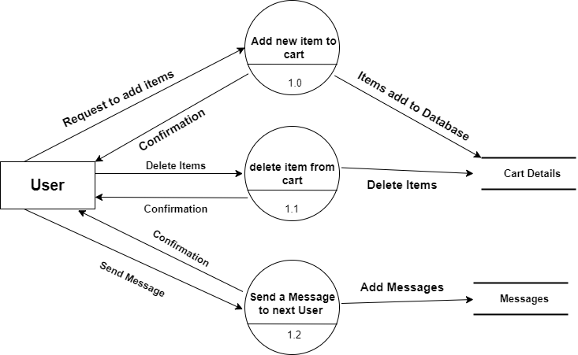

* **First Level DFD for Admin:**

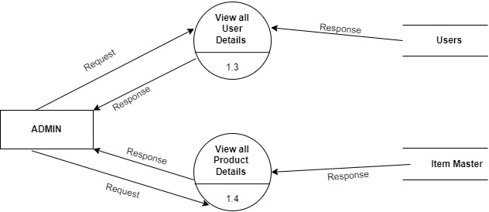

* **Second Level DFD for User:**

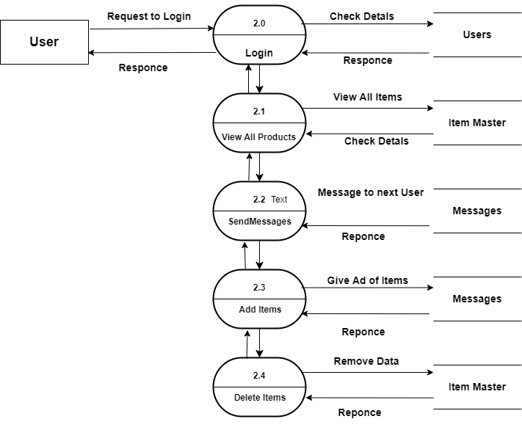

* **Second Level DFD for Admin:**

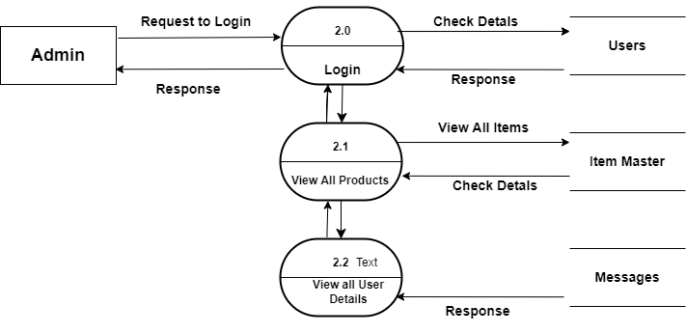

* 1. **ERD (Entity Relationship Diagram):**

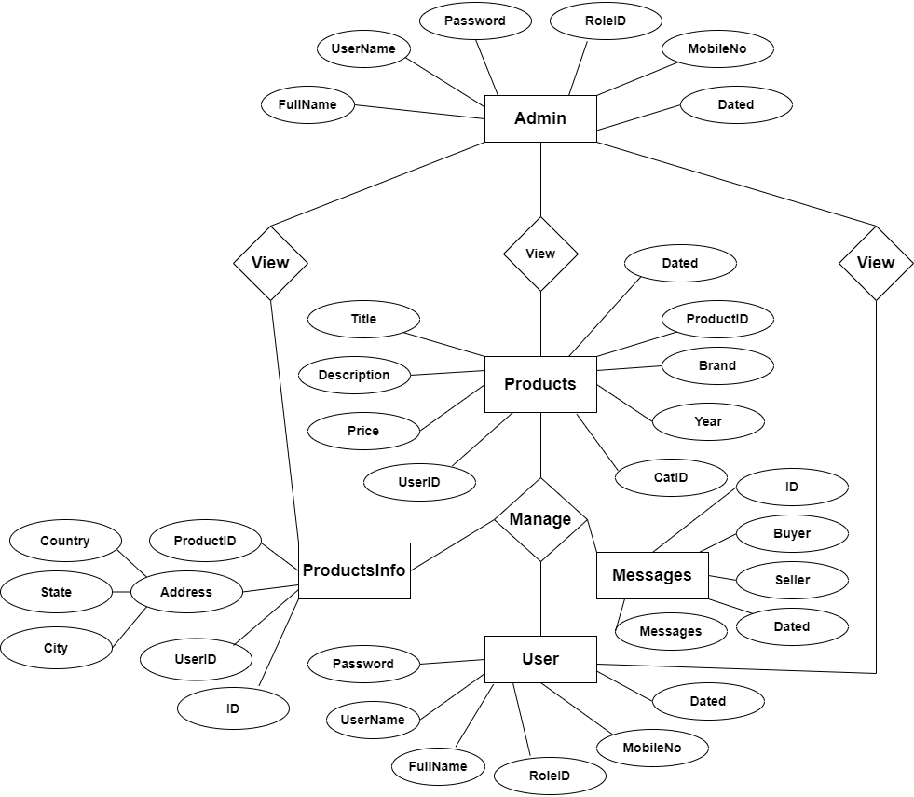

* 1. **Database Design:**

**1. Users:**

|  |  |  |
| --- | --- | --- |
| **Name** | **Data Type** | **Constraint** |
| UserId | Int | Primary Key |
| UName | Varchar(100) | Uinque Key |
| UPassword | nvarchar(20) | Not Null |
| RoleID | Int | Not Null |
| FullName | Varchar(100) | Not Null |
| SeqQue | Varchar(200) | Not Null |
| SeqAns | Varchar(200) | Not Null |
| Dated | Date | Not Null |
| Active | Bit | Not Null |
| Mobile | Varchar(10) | Not Null |

**2. User Info:**

|  |  |  |
| --- | --- | --- |
| **Name** | **Data Type** | **Constraint** |
| PicId | Int | Primary Key |
| UserId | Varchar(100) | Foreign Key |
| PicPath | Varchar(200) | Null |
| Address | Varchar(MAX) | Null |
| Description | Varchar(300) | Null |
| Productselled | Varchar(100) | Not Null |

**3. States:**

|  |  |  |
| --- | --- | --- |
| **Name** | **Data Type** | **Constraint** |
| Id | Int | Primary Key |
| Name | Varchar(100) | Not Null |
| CountryId | Int | Not Null |

**9.Cities**

|  |  |  |
| --- | --- | --- |
| **Name** | **Data Type** | **Constraint** |
| Id | Int | Primary Key |
| City | Varchar(255) | Not Null |
| State_id | nvarchar(10) | Foreign Key |

**10.Countries**

|  |  |  |
| --- | --- | --- |
| **Name** | **Data Type** | **Constraint** |
| Id | Int | Primary Key |
| countryCode | Varchar(50) | Foreign Key |
| Name | varchar(100) | Not Null |

**4. Bikes:**

|  |  |  |
| --- | --- | --- |
| **Name** | **Data Type** | **Constraint** |
| BikeId | Int | Primary Key |
| Brand | Varchar(200) | Not Null |
| Year | Int | Not Null |
| KMDriven | Int | Not Null |
| Title | Varchar(200) | Not Null |
| Description | Varchar(MAX) | Not Null |
| Price | Int | Not Null |
| CatID | Int | Not Null |
| UserId | Varchar(200) | Foreign Key |
| Dated | Date | Not Null |

**5.Bikes Info**

|  |  |  |
| --- | --- | --- |
| **Name** | **Data Type** | **Constraint** |
| PicId | Int | Primary Key |
| PicPath1 | Varchar(MAX) | Not Null |
| PicPath2 | Varchar(MAX) | Not Null |
| PicPath3 | Varchar(MAX) | Not Null |
| PicPath4 | Varchar(MAX) | Not Null |
| PicPath5 | Varchar(MAX) | Not Null |
| PicPath6 | Varchar(MAX) | Not Null |
| BikeId | Int | Foreign Key |
| Country | Varchar(50) | Not Null |
| State | Varchar(50) | Not Null |
| City | Varchar(50) | Not Null |

**6.Cars**

|  |  |  |
| --- | --- | --- |
| **Name** | **Data Type** | **Constraint** |
| CarId | Int | Primary Key |
| Brand | Varchar(100) | Not Null |
| Year | Int | Not Null |
| Fuel | Varchar(50) | Not Null |
| Transmission | Varchar(50) | Not Null |
| KMDriven | Int | Not Null |
| NoOfOwners | Varchar(30) | Not Null |
| Title | Varchar(100) | Not Null |
| Description | Varchar(MAX) | Not Null |
| Price | Float | Not Null |
| CatID | Int | Not Null |
| UserID | nVarchar(100) | Foreign Key |
| Dated | Date | Not Null |

**7.CarsInfo**

|  |  |  |
| --- | --- | --- |
| **Name** | **Data Type** | **Constraint** |
| PicId | Int | Primary Key |
| PicPath1 | Varchar(MAX) | Not Null |
| PicPath2 | Varchar(MAX) | Not Null |
| PicPath3 | Varchar(MAX) | Not Null |
| PicPath4 | Varchar(MAX) | Not Null |
| PicPath5 | Varchar(MAX) | Not Null |
| PicPath6 | Varchar(MAX) | Not Null |
| CarId | Int | Foreign Key |
| Country | Varchar(50) | Not Null |
| State | Varchar(50) | Not Null |
| City | Varchar(50) | Not Null |

**8.Categories**

|  |  |  |
| --- | --- | --- |
| **Name** | **Data Type** | **Constraint** |
| CatId | Int | Primary Key |
| Name | Varchar(200) | Not Null |

**11.Electronics**

|  |  |  |
| --- | --- | --- |
| **Name** | **Data Type** | **Constraint** |
| EID | Int | Primary Key |
| Title | Varchar(100) | Not Null |
| Description | varchar(Max) | Not Null |
| Price | Int | Not Null |
| CatId | Int | Not Null |
| UserID | Varchar(50) | Foreign Key |
| Dated | Date | Not Null |

**12ElectronicsInfo**

|  |  |  |
| --- | --- | --- |
| **Name** | **Data Type** | **Constraint** |
| PicId | Int | Primary Key |
| PicPath1 | Varchar(MAX) | Not Null |
| PicPath2 | Varchar(MAX) | Not Null |
| PicPath3 | Varchar(MAX) | Not Null |
| PicPath4 | Varchar(MAX) | Not Null |
| PicPath5 | Varchar(MAX) | Not Null |
| PicPath6 | Varchar(MAX) | Not Null |
| EId | Int | Foreign Key |
| Country | Varchar(50) | Not Null |
| State | Varchar(50) | Not Null |
| City | Varchar(50) | Not Null |

**13.Furniture**

|  |  |  |
| --- | --- | --- |
| **Name** | **Data Type** | **Constraint** |
| FulID | Int | Primary Key |
| Title | Varchar(100) | Not Null |
| Description | varchar(Max) | Not Null |
| Price | Int | Not Null |
| UserId | Varchar(50) | Foreign Key |
| Dated | Date | Not Null |
| CatID | Int | Not Null |

**13.FurnitureInfo**

|  |  |  |
| --- | --- | --- |
| **Name** | **Data Type** | **Constraint** |
| PicId | Int | Primary Key |
| PicPath1 | Varchar(MAX) | Not Null |
| PicPath2 | Varchar(MAX) | Not Null |
| PicPath3 | Varchar(MAX) | Not Null |
| PicPath4 | Varchar(MAX) | Not Null |
| PicPath5 | Varchar(MAX) | Not Null |
| PicPath6 | Varchar(MAX) | Not Null |
| FId | Int | Foreign Key |
| Country | Varchar(50) | Not Null |
| State | Varchar(50) | Not Null |
| City | Varchar(50) | Not Null |

**14.MobileInfo**

|  |  |  |
| --- | --- | --- |
| **Name** | **Data Type** | **Constraint** |
| PicId | Int | Primary Key |
| PicPath1 | Varchar(MAX) | Not Null |
| PicPath2 | Varchar(MAX) | Not Null |
| PicPath3 | Varchar(MAX) | Not Null |
| PicPath4 | Varchar(MAX) | Not Null |
| PicPath5 | Varchar(MAX) | Not Null |
| PicPath6 | Varchar(MAX) | Not Null |
| MobId | Int | Foreign Key |
| Country | Varchar(50) | Not Null |
| State | Varchar(50) | Not Null |
| City | Varchar(50) | Not Null |

**15.Mobiles**

|  |  |  |
| --- | --- | --- |
| **Name** | **Data Type** | **Constraint** |
| MobID | Int | Primary Key |
| Brand | Varchar(50) | Not null |
| Title | Varchar(100) | Not Null |
| Description | varchar(Max) | Not Null |
| Price | Int | Not Null |
| CatId | Int | Not Null |
| UserID | Varchar(50) | Foreign Key |
| Dated | Date | Not Null |

**16.Others**

|  |  |  |
| --- | --- | --- |
| **Name** | **Data Type** | **Constraint** |
| OID | Int | Primary Key |
| Brand | Varchar(50) | Not null |
| Title | Varchar(100) | Not Null |
| Description | varchar(Max) | Not Null |
| Price | Int | Not Null |
| CatId | Int | Not Null |
| UserID | Varchar(50) | Foreign Key |
| Dated | Date | Not Null |

**17.OthersInfo**

|  |  |  |
| --- | --- | --- |
| **Name** | **Data Type** | **Constraint** |
| PicId | Int | Primary Key |
| PicPath1 | Varchar(MAX) | Not Null |
| PicPath2 | Varchar(MAX) | Not Null |
| PicPath3 | Varchar(MAX) | Not Null |
| PicPath4 | Varchar(MAX) | Not Null |
| PicPath5 | Varchar(MAX) | Not Null |
| PicPath6 | Varchar(MAX) | Not Null |
| OId | Int | Foreign Key |
| Country | Varchar(50) | Not Null |
| State | Varchar(50) | Not Null |
| City | Varchar(50) | Not Null |

**Output Screens:**

**1.Login Page**

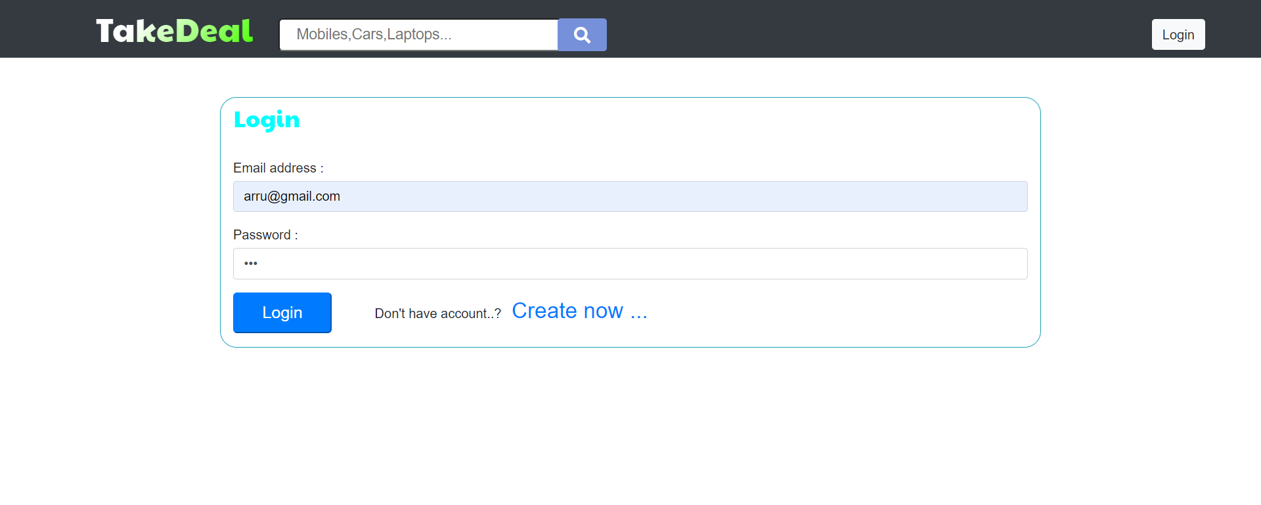

**2.Home Page**

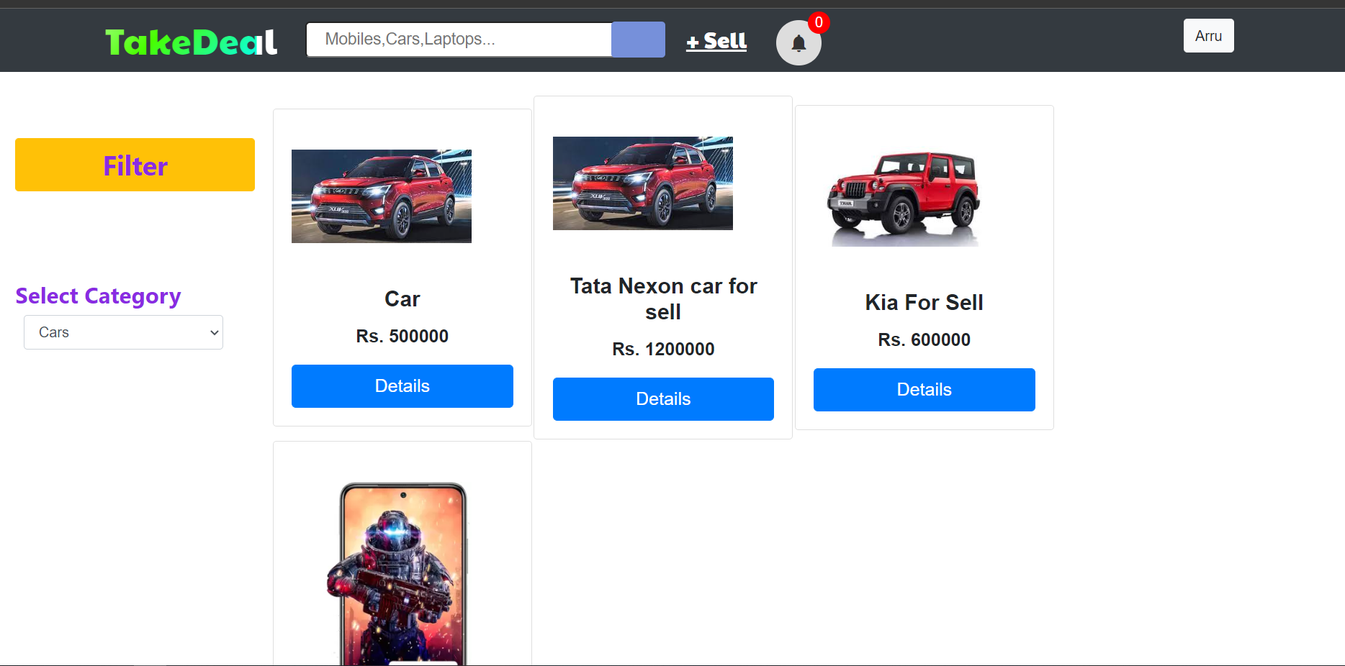

**3.Posting Ads**

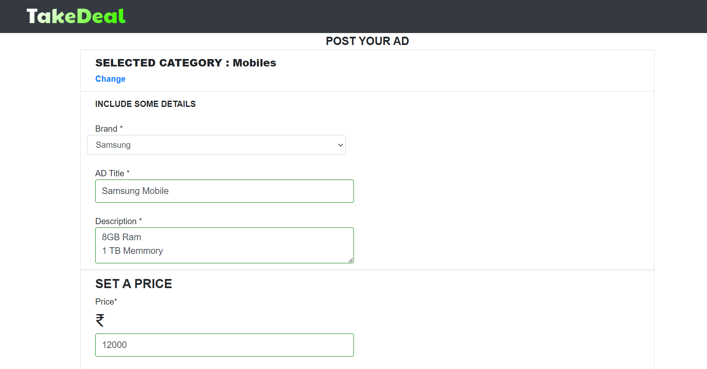

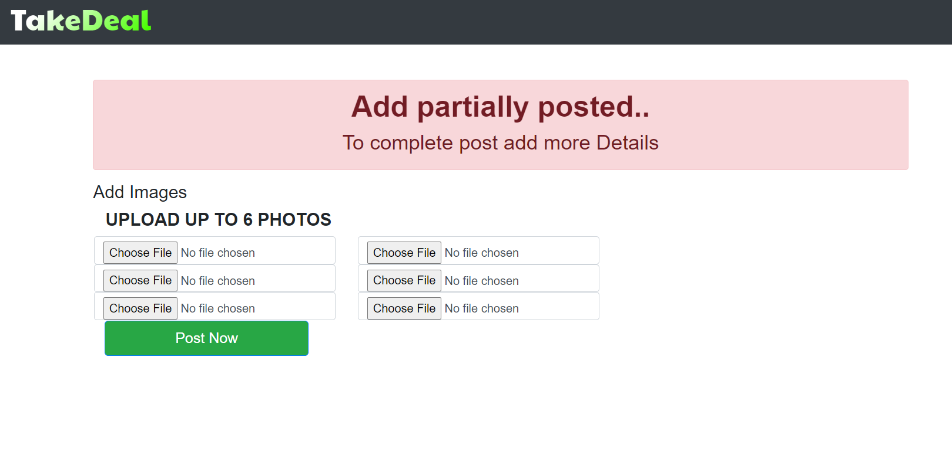

**4.Category List**

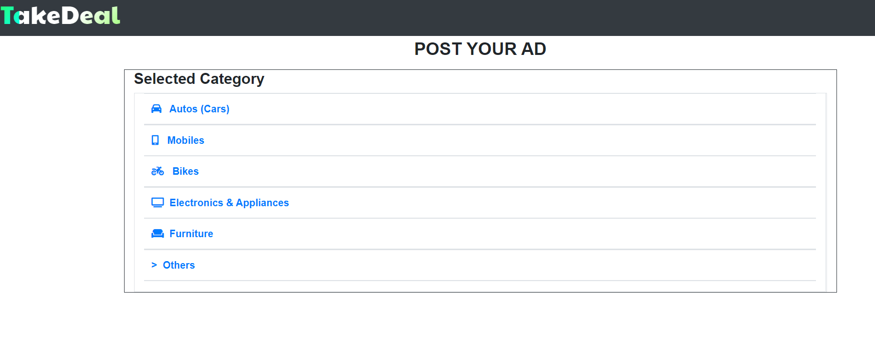

**5.Profile**

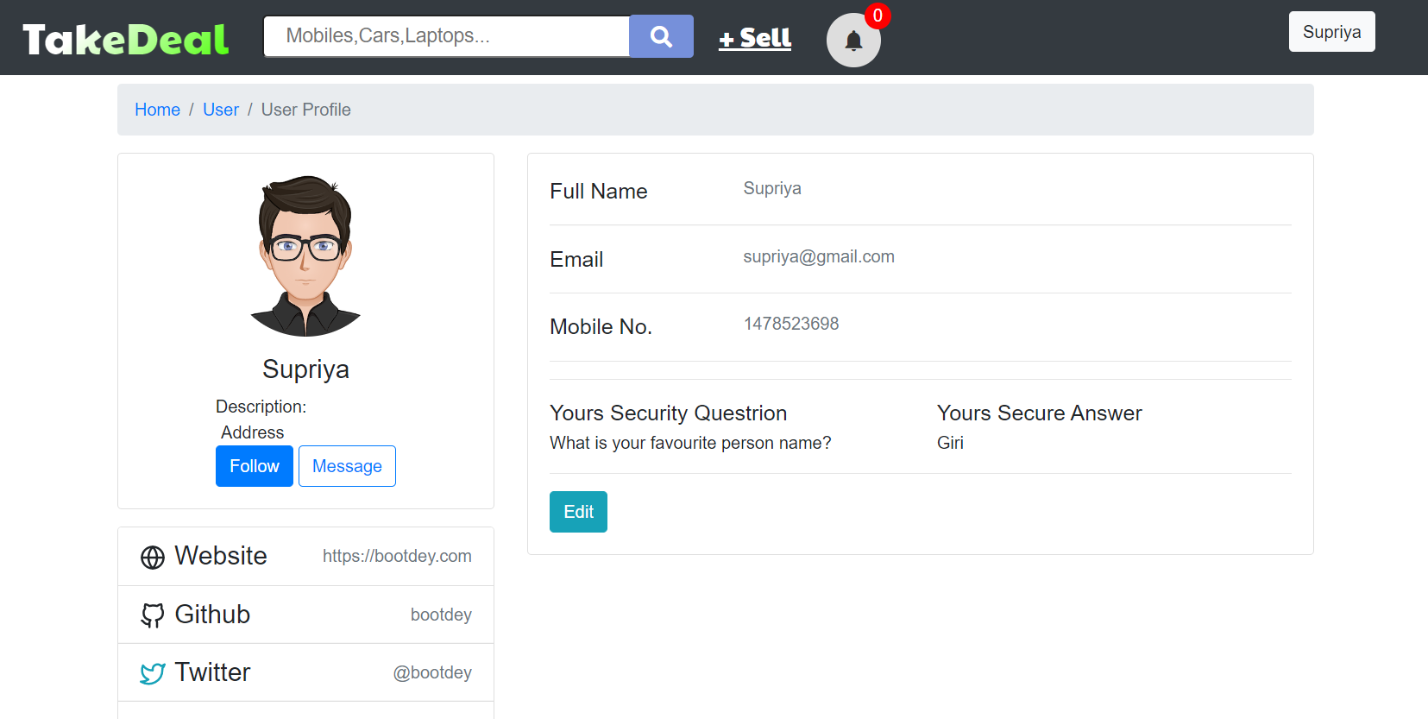

**6.User Posted Ad’s**

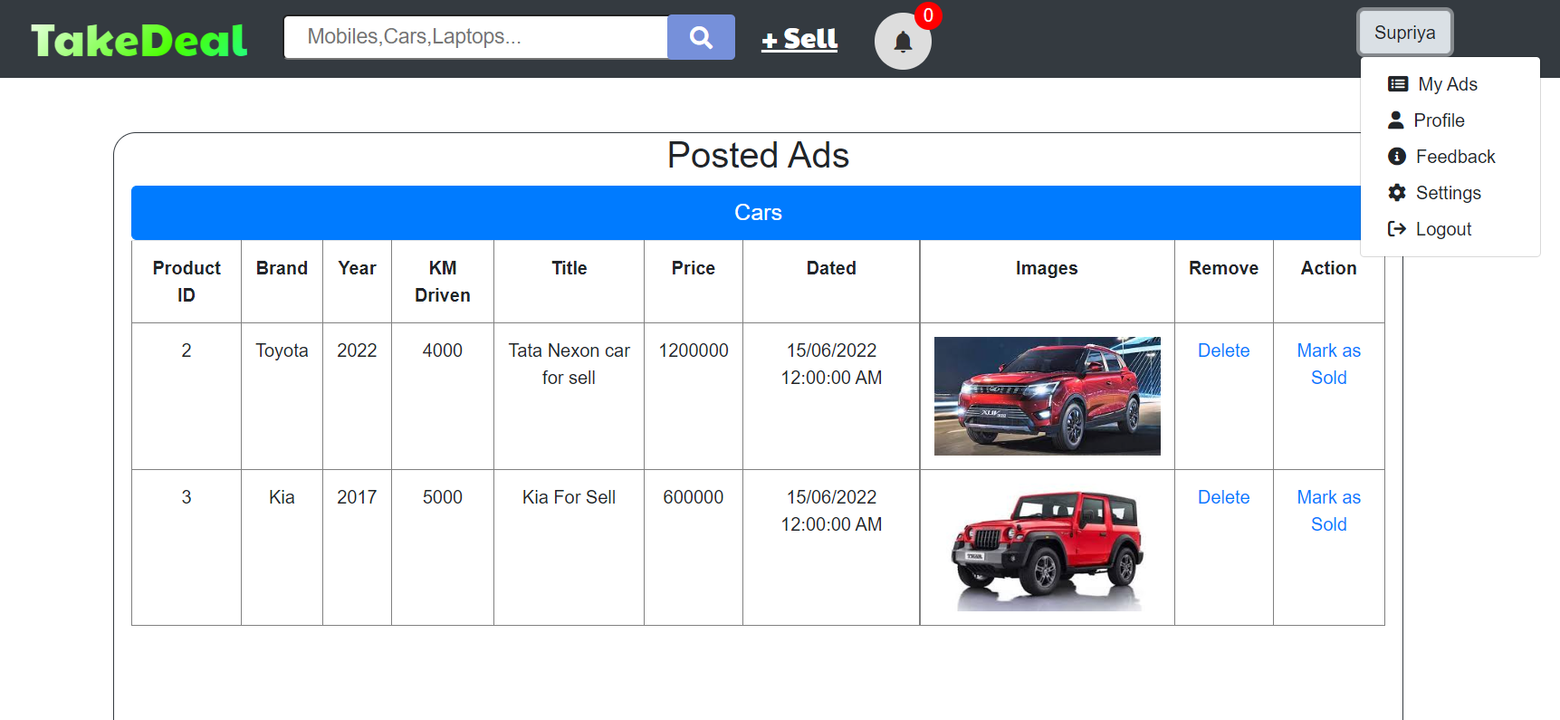

**7.Admin Panel**

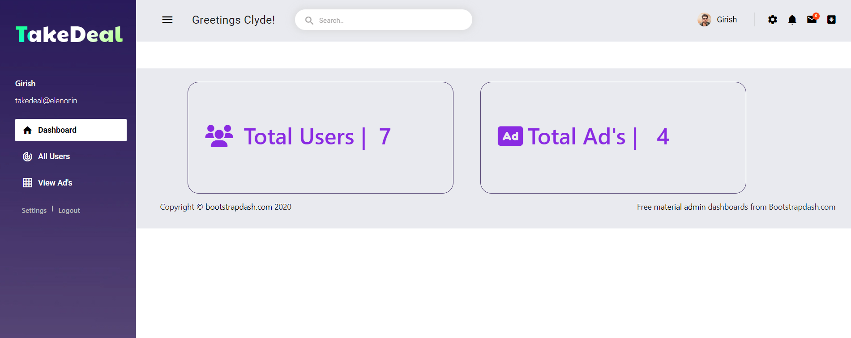

**6.Show all ads to admin**

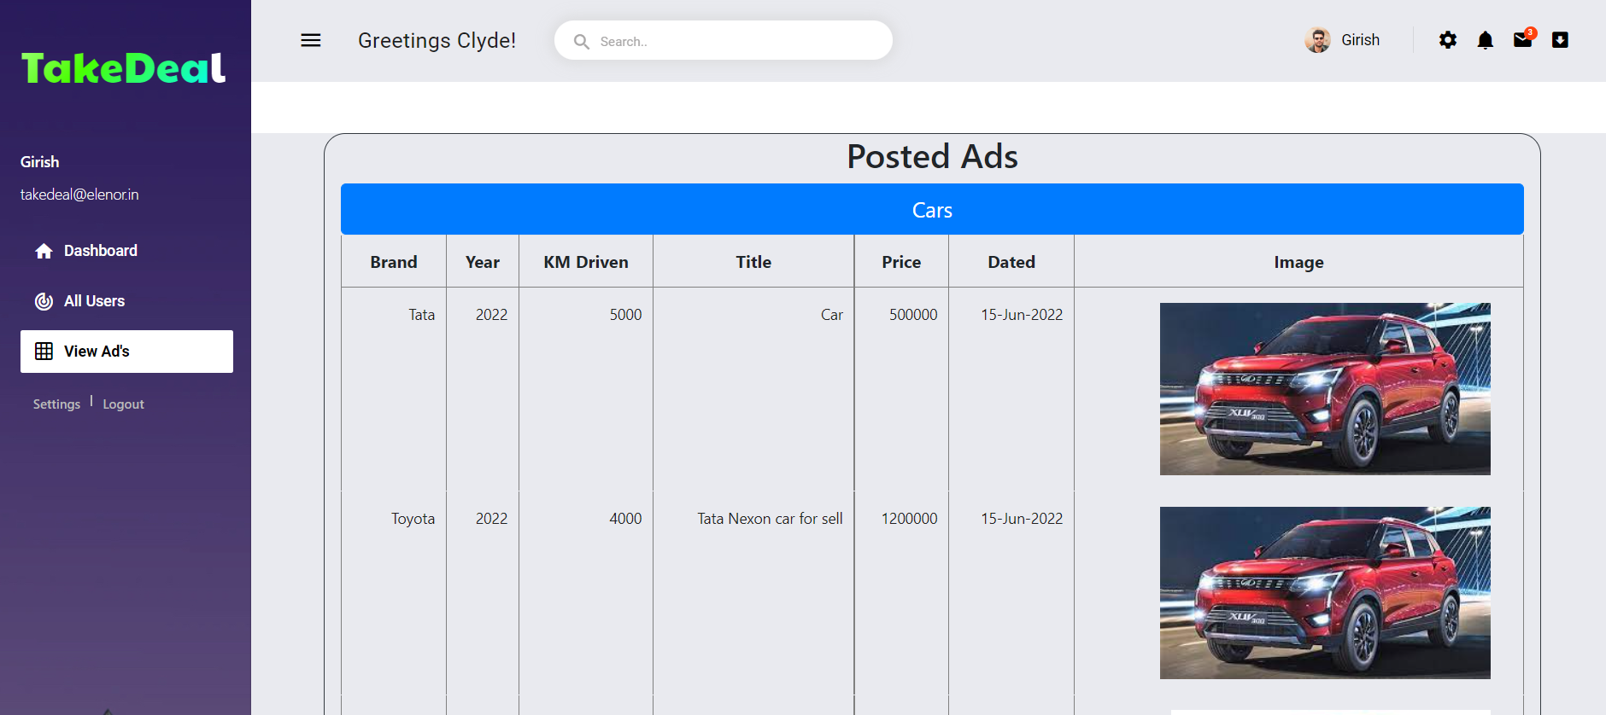

**6.Show all Users to admin**

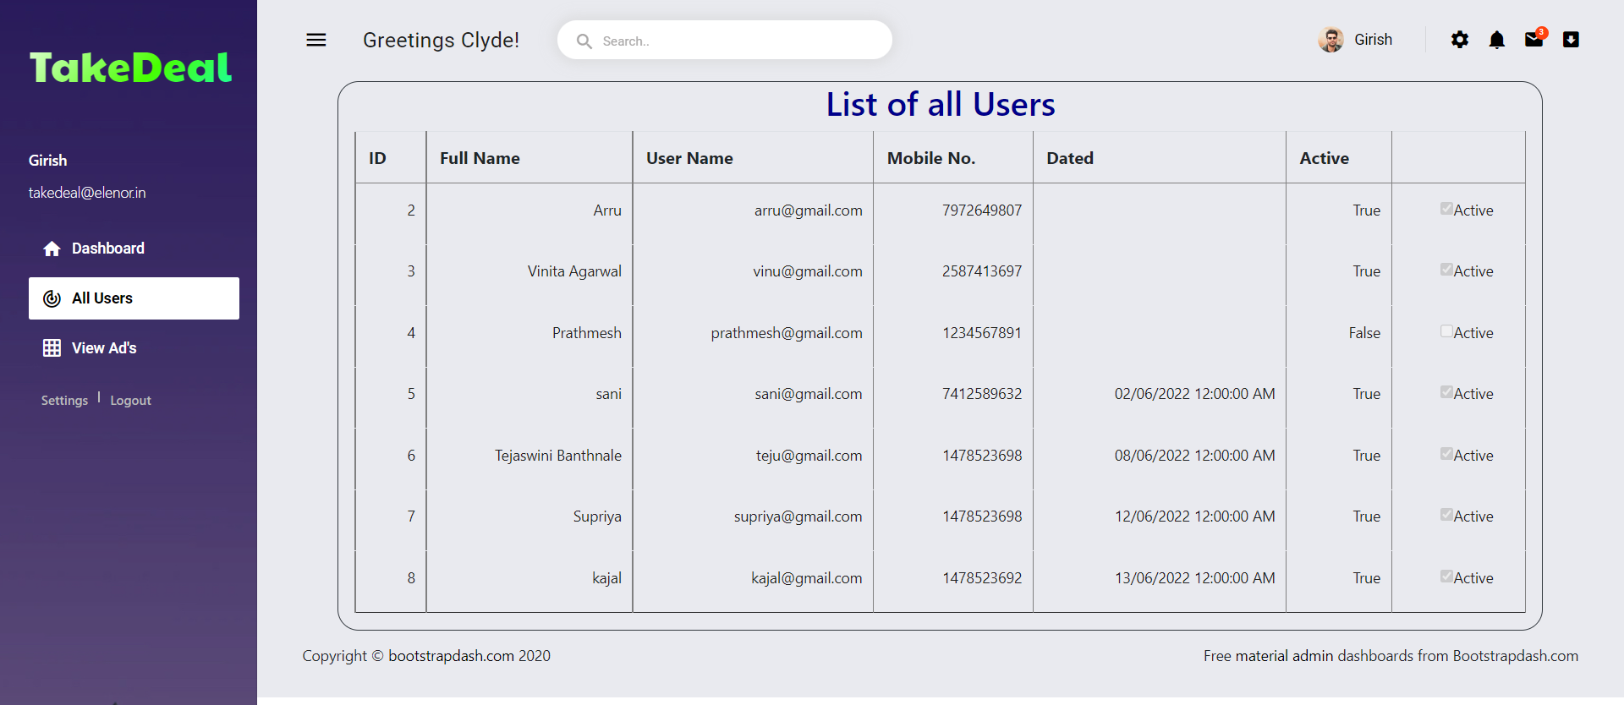

**IMPLIMENTATION**

**4.Implimentation:**

**4.1Code Script:**

**A) Login.aspx**

<%@ Page Title="" Language="C#" MasterPageFile="~/NavMaster.master" AutoEventWireup="true" CodeFile="Login.aspx.cs" Inherits="_Default" %>

<asp:Content ID="Content1" ContentPlaceHolderID="head" runat="Server">

<link rel="stylesheet" href="css/StyleSheet1.css" />

</asp:Content>

<asp:Content ID="Content2" ContentPlaceHolderID="ContentPlaceHolder1" runat="Server">

<div class="container mt-5 border border-info " style="border-radius:20px; width:1000px;">

<h3 class="mt-2 " id="lblReg">Login </h3>

<br />

<div class="form-group">

<asp:Label ID="Label1" runat="server" Text="Email address :"></asp:Label>

&nbsp;

<asp:RequiredFieldValidator ID="RequiredFieldValidator1" runat="server" ControlToValidate="email" ErrorMessage="* Enter email" ForeColor="Red" ValidationGroup="a"></asp:RequiredFieldValidator>

&nbsp;<asp:RegularExpressionValidator ID="RegularExpressionValidator1" runat="server" ControlToValidate="email" ErrorMessage="* Enter correct email" ForeColor="Red" ValidationGroup="a" ValidationExpression="\w+([-+.']\w+)*@\w+([-.]\w+)*\.\w+([-.]\w+)*"></asp:RegularExpressionValidator>

&nbsp;<asp:Label ID="Label4" runat="server" ForeColor="Red" Text="Enter email " Visible="False"></asp:Label>

<asp:TextBox ID="email" CssClass="form-control mt-1" runat="server" MaxLength="50" style="margin-bottom: 0" />

</div>

<div class="form-group">

<asp:Label ID="Label3" runat="server" Text="Password :"></asp:Label>

&nbsp;&nbsp;

<asp:RequiredFieldValidator ID="RequiredFieldValidator2" runat="server" ControlToValidate="pass" ErrorMessage="* Enter Password" ForeColor="Red" ValidationGroup="a"></asp:RequiredFieldValidator>

&nbsp;<asp:Label ID="Label5" runat="server" ForeColor="Red" Text="Enter password" Visible="False"></asp:Label>

<asp:TextBox ID="pass" CssClass="form-control mt-1" runat="server" MaxLength="20" TextMode="Password" />

</div>

<asp:Button ID="btnlogin" Width="120px" CssClass="btn-lg btn-primary mb-3" runat="server" Text="Login" ValidationGroup="a" OnClick="btnlogin_Click" />

<asp:Label ID="Label2" CssClass="font-monospace ml-5" runat="server" Text="Don't have account..? "></asp:Label>

<asp:HyperLink ID="createAc" class="ml-2 font-monospace createAc" NavigateUrl="~/Registration.aspx" runat="server">Create now ...</asp:HyperLink>

&nbsp;</div>

</asp:Content>

**A) Login.aspx.cs**

using System;  
using [System.Collections.Generic](http://System.Collections.Generic);  
using [System.Linq](http://System.Linq);  
using [System.Web](http://System.Web);  
using [System.Web.UI](http://System.Web.UI);  
using [System.Web.UI.WebControls](http://System.Web.UI.WebControls);  
using [System.Data](http://System.Data);  
using [System.Data.SqlClient](http://System.Data.SqlClient);  
using [System.Configuration](http://System.Configuration);  
  
public partial class _Default : [System.Web.UI.Page](http://System.Web.UI.Page)  
{  
    protected void Page_Load(object sender, EventArgs e)  
    {  
        if (Session["RoleID"].ToString()!= "")  
        {  
            [Response.Redirect](http://Response.Redirect)("~/[Home.aspx](http://Home.aspx)");  
        }  
    }  
    protected void btnlogin_Click(object sender, EventArgs e)  
    {  
        try  
        {  
               string strCon = [ConfigurationManager.ConnectionStrings](http://ConfigurationManager.ConnectionStrings)["MyCon"].ConnectionString;  
                SqlConnection con = new SqlConnection(strCon);  
                string strCmd = "select UName,UPassword,Mobile,RoleID,FullName

,Active from Users where Uname ='" + [email.Text](http://email.Text) + "'";  
                SqlCommand cmd = new SqlCommand(strCmd, con);  
                SqlDataAdapter dtadp = new SqlDataAdapter();  
                [dtadp.SelectCommand](http://dtadp.SelectCommand) = cmd;  
                DataTable dt = new DataTable();  
                [dtadp.Fill](http://dtadp.Fill)(dt);  
                if ([dt.Rows.Count](http://dt.Rows.Count) > 0)  
                {  
                    if ([Convert.ToBoolean](http://Convert.ToBoolean)([dt.Rows](http://dt.Rows)[0]["Active"]) == false)  
                    {  
                        [Label2.Text](http://Label2.Text) = "Account is Suspended !!!!!";  
                    }  
                    else  
                    {  
                        string strPassword = [dt.Rows](http://dt.Rows)[0]["UPassword"].ToString();  
                        if ([pass.Text](http://pass.Text) == strPassword)  
                        {  
                            Session["RoleID"] = [dt.Rows](http://dt.Rows)[0]["RoleID"].ToString();

                            Session["UName"] = [dt.Rows](http://dt.Rows)[0]["UName"].ToString();  
                            Session["FullName"] = [dt.Rows](http://dt.Rows)[0]["FullName"].ToString();  
                            Session["Mobile"] = [dt.Rows](http://dt.Rows)[0]["Mobile"].ToString();  
  
                            if (Session["RoleID"].ToString() == "1")  
                            {  
                                //Admin  
                                [Response.Redirect](http://Response.Redirect)("~/Admin/template/demo/[AdminHome.aspx](http://AdminHome.aspx)");  
                            }  
                            else  
                            {  
                                //Else  
                                [Response.Redirect](http://Response.Redirect)("~/[Home.aspx](http://Home.aspx)");  
                            }  
                        }  
                        else  
                        {  
                            [Label2.Text](http://Label2.Text) = "Invalid Password ..!!!";  
                            [RequiredFieldValidator2.Visible](http://RequiredFieldValidator2.Visible) = true;  
                            [RequiredFieldValidator2.Text](http://RequiredFieldValidator2.Text) = "Invalid Password..";  
                        }  
                    }  
                }  
                else  
                {  
                    [Label2.Text](http://Label2.Text) = "You Don’t have any account here";  
             }  
            }  
        catch (Exception ex)  
        {  
            [Label2.Text](http://Label2.Text) = [ex.Message](http://ex.Message);  
        }  
    }         
}

**TECHNOLOGY AND**

**TOOLS**

**5.Tools and Technology:-**

**1.Visual studio code 2015:**

Visual Studio Code is a source-code editor made by Microsoft for Windows, Linux and macOS. Features include support for debugging, syntax highlighting, intelligent code completion, snippets, code refactoring, and embedded Git. Users can change the theme, keyboard shortcuts, preferences, and install extensions that add additional functionality. In the Stack Overflow 2021 Developer Survey, Visual Studio Code was ranked the most popular developer environment tool, with 70% of 82,000 respondents reporting that they use it..

**2.SQL Server Database:**

SQL Server Database has been claimed to be used by Google to track users without their knowledge. On July 14, 2020, a lawsuit was filed accusing Google of violating federal wire tap law and California privacy law. It stated that through Firebase, Google collected and stored user data, logging what the user was looking at in many types of apps, despite the user following Google's own instructions to turn off the web and app activity collected by creating  applications. It was originally an independent company founded in 2011. In 2014, Google acquired the platform and it is now their flagship offering for app development.

IT has been claimed to be used by Google to track users without their knowledge. On July 14, 2020, a lawsuit was filed accusing Google of violating federal wire tap law and California privacy law. It stated that through Database, Google collected and stored user data, logging what the user was looking at in many types of apps, despite the user following Google's own instructions to turn off the web and app activity collected by the company.

**FUTURE SCOPE**

**6. Future scope:**

1. Online cash payment can be done in future.
2. Additional features will be added.

**BILBLIOGRAPHY**

**7. Bibliography and References:**

* www.geeksforgeeks.com
* .<http://WWW.w3schools.com>