**VISVESHVARAYA TECHNOLOGICAL UNIVERSITY**

**JNANA SANGAMA, BELGAVI -590018**



|  |
| --- |
| **H. K. E. SOCIETY’S**  **S. L. N COLLEGE OF ENGINEERING**  **YERAMARUS CAMP, RAICHUR-584136** |

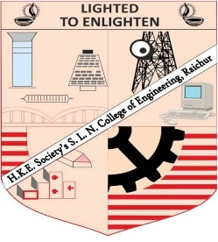

Seminar Report On

SMART FARMING USING IOT

Submitted By:

SUDEEP

ROLL NO -49

E&C Engineering

S. L. N. College of Engineering

Under the Guidance of

Dr.SHARANA KUMAR

Asst. Professor

Dept. of Internet of Things

S. L. N College of Engineering