Name: ALTAHAN RAUF  
Enrollment: 02-135252-050  
Class: BS-IT (1-A)

**TASKS**

# Task 1:

Install Visual C++ and attach proper screenshots to Lab File.  
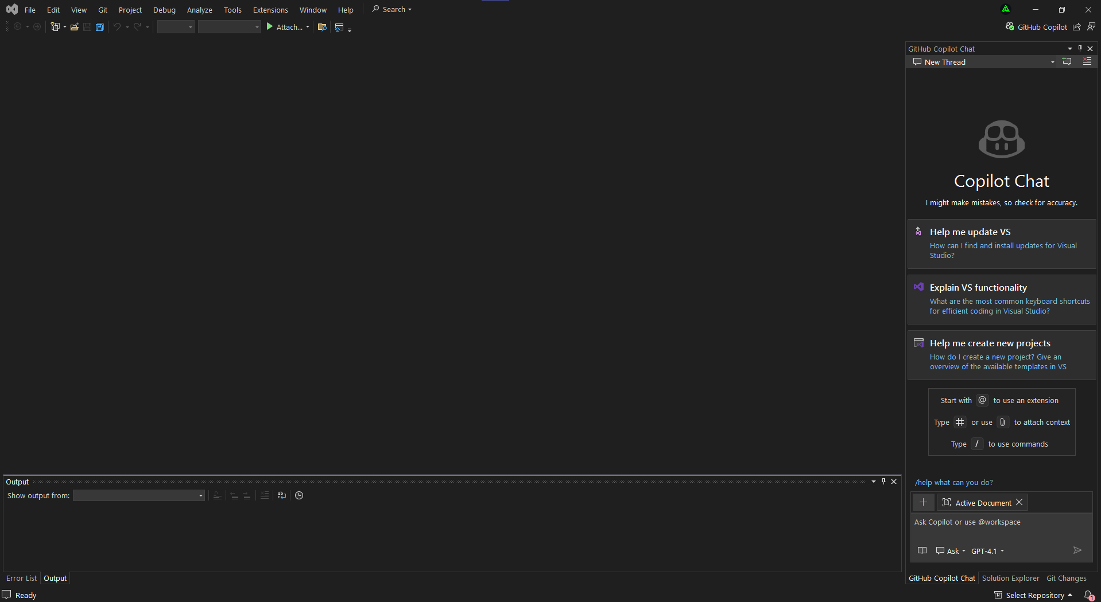

# Task 2:

Draw a flowchart & Write a C++ program to store statement record such as (Name, Age, Grade and CGPA).

Code:

#include <iostream>

#include <string>

using namespace std;

int main()

{

string name, grade;

int age;

float cgpa;

cout<<"\nEnter Name: ";

getline(cin, name);

cout << "\nEnter Age: ";

cin>>age;

cout << "\nEnter Grade: ";

cin>>grade;

cout<<"\nEnter CGPA: ";

cin>>cgpa;

cout<<"\nStudent Record:\n";

cout<<"Name: " <<name<<"\nAge: "<<age<<"\nGrade: "<<grade<<"\nCGPA: "<<cgpa<<endl;

return 0;

}  
  
Output:  
  
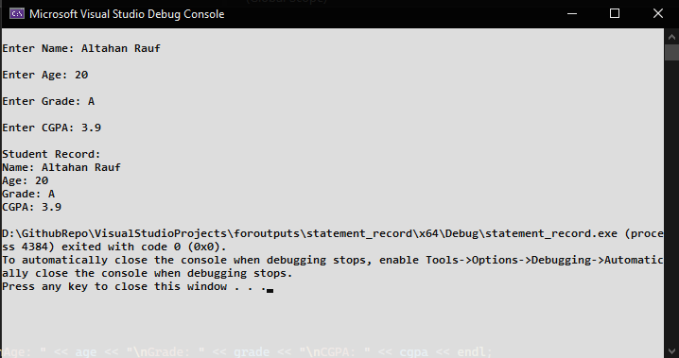  
Flowchart:  
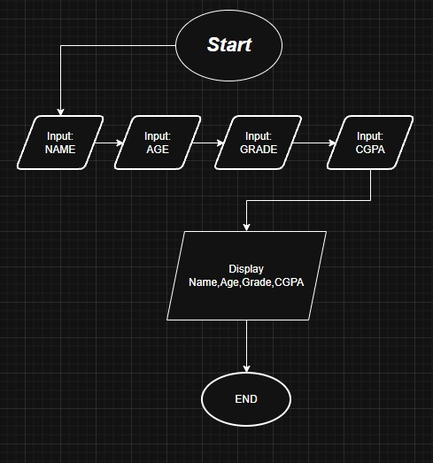

# Task 3:

Draw a flowchart and Write a C++ program to read student’s three grade, calculate the average of the grade, and then display the average grade.  
Code:  
#include <iostream>

using namespace std;

int main(){

    float grade1, grade2, grade3, avg;

    cout<<"\nEnter Grade 1: ";

    cin>>grade1;

    cout<<"\nEnter Grade 2: ";

    cin>>grade2;

    cout<<"\nEnter Grade 3: ";

    cin>>grade3;

    avg=(grade1 + grade2 + grade3)/3;

    cout<<"Average Grade = " <<avg<<endl;

    return 0;

}

Output:   
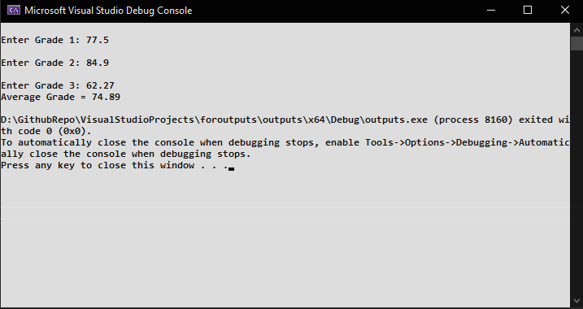Flowchart:  
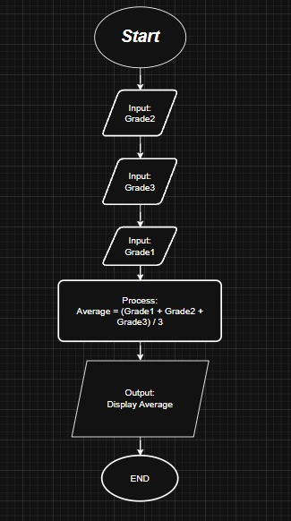

# Task 4:

Write program & draw a flowchart that reads the height, length, and width of the rectangular box, Calculates and displays the volume.

Note: Volume = lwh.

Code:  
#include<iostream>

using namespace std;

int main() {

    float length, width, height, volume;

    cout<<"\nEnter Length: ";

    cin>>length;

    cout<<"Enter Width: "<<endl;

    cin>>width;

    cout<<"Enter Height: "<<endl;

    cin>>height;

    volume = length*width*height;

    cout<<"Volume = "<<volume<<endl;

    return 0;

}

Output:  
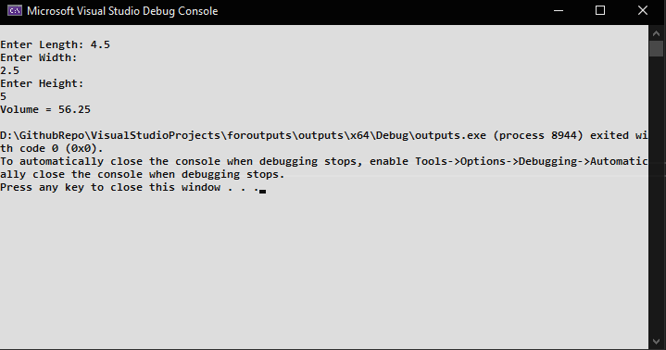

Flowchart:  
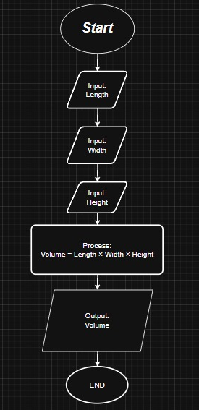

# Task 5:

Write a program to read the salary of an employee and prints particular designation of the concern person for example Manager salary = 200k, Supervisor = 150k and

Technician = 80k.  
Code:  
#include <iostream>

using namespace std;

int main() {

    int salary;

    cout<<"\nEnter salary: ";

    cin>>salary;

    if(salary==200000)

        cout<<"\nManager's Salary"<<endl;

    else if(salary == 150000)

        cout<<"\nSupervisor Salary"<<endl;

    else if(salary == 80000)

        cout<<"\nTechnician Salary"<<endl;

    else

        cout<<"\nUnknown Designation Please enter valid salary"<<endl;

    return 0;

}  
  
Output:  
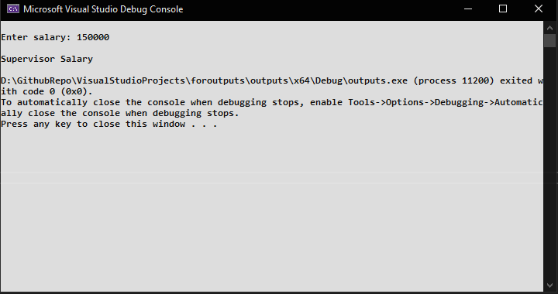

Flowchart:  
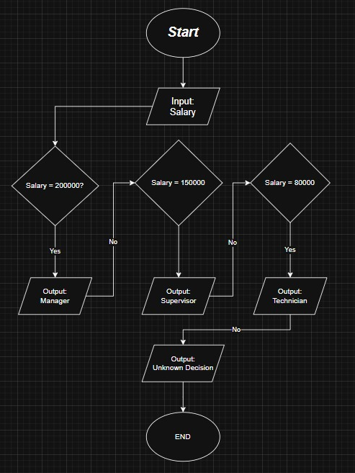  
  
  
-----------------------------------------------------------END--------------------------------------------------------------  
  
Name: ALTAHAN RAUF  
Enrollment: 02-135252-050  
Class: BS-IT (1-A)