|  |
| --- |
| **TASKS** |

**Task 1: Personal Information**

Write a C++ program that takes the following information as input from the user:

1. **Name**
2. **Age**.
3. **Height** (height in feet).
4. **A short description about themselves** (a multi-line string).

The program should display the entered details in a well-formatted way. The output should be organized in the following format:

**Task 2: World Travel Planner**

## Assume that you are developing for a World Travel Planner program in C++ that caters to globetrotters. The program should assist users in planning their international travels by allowing them to convert distances from miles to kilometers. Users will input the distance in miles, and the program will output the converted distance in kilometers, considering the international metric system commonly used in many countries.

## 1 mile = 1.60934 kilometers

## Sample Output:

**Task 3: Bank Account Transactions**

Asad is managing his bank account and intends to carry out two transactions. Initially, he plans to withdraw Rs. 2000 in cash, followed by a deposit of Rs. 10,000 into his account. Your task is to create a simple C++ program to facilitate these transactions. Display the account balance after each transaction. Write a C++ program to realize the specified scenario.

**Task 4: Letter Design**

Write a program that prints a big letter of your name’s initial using the same letter. Sample output for letter H is shown below.

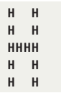

**Task 5: EXCEL Laboratories Receipt Generator**

Excel Laboratories is implementing a new system for generating bills at its lab. As a software developer, you have been assigned the task of creating a program that will help generate detailed receipts for the patients. The Lab provides various medical services, and the billing system needs to be able to handle different types of services with appropriate fees.

The program should prompt the user to enter the following information for each medical service provided at the clinic:

Service description (e.g., MRI,CT scan, blood test, X-ray)

Quantity (for services like blood tests or X-rays)

Service fee per unit

Calculate the total cost for each medical service (quantity * service fee per unit). Also Apply 5% tax on each bill. Print Receipt which display all the information.

**Sample Input:**

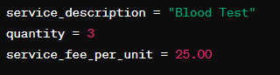

**Output:**

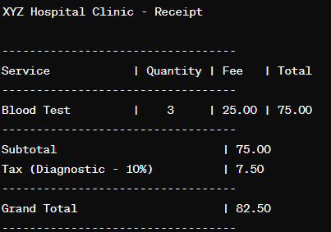

**Task 6: Clock Time Conversion**

## Write a program to convert a given time in seconds into hours, minutes, and remaining seconds.

## Hint: Use the modulus operator to perform the necessary calculations.

## Sample Output:

