# Name: ALTAHAN RAUF Enrollment: 02-135252-050 Class: BS-IT (1-A) LabTask:3

# Task 1: Character Classification

Write a C++ program that checks whether a given character is a vowel, consonant, or a digit. The program should prompt the user to enter a character and then display a message indicating the classification.

Sample Output:

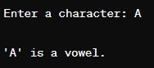 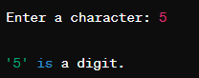

Code:  
**#include <iostream>**

**#include <cctype> // for toupper() function**

**using namespace std;**

**int main() {**

**char ch;**

**cout<<"Enter a character: ";**

**// Digits are from 0-9 , it should consider a multidigit number like 45 as single digit 4 , requirement is digit so it fulfills the purpose.**

**cin>>ch;**

**ch = toupper(ch); // Converted to uppercase for simplification**

**if (ch>='0' && ch<='9') {**

**cout<<"'"<<ch<<"' is a digit."<<endl;**

**}**

**else if(ch=='A' || ch=='E' || ch=='I' ||ch =='O' || ch=='U') {**

**cout<<"'"<<ch<<"' is a vowel."<<endl;**

**}**

**else if(ch >= 65 && ch <= 90) {**

**cout<<"'"<<ch<<"' is a consonant."<<endl;**

**}**

**else {**

**cout<<"'"<<ch<<"' is not a letter or digit."<<endl;**

**}**

**return 0;**

**}**

**Output:  
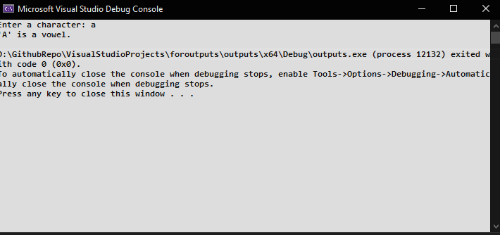  
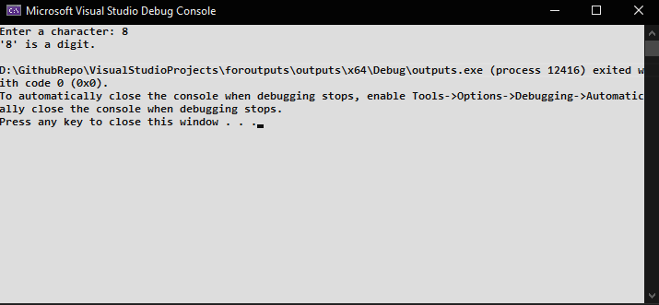**

# Task 2: Shopping Cart

You are developing an online shopping application for a retail store. The store wants to offer discounts to customers based on their total purchase amount. If the total purchase amount exceeds 15000 Rupees, a 10% discount will be applied to the customer's order.

Write a C++ program that prompts the user to enter the total purchase amount. Based on the entered amount, apply the appropriate discount using if-else statements and display the discounted amount to the customer.

Sample Output:

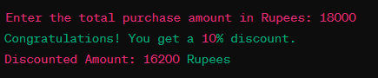

Code:  
#include<iostream>

using namespace std;

int main()

{

int total, discount;

cout << "Enter the total purchase amount in Rupees: ";

cin >> total;

if(total > 15000)

{

discount = total * 0.1;

cout<<"Congratulations! You get a 10% discount of "<<discount<<" rupees"<<endl;

cout<<"Discounted Amount : "<<total - discount<<" rupees"<<endl;

}

else

{

cout<<"The final amount to be paid is: "<<total<<" PKR"<<endl;

cout<<"No Discount "<<endl;

}

return 0;

}

Output:  
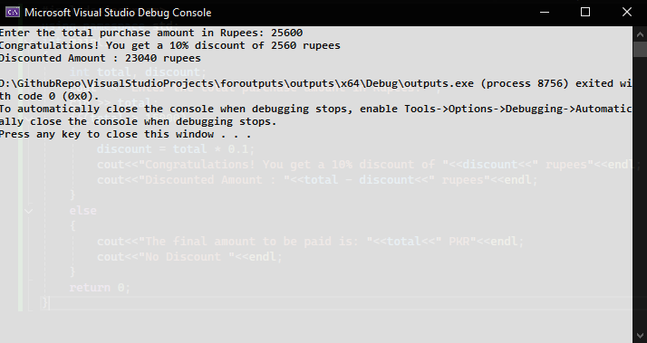

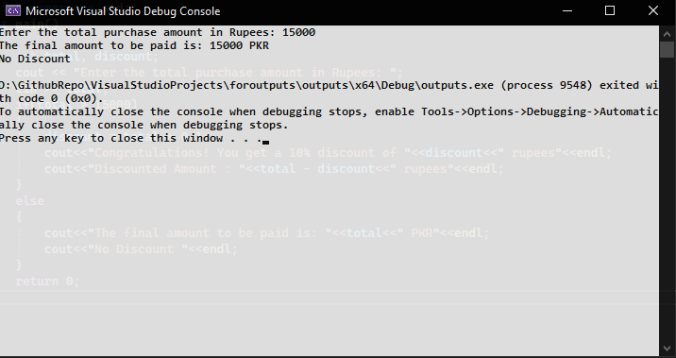  
 As discount applies if total>15000.

# Task 3: Age Analysis

Assume that three friends are planning to do zip line adventure. Where age will be evaluated first to send the younger one first. Write a C++ program where compare age of 3 friends. Find the youngest one from all three

Sample Output:

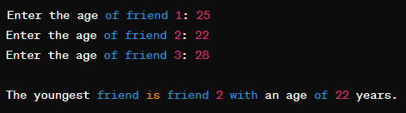

Code:  
#include<iostream>

using namespace std;

int main() {

int age1, age2, age3;

cout<<"Enter age of friend 1: ";

cin>>age1;

cout<<"Enter age of friend 2: ";

cin>>age2;

cout<<"Enter age of friend 3: ";

cin >> age3;

if (age1<age2 && age1<age3) {

cout<<"The youngest friend is friend 1 with an age of "<<age1<<" years."<<endl;

}

else if (age2<age1 && age2<age3) {

cout<<"The youngest friend is friend 2 with an age of "<<age2<<" years."<<endl;

}

else if (age3 < age1 && age3 < age2) {

cout <<"The youngest friend is friend 3 with an age of "<<age3<<" years."<<endl;

}

else {

cout<<"Two or more friends have the same youngest age."<<endl;

}

return 0;

}

Output:  
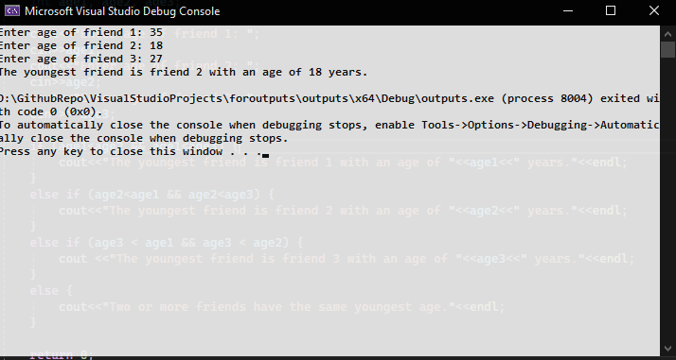

# Task 4: Ticket Reservation System

In a ticket reservation system, check the availability of seats for a particular event. In total bus has 35 seats capacity. Ask user to enter quantity of seats required and update the remaining unreserved seats. For that purpose you have to write a C++ program to check the conditions.

**Conditions to be checked:**

1. Available seats

If the number of seats requested is within the available limit, we reserve the seats and update the number of available seats accordingly.

2. Limit Exceed

If the number of seats requested exceeds the available limit, we inform the user that there are not enough seats available.

If seats are successfully reserved, display a confirmation message like: "Seats reserved successfully! Enjoy your journey."

Sample Output:

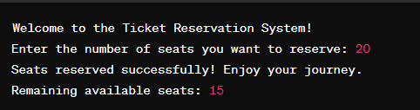

Code:  
#include<iostream>

using namespace std;

int main() {

const int total =35;

int available =total;

int booked;

cout<<"Welcome to the Ticket Reservation System!\n";

cout << "Enter the number of seats you want to reserve: \n";

cin>>booked;

if(booked <= available){

available -= booked;

cout<<"\n"<<booked << " Seats Reserved successfully!, Enjoy your Journey.\n";

cout<<"Remaining Available Seats: " << available << endl;

}

else{

cout<<"Sorry, only "<<available<<" seats are available.\n";

}

return 0;

}

Output:  
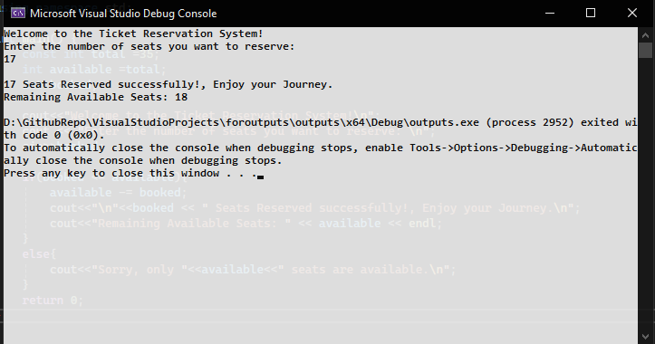

# Task 5: Find the Weekday

Write a program using Switch case statement to find weekday from number of days example: 1 = Monday etc.

Code:  
#include<iostream>

using namespace std;

int main(){

int day;

cout<<"Enter number of the week day (1-7):";

cin>>day;

switch (day) {

case 1:

cout<<"Monday"<<endl;

break;

case 2:

cout<<"Tuesday"<<endl;

break;

case 3:

cout<<"Wednesday"<< endl;

break;

case 4:

cout<<"Thursday"<<endl;

break;

case 5:

cout<<"Friday"<<endl;

break;

case 6:

cout<<"Saturday"<<endl;

break;

case 7:

cout<<"Sunday"<<endl;

break;

default:

cout<<"Invalid input! Please enter day number between 1 and 7."<<endl;

}

return 0;

}

Output:  
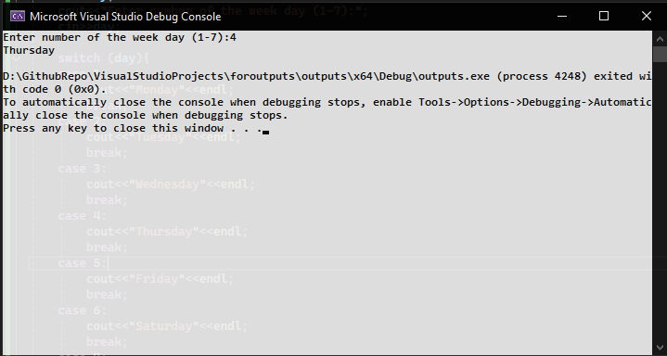

# Task 6: Medical Diagnosis System

Write a C++ program that takes the user's input for body temperature and uses if-else statements to determine and display a basic medical diagnosis such as "Hypothermia," "Normal Body Temperature," "Low-Grade Fever," or "High Fever" based on different temperature ranges. Students can run the program with various temperature inputs to observe the different diagnoses.

|  |  |
| --- | --- |
| Temp less than 36.5 | Hypothermia |
| Temp in between 36.5 and 37.5 | Normal Body Temperature |
| Temp in between 37.6 and 38.5 | Low grade Fever |
| More than 38.5 | High Fever |

Sample Output: (There is a mistake in Output. 38.2 should be consider LOW GRADE FEVER as per the Chart)

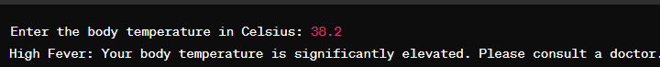

Code:

#include<iostream>

using namespace std;

int main() {

double temp; // used this for more precision. at 3rd else if condition.

cout<<"Enter the body temprature in celcius: "<<endl;

cin>>temp;

if (temp<36.5)

{

cout<<"You are hypothermic"<<endl;

}

else if (temp>36.5 && temp<=37.5)

{

cout<<"Normal Body Temprature"<<endl;

}

else if(temp>=37.6 && temp<=38.5)

{

cout<<"Low Grade Fever"<<endl;

}

else if(temp>38.5)

{

cout<<"High fever, Consult a doctor!";

}

else {

cout<<"Invalid Input"<<endl;

}

return 0;

}

Output:

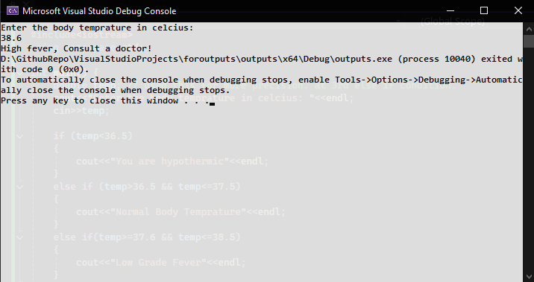

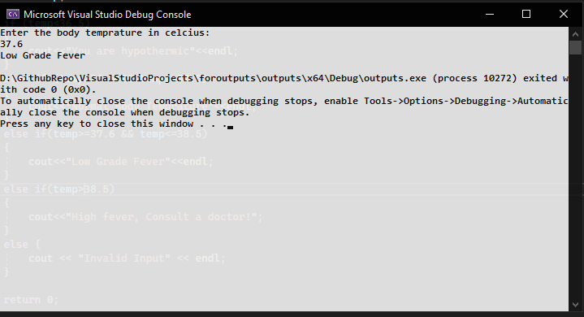

_____________________________________________END_________________________________________

# Name: ALTAHAN RAUF Enrollment: 02-135252-050 Class: BS-IT (1-A) LabTask:3