Dean LeBaron and Chris McNeill

Grid Lab using Bayes Law

In probability theory, Bayes' law takes into account prior beliefs about the probability of events that allow us to make statements about the probability of a given event based on not only the evidence we currently have access to but also based on prior belief. This approach is useful when dealing with noisy data because beliefs about observations and the noisiness of the sensor can be used to make a more intelligent guess as to whether or not the sensor is accurate.
In this lab we use a sensor on our agents to explore the environment the agents are placed in. The sensor is noisy, but using Bayes' law we are able to determine the location of obstacles in the environment with high probability. We use OpenGL to help model the beliefs about the environment, darker patches in the images represent little or no belief that there is an obstacle present and lighter patches represent a high belief that an obstacle is present. For our lab Bayes' law was set up as follows:

P(S|O) = P(O|S)P(S)/P(O)

where S represents the state of reality and takes on either true or false based on whether a given location is occupied by an obstacle; O is the observation from the sensor either true or false for a given location. P(S), or the prior of S, was originally set to .07 based on the fact that we estimate about 7% of the squares are occupied in the bzflag world. P(O|S) or the likelihood, are passed as parameters to the server where the true positive (O = t, S = t) and true negative ( O = f, S =f) rates were given. The last piece, the prior P(O) was a bit harder to determine. This number represents our belief in the accuracy of the sensor. However, we know that P(O,S) = P(O|S)*P(S), which is given by the chain rule and the fact that O is conditionally dependent on S. We can then simplify P(O,S) to P(O) by summing out the S variable. This gives P(O=t) = P(O=t|S=t)*P(S=t) + P(O=t|S=f)*P(S=f).

Visualizations

The following for screen shots show how the observations taken over time increase the belief as to whether a space is occupied or not. The first image shows the first observation of the red teams tanks. The size of the grid that the sensor can observe is 100X100 and it reflected in the fact that only the very bottom of the image shows any detail. Even so, there are no obstacles to be observed near the base so the image is mostly black. However, as the tanks move toward the middle of the map and continue to take observations. The second image shows the world after three observations have been made by the team. Notice that the obstacles are beginning to show up, but they are gray reflecting the only somewhat confident belief about what lies there. In the third image more observations have been made and obstacles are beginning to be fleshed out and the belief about non occupied squares is quite high. The final image took approximately six minutes to produce and reflects sixty-five rounds of observation. The long run time is due to the time it took for the tanks to fully explore the world, not a function of needed several observations before beliefs were established.

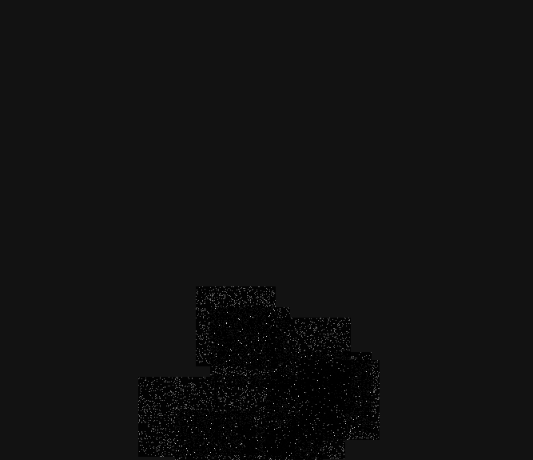
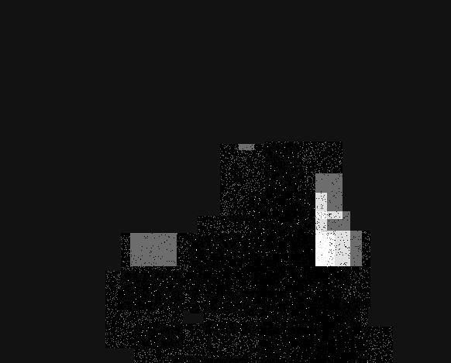

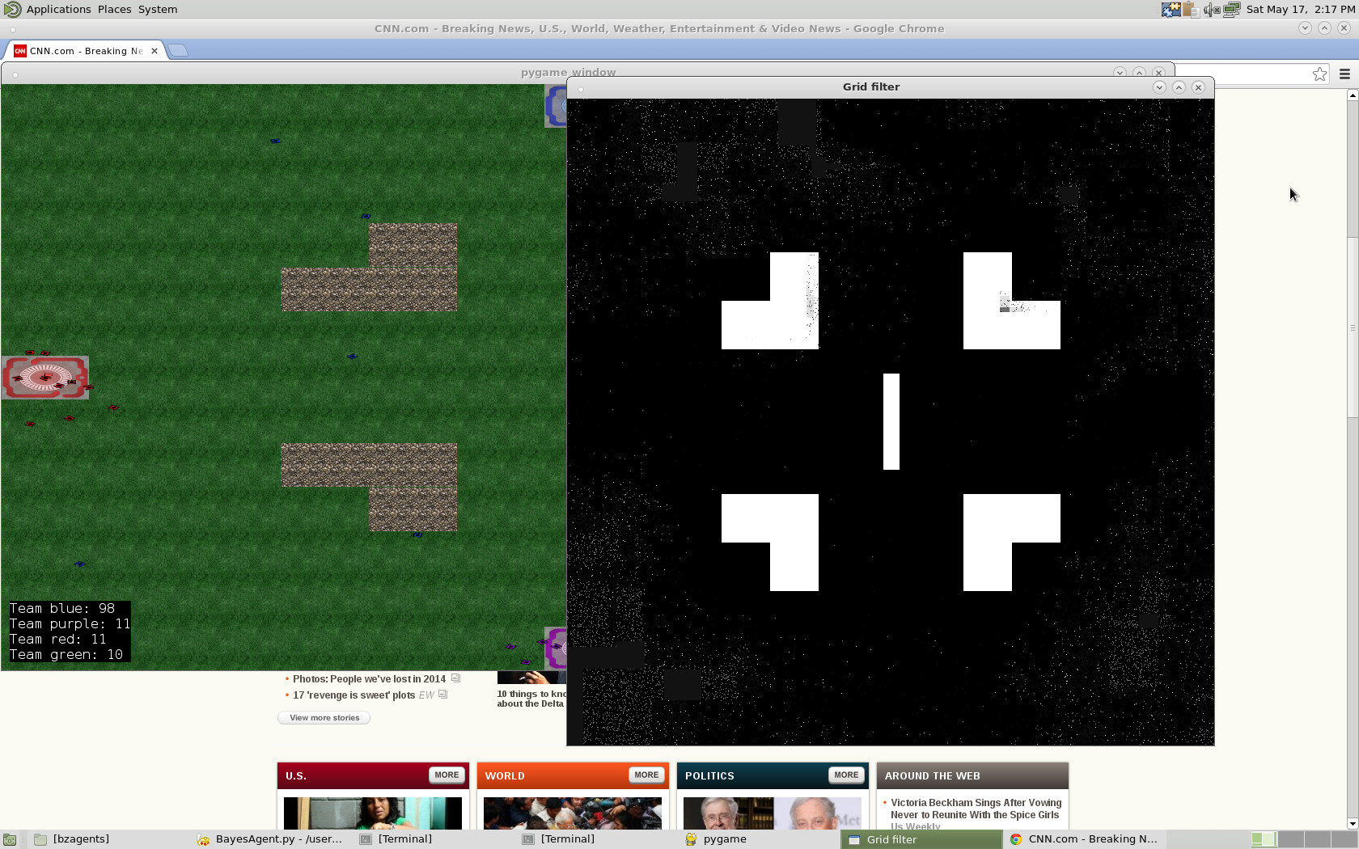
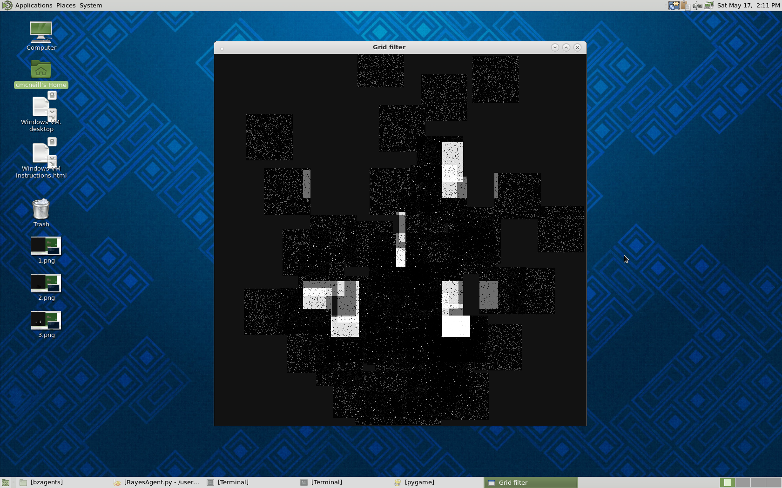

The following tables show the probabilities of a square being occupied given the sensor reading. It is easy to see that after only 4 observations the beliefs about any given square are pretty well established.

Table of Probabilities for a known nonobstacle point
Observation Number  True Postive rate = .97  True Negative rate = .9 | P(S=t|o={1,0}) | Sensor observed
0 | .07 | n.a.
1 | .008 | 0
2 | .009 | 0
3 | .001 | 0
4 | 1.6925e-05 | 0

Table of Probabilities for a known obstacle point
True Postive rate = .97
True Negative rate = .9
Observation Number | P(S=t|o={1,0}) | Sensor observed
0 | .07 | n.a.
1 | .425 | 1
2 | .878 | 1
3 | .985 | 1
4 | .998 | 1

Exploration Algorithm

Our tanks searched the world using a wandering divide-and-conquer pattern. Two tanks would explore each quadrant and the two remaining tanks would explore the center of the map. Each tank would choose a random point within its quadrant and move towards it. If the random point chosen was believed to occupied (i.e. the probability of the point being occupied was above .9), the tank would choose a different point. Once the tank arrived at the point, a new point would be chosen. In order to avoid getting stuck in a corner, the tanks would add a random field in addition to the attractive field that attracted them to their current target point.

The tanks would drive towards their respective targets for about 5 seconds, then they would all stop and observe the world once. The tanks would stop to observe because observing while moving could result in the tanks overshooting their target point. We experimented with observing multiple times each stop. This did produce a more accurate section faster, however the tanks would spend quite a bit of time stopped and would not explore different parts of the map as quickly.

We did not do anything tricky such as check the cells next to a cell that the observation said was occupied in order to see if it were a possible false positive. This was because doing so would cause the tanks to be stopped longer. We also deemed it unnecessary since after only four observations, the cell's probability would be sufficiently high or low enough for a good prediction of whether it was occupied or not. When exploring in the presence of a hostile opponent, time is of the essence and observations must be fast.

Experimenting with Different Sensor Parameters

The following two tables express the same values as the tables given above, but the difference is the true positive and true negative rates have changed. With lower rates it is much more common to have false positive and false negative reads. Note that when a false positive or false negative is seen it doesn't affect the probability as strongly as a true positive or negative would. This shows how Bayes law factors in prior beliefs too.

Table of Probabilities for a known nonobstacle point
Observation Number  True Postive rate = .65  True Negative rate = .55 | P(S=t|o={1,0}) | Sensor observed
0 | .07 | n.a.
1 | .059 | 0
2 | .04 | 0
3 | .057 | 1 false positive
4 | .08 | 1 false positive
5 | .066 | 0

Table of Probabilities for a known obstacle point
True Postive rate = .65
True Negative rate = .55
Observation Number | P(S=t|o={1,0}) | Sensor observed
0 | .07 | n.a.
1 | .09 | 1
2 | .13 | 1
3 | .18 | 1
4 | .25 | 1
5 | .21 | 0 false negative
6 | .28 | 1

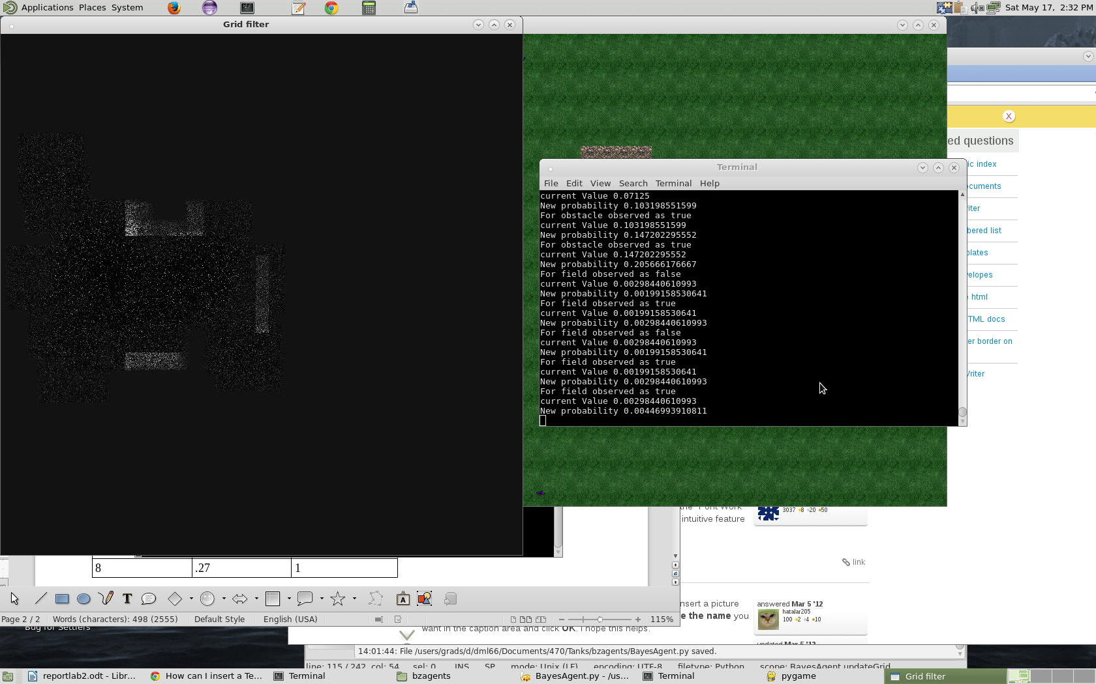
Known obstacle point
Known nonobstacle point
The image shown on the left visualizes the two points that were tracked in the tables above. Note that the obstacle is beginning to take shape. It is also easy to see the noisiness of a less accurate sensor.

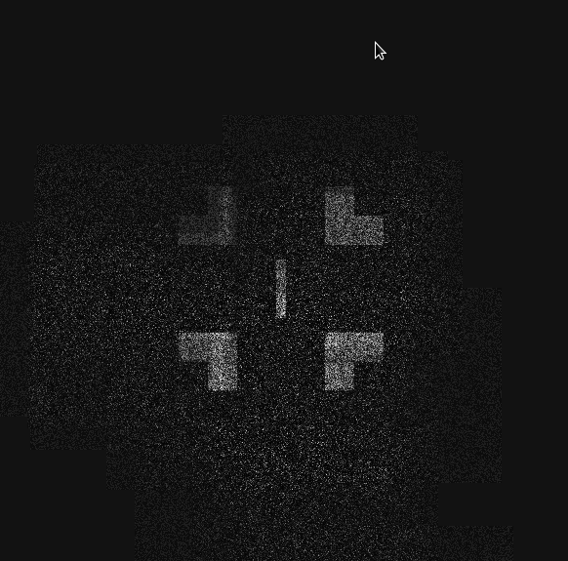
The picture at the left shows a different map being explored with a larger occupancy grid and a noisier sensor. As can be seen from the picture, more observations need to be taken to get a clearer picture of the map. The obstacles are beginning to form, however, they are still riddled with holes from inaccurate observations.

Using a larger occupancy grid allows the picture to be completed without as much exploration. However, a larger occupancy grid also takes longer to be processed and would limit computing time to do other things such as track enemies and capture flags.

Competing with a Live Opponent

When competing against a live opponent, observations must be quick and accurate. Time spent observing and then processing the observation in order to update the overall occupancy map must be minimal. In the presence of an opponent, we would change our algorithm so that the tank would move while observing and processing. This may cause the tank to overshoot its target, but if we are clever, we could make it work. For example, if we can sense enemies with fairly good accuracy, we may take more observations when enemies are far away as opposed to close by. A tank may take observations while heading in a straight line towards a far away target so that it does not overshoot it. We could also divide the labor up and have some tanks only observe while the other tanks guard them.

Time Spent on Lab

Dean: 10 hours
Chris: 10 hours

