Kalman Filter Lab

Dean LeBaron:
Chris McNeill: 5 hours

Design Decisions

We used a Kalman Filter in order to track an enemy tank in a noisy sensor environment and in order to predict where a tank was likely to be a short time in the future in order to shoot and hit it. The Kalman Filter was very effective at hitting motionless targets, targets moving in a straight line at a constant acceleration, and at a target that would vary in acceleration and in direction.
We decided to have the Kalman agent take a reading of the enemy tank's position and to calculate the likely current position of the enemy tank and predict where the enemy tank would be in a short time every half second. This would give our agent enough time to make the full calculations and make a decision about rotation before having to take the next observation. We tried using more frequent rates (ten times per second and five times per second), however, due to the high frequency and the noise of the sensor, the Kalman Filter sometimes made the tank believe that the enemy tank was traveling backwards and would start rotating the tank in the wrong direction.
In order to know where to shoot in order for the bullet to hit the enemy tank at a future position we took the distance to the enemy tank and divided it by the speed of the bullet in distance units per half second (since the observations are taken every half second). This would tell us how many prediction steps we would likely have to calculate in order to find the position of the tank in the time it would take the bullet to reach the enemy tank. If the predicted position was too far away or our tank was not facing the targeted area at the correct time, our tank would not shoot and would recalculate a new predicted target.
We also decied to reset the Kalman Filter every 20 iterations (10 seconds) in order to avoid overfit. If we did not reset the filter, it may have started to believe it was more accurate than it truly was and would become less accurate as time went on. We chose every 20 iterations because Dr. Seppi suggested this number and it seemed to work well in trials.
We initialized the matrices that never changed as constant variables so that we would not have to recalculate them every iteration. This included the F, H, E, F transpoe, and H transpose matrices. The matrices that changed were the current and previous Sigma matrices which held our beleifs about how accurate our assumptions were (such as constant accelteration), the current and previous Mu matrices which held the means of the distribution of the observed enemy tank position, and the Kt matrix which was used in the calculations of the Sigma and Mu matrices. These chaning matrices were the ones reset every 20 iterations in order to avoid overfit.

Building the Conforming Agent

The conforming agent was extremely simple to build. The “sitting duck” agent did not need any code and just sat in its starting position. The constant velocity agent simply set it's speed to a constant velocity (in our case we chose .5) and traveled in the direction it faced when spawned. The agent performed extremely well in these regards.

Building the Non-Conforming Agent

The non-conforming agent took more thought to build than the conforming agent. Initially we built the non-conforming agent to move forward about 75% of the time and backwards 25% of the time. However, this led to the tank stopping in order to reverse and made it quite easy to hit. We changed it so that the non-conforming agent moved forward the entire time. The speed of the non-conforming agent varied randomly between .4 and 1.0. The angular velocity of the non-conforming agent varied randomly from 0 to 1.0. The non-conforming agent would change velocity every 2 seconds and would change angular velocity every second. This violated the assumption of the Kalmas filter that the acceleration was constant.

Hitting the Stationary Agent

Hitting the stationary agent was quite easy. Our tank was about 200 distance units away from the enemy tank. The first shot was a little to the south of the target and missed probably due to the noise of the sensor and not having build up enough observations. The second shot was closer but also missed. However, the third shot successfully hit the enemy tank. The following plot shows the position belief distribution of the enemy tank. The tank was supposedly somewhere around (210,0).
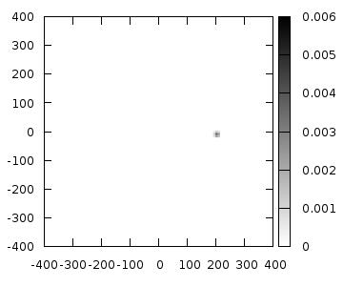

Hitting the Conforming Agent

When shooting at a target moving at constant velocity, the agent was still able to hit it. The first two shots missed probably due to noise in the observations. However, the third shot successfully hit the target. The following plot shows the distribution of the position of the enemy tank in the spot where it was shot. As can be seen from the plot, the Kalman Filter believes the tank to be around the position
(-220, -365). The belief becomes smaller as we get farther away from that point. Since the position noise is only 5, the circle is quite small.
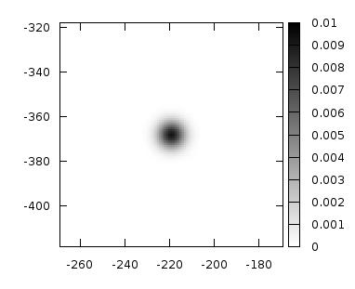

Hitting the Non-Conforming Agent

Hitting the non-conforming agent was a much more difficult task. Our tank would make good predictions based on the current data and the assumption that acceleration was constant. The shots it made would have hit the enemy tank had it followed these parameters. However, the non-conforming agent would change velocity and direction while the bullet was traveling and, thus, the bullet would miss. Our agent was finally able to hit the non-conforming agent while it was pushing up against a while and, thus its velocity was reduced and was an easy target to hit. The following plot shows the position belief distribution of the enemy tank as it moves around the map.
