**📊 Loan Analysis Dashboard – Power BI**

**📌 Project Overview**

**This Power BI project provides a comprehensive Loan Portfolio Analysis, enabling financial institutions to monitor loan applications, funded amounts, repayments, interest rates, and borrower health. The dashboard highlights both portfolio-wide KPIs and Good vs Bad loan performance, supporting data-driven decision-making.**

**🚀 Key Features**

**🔑 KPI Analysis**

* **Total Loan Applications (with MTD & MoM growth)**
* **Total Funded Amount (with MTD & MoM growth)**
* **Total Amount Received (with MTD & MoM growth)**
* **Average Interest Rate (MTD & MoM variations)**
* **Average Debt-to-Income Ratio (DTI) (MTD & MoM fluctuations)**

**✅ Good Loan vs ❌ Bad Loan KPIs**

**Good Loans**

* **Good Loan Applications & % of total**
* **Good Loan Funded Amount**
* **Good Loan Amount Received**

**Bad Loans**

* **Bad Loan Applications & % of total**
* **Bad Loan Funded Amount**
* **Bad Loan Amount Received**

**📋 Loan Status Grid View**

**A detailed grid categorized by Loan Status displaying:**

* **Total Loan Applications**
* **Total Funded Amount**
* **Total Amount Received**
* **MTD Funded Amount**
* **MTD Amount Received**
* **Average Interest Rate**
* **Average Debt-to-Income Ratio (DTI)**

**📈 Visualizations in Dashboard**

* **Monthly Trends by Issue Date (Line Chart): Detect seasonality and long-term lending trends**
* **Regional Analysis by State (Filled Map): Highlight geographic loan distribution**
* **Loan Term Analysis (Donut Chart): Show loan distribution by term lengths**
* **Employment Length Analysis (Bar Chart): Explore borrower employment history impact**
* **Loan Purpose Breakdown (Bar Chart): Understand reasons for borrowing**
* **Home Ownership Analysis (Tree Map): Assess impact of home ownership on loans**

**Each visualization is tied to key metrics:**

* **Total Loan Applications**
* **Total Funded Amount**
* **Total Amount Received**

**🛠️ Tech Stack**

* **Power BI Desktop**
* **DAX (Data Analysis Expressions) for calculations (MTD, MoM, YoY, grouping)**
* **Data Source: Loan dataset (cleaned & anonymized)**

**🧮 Key DAX Measures**

📌 Applications

Total Loan Application =

COUNT('bank_loan financial_loan'[id])

MTD Loan Application =

TOTALMTD(

[Total Loan Application],

'Date table'[Date]

)

Previous Month Loan Application =

CALCULATE(

[Total Loan Application],

PREVIOUSMONTH('Date table'[Date])

)

MoM Growth % Loan Applications =

DIVIDE(

[Total Loan Application] - [Previous Month Loan Application],

[Previous Month Loan Application]

)

📌 Loan Amounts

Total Loan Sanctioned =

SUM('bank_loan financial_loan'[loan_amount])

Previous Month Loan Sanctioned =

CALCULATE(

[Total Loan Sanctioned],

PREVIOUSMONTH('Date table'[Date])

)

MoM Growth % Loan Sanctioned =

DIVIDE(

[Total Loan Sanctioned] - [Previous Month Loan Sanctioned],

[Previous Month Loan Sanctioned]

)

📌 Payments

Total Loan Payment Received =

SUM('bank_loan financial_loan'[payment_received])

Previous Month Loan Payment Received =

CALCULATE(

[Total Loan Payment Received],

PREVIOUSMONTH('Date table'[Date])

)

MoM Growth % Loan Payment Received =

DIVIDE(

[Total Loan Payment Received] - [Previous Month Loan Payment Received],

[Previous Month Loan Payment Received]

)

📌 Interest Rate & DTI

Monthly Avg Interest Rate =

CALCULATE(AVERAGE('bank_loan financial_loan'[int_rate]))

Previous Month Avg Interest Rate =

CALCULATE(

[Monthly Avg Interest Rate],

PREVIOUSMONTH('Date table'[Date])

)

MoM Growth % Avg Interest Rate =

DIVIDE(

[Monthly Avg Interest Rate] - [Previous Month Avg Interest Rate],

[Previous Month Avg Interest Rate]

)

Monthly Avg DTI =

CALCULATE(AVERAGE('bank_loan financial_loan'[dti])) * 100

Previous Month Avg DTI =

CALCULATE(

[Monthly Avg DTI],

PREVIOUSMONTH('Date table'[Date])

)

MoM Growth % Avg DTI =

DIVIDE(

[Monthly Avg DTI] - [Previous Month Avg DTI],

[Previous Month Avg DTI]

)

📌 Loan Status (Good vs Bad)

Current + Fully Paid =

CALCULATE(

COUNTROWS('bank_loan financial_loan'),

'bank_loan financial_loan'[loan_status] IN {"Current", "Fully Paid"}

)

% Current + Fully Paid =

DIVIDE(

[Current + Fully Paid],

COUNTROWS('bank_loan financial_loan')

)

Charged Off =

CALCULATE(

COUNTROWS('bank_loan financial_loan'),

'bank_loan financial_loan'[loan_status] = "Charged Off"

)

% Charged Off =

DIVIDE(

[Charged Off],

COUNTROWS('bank_loan financial_loan')

)

**📸 Dashboard Preview**

**SUMMARY**

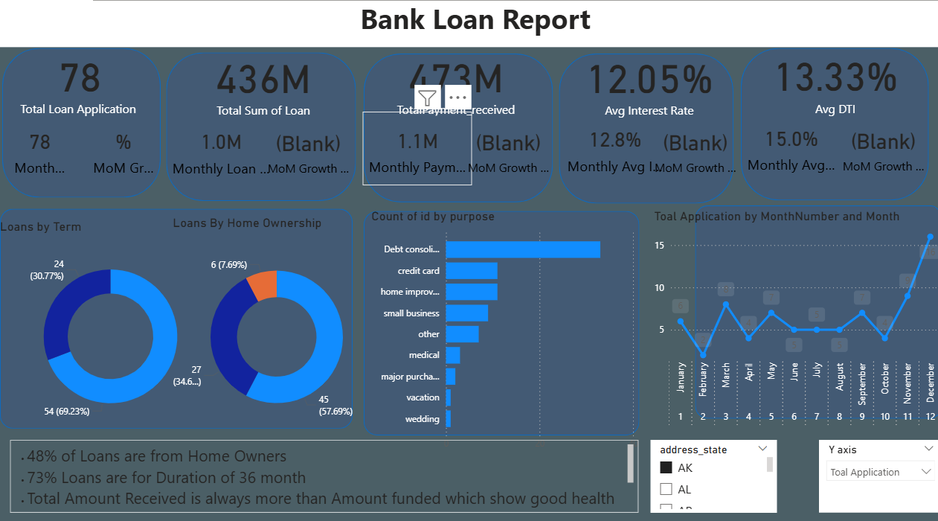

OVERVIEW

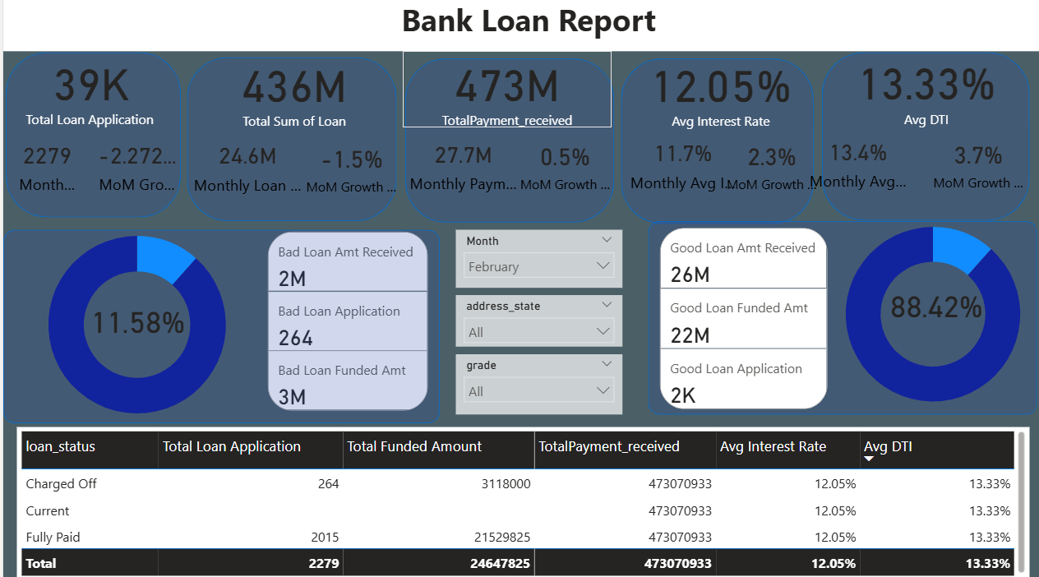

* **Home Ownership Impact**: 48% of loans are taken by **homeowners**, indicating strong participation of financially stable borrowers.
* **Loan Term Preference**: 73% of loans have a **36-month duration**, highlighting borrowers’ preference for shorter-term commitments.
* **Portfolio Health**: The **total amount received consistently exceeds the total funded amount**, reflecting healthy repayment behavior and strong loan portfolio performance.