Q.1 Write a function that prints the numbers from 1 to 100. But for multiples of three, print "Fizz" instead of the number, and for the multiples of five, print "Buzz". For numbers that are multiples of both three and five, print "FizzBuzz".

function fizzBuzz() {

  for (let i = 1; i <= 100; i++) {

    if (i % 3 === 0) {

      console.log("Fizz");

    } else if (i % 5 === 0) {

      console.log("Buzz");

    } else if (i % 5 === 0 && i % 5 === 0) {

      console.log("FizzBuzz");

    } else {

      console.log(i);

    }

  }

}

fizzBuzz();

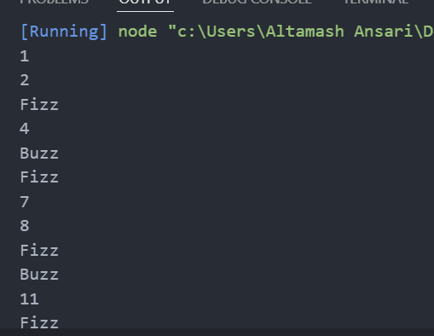

Q.2 Write a function that takes a string input representing a simple arithmetic expression (only addition and subtraction) and returns the result.

function evaluateExpression(expression) {

  let currentNumber = 0;

  let result = 0;

  let sign = 1;

  for (let i = 0; i < expression.length; i++) {

    const char = expression[i];

    if (!isNaN(char)) {

      currentNumber = currentNumber * 10 + parseInt(char, 10);

    } else if (char === "+") {

      result += sign * currentNumber;

      currentNumber = 0;

      sign = 1;

    } else if (char === "-") {

      result += sign * currentNumber;

      currentNumber = 0;

      sign = -1;

    }

  }

  result += sign * currentNumber;

  return result;

}

console.log(evaluateExpression("12+34-5+6"));

console.log(evaluateExpression("1+2-3+4"));

console.log(evaluateExpression("10-2+3-4+5"));

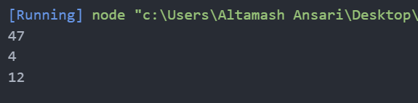

Q.3 Write a function that takes a nested array and returns a flattened array.

function flattenArray(nestedArray) {

  const flattenedArray = [];

  function flatten(element) {

    if (Array.isArray(element)) {

      element.forEach(flatten);

    } else {

      flattenedArray.push(element);

    }

  }

  nestedArray.forEach(flatten);

  return flattenedArray;

}

console.log(flattenArray([1, [2, [3, 4], 5], 6]));

console.log(flattenArray([[1, 2, [3]], 4]));

console.log(flattenArray([[[1], 2], 3, [4, [5]]]));

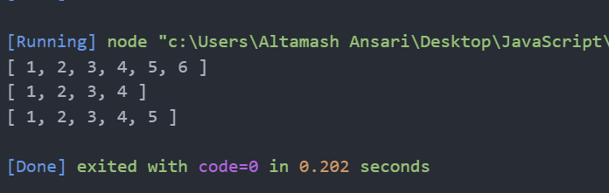

Q.4 Write a function that checks if two given strings are anagrams of each other.

function areAnagrams(str1, str2) {

  const sortString = (str) => str.split("").sort().join("");

  return sortString(str1) === sortString(str2);

}

console.log(areAnagrams("listen", "silent"));

console.log(areAnagrams("hello", "world"));

console.log(areAnagrams("evil", "vile"));

console.log(areAnagrams("fluster", "restful"));

console.log(areAnagrams("example", "samples"));

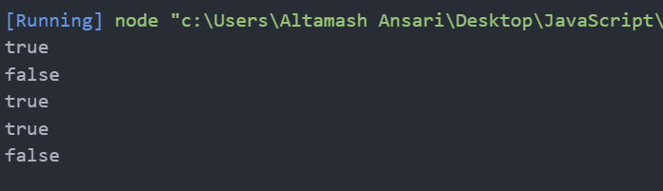

Q.5 Write a function that takes an array and returns a new array with duplicates removed.

function removeDuplicates(array) {

  return array.filter((value, index) => array.indexOf(value) === index);

}

console.log(removeDuplicates([1, 2, 2, 3, 4, 4, 5]));

console.log(removeDuplicates(["a", "b", "a", "c", "b"]));

console.log(removeDuplicates([1, 1, 1, 1, 1]));

console.log(removeDuplicates([]));

console.log(removeDuplicates([1, 2, 3, 4, 5]));

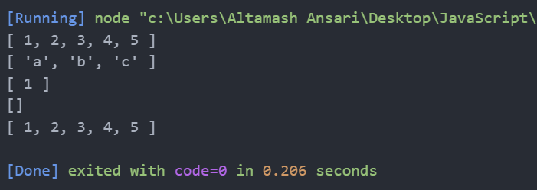

Q.6 Write a function that takes a string and capitalizes the first letter of each word in the string.

function capitalizeWords(str) {

  return str.replace(/\b\w/g, (char) => char.toUpperCase());

}

console.log(capitalizeWords("hello world"));

console.log(capitalizeWords("javascript is awesome"));

console.log(capitalizeWords("capitalize every word"));

console.log(capitalizeWords("one"));

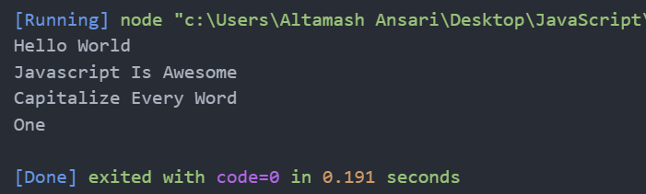

Q.7 Write a function that generates the first n numbers of the Fibonacci sequence.

function fibonacci(n) {

  if (n <= 0) return [];

  if (n === 1) return [0];

  const sequence = [0, 1];

  for (let i = 2; i < n; i++) {

    sequence.push(sequence[i - 1] + sequence[i - 2]);

  }

  return sequence;

}

console.log(fibonacci(10));

console.log(fibonacci(5));

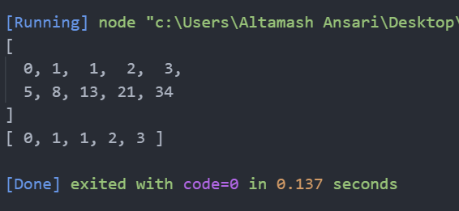

Q.8 Implement a simple HashMap class with put, get, and remove methods.

class HashMap {

  constructor() {

    this.map = {};

  }

  put(key, value) {

    this.map[key] = value;

  }

  get(key) {

    return this.map[key];

  }

  remove(key) {

    if (this.map.hasOwnProperty(key)) {

      delete this.map[key];

    }

  }

}

const map = new HashMap();

map.put("a", 1);

map.put("b", 2);

map.put("c", 3);

console.log(map.get("a"));

console.log(map.get("b"));

console.log(map.get("c"));

map.remove("b");

console.log(map.get("b"));

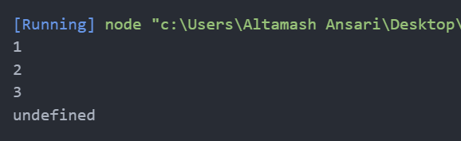

Q.9 Write a function that filters out even numbers from an array.

function filterOutEvenNumbers(array) {

  return array.filter((num) => num % 2 !== 0);

}

console.log(filterOutEvenNumbers([1, 2, 3, 4, 5, 6]));

console.log(filterOutEvenNumbers([2, 4, 6, 8, 10]));

console.log(filterOutEvenNumbers([1, 3, 5, 7, 9]));

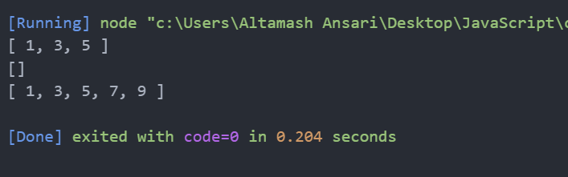

Q.10 Write a function that converts a given string to title case (capitalizing the first letter of each word).

**Same as Question number 6.**

function capitalizeWords(str) {

  return str.replace(/\b\w/g, (char) => char.toUpperCase());

}

console.log(capitalizeWords("hello world"));

console.log(capitalizeWords("javascript is awesome"));

console.log(capitalizeWords("capitalize every word"));

console.log(capitalizeWords("one"));

