FP300Service Testing on linux.

**Running test utility**

Go to FP300Java by cd command.

Run java test utility as following:

java -Djava.library.path=. FP300Service

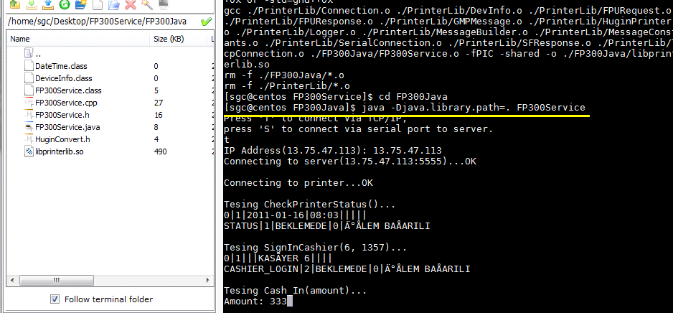

To connect via TCP/IP, press 't'.

To connect via Serial port, press 's' or any key.

Now java test utility only tests CheckPrinterStatus, SignInCashier and Cash_In.

You can modify FP300Service.java with using another printer functions to write new test utilities.