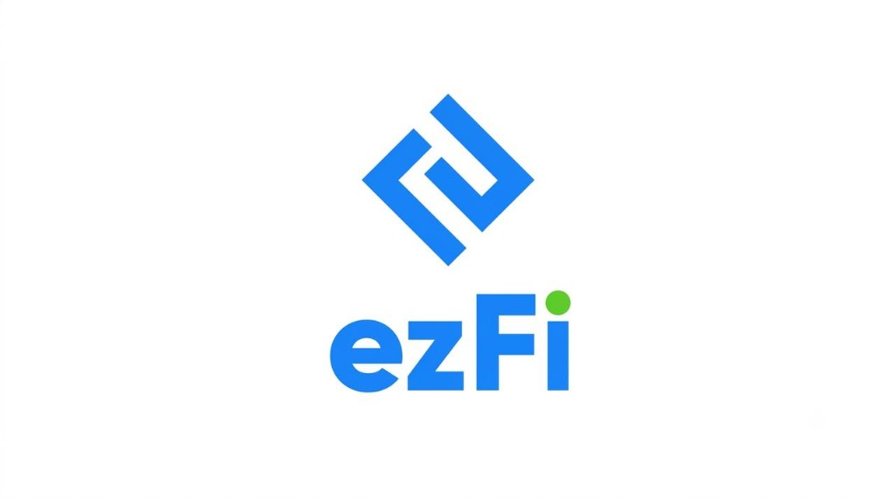

AI-Powered Insurance Verification
& Revenue Cycle Automation Platform
Enterprise Automation for Modern Dental Organizations
Eligibility Verification · OpenDental Writeback · Voice AI · RCM Roadmap

Prepared for DSOs · Enterprise Dental Groups · Practice Owners
Investors · Strategic Technology Partners
Powered by Smile Suites
Executive Product Overview · Confidential

Contents
01 | Executive Summary
02 | Why Insurance Verification Matters
03 | ezFi Platform Overview
04 | Eligibility Verification
05 | Specialist-Level Verification of Benefits
06 | OpenDental Writeback
07 | Safety & Data Integrity
08 | Voice Verification
09 | Future Revenue Cycle Roadmap
10 | EOB / ERA Automation
11 | Product Roadmap
12 | Closing

1. Executive Summary
Dental insurance verification remains one of the largest administrative burdens in modern practice operations. Front-desk and billing teams spend hours each day calling payers, interpreting benefits, updating OpenDental, and explaining patient responsibility—work that is slow, inconsistent, and difficult to scale across locations.
ezFi is an AI-powered platform that automates insurance verification, structured documentation, and OpenDental writeback—while keeping clinical and administrative staff in control of every final decision.
Eligibility  Verification  Flagship Capability | OpenDental  Writeback  Native Integration | Review &  Approval  Human Control | End-to-End  RCM  Roadmap

Platform Philosophy
Automate the work. Preserve clinical and financial judgment. Never overwrite what staff have carefully entered. OpenDental remains the system of record; ezFi is the intelligence and orchestration layer that makes verification accurate, auditable, and fast.

With ezFi, organizations can:
- Reduce phone-time and manual benefit interpretation
- Produce specialist-quality Verification of Benefits summaries from electronic eligibility
- Write structured results safely into OpenDental
- Extend incomplete electronic responses with Voice AI
- Build toward claim preparation, ERA/EOB posting, and denial management on the same platform

2. Why Insurance Verification Matters
Accurate insurance verification sits at the front of every successful revenue cycle. When benefits are wrong or incomplete, estimates fail, collections suffer, and patients lose trust at the chairside conversation that matters most.
Traditional Workflow
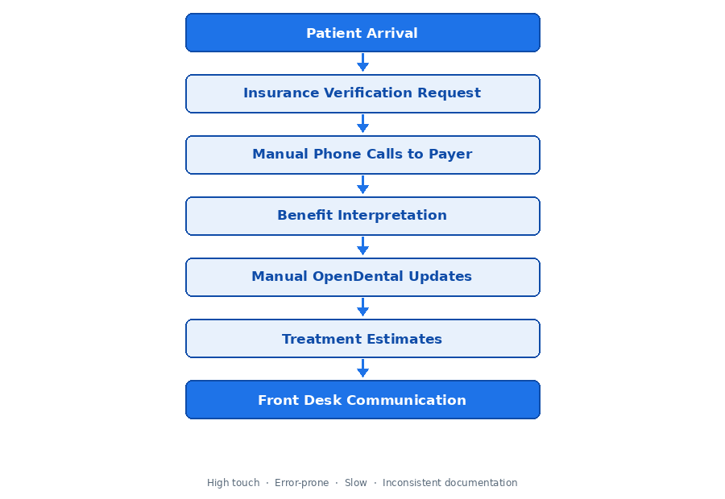
Where the Traditional Model Breaks Down
Challenge | Operational Impact
Manual payer calls | Hours of hold time; inconsistent answers across staff
Benefit interpretation | Variable quality; tribal knowledge; training burden
OpenDental updates | Incomplete notes; missed fields; estimate drift
Patient communication | Surprise balances; delayed treatment acceptance
Multi-location scale | No shared standard; hard to audit or measure

How ezFi Modernizes Verification
ezFi replaces fragmented phone-and-notes workflows with a layered eligibility engine, structured Verification of Benefits output, confidence scoring, and controlled OpenDental writeback—so every location verifies the same way, with the same documentation standard.

3. ezFi Platform Overview
ezFi sits between OpenDental and the payer ecosystem as an AI orchestration layer. Eligibility Verification is the flagship capability today. Voice Verification and OpenDental Writeback complete the live operating stack. Additional revenue cycle agents extend the same architecture over time.
OpenDental · System of Record
▼
ezFi AI Platform
Current Capabilities
✓ Eligibility Verification (Flagship)
✓ Voice Verification
✓ OpenDental Writeback
Revenue Cycle Roadmap
○ Coding Agent
○ Prior Authorization
○ ERA / EOB Processing & Reconciliation
○ Denial Management
▼
ezFi Dashboard | Staff Review & Approval

Design Principles
Principle | Meaning
OpenDental as system of record | ezFi reads and writes; it does not replace the PMS
Human-in-the-loop by default | Staff approve consequential actions
Confidence before mutation | Low-confidence results route to review
Preserve manual edits | Staff corrections are never blindly overwritten
Auditability | Every verification and writeback is traceable

4. Eligibility Verification
Eligibility Verification is ezFi’s flagship capability—a complete, layered pipeline that turns a patient and plan into a specialist-quality Verification of Benefits, ready for staff review and safe OpenDental synchronization.
Layered Architecture
01 | Intake & Validation  Patient · Insurance · Carrier validation against OpenDental records
02 | Electronic Eligibility  Stedi 270/271 inquiry with payer routing and response capture
03 | Normalization & Interpretation  Canonical benefits model · coverage percentages · accumulators
04 | Business Rules & Confidence  Payer rules · caching · confidence scoring · exception routing
05 | Human Review  Dashboard review queue · exception queue · approval workflow
06 | OpenDental Writeback  Benefit Notes · InsVerify · Commlog · Benefits Grid · Adjustments

Pipeline Detail
Layer | What ezFi Does
Patient validation | Confirms identity and demographics against OpenDental before payer inquiry
Insurance validation | Validates plan linkage, subscriber relationships, and coverage order
Carrier validation | Resolves payer identity and routing for electronic eligibility
OpenDental integration | Pulls live plan context and prepares deterministic writeback targets
Stedi 270/271 eligibility | Issues electronic benefit inquiry and captures structured 271 responses
Eligibility normalization | Maps heterogeneous payer responses into a canonical dental benefits model
Coverage interpretation | Derives percentages, accumulators, limitations, and plan clauses
Business rules | Applies organization and payer-specific policies before staff see results
Caching | Reuses recent, still-valid eligibility where appropriate to reduce cost and latency
Confidence scoring | Scores completeness and reliability; gates automated vs. review paths
Review queue | Surfaces incomplete, conflicting, or low-confidence cases for staff
Dashboard | Operational workspace for queue management, detail review, and approval
Exception handling | Routes failures, payer gaps, and writeback conflicts into owned exception queues

Outcome
Staff receive a consistent, specialist-level Verification of Benefits—not a raw 271 dump—with clear confidence signals and a controlled path into OpenDental.

5. Specialist-Level Verification of Benefits
Raw electronic eligibility is incomplete for dental operations. ezFi transforms 271 data into structured, specialist-quality Verification of Benefits summaries that front desk, treatment coordinators, and billing teams can act on immediately.
Extracted & Interpreted Benefit Elements
Active Coverage | Coverage Percentages | Deductibles
Remaining Deductibles | Annual Maximums | Remaining Maximums
Preventive / Basic / Major | Orthodontic Benefits | Implant Benefits
Waiting Periods | Frequency Limitations | Age Limitations
Missing Tooth Clauses | Alternate Benefits | Downgrade Rules
Prior Auth Indicators | Individual vs Family Accumulators | Last Service Dates
Subscriber Information | Dependent Information | Patient Estimates

From Raw 271 to Operational Clarity
Source Reality | ezFi Output
Fragmented EDI segments | Canonical dental benefits record
Payer-specific naming | Normalized coverage categories
Missing narrative context | Deterministic VOB summary for Benefit Notes
Unclear patient cost | Procedure-aware patient estimates where data allows
No audit trail | Verification timestamp, check ID, and review status

Specialist Standard
ezFi is designed to produce the same depth a skilled insurance coordinator would document after a thorough payer call—coverage, deductibles, maximums, limitations, clauses, and patient estimates—then keep that standard consistent across every location.

6. OpenDental Writeback
Verification only creates value when it lands where staff already work. ezFi writes structured eligibility results into OpenDental across multiple, purpose-built locations—each with clear intent, isolation of failures, and safeguards for manually curated data.
Writeback Locations
OpenDental Location | What ezFi Writes | Purpose
Benefit Notes | Complete deterministic VOB summary: coverage, deductibles, annual maximums, patient estimates, verification timestamp | Primary structured snapshot for clinical and billing review
Subscriber Notes | Short insurance summary visible on the insurance grid | At-a-glance status for front desk
Insurance Verification | Verification status update (Patient Enrollment & Insurance Benefit) | Audit trail of when and how benefits were verified
Communication Log | Front desk documentation and estimated patient responsibility | Patient-facing conversation support
Benefits Grid | Coverage percentages, deductibles, annual maximums; preserves manually edited rows | Structured plan benefits for estimates and claims
Insurance Adjustments | Remaining vs. used totals when sufficient payer information exists | Financial accumulator sync—only with adequate data

Writeback Execution Model
Each writeback step is isolated. A failure in one location does not abort the others. Financial and benefits-grid mutations support dry-run / shadow comparison and confidence gating before live mutation.
OpenDental Remains Authoritative
ezFi never invents fee schedules, ledger payments, or fabricated adjustments. Writeback is deterministic, reversible where snapshots exist, and designed for enterprise trust—not silent ledger mutation.

7. Safety & Data Integrity
Automation without control is a liability. ezFi is engineered so clinics retain complete authority over financial and benefits data while still capturing the speed and consistency of AI-assisted verification.
ezFi Intentionally Does Not
Prohibited Action | Why It Matters
Overwrite manually edited benefits | Staff corrections reflect real-world plan knowledge
Fabricate adjustments | Ledger integrity must never be invented by a model
Fabricate payments | Cash and remittance must originate from real payer activity
Create fake ledger transactions | OpenDental financials stay audit-safe
Auto-assign fee schedules | Contractual fees remain a human / contract decision

Control Surfaces
Shadow Mode  Run full verification and proposed writeback without mutating OpenDental. Compare before go-live. | Review Queue  Low-confidence, incomplete, or policy-sensitive results wait for staff judgment.
Exception Queue  Failures and conflicts are aged, owned, and actionable—never lost in inboxes. | Approval Workflow  Consequential writebacks proceed only after configured review, preserving control.
8. Voice Verification
Electronic eligibility is powerful—but not always complete. Voice AI extends the eligibility stack when the 271 leaves gaps that used to require a staff phone call.
Workflow
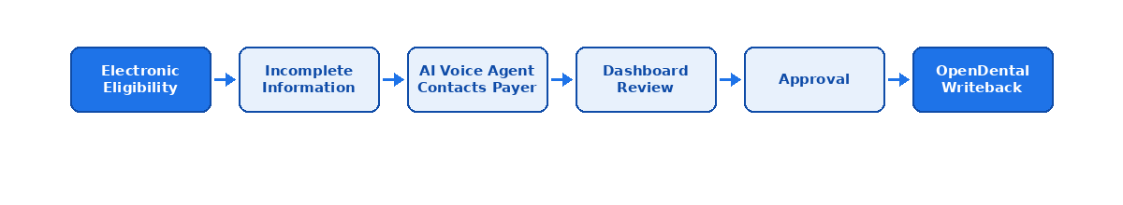
Conversation Design
Capability | Description
Context-aware conversations | The agent knows the patient, plan, and missing benefit fields before dialing
One question at a time | Payer agents receive clear, sequential questions—not overwhelming scripts
Intelligent follow-up | Answers drive the next question; ambiguity is clarified, not ignored
Dashboard review | Transcripts and extracted fields land in the same review workspace as electronic checks
Safe reconciliation | Voice findings merge into the VOB and writeback path only after review and approval

Complement, Don’t Replace
Voice Verification is an extension of electronic eligibility—not a parallel process. The destination is the same: a complete VOB, staff control, and safe OpenDental writeback.

9. Future Revenue Cycle Roadmap
Eligibility Verification is the foundation. The same architecture—OpenDental as system of record, confidence gating, human review, and deterministic writeback—extends across the dental revenue cycle.
Coding Agent  • AI-assisted CDT coding  • Documentation review  • Clinical narratives | Prior Authorization  • Auth requirement detection  • Attachments & submission  • Tracking & renewals | Claim Preparation  • Pre-submission validation  • Missing documentation  • Readiness scoring
One Operating Model
Each future agent reuses ezFi’s review queues, confidence thresholds, audit trail, and OpenDental synchronization patterns—so DSOs do not adopt a patchwork of point tools.
10. EOB / ERA Automation
As ezFi expands from verification into full revenue cycle automation, remittance processing becomes a natural next layer—structured data first, confidence gates, deterministic OpenDental posting, and human ownership of exceptions.
Planned Remittance Pipeline
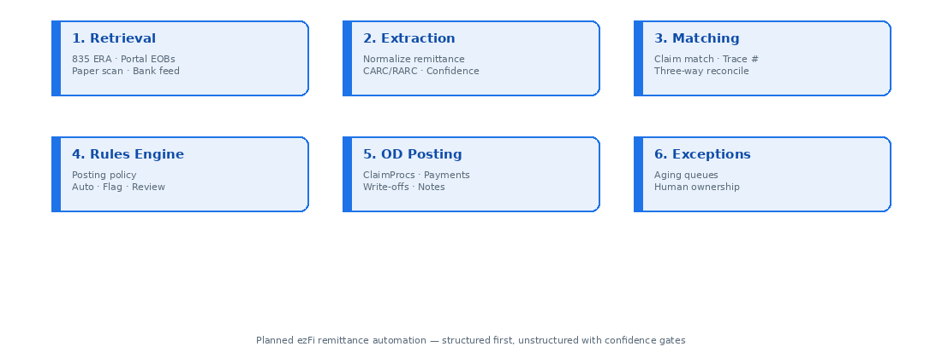
Capability Overview
Capability | ezFi Approach
ERA ingestion | Prefer X12 835 / ERA as the highest-fidelity input; maximize electronic remittance share
EOB interpretation | Document understanding for paper and portal EOBs, with field-level confidence scores
Payment posting | Deterministic OpenDental API posting to claimprocs—never generative ledger writes
Payment reconciliation | Three-way match: remittance total = ledger payment = bank credit (EFT trace / check #)
Exception handling | Named, aging queues for unmatched remits, denials, downgrades, takebacks, and refunds
Human review | Auto-post only when confidence, match, and rules thresholds are met; otherwise review
OpenDental sync | Payments, write-offs, deductibles, source documents, and posting rationale notes

Posting Integrity Principles
- Rules engine primary for write-off vs. patient responsibility vs. denial classification
- Procedure-level posting for PPO accuracy—not lump totals that corrupt A/R
- No silent netting of takebacks; reverse with reference to the original claim
- Immutable audit: source document, rule version, confidence, before/after ledger state
Part of the Same Platform
EOB/ERA automation is the remittance chapter of ezFi’s end-to-end revenue cycle platform—built on the trust model proven in Eligibility Verification and OpenDental Writeback.

11. Product Roadmap
ezFi delivers value now in verification and writeback, then expands along a clear path toward enterprise DSO revenue cycle operations.
CURRENT | NEXT | FUTURE
• Eligibility Verification  • Voice Verification  • OpenDental Writeback | • Coding Agent  • Prior Authorization  • Claim Preparation | • ERA Processing  • EOB Automation  • Denial Management  • Revenue Analytics  • Enterprise DSO Features

Investment Thesis for Enterprise Buyers
Horizon | Buyer Outcome
Current | Standardize verification quality; cut admin time; harden OpenDental documentation
Next | Reduce coding and auth friction; improve claim readiness before submission
Future | Compress remittance-to-cash; control denials; measure RCM performance at scale

12. Closing
ezFi combines intelligent insurance verification, OpenDental integration, and AI-driven automation to reduce administrative burden while helping dental organizations improve efficiency, accuracy, and patient financial transparency.

Engage With ezFi
Whether you operate a single high-volume specialty practice or a multi-state DSO, ezFi is built to meet you where you work today—in OpenDental—and to grow with your revenue cycle ambitions.
Eligibility  Verification  Start With | OpenDental  Writeback  Integrate Via | Voice +  RCM Agents  Scale With | Review &  Shadow Mode  Govern With


Powered by Smile Suites
© Smile Suites · ezFi Executive Product Overview · Confidential

