Steps to properly install the Networking Library
Dated 12/04/2019

- You will NOT need to install any additional programs
- The library is inside the NetworkingLib folder
- Additional/Reference information can be found on Microsoft’s Documentation Website

- You will need to add NetworkLib to your project folder (Under CoreGame/NetworkLibrary)

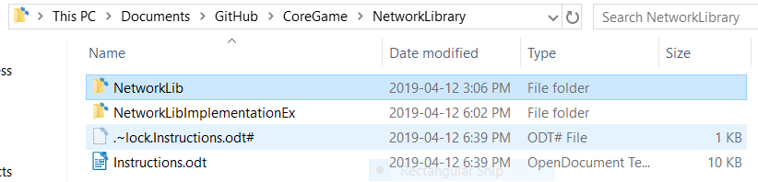

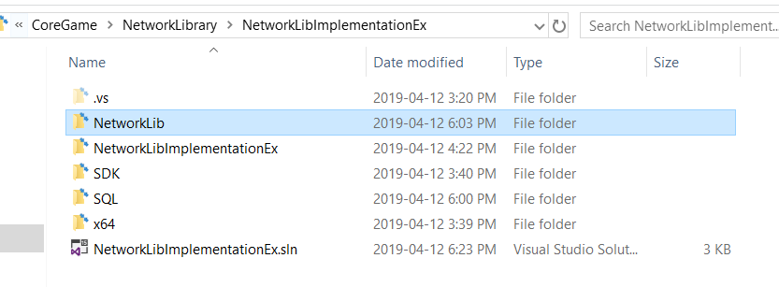

- Add the NetworkingLib to the solution
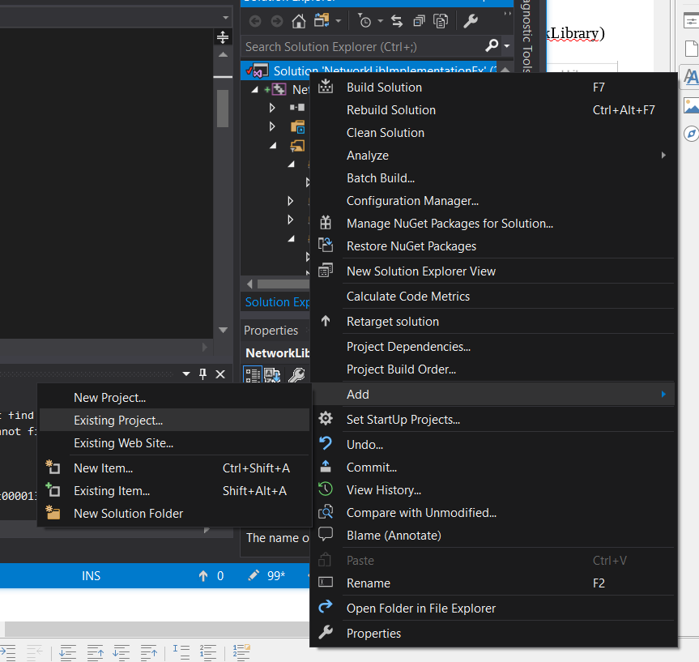

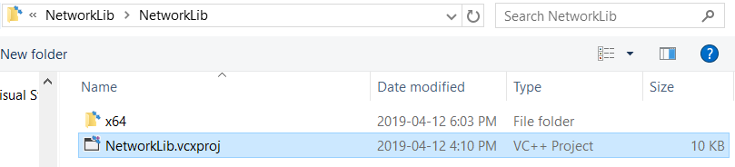

- Go to your project and add a reference to the library
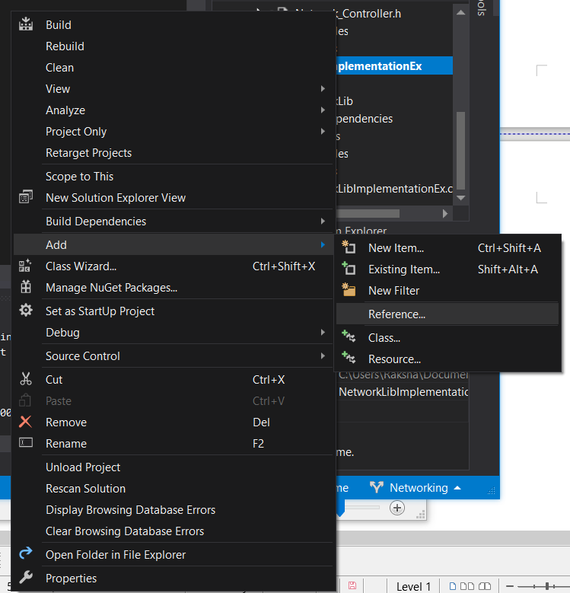
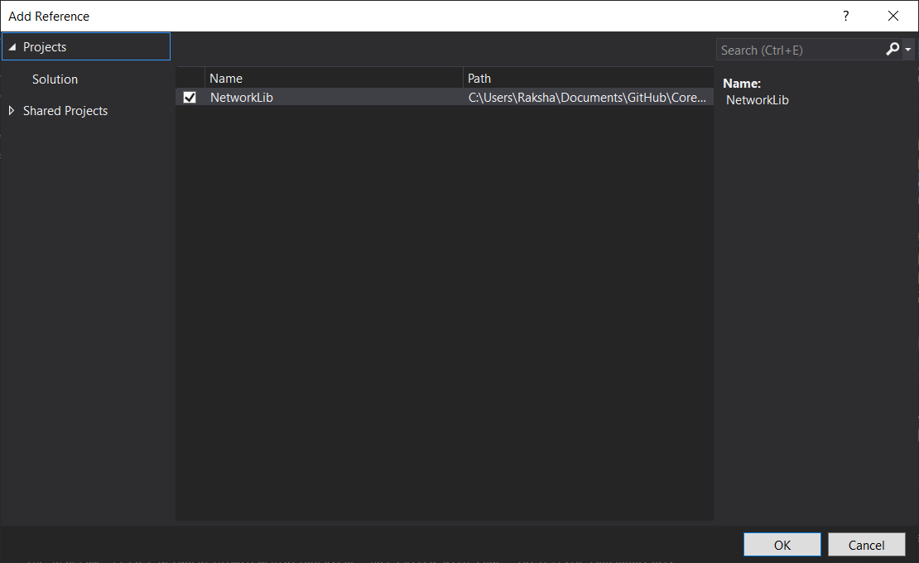

- Add the header files you need to use!

These are all the .h files that can be used from the library
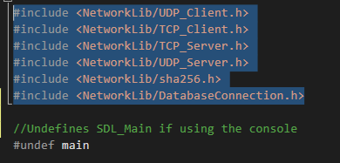

- Add required folders to your project

They can be found under NetworkLibImplementationEx
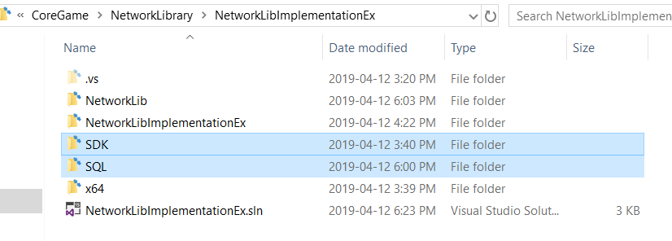

- IMPORTANT! Make sure your solution configuration matches the following
- Release / x64

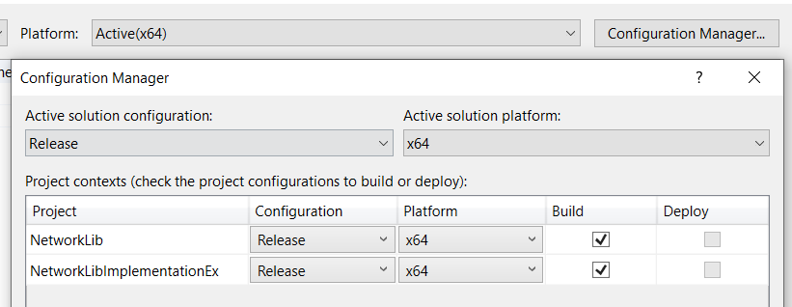

- Under Solution Property -> Configuration Properties -> C/C++ -> Additional Include Directories, add the following includes.

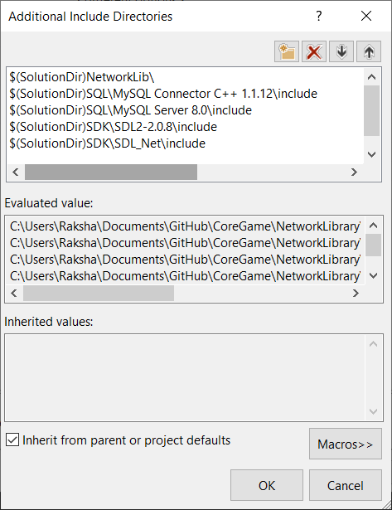
- $(SolutionDir)NetworkLib\
- $(SolutionDir)SQL\MySQL Connector C++ 1.1.12\include
- $(SolutionDir)SQL\MySQL Server 8.0\include
- $(SolutionDir)SDK\SDL2-2.0.8\include
- $(SolutionDir)SDK\SDL_Net\include

- Under Linker -> General, add the following includes
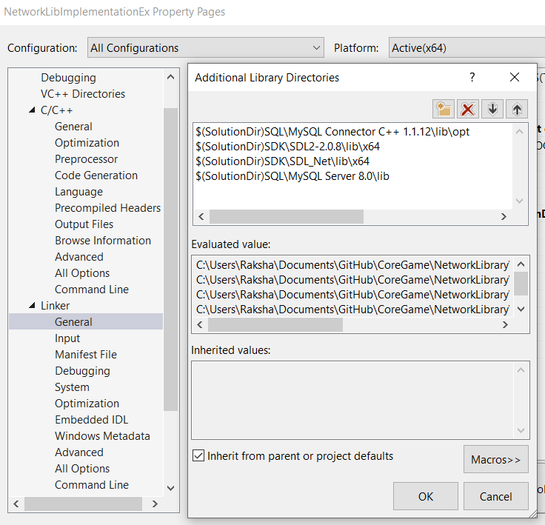
- $(SolutionDir)SQL\MySQL Connector C++ 1.1.12\lib\opt
- $(SolutionDir)SDK\SDL2-2.0.8\lib\x64
- $(SolutionDir)SDK\SDL_Net\lib\x64
- $(SolutionDir)SQL\MySQL Server 8.0\lib

- Under Linker -> Input, add the following libraries
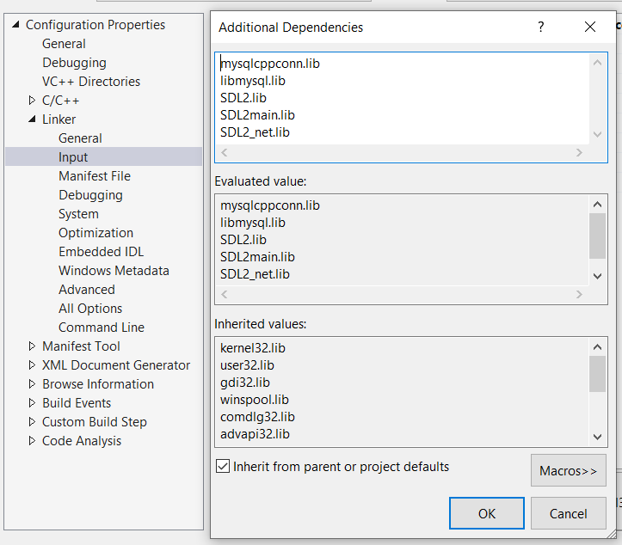

- mysqlcppconn.lib
- libmysql.lib
- SDL2.lib
- SDL2main.lib
- SDL2_net.lib

- Copy .dlls

- Copy libmysql.dll
- Copy libeay32.dll
- Copy ssleay32.dll
- Copy SDL2.dll
- Copy SDL2_net.dll
- to the executable directory of your project (Under x64/Release)
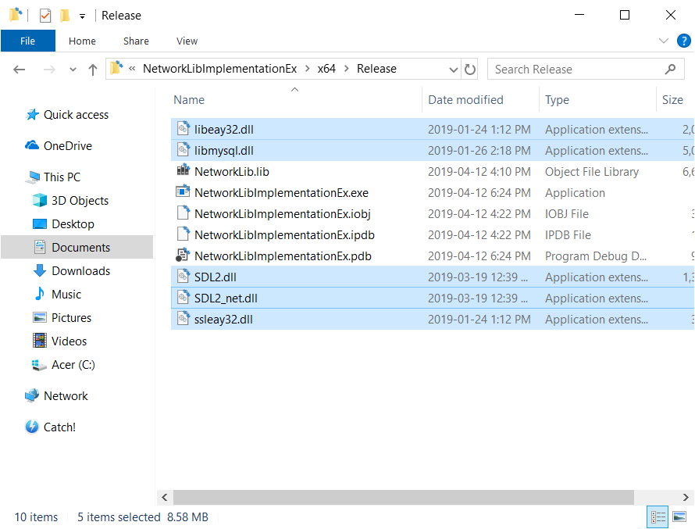

Finally ! Add a Preprocessor Definition under C/C++ -> Preprocessor
