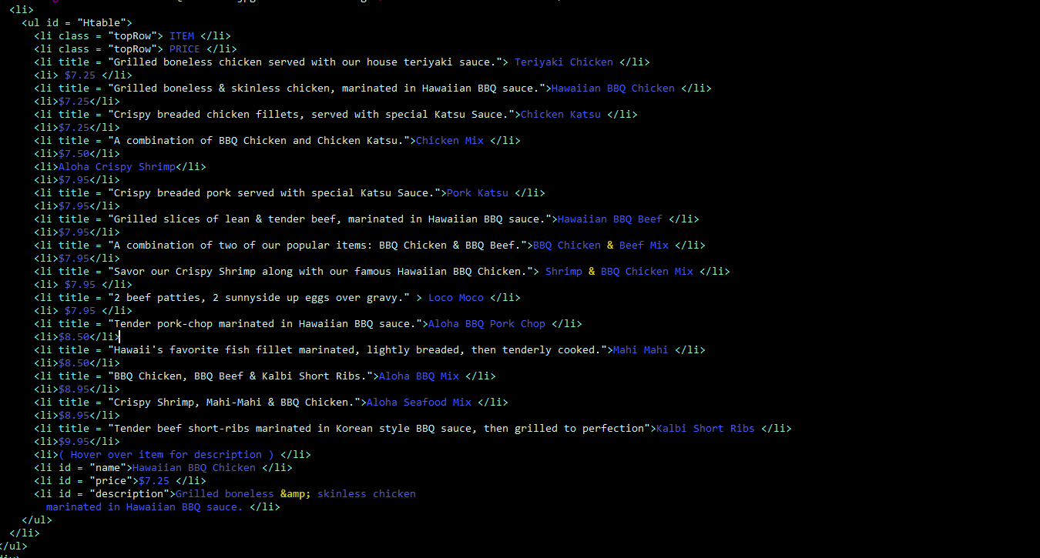

<ul id = "HawaiianMenu">

<li><img src = "Hawaiian BBQ Chicken.jpg" id = "currentImg" /> ====CONTENT GOES HERE====</li>

<li>

<ul id = "Htable">

<li class = "topRow"> ITEM </li>

<li class = "topRow"> PRICE </li>

<li title = "Grilled boneless chicken served with our house teriyaki sauce."> Teriyaki Chicken </li>

<li> $7.25 </li>

<li title = "Grilled boneless & skinless chicken, marinated in Hawaiian BBQ sauce.">Hawaiian BBQ Chicken </li>

<li>$7.25</li>

<li title = "Crispy breaded chicken fillets, served with special Katsu Sauce.">Chicken Katsu </li>

<li>$7.25</li>

<li title = "A combination of BBQ Chicken and Chicken Katsu.">Chicken Mix </li>

<li>$7.50</li>

<li>Aloha Crispy Shrimp</li>

<li>$7.95</li>

<li title = "Crispy breaded pork served with special Katsu Sauce.">Pork Katsu </li>

<li>$7.95</li>

<li title = "Grilled slices of lean & tender beef, marinated in Hawaiian BBQ sauce.">Hawaiian BBQ Beef </li>

<li>$7.95</li>

<li title = "A combination of two of our popular items: BBQ Chicken & BBQ Beef.">BBQ Chicken & Beef Mix </li>

<li>$7.95</li>

<li title = "Savor our Crispy Shrimp along with our famous Hawaiian BBQ Chicken."> Shrimp & BBQ Chicken Mix </li>

<li> $7.95 </li>

<li title = "2 beef patties, 2 sunnyside up eggs over gravy." > Loco Moco </li>

<li> $7.95 </li>

<li title = "Tender pork-chop marinated in Hawaiian BBQ sauce.">Aloha BBQ Pork Chop </li>

<li>$8.50</li>

<li title = "Hawaii's favorite fish fillet marinated, lightly breaded, then tenderly cooked.">Mahi Mahi </li>

<li>$8.50</li>

<li title = "BBQ Chicken, BBQ Beef & Kalbi Short Ribs.">Aloha BBQ Mix </li>

<li>$8.95</li>

<li title = "Crispy Shrimp, Mahi-Mahi & BBQ Chicken.">Aloha Seafood Mix </li>

<li>$8.95</li>

<li title = "Tender beef short-ribs marinated in Korean style BBQ sauce, then grilled to perfection">Kalbi Short Ribs </li>

<li>$9.95</li>

<li>( Hover over item for description ) </li>

<li id = "name">Hawaiian BBQ Chicken </li>

<li id = "price">$7.25 </li>

<li id = "description">Grilled boneless &amp; skinless chicken

marinated in Hawaiian BBQ sauce. </li>

</ul>

</li>

</ul>