GoMall

View System Statistics

Version <1.2>

Revision History

|  |  |  |  |
| --- | --- | --- | --- |
| **Date** | **Version** | **Description** | **Author** |
| 07/07/2025 | 1.0 | <<Add>> Fully add details of this use case specification | Nguyễn Đặng Minh Duy |
| 08/07/2025 | 1.1 | <<Update>> Add detail description of Special requirement: usability | Nguyễn Đặng Minh Duy |
| 10/07/2025 | 1.2 | <<Update>> Add interfere images (created by v0.dev) to support basic flow’s description | Nguyễn Đặng Minh Duy |

Table of Contents

1. Manage Seller Product 4

1.1 Brief Description 4

2. Flow of Events 4

2.1 Basic Flow 4

2.2 Alternative Flows 4

3. Special Requirements 4

3.1 Usability 4

3.2 Security 4

4. Preconditions 5

4.1 Admin is already authenticated 5

4.2 Product data exists in the system 5

5. Postconditions 5

5.1 No data has changed 5

5.2 Admin has viewed the user list. 5

6. Extension Points 5

6.1 <Name of Extension Point> 5

# Manage Seller Product

## Brief Description

The admin accesses to the dashboard page to The Dashboard Page provides the admin with an overview of key system metrics, including the number of users, orders, revenue, support requests, traffic sources, revenue statistics chart, and trending products.

# Basic Flow

### From the admin interface, the admin navigates to the Dashboard by clicking the “Dashboard” on the left side tab.

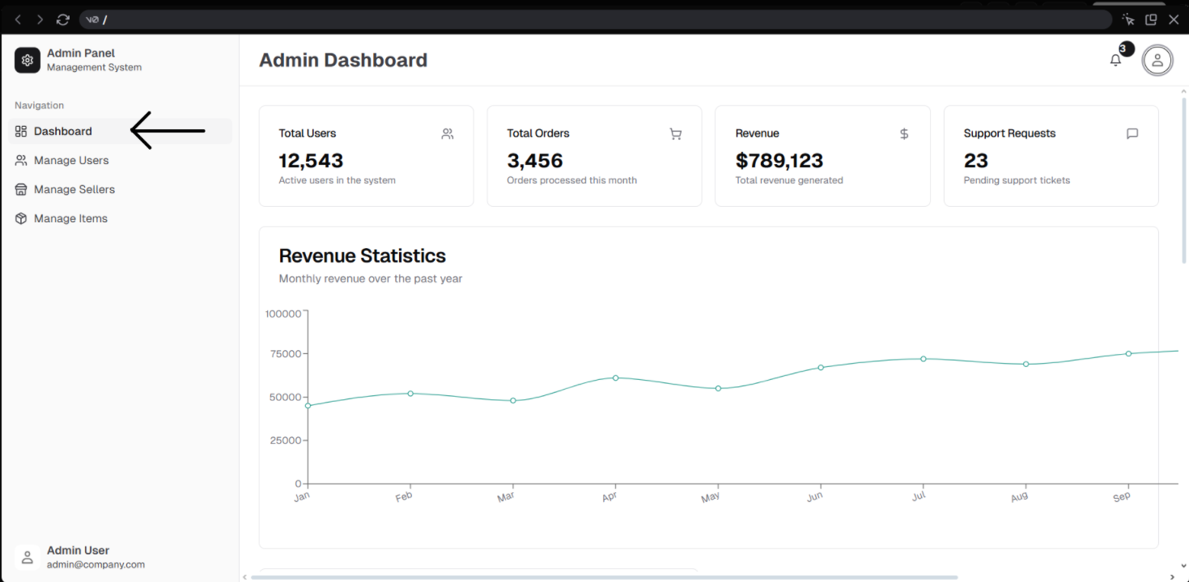

**Image 1:** Admin dashboard navigation

### The system displays the following overview information:

### Summary cards showing the number of users, orders, revenue, and support requests.

### A revenue statistics chart by month.

### A pie chart showing revenue distribution, based on product categories.

### A table of trending products, including ID, product name, quantity sold, and revenue.

### Admin avatar and notification (bell) button.

1. The admin can click the avatar to open an account modal with a logout button.

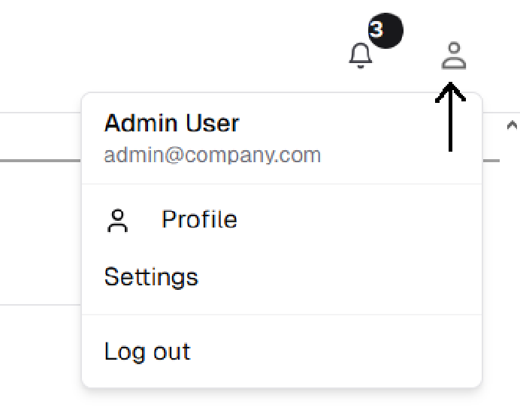

**Image 2:** Click the user’s avatar to open the account modal

### The admin can view all displayed information but cannot edit data directly from the dashboard.

## Alternative Flows

### No Data Available:

This alternative flow starts at Step 2 of the Basic Flow.

If there is no data no users, orders, or revenue), the summary cards and tables will display zero or be empty.

# Special Requirements

## Usability

* The interface must be user-friendly, intuitive, and responsive.
* Charts and tables must be clear and easy to understand.
* The account modal must be easy to open and close.

## Security

Only authenticated users with the admin role may access this use case. Any unauthorized access must result in a redirect to the login page or a “403 Forbidden” error.

# Preconditions

## Admin is already authenticated

The admin is already logged in and has access to the admin dashboard.

# Postconditions

## No data has changed

No changes are made to user data in the current implementation (view-only).

## The admin has viewed the system overview information.

Admin has successfully viewed the system overview, including revenue summaries, distribution and hot products.