Step 1. Click this to fork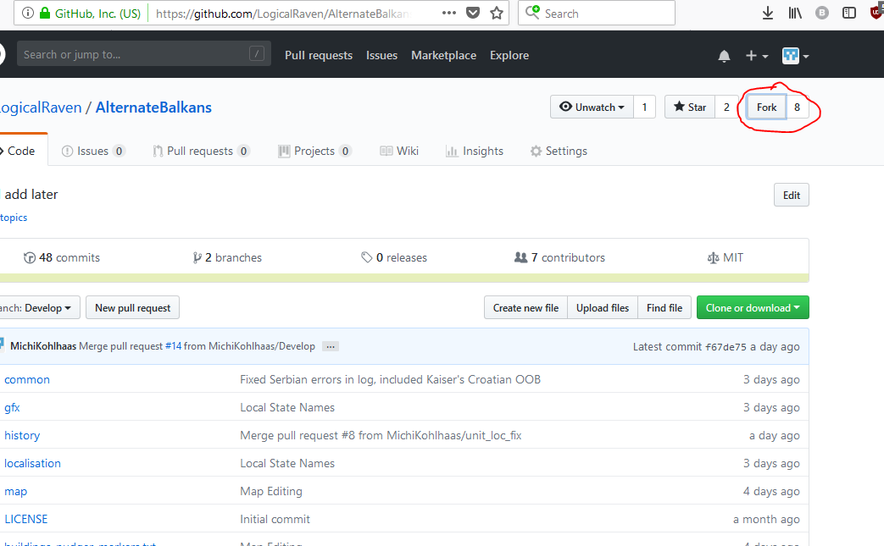

Step 2. Your account will appear in the popup. Click it

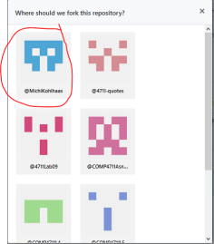

Step 3. Download Git. <https://git-scm.com/downloads>

Just follow the installation wizard. When you get to the image choose git Bash and then next

[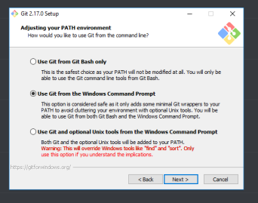](https://cdn.discordapp.com/attachments/445329389513605141/451835186569543720/unknown.png)

Step 4. Open Git Bash and change directory to the folder with the mod in it. Make sure you can see hidden folders. The reason you want to have hidden folders shown is to see if you have the .git folder already

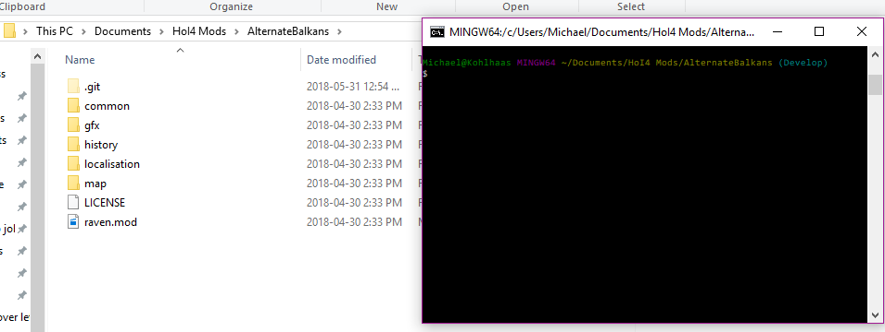

to change directory type cd "C:\Users\Your username\wherever you have folders"

Step 5. once you're in the alternate balkans mod folder on your computer type git init this will create the .git folder if it doesn't already exist.

Step 6. Now we want git to know where to push and pull your changes from. Type git remote add origin "https://github.com/The URL to **Your** fork of the project" this will let Git know to pull and push changes to your fork of the project on github

You can find the URL in pic (Below)

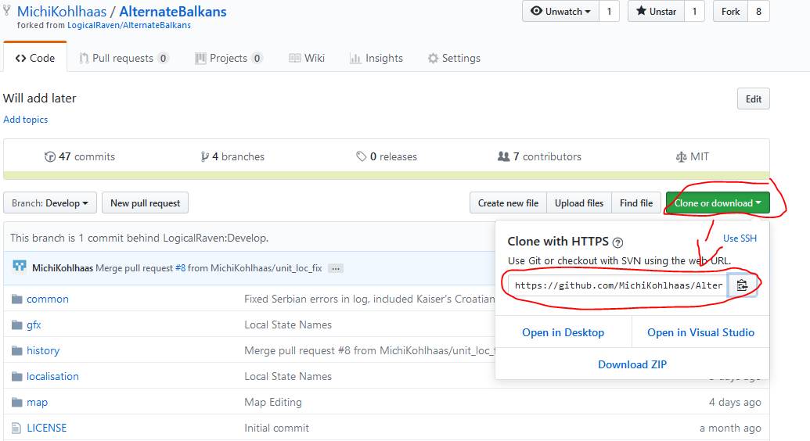

Step 6.5. Do the same but now add the URL for the organization's repo: git add remote upstream "https://github.com/LogicalRaven/AlternateBalkans.git"

Step 7. type git fetch origin

Step 8. type git checkout Develop (the uppercase is important)

Step 9. type git branch --set-upstream-to origin/Develop

and then if you type cat .git/config you should get output similar to:

[core]

repositoryformatversion = 0

filemode = false

bare = false

logallrefupdates = true

symlinks = false

ignorecase = true

[remote "origin"]

url = <https://github.com/MichiKohlhaas/AlternateBalkans.git>

fetch = +refs/heads/*:refs/remotes/origin/*

[remote "upstream"]

url = <https://github.com/LogicalRaven/AlternateBalkans.git>

fetch = +refs/heads/*:refs/remotes/upstream/*

[branch "Develop"]

remote = origin

merge = refs/heads/Develop

Step 10. Now you can download the project. Type: git pull https://github.com/MichiKohlhaas/AlternateBalkans.git

But replace it with the URL of your own repo

Step 11.

Before you make your changes to any files, make sure you pull from the Team’s repo to see if anyone has made any changes while you’ve been away. To do this type:

git pull upstream Develop

Once you’ve made your changes and you’re ready to commit them type:

* git add * (the asterisk, *, adds all the files you’ve changed and want to commit. If you want to add only certain files you’ll have to manually add them)
* git commit -a -m “Your commit message goes here. Make it descriptive and succinct”
* git push origin Develop (once again, the uppercase is important)

Step 12.

Now that you’ve pushed your changes to your repo you’ll want to make a pull request to the Team’s repo. This pulls the changes you’ve made and committed to your repo to the Team’s repo. From there someone will review them.

To make a pull request, go to GitHub.com and navigate to your AlternateBalkans repo and then click on the pull request link (see picture below)

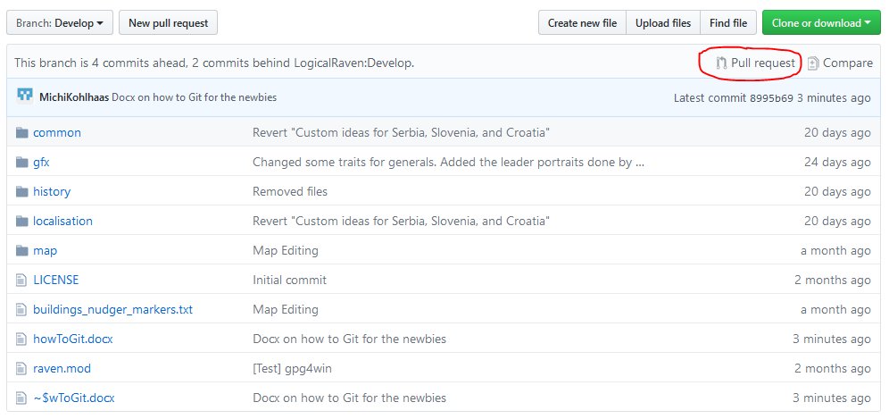

Clicking this will take you to a new screen where you can review your changes. There will be a big green button, click this to make your pull request. Give your pull request a title and a short description of what files you’ve changed.

Make sure you have the green checkmark saying your branch is “Able to merge” and double check which branches are the base fork and head fork. Base fork ***should always*** “LogicalRaven/AlternateBalkans Develop”. See picture below for example

