**Lab worksheet 1: Introduction to Program Components**

**CT/2021/055 – M.S.M.Althaf**

**Question: 01**

Code

package Q_01;  
  
import javax.swing.*;  
  
public class SampleWindow {  
 public static void main(String[] args) {  
 JFrame My_Window = new JFrame();  
 My_Window.setSize(800,600);  
 My_Window.setTitle("Welcome to Java");  
 My_Window.setVisible(true);  
 }  
}

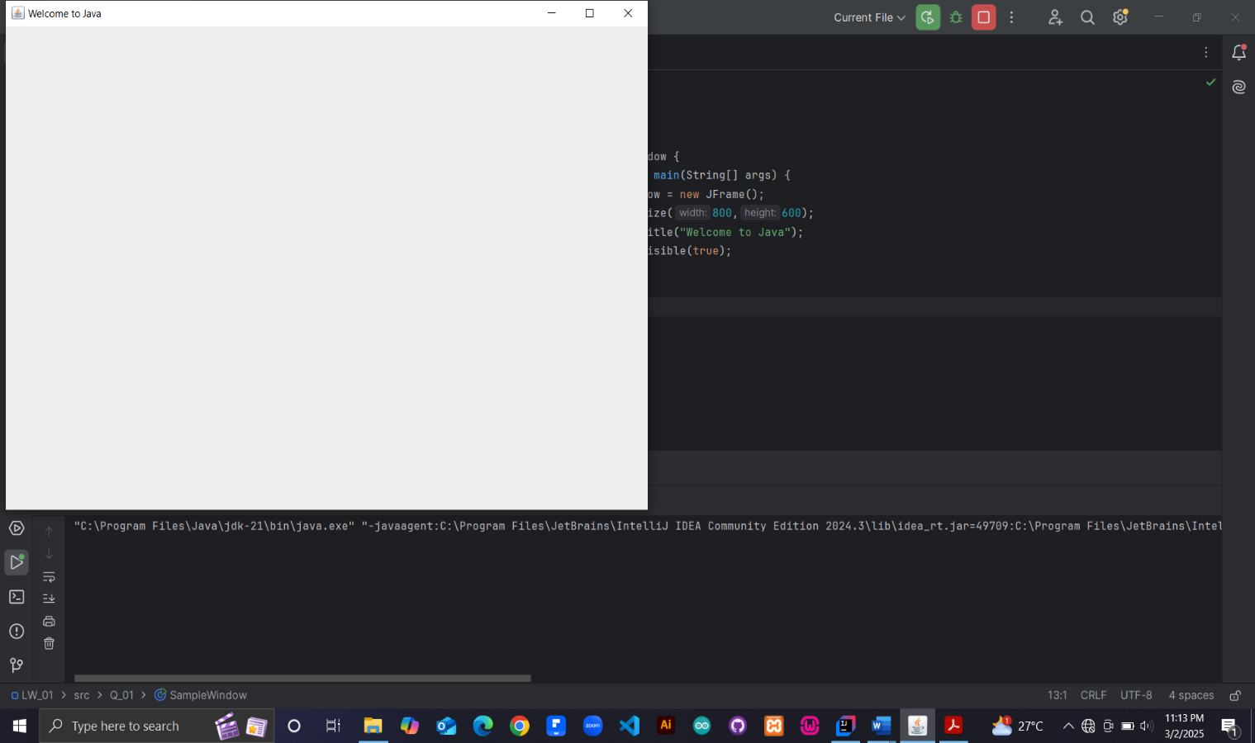Output

**Question: 02**

Code

package Q_02;  
  
import javax.swing.*;  
import java.util.Scanner;  
  
public class NameWindow {  
 public static void main(String[] args) {  
 Scanner Input = new Scanner(System.*in*);  
 System.*out*.print("Enter the First_Name : ");  
 String First_Name = Input.nextLine();  
 System.*out*.print("Enter the Last_Name : ");  
 String Last_Name = Input.nextLine();  
  
 JFrame My_Window = new JFrame();  
 My_Window.setSize(500,200);  
 My_Window.setTitle(First_Name + " " + Last_Name);  
 My_Window.setVisible(true);  
  
 }  
}

Output

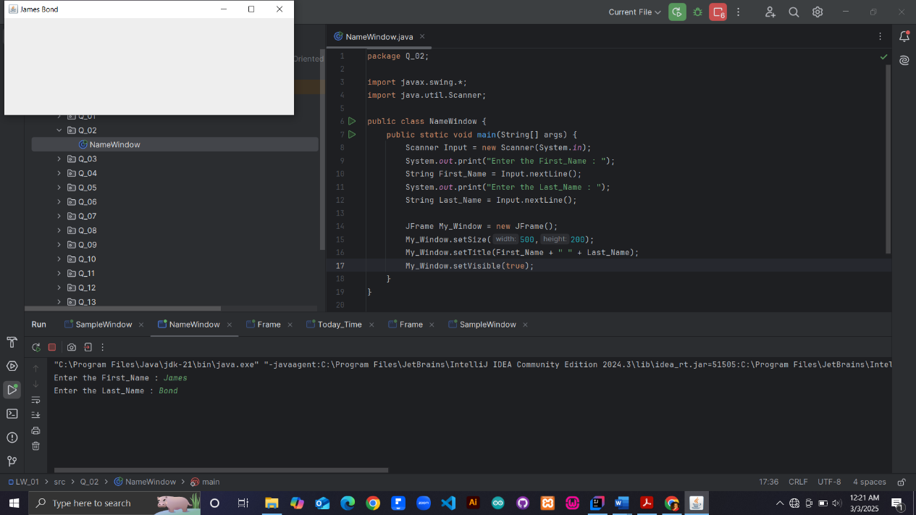

**Question: 03**

package Q_03;  
  
import java.util.Scanner;  
  
public class Name {  
 public static void main(String[] args) {  
 Scanner Input = new Scanner(System.*in*);  
 System.*out*.print("Enter the First Name : ");  
 String First_Name = Input.next();  
 System.*out*.print("Enter the Middle Name : ");  
 String Middle_Name = Input.next();  
 System.*out*.print("Enter the Middle Name : ");  
 String Last_Name = Input.next();  
  
 String Middle_Initial = Middle_Name.substring(0,1);  
 System.*out*.println(First_Name + " " + Middle_Initial + "." + Last_Name);  
  
 }  
}

Output

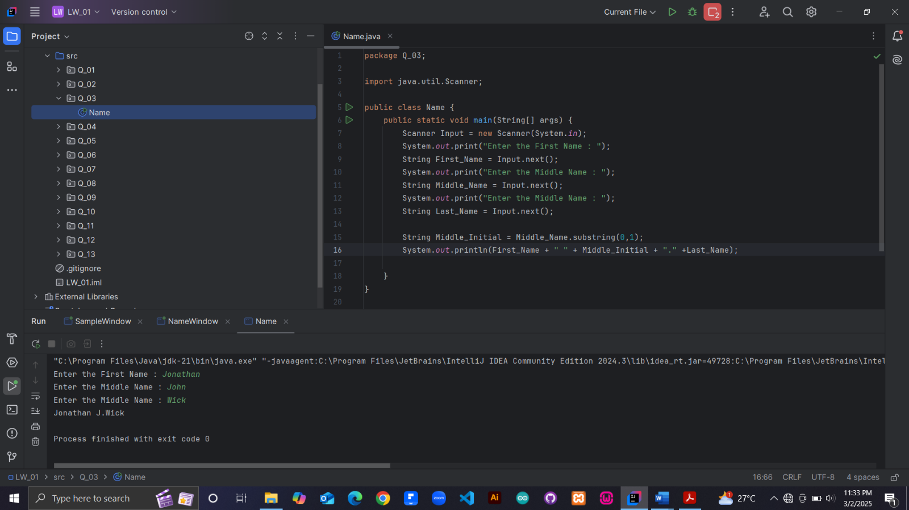

**Question: 04**

package Q_04;  
  
import java.util.Date;  
import java.text.SimpleDateFormat;  
  
  
public class Today_Date {  
 public static void main(String[] args) {  
 Date Today = new Date();  
 SimpleDateFormat sdf = new SimpleDateFormat("dd MMM yyyy");  
 System.*out*.println(sdf.format(Today));  
 }  
}

Output:

**Question: 05**

package Q_05;

import java.text.SimpleDateFormat;  
import java.util.Date;  
  
public class Today_Date {  
 public static void main(String[] args) {  
 Date Today = new Date();  
 SimpleDateFormat sdf = new SimpleDateFormat("EEEE, dd MMM yyyy");  
 System.*out*.println(sdf.format(Today));  
 }  
}

Output:

**Question: 06**

package Q_06;  
  
import javax.swing.*;  
import java.util.Scanner;  
  
public class Frame {  
 public static void main(String[] args) {  
  
 Scanner Input = new Scanner(System.*in*);  
 System.*out*.print("Enter the Number of pixels for window width : ");  
 int W = Input.nextInt();  
  
 System.*out*.print("Enter the Number of pixels for window height : ");  
 int H = Input.nextInt();  
  
 System.*out*.print("Enter the title for the frame : ");  
 String Title = Input.next();  
  
 JFrame MyWindow = new JFrame();  
 MyWindow.setSize(W,H);  
 MyWindow.setTitle(Title);  
 MyWindow.setVisible(true);  
 }  
}

Output

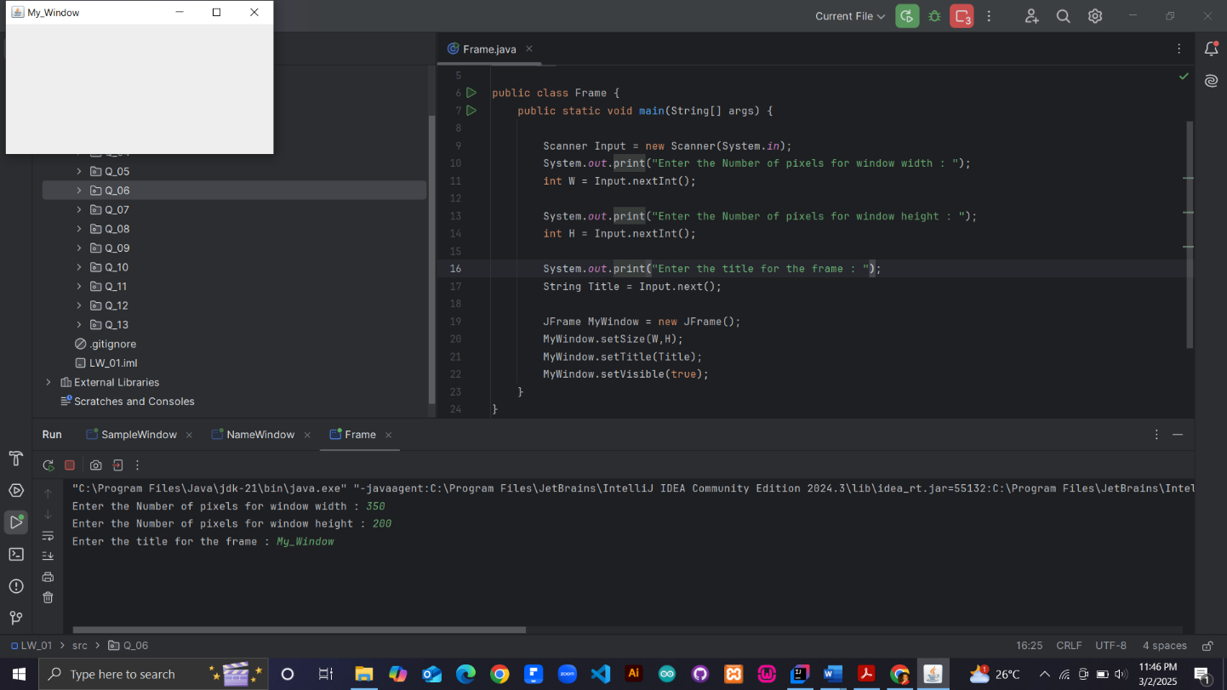

**Question: 07**

package Q_07;  
  
import javax.swing.*;  
import java.text.SimpleDateFormat;  
import java.util.Date;  
  
public class Today_Time {  
 public static void main(String[] args) {  
  
 Date Today = new Date();  
 SimpleDateFormat sdf = new SimpleDateFormat("HH:mm:ss a");  
 // System.out.println(sdf.format(Today));  
  
 String Time = sdf.format(Today);  
  
 JFrame MyWindow = new JFrame();  
 MyWindow.setSize(350,300);  
 MyWindow.setTitle(Time);  
 MyWindow.setVisible(true);  
 }  
}

Output:

**Question: 08**

package Q_08;  
  
import java.util.Scanner;  
  
public class Divide_String {  
 public static void main(String[] args) {  
 Scanner Input = new Scanner(System.*in*);  
 System.*out*.print("Enter the sentence with exclamation mark: ");  
 String Sentence = Input.nextLine();  
  
 int Exclamation_Index = Sentence.indexOf('!');  
 String First_String = Sentence.substring(0,Exclamation_Index).trim();  
 String Second_String = Sentence.substring(Exclamation_Index+1).trim();  
  
 System.*out*.println(First_String);  
 System.*out*.println(Second_String);  
  
 }  
}

Output:

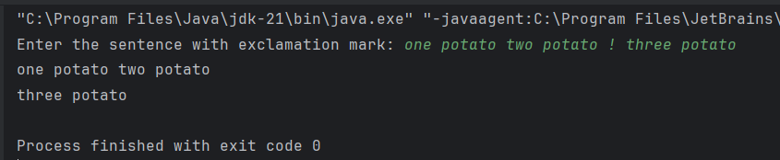

**Question: 09**

package Q_09;  
  
import java.util.Scanner;  
  
public class String_Input {  
 public static void main(String[] args) {  
 Scanner Input = new Scanner(System.*in*);  
 System.*out*.print("Enter the String : ");  
 String Sentence = Input.nextLine();  
  
 int Length = Sentence.length();  
 String first_Character = Sentence.substring(0,1);  
 String last_Character = Sentence.substring(Length-1);  
  
  
  
 System.*out*.println(Length);  
 System.*out*.println(first_Character);  
 System.*out*.println(last_Character);  
 }  
}

Output:

**Question: 10**

package Q_10;  
  
import java.util.Scanner;  
  
public class Odd_String {  
 public static void main(String[] args) {  
 Scanner Input = new Scanner(System.*in*);  
 System.*out*.print("Enter the string with number of odd characters : ");  
 String Sentence = Input.nextLine();  
  
 int Length = Sentence.length();  
  
 int Index_of_Middle = (Length/2)+1;  
 System.*out*.println(Sentence.substring(Length/2,Index_of_Middle));  
 }  
}

package Q_10;  
  
import java.util.Scanner;  
  
public class Odd_String {  
 public static void main(String[] args) {  
 Scanner Input = new Scanner(System.*in*);  
 System.*out*.print("Enter the string with number of odd characters:");  
 String Sentence = Input.nextLine();  
  
 int Length = Sentence.length();  
  
 int Index_of_Middle = (Length/2)+1;  
 System.*out*.println(Sentence.substring(Length/2,Index_of_Middle));  
 }  
}

Output:

**Question: 11**

package Q_11;  
  
import java.util.Scanner;  
  
public class Name {  
 public static void main(String[] args) {  
 Scanner Input = new Scanner(System.*in*);  
 System.*out*.print("Enter the First Name : ");  
 String First_Name = Input.next();  
  
 System.*out*.print("Enter the Middle Name : ");  
 String Middle_Name = Input.next();  
  
 System.*out*.print("Enter the Last Name : ");  
 String Last_Name = Input.next();  
  
 String Middle_Initial = Middle_Name.substring(0,1);  
  
 System.*out*.println(Last_Name + ", " + First_Name + " " + Middle_Initial + ".");  
  
 }  
}

Output:

**Question: 12**

package Q_12;  
  
import javax.swing.*;  
  
public class Frame {  
 public static void main(String[] args) {  
 JFrame My_Window = new JFrame();  
 My_Window.setSize(300,200);  
 My_Window.setTitle("My First Frame");  
 My_Window.setLocation(100,50);  
 My_Window.setVisible(true);  
 }  
}

Output:

**Question: 13**

package Q_13;  
  
  
import javax.swing.*;  
  
public class SampleWindow {  
 public static void main(String[] args) {  
 JFrame myWindow;  
 myWindow = new JFrame();  
 myWindow.setSize(500, 250);  
 myWindow.setTitle("UOK");  
 myWindow.setVisible(true);  
 try {Thread.*sleep*(500);} catch(Exception e) { }  
 myWindow.setVisible(false);  
 try {Thread.*sleep*(500);} catch(Exception e) { }  
 myWindow.setVisible(true);  
 }  
}

Output: