Implementation of Binary Tree
program

#include<stdio.h>
#include<stdbool.h>
void main()
{
int n,pos;
char choice;
printf("Enter the number of nodes:");
scanf("%d",&n);
int tree[n+1];
printf("Enter the elements in the binary tree:\n");
for (int i=1;i<=n;i++)
{
scanf("%d",&tree[i]);
}
while(true)
{
printf("Enter the position of the node:\n");
scanf("%d",&pos);

if (pos>=1 && pos<n+1)
{
if (pos==1)
printf("This node is the root of tree and has no parent.\n");
else
printf("Parent of the node : %d\n",tree[pos/2]);

if (pos*2>n)
printf("This node has no left child\n");
else
printf("Left child of the node : %d\n",tree[pos*2]);

if (pos*2+1>n)
printf("This node has no right child\n");
else
printf("Right child of the node : %d\n",tree[pos*2+1]);
}
else
printf("Invalid Entry\n");
printf("========================================\n");
printf("Do you want to continue?(y/n)\n");
scanf(" %c",&choice);
if (choice!='y')
break;
}
}

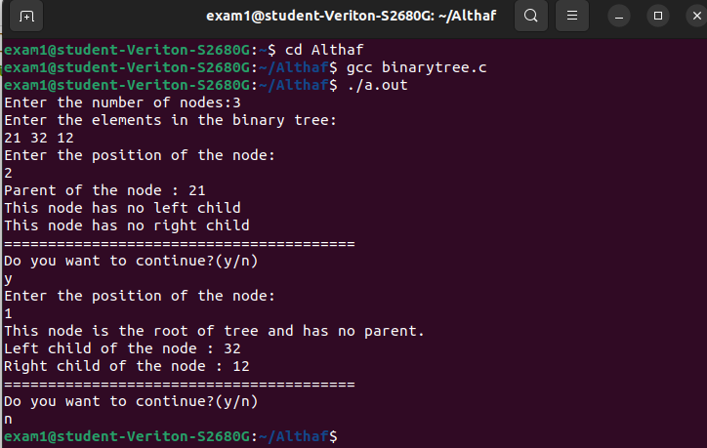
output

