Global Economic Trends Analysis using IMF World Economic Outlook (WEO) Dataset

Project Overview

This project analyzes the International Monetary Fund (IMF) World Economic Outlook (WEO) dataset using Python. The objective is to explore global economic trends, compare country-level economic performance, and visualize economic indicators using data analytics techniques.
The project demonstrates the complete data analysis workflow, including data cleaning, exploratory data analysis (EDA), statistical analysis, and data visualization.

Tools Used

Pandas

NumPy

Matplotlib

Seaborn

Plotly

Jupyter Notebook

Dataset
  - Source: IMF World Economic Outlook (WEO)
  - Description: The dataset used in this project is the International Monetary Fund (IMF) World Economic Outlook (WEO) Dataset, which contains economic indicators and forecasts for countries around the world:

- Country Information
- Economic Indicators
- Observation Measures
- Series Codes
- Year-wise Economic Values (1980–2030)
Dataset Characteristics:

- Source: IMF World Economic Outlook (WEO)
- Rows: 8,208
- Columns: 116
- Data Type: Structured tabular data
- Coverage: Multiple countries and economic indicators

Important Columns:

- COUNTRY – Country name
- INDICATOR – Economic indicator description
- SERIES_CODE – Unique code for each indicator
- SCALE – Scale used for values
- 2021–2030 – Year-wise economic values
- Average_Value – Derived column representing the average economic value across years

Steps Followed
- Imported the dataset using Pandas.
- Cleaned the data by:
  - Removing missing and duplicate values
  - Converting date and numeric columns to proper formats
- Performed exploratory data analysis (EDA) using Pandas.
- Created visualizations using Matplotlib and Seaborn,plotly such as:
- Line Charts
- Bar Charts
- Histograms
- Pie Charts
- Heatmaps
- Country Comparison Charts
- Global Economic Trend Analysis
- Interpreted the results to extract meaningful insights.

Key Insights

Economic performance differs significantly among countries.

Several countries show strong economic growth trends during 1980–2030.

Country-wise aggregation helps identify top-performing economies.

Time-series analysis reveals long-term economic patterns.

Data visualization simplifies the interpretation of complex economic indicators.

Visualizations

This bar chart compares the average economic indicator values across the top 10 countries

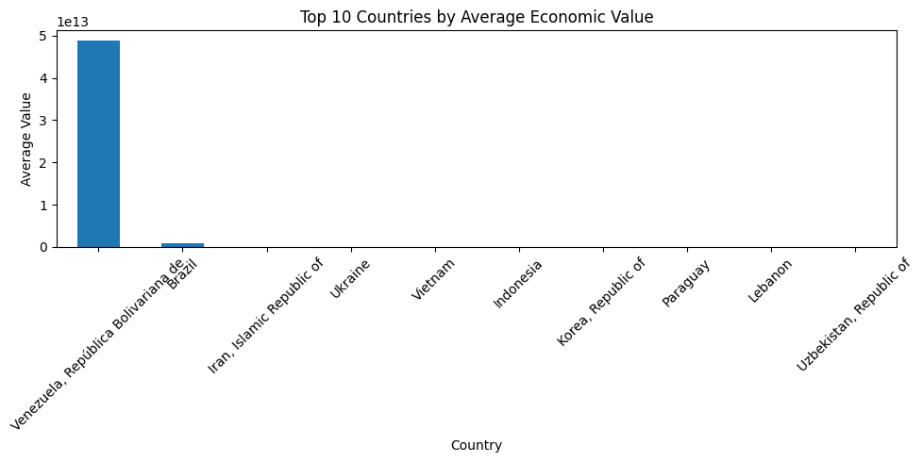

Pie Chart

The pie chart visualizes the distribution of records among the top 10 most frequently occurring countriesin the dataset. Each slice represents the proportion of observations contributed by a country relative to the total records of the top 10 countries.

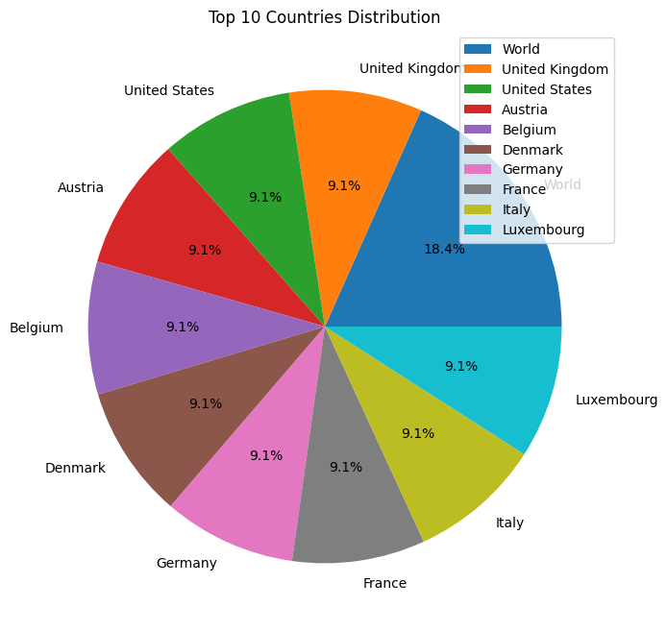

Scatter Plot – Relationship Between Two Years

A scatter plot was created to examine the relationship between economic values in 1980 and 2030.

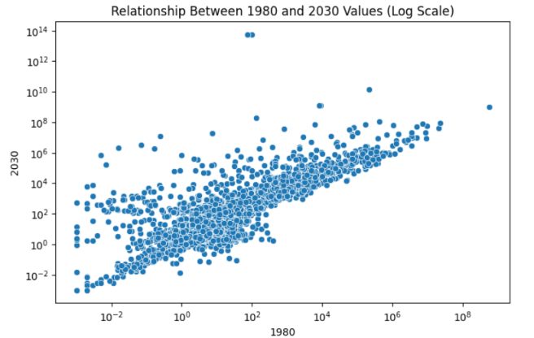

Line Chart

This line chart tracks the average economic values of the first five countries in the grouped dataset across multiple years. By plotting yearly averages, the visualization reveals how economic indicators evolve over time for each country

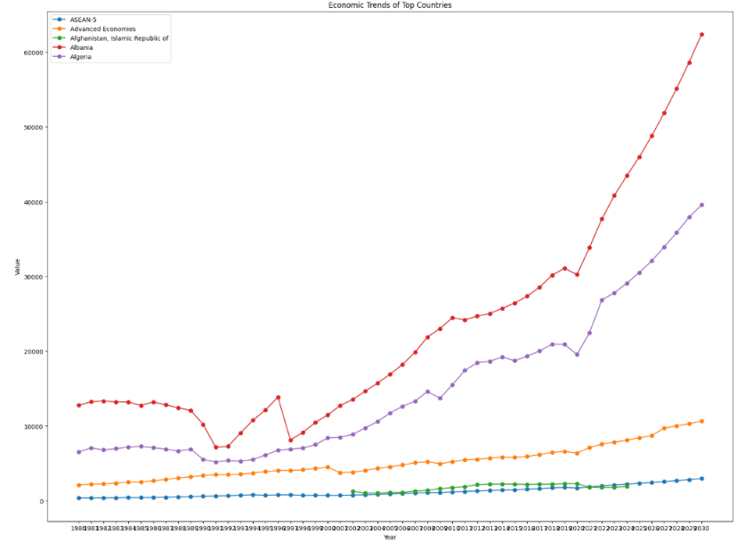

Radar Chart

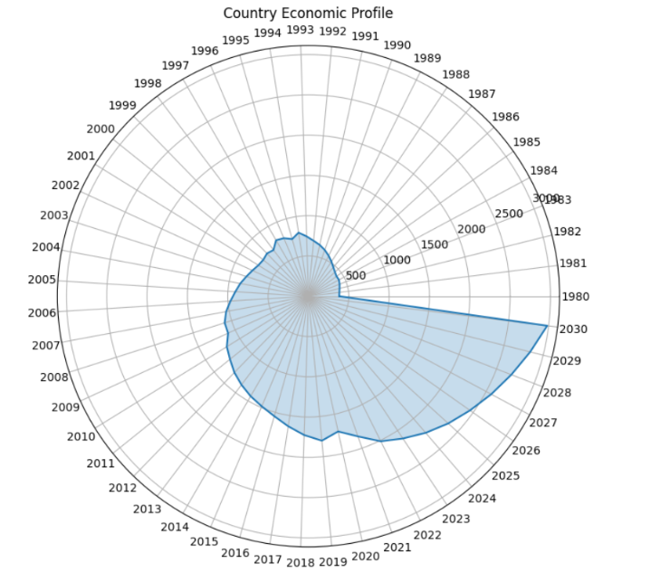

Animated Trend Visualization (Plotly)

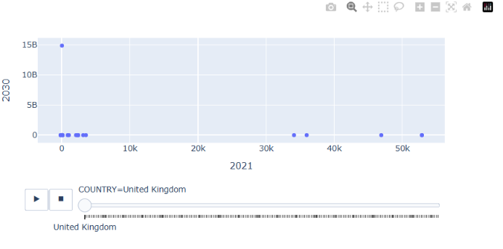

Files Included
  - WEO_Dataset.csv – Raw dataset
  - Global_Economic_Trends_Analysis.ipynb – Pandas analysis and visualizations
  - README.md – Project description and usage instructions

How to Use

Clone the Repository

Install Required Libraries : pip install pandas numpy matplotlib seaborn plotly.

Open jupyter Notebook
```bash
jupyter notebook

Ruun the notebook cells one by one

Conclusion
This project demonstrates how Python-based data analytics can be used to analyze large-scale economic datasets effectively. Through data preprocessing, visualization, and exploratory analysis, valuable insights were extracted from the IMF World Economic Outlook dataset, providing a strong foundation for future economic research and predictive modeling.

