# Hospital Information System

# Inpatient Department

In-patient services. Indoor Patients Department (IPD) refers to the areas of the hospital where patients are accommodated after being admitted, based on doctor's/specialist's assessment, from the Out-Patient Department, Emergency Services and Ambulatory Care.

In-patients require a higher level of care through nursing services, availability of drugs /

diagnostic facilities, observation by doctors, etc.

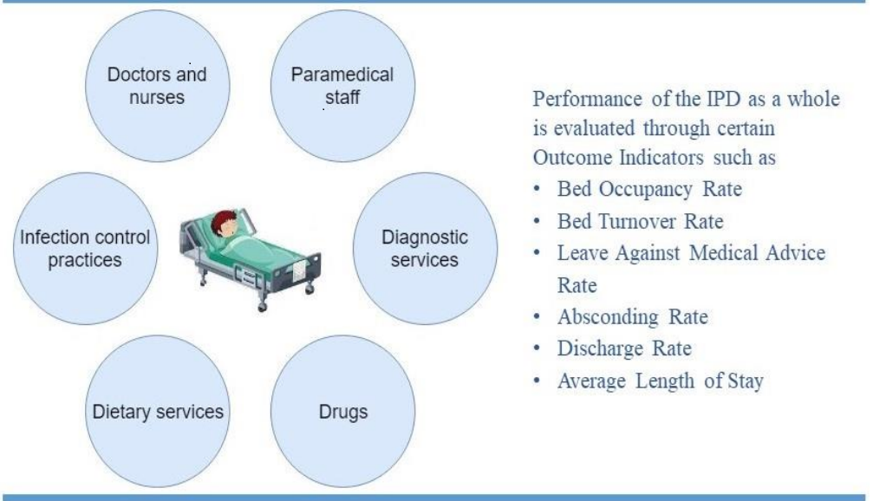

## Connecting to Data:

- Necessary software was installed to integrate the data into Power BI.

- Required tables were loaded into Power BI.

1. Admission Requests
2. Core Orders
3. Core Patients
4. Core TreatmentVisits
5. Core TreatmentVisitStatusHistory
6. Core PatientStay
7. Discharges
8. HR Departments
9. InPatient Beds
10. Rooms

Data Modelling

Data modelling was done and relationships between the tables are established.

|  |  |  |
| --- | --- | --- |
| **Table 1** | **Table 2** | **Cardinality** |
| AdmissionRequests (BedID) | InPatient_Beds (BedID) | Many to One |
| AdmissionRequests (DepartmentID) | HR_Departments (DepartmentID) | Many to One |
| Core Orders (TreatmentVisitID) | Core TreatmentVisits (TreatmentVisitID) | Many to One |
| Core Treatment VisitStatusHistory (TreatmentVisitID) | Core TreatmentVisits (TreatmentVisitID) | Many to One |
| Core_PatientStay (DepartmentID) | HR_Departments (DepartmentID) | Many to One |
| Core_PatientStay (RoomID) | Rooms (RoomID) | Many to One |
| InPatient_Beds (RoomID) | Rooms (RoomID) | Many to One |

Business Metrics

### **Total Admissions**

Admissions =

-- Number of admissions

CALCULATE(

COUNT('AdmissionRequests'[AdmissionRequestID]),

'AdmissionRequests'[Status] in {3,5},

AdmissionRequests[Month] = SELECTEDVALUE(Calendar[Month_name]))

### **Average Length of Stay**

Avg_length_of_stay =

var total_discharged = [Total_Discharged]

var length_of_stay= [Length_of_stay]

var avg_length_of_stay =

DIVIDE(length_of_stay,total_discharged,0)

return avg_length_of_stay

### **Total Departments**

Departmetns_count =

-- Number of InPatient Departments

CALCULATE(

COUNT('HR_Departments'[DepartmentTypeID]),

'HR_Departments'[DepartmentTypeID] = 6)

### **Discharges**

Discharged =

-- Number of Discharge

var discharge =

CALCULATE(

COUNT(Discharges[AdmissionRequestID]),

Discharges[Status] = 3,

Discharges[Month] = SELECTEDVALUE('Calendar'[Month_name]))

RETURN discharge

### **In Patient Count**

Inpatient =

-- Total number of inpatients

CALCULATE(

COUNT(AdmissionRequests[PatientID]),

AdmissionRequests[Status] = 3) -- 3 is admitted

### **Length of Stay**

Length_of_stay =

----- total length of stay

CALCULATE(

SUM(Core_PatientStay[Days_diff]),

Core_PatientStay[Status] in {2,3,4},

Core_PatientStay[IsDeleted] = FALSE())

### **Bed Occupancy rate**

Occupancy_rate_beds =

-- Beds occupancy rate

var beds_occupied = [Total_Beds_Occupied]

var total_beds = [Total_Beds]

var occupancy_rate =

DIVIDE(

beds_occupied,

total_beds,

0)

RETURN occupancy_rate

### **Total Rooms**

Rooms_count =

-- Number of Rooms

CALCULATE(

COUNT('Rooms'[DepartmentID]),

'Rooms'[IsDeleted] = FALSE())

### **Total Beds**

Total_Beds =

-- Total number of beds

CALCULATE(

COUNT('InPatient_Beds'[BedID]),

'InPatient_Beds'[IsDeleted] = FALSE(),

'HR_Departments'[DepartmentTypeID] = 6)

### **Total unoccupied beds**

Total_Beds_Available =

-- Number of available

[Total_Beds] - [Total_Beds_Occupied]

### **Beds Occupied**

Total_Beds_Occupied =

-- Total number of occupied

var start_date = min('Calendar'[Date])

var end_date = max('Calendar'[Date])

var result = CALCULATE(

COUNT('Core_PatientStay'[BedID]),

'Core_PatientStay'[IsDeleted] = FALSE(),

not(ISBLANK('Core_PatientStay'[BedID])),

'Core_PatientStay'[Status] = 2,

Core_PatientStay[StartTime] >= start_date && Core_PatientStay[EndTime] <= end_date

)

return result

### **Discharges**

Total_Discharged =

-- Number of Discharge

var discharge =

CALCULATE(

COUNT(Discharges[AdmissionRequestID]),

Discharges[Status] in {3,4},

Discharges[Month] = SELECTEDVALUE('Calendar'[Month_name])

)

RETURN discharge

## Canvas Designing:

- Necessary shapes were created for visual appeal.

## KPIs:

### **1. Departments Count KPI:**

- Count of departments visualized with Visual Font: Segoe UI, Font Size: 24, Colour: RGB #0E1A77.

- KPI Title Font: Segoe UI, Size: 12, Colour: RGB #333333.

### **2. Rooms KPI:**

- Count of available rooms visualized with Visual Font: Segoe UI, Font Size: 24, Colour: RGB #0E1A77.

- KPI Title Font: Segoe UI, Size: 12, Colour: RGB #333333.

### **3. Bed Management Card Visual:**

- Visual created by grouping Beds, Occupied Beds, Available Beds, and Occupancy Rate with department-wise occupancy rate of a column chart.

- Card Font: Arial, Size: 10, Colour: RGB #CCCCCC.

### **4. Bed KPI:**

- Total bed count visualized with Card Font: Segoe UI, Size: 18, Colour: RGB #0E1A77.

- Title Font: Segoe UI, Size: 10, Colour: RGB #333333.

### **5. Occupied Beds KPI:**

- Count of occupied beds visualized with Card Font: Segoe UI, Size: 18, Colour: RGB #0E1A77.

- Title Font: Segoe UI, Size: 10, Colour: RGB #333333.

**6. Available Beds KPI:**

- Count of available beds visualized with Card Font: Segoe UI, Size: 18, Colour: RGB #0E1A77.

- Title Font: Segoe UI, Size: 10, Colour: RGB #333333.

### **7. Occupancy Rate KPI:**

- Occupancy rate visualized with Card Font: Segoe UI, Size: 18, Colour: RGB #0E1A77.

- Title Font: Segoe UI, Size: 10, Colour: RGB #333333.

## Visualizations:

### **Month-wise Admission and Discharge Data:**

- Month name plotted against admissions and discharges Column Chart.

- X-axis Font Size: Segoe UI, Size: 9.

- Visual Title Font: Segoe UI, Size: 10, Colour: #333333.

- Admitted Bar Colour: #A0A7D8, Discharged Bar Colour: #A0D1FF.

- Data labels turned on with horizontal orientation.

### **2. Department-wise Occupancy Rate:**

- Occupancy bed rate plotted against departments on a column chart.

- Visual Font: Segoe UI, Size: 10, Colour: #333333.

- X-axis Font Size: Segoe UI, Size: 9.

- Bar Colour: #414FB1.

- Data labels turned on with horizontal orientation.

### **3. Departments vs Length of Stay:**

- Departments plotted against the length of stay on bar chart.

- Visual Title Font: Din, Size: 14, Colour: #333333.

- Y-axis Font: Segoe UI, Size: 9.

- Bar Colour: #414FB1.

### **4. Average Length of Stay:**

- Departments plotted against the average length of stay on a bar chart.

- Visual Title Font: Din, Size: 14, Colour: #333333.

- Y-axis Font: Segoe UI, Size: 9.

- Bar Colour: #414FB1.

### **5. Admitted Inpatients:**

- Departments plotted against inpatients on a bar chart.

- Visual Title Font: Din, Size: 14, Colour: #333333.

- Y-axis Font: Segoe UI, Size: 9.

- Bar Colour: #414FB1.