Write Terraform script to create highly available infrastructure in AWS. The infra should have1 vpc, 3 subnets setup in 3 different az and 2 instances setup in 2 different subnets

Solution:

Created an AMI

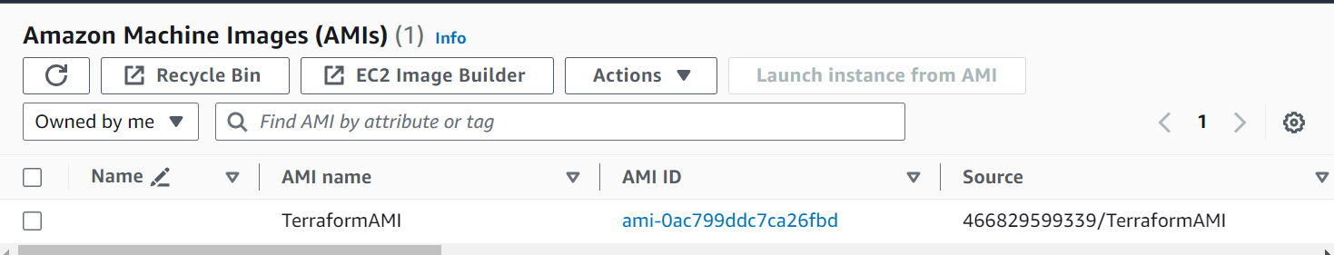

Created an Key Pair

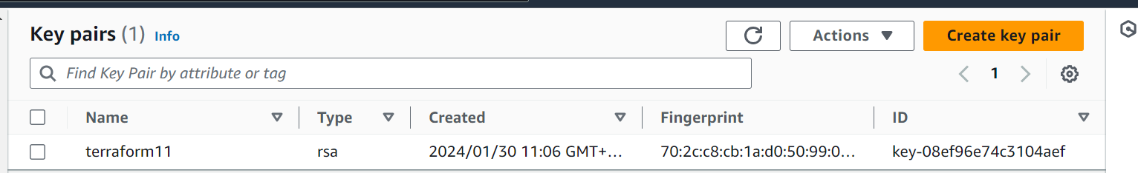

Written an Terraform State file to create an Infra

**provider "aws" {**

**region = "ap-south-1"**

**}**

**resource "aws_vpc" "main" {**

**cidr_block = "10.0.0.0/16"**

**enable_dns_support = true**

**enable_dns_hostnames = true**

**tags = {**

**Name = "MyVPC"**

**}**

**}**

**resource "aws_subnet" "subnet_a" {**

**vpc_id = aws_vpc.main.id**

**cidr_block = "10.0.1.0/24"**

**availability_zone = "ap-south-1a"**

**map_public_ip_on_launch = true**

**tags = {**

**Name = "SubnetA"**

**}**

**}**

**resource "aws_subnet" "subnet_b" {**

**vpc_id = aws_vpc.main.id**

**cidr_block = "10.0.2.0/24"**

**availability_zone = "ap-south-1b"**

**map_public_ip_on_launch = true**

**tags = {**

**Name = "SubnetB"**

**}**

**}**

**resource "aws_subnet" "subnet_c" {**

**vpc_id = aws_vpc.main.id**

**cidr_block = "10.0.3.0/24"**

**availability_zone = "ap-south-1c"**

**map_public_ip_on_launch = true**

**tags = {**

**Name = "SubnetC"**

**}**

**}**

**resource "aws_instance" "instance_a" {**

**ami = "ami-0ac799ddc7ca26fbd"**

**instance_type = "t2.micro"**

**subnet_id = aws_subnet.subnet_a.id**

**key_name = "terraform11"**

**tags = {**

**Name = "InstanceA"**

**}**

**}**

**resource "aws_instance" "instance_b" {**

**ami = "ami-0ac799ddc7ca26fbd"**

**instance_type = "t2.micro"**

**subnet_id = aws_subnet.subnet_b.id**

**key_name = "terraform11"**

**tags = {**

**Name = "InstanceB"**

**}**

**}**

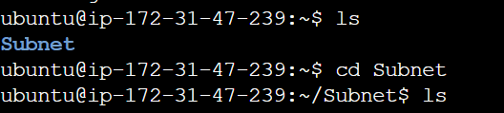

**Terraform Init**

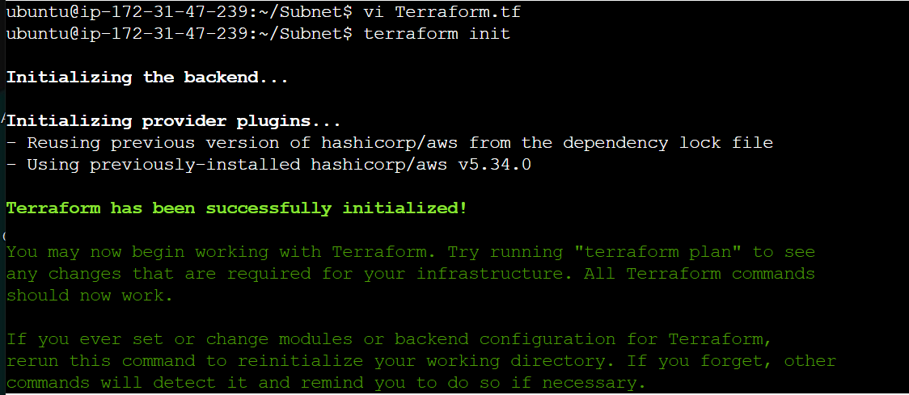

**Terraform Plan**

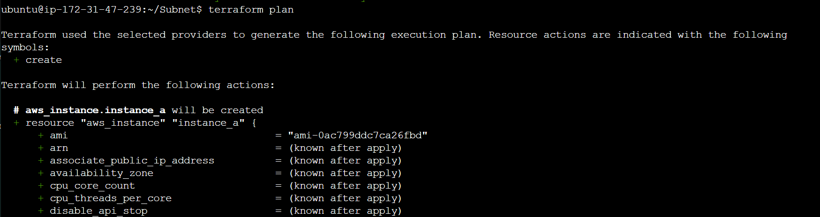

**Terraform Apply**

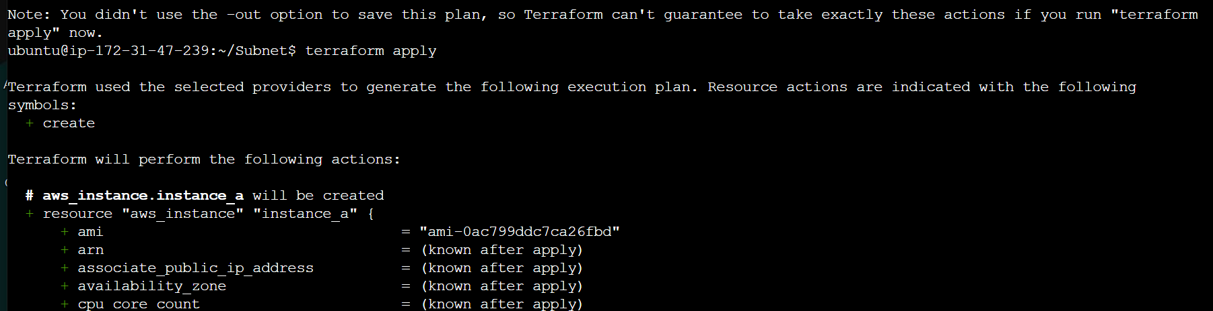

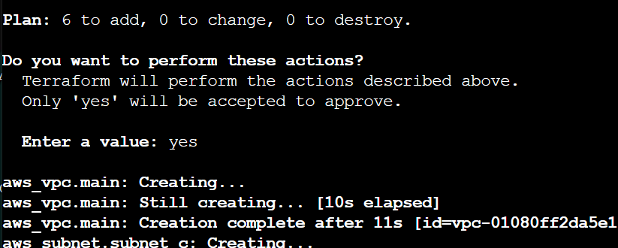

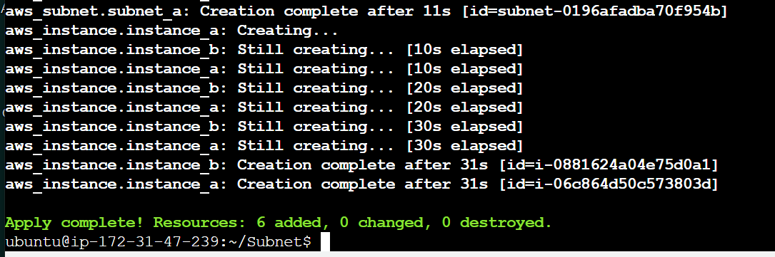

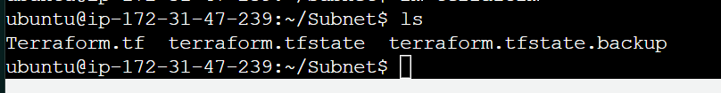

**VPC**

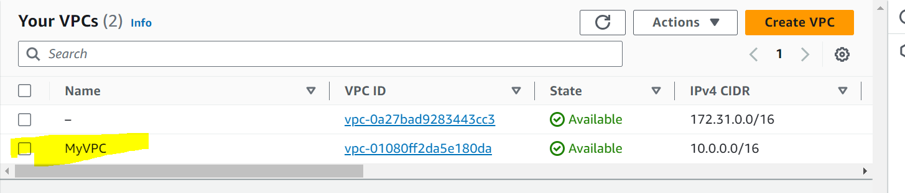

**Subnets**

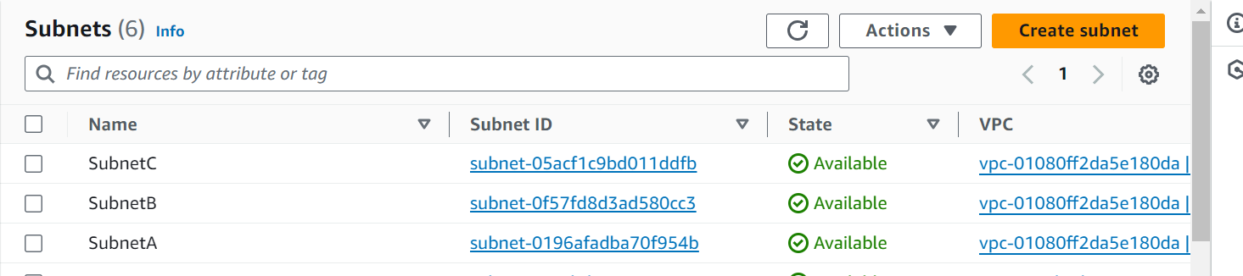

**Routetable**

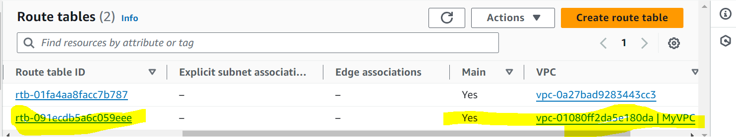

**IGW**

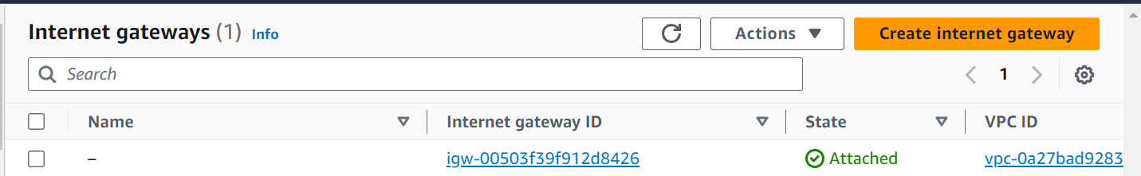

**Instances:**

