RECOGNITION OF ALPHANUMERIC IN VEHICLE REGISTRATION USING OCR

*Report submitted to the SASTRA Deemed to be University as the requirement for the course*

ECE300: MINI PROJECT

*Submitted by*

S.JONES PETERSON (Reg. No.: 125004110) J.MOHAMED AL THAMEES (Reg. No.: 125004158) `S.SHRIRAM (Reg. No.: 125004274)

April 2024



SCHOOL OF ELECTRICAL & ELECTRONICS ENGINEERING THANJAVUR, TAMIL NADU, INDIA – 613 401



SCHOOL OF ELECTRICAL & ELECTRONICS ENGINEERING THANJAVUR – 613 401

Bonafide Certificate

This is to certify that the report titled “Recognition of Alphanumeric in Vehicle Registration Plate using OCR” submitted as a requirement for the course, ECE300: MINI PROJECT for B.Tech. ELECTRONICS & COMMUNICATION ENGINEERING programme,

is a bonafide record of the work done by Mr.Jones Peterson(Reg. No.125004110),J.Mohamed Al Thamees(Reg no:125004158),S.Shriram(Reg no:125004274) during the academic year 2022- 23, in the School of ELECTRICAL & ELECTRONICS ENGINEERING, under my supervision.

Signature of Project Supervisor : Name with Affiliation :

Date :

Project *Vivavoc*e held on

Examiner 1 Examiner 2



SCHOOL OF ELECTRICAL & ELECTRONICS ENGINEERING THANJAVUR – 613 401

Declaration

We declare that the report titled “Recognition of Alphanumeric in Vehicle Registration Plate using OCR” submitted by me/us is an original work done by us under the guidance of Dr.Arun.K , Designation, School of Electrical and Electronics Engineering, SASTRA Deemed to be University during the sixth semester of the academic year 2022-23, in the School of Electrical and Electronics Engineering. The work is original and wherever we have used materials from other sources, we have given due credit and cited them in the text of the report. This report has not formed the basis for the award of any degree, diploma, associate-ship, fellowship or other similar title to any candidate of any University.

Signature of the candidate(s) :

Name of the candidate(s) :

Date :

**Acknowledgements**

I would like to thank our Honorable Chancellor **Prof. R. Sethuraman** for providing us with an opportunity and the necessary infrastructure for carrying out this project as a part of our curriculum.

I would like to thank our Honorable Vice-Chancellor **Dr. S. Vaidhyasubramaniam** and **Dr. S. Swaminathan**, Dean, Planning & Development, for the encouragement and strategic support at every step of our college life.

I extend our sincere thanks to **Dr. R. Chandramouli,** Registrar, SASTRA Deemed to be University for providing the opportunity to pursue this project.

I extend our heartfelt thanks to **Dr. K. Thenmozhi**, Dean, School of Electrical and Electronics Engineering, **Dr. K. Sridhar,** Dean – Research, School of Electrical and Electronics Engineering and all Associate Deans of School of Electrical and Electronics Engineering for their motivation and support offered in materializing this project.

I would like to extend my gratitude to **Dr. R. Ramesh**, Project coordinator, School of Electrical and Electronics Engineering, SASTRA Deemed to be University for providing immense support to complete this work.

My guide **Mr. K.Arun**, Asst. Professor - II, School of Electrical and Electronics Engineering was the driving force behind this whole idea from the start. His deep insight into the field and invaluable suggestions helped us in making progress throughout our project work.

I also thank the project review panel members for their valuable comments and insights which made this project better.

I gratefully acknowledge all the contributions and encouragement from my family and friends resulting in the successful completion of this project. I thank you all for providing me an opportunity to showcase my skills through projects.

# Abstract

More and more cars entered the schoolyard, causing accidents. The current manual process cannot ensure that only authorized vehicles enter the site. Therefore, this proposal aims to solve this problem by creating ANPR. Automatic License Recognition (ANPR) is changing the way we interact with cars, turning a simple license into a digital key and opening up a world of possibilities. This technology, based on computer vision and image processing, allows the system to "read" the driver's license, extracting important information accurately and quickly. The ANPR system expands in several stages. First, cameras capture images of passing vehicles. Complex algorithms then come into play and examine each post to find a license. Once located, important data is separated from the crash environment and the license area is extracted. Finally, the magic of character recognition comes to the fore; The numbers written in the list are carefully decrypted and converted into machine-readable text. The police use their authority to instantly track stolen vehicles, prevent crime and conduct rapid investigations. As technology continues to evolve, its accuracy and robustness will begin to deteriorate, leading to new uses.

# Specific Contribution S.Jones Peterson :

1)Analysing and identifying the fundamental keywords and techniques. Building the workdown structure in coding aspects.

# J.mohamed al thamees

1)Ideating the flowchart and the algorithm. 2)Executing logical ideas.

# S.shriram

1. Testing the real time application.
2. Error handling

# Specific Learning:

1. Jones Peterson: Median knowledge in matlab coding.
2. Mohamed Al Thamees: Transition from code to real time challenges
3. Shriram: Understanding the logical aspects behind ANPR.

Signature of the Guide Student Reg. No :

Name : Name :

Table of Contents

Title Page No.

Bona-fide Certificate ii

Declaration iii

Certificate (if any) for external projects iv

Acknowledgements v

Abstract vi

List of Figures vii

List of Tables viii

Abbreviations ix

Notations x

1. Introduction 1
2. Objective 3
3. Methodology 4
4. Working principle 5
5. Results 8
6. Challenges 11
7. Conclusions 12
8. References 14

List of Figures

|  |  |  |
| --- | --- | --- |
| Figure No. | Title | Page No. |
| 1. | INTRODUCTION | 14 |
| 2. | OBJECTIVE | 17 |
| 3. | METHODOLOGY | 18 |
| 4. | WORKING PRINCIPLE | 19 |
| 5. | CODE | 23 |
| 6. | RESULTS | 32 |
| 7. | CHALLENGES | 35 |
| 8. | CONCLUSION | 36 |
| 9. | REFERENCES | 38 |
| 10. | ABBREVIATIONS | 39 |
| 11. | NOTATIONS | 40 |

**ABBREVIATIONS:**

1. **OCR:** optical character recognition
2. **ANPR:** automatic number plate recognition
3. **ROI**: region of interest
4. **CCTV**: closed circuit television
5. **ALPR:** automatic license plate recognition
6. **DMS**: document management systems
7. **NVR:** network video recorder
8. **AI:** artificial intelligence
9. **.BMP:** bit map image
10. **Numel:** number of elements
11. **imshow**: image show

12. **imread**() – This command is used to open the photo into MATLAB from the goal folder.  
13. **rgb2gray**() –This command is used to convert the RGB image into grayscale layout.  
14. **imbinarize**() – This command is used to Binarize 2-D grayscale pictures or actually we will say it converts the photo into the black and white format.  
15. **side**() – This command is used to stumble on the edges in the picture, by means of the usage of various methods like Roberts, Sobel, Prewitt and lots of others.

16. **regionprops**() – This command is used to degree houses of the image location.  
17. **numel**() – This command is used to calculate the quantity of array factors.  
18. **imcrop**() – This command is used to crop the photo in the entered size.  
19. **bwareaopen**() – This command is used to remove small items from binary picture.

Using the above command in the code, we call the input image and convert it to grayscale. The grayscale is then converted to a binary image and the edges of the binary image are checked by the Prewitt method.

**NOTATIONS**:

“;” = Semicolon

“ ,” = comma

“ ||” = short circuiting operator

‘ ‘ = apostrophe

“:” = colon

“[]” = square bracket

“&” = and

“%” = array dimension whose length is greater than 1

“ ()” = paranthesis

**INTRODUCTION**

Automatic license plate recognition (ANPR) is a major surveillance method which uses optical imaging of the image to read the vehicle's license plate. They are used by different authorities and monitor movement. ANPR can be implemented to capture images of license plates and some setups are used to capture images of drivers. Most systems use infrared illumination to allow the camera to capture photos at any time of day. At least one of the intersection surveillance cameras is equipped with a powerful light to both enlighten and warn criminals of their mistakes. ANPR technology is often location specific as permits vary from location to location. The purpose of this article is to find the standard Nigerian license plate, part number and recognize them from car photos. ANPR was developed by the United Kingdom Police Research Service in 1976. In 1979, prototypes were built and contracts were awarded for the production of commercial systems, first at EMI Electronics and then at Computer Recognition Systems (CRS) in Wokingham, United Kingdom. The first test systems were used on the A1 motorway and in the Dufford Tunnel. However, ANPR did not become widely used until the 1990s with new developments in cheaper and easier to use software. In the early 2000s, the collection of ANPR data was recorded for future use to solve unexplained crime problems. The first recordings of ANPR being used to help solve a murder occurred in Bradford, England, in November 2005; where ANPR played a key role in the investigation and subsequent conviction of Sharon Beshenivsky's murderer.

The purpose of this trainingis to find the standard Nigerian license plate, segment the symbols and recognize them based on the vehicle image. The system uses optical marks on the image to analyse the license plate and must control different angles, distances, times, resolutions and lighting. It can use existing CCTVs, security cameras or special cameras designed for the job. In some countries, license plate recognition systems installed at national borders can detect and monitor border crossings. All cars can be registered in the central database and compared with the blacklist of stolen cars. In traffic management, vehicles can be directed to different lanes to better control urban traffic during peak hours. To be something very important in life. However, this is a difficult problem because of the variety of paper plates, different scales, rotations and uneven lighting conditions when capturing the image. This article mainly introduces the automatic license plate recognition system (ANPR), which uses morphological functions, histogram functions and edge detection tools for license plate and sign segmentation.

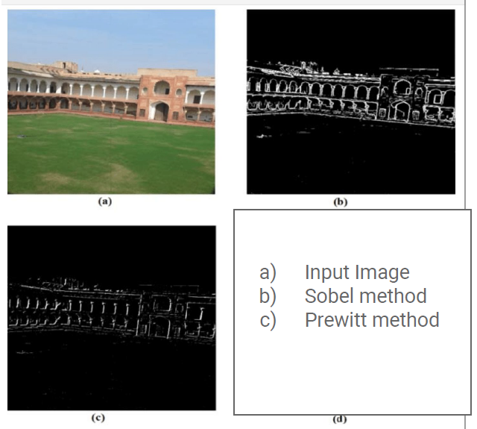

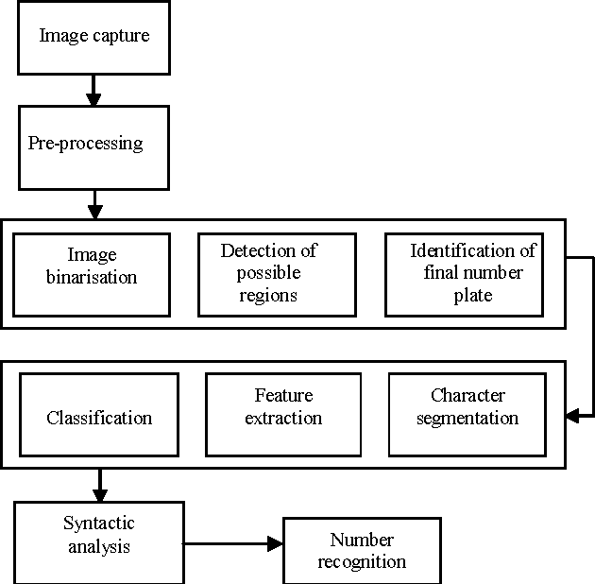

Fig.1 block diagram

Driving license recognition is accomplished by capturing the front or rear image of the car using a ca mera and then processing the image to verify the driver's license. It has three main stages. The first of these is the license certificate, and in this section, the visual quality of the site is increased by process ing the visual of the site. This is based on partitioning of characters, where characters are divided into sections according to the license agreement in order to store important information for the system for further processing. The third is OCR optical character recognition.

# Objective

1)The automatic license plate recognition system ANPR is an significant step in transportation. 2)Nowadays, cars are used more and more, so traffic control is very important.

1. Traffic information is difficult to store and preserve
2. Automatic license plate recognition systems enable better vehicle management and automatically capture and store vehicle information.
3. We use the ANPR (Automatic License Plate Recognition) system concept to capture license plate images.
4. The image is then processed by various algorithms and the alphanumeric characters of the image are converted into text. The ANPR system automatically translates the permit, eliminating the need for manual entry.

# Methodology

ANPR for vehicle recognition is divided into two parts: hardware and software. The hardware configuration is a combination of modules and a single computer (SBC). Hardware and software are integrated. The project followed two different paths. The first way is to connect the software directly to the camera to make sure the simulation works. Once completed, the second method is to integrate the SBC with the structure and software. Software configuration is a way to capture license image and process them through mathematical models using MATLAB tools. The process used in the software has two levels; plate extraction and segmentation and identification. Before starting the cognitive process, it is necessary to first define the area of interest. There may be cases where two or more contours are around each other, as in the number "zero". If internal contours are detected during contour processing, these may be confused with separate symbols, resulting in two different symbols being recognized during the recognition process. To avoid this, we update the image as needed as we progress. Keystone correction for licensing: Keystone is the rotation required to bring the image

back into relationship with its horizontal & vertical axis. Degrees are implemented to measure differences. Deskew is a way of removing curvature by rotating an image in different directions by the same a mount of its curvature. This allows text to flow across the page rather than in a single view, creating oblique and vertically aligned images. We use contrast and rotation to complete these steps in our project.

# Working principle:

* + The plan is to capture the vehicle's license plate number to the organization and keep the entry and exit time in the data without the need for human intervention. a) Image acquisition b) Image previe w c) Licensed input d) Segmentation e) Markup f) Time input and output data.Image Acquisition

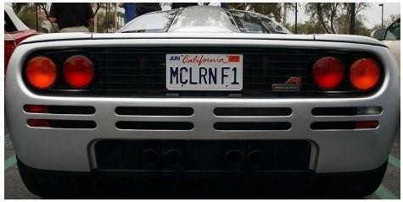

Fig 4.1: Acquired Image

Figure 4.1 shows the resulting driver's license image. Cameras are used to capture images of the vehicles at the entrance. The webcam connects to the system processor. When the ultrasonic sensor detects a vehicle, it sends a trigger pulse to the camera, which captures the image and sends it to the processor.

Image Pre-Processing

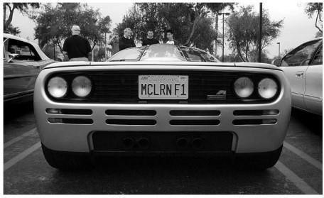

Fig 4.2: Processed grey scale image

Fig 4.2 shows the processed gray scale image of captured image. Image preprocessing is followed

to eradicate the added noise and distortion present in the captured image. Here we use Gaussian filter and adaptive thresholding to preprocess the image.

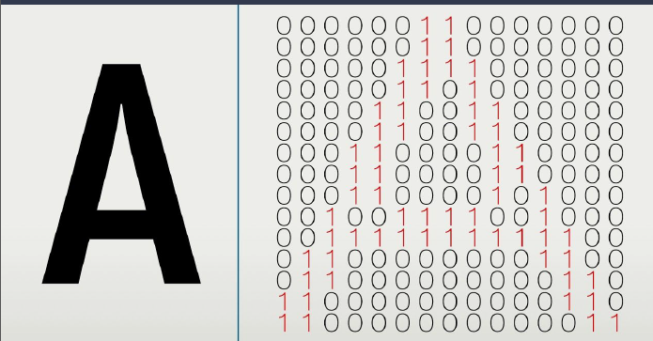

**Fig**:grayscale to bitwise

* + - Localization of Number Plate

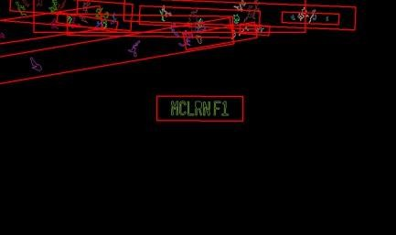

Fig 4.3: Localization of number plate

Figure 4.3 shows the plate. Use the edge operator for the foreground image to remove the plate area from the background. Usually the plate is rectangular and the area of interest is obtained by comparing the difference between the edges. The next step is the contour detection method, which removes any closed or bordered images.

* Character Segmentation



Fig 4.4: Character Segmentation

Fig 4.4 shows the character segmentation of captured image. In optical character recognition

(OCR) system, Python-

tesseract is an important tool used in python. He will read and recognize the information in the pict ure. If used as a letter, it will print the confirmation letter instead of writing it to the file. When the license is approved, the domain is created as a new image. OCR is applied to the new image and extracts all characters. Characters in the license can be numbers and letters.

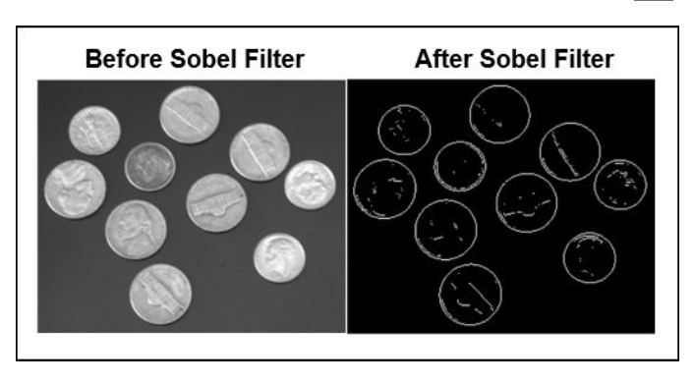

**CODE:**

%CREATE TEMPLATES

%Alphabets

A=imread('alpha/A.bmp');

B=imread('alpha/B.bmp');

C=imread('alpha/C.bmp');

D=imread('alpha/D.bmp');

E=imread('alpha/E.bmp');

F=imread('alpha/F.bmp');

G=imread('alpha/G.bmp');

H=imread('alpha/H.bmp');

I=imread('alpha/I.bmp');

J=imread('alpha/J.bmp');

K=imread('alpha/K.bmp');

L=imread('alpha/L.bmp');

M=imread('alpha/M.bmp');

N=imread('alpha/N.bmp');

O=imread('alpha/O.bmp');

P=imread('alpha/P.bmp');

Q=imread('alpha/Q.bmp'); 1.This section reads images of individual alphabet

characters (A-Z) from bitmap files located in the

'alpha' directory and assigns them to variables A-Z

R=imread('alpha/R.bmp');

S=imread('alpha/S.bmp');

T=imread('alpha/T.bmp');

U=imread('alpha/U.bmp');

V=imread('alpha/V.bmp');

W=imread('alpha/W.bmp');

X=imread('alpha/X.bmp');

Y=imread('alpha/Y.bmp');

Z=imread('alpha/Z.bmp');

%Natural Numbers

one=imread('alpha/1.bmp'); 2. Similar to the previous section, this part reads images

of numeric digits (0-9) from bitmap files in the 'alpha'

directory and assigns them to variables one through

zero

two=imread('alpha/2.bmp');

three=imread('alpha/3.bmp');

four=imread('alpha/4.bmp');

five=imread('alpha/5.bmp');

six=imread('alpha/6.bmp');

seven=imread('alpha/7.bmp');

eight=imread('alpha/8.bmp');

nine=imread('alpha/9.bmp');

zero=imread('alpha/0.bmp');

3. Here, two arrays 'letter' and 'number' are created by

concatenating the variables holding the alphabet and

numeric images, respectively.

letter=[A B C D E F G H I J K L M N O P Q R S T U V W X Y Z];

%Creating Array for Numbers

number=[one two three four five six seven eight nine zero];

NewTemplates=[letter number]; 4. Combines the 'letter' and 'number' arrays into a single

array called 'NewTemplates

save ('NewTemplates','NewTemplates') 5. Saves the 'NewTemplates' array into a file named

'NewTemplates.mat’.

clear all

%Letter Detection

function letter=readLetter(snap)

load NewTemplates

snap=imresize(snap,[42 24]);

rec=[ ];

for n=1:length(NewTemplates)

cor=corr2(NewTemplates{1,n},snap);

rec=[rec cor];

end

ind=find(rec==max(rec));

display(ind);

% Alphabets listings.

if ind==1 || ind==2

letter='A';

elseif ind==3 || ind==4

letter='B';

elseif ind==5

letter='C';

elseif ind==6 || ind==7

letter='D';

elseif ind==8

letter='E';

elseif ind==9

letter='F';

elseif ind==10

letter='G';

&%iuyui

elseif ind==11

letter='H';

elseif ind==12

letter='I';

elseif ind==13

letter='J';

elseif ind==14

letter='K';

elseif ind==15

letter='L';

elseif ind==16

letter='M';

elseif ind==17

letter='N';

elseif ind==18 || ind==19

letter='O';

elseif ind==20 || ind==21

letter='P';

elseif ind==22 || ind==23

letter='Q';

elseif ind==24 || ind==25

letter='R';

elseif ind==26

letter='S';

elseif ind==27

letter='T';

elseif ind==28

letter='U';

elseif ind==29

letter='V';

elseif ind==30

letter='W';

elseif ind==31

letter='X';

elseif ind==32

letter='Y';

elseif ind==33

letter='Z';

%*-*-*-*-*

% Numerals listings.

elseif ind==34

letter='1';

elseif ind==35

letter='2';

elseif ind==36

letter='3';

elseif ind==37 || ind==38

letter='4';

elseif ind==39

letter='5';

elseif ind==40 || ind==41 || ind==42

letter='6';

elseif ind==43

letter='7';

elseif ind==44 || ind==45

letter='8';

elseif ind==46 || ind==47 || ind==48

letter='9';

else

letter='0';

end

end

%Plate Detection

close all;

clear all;

im = imread('Number Plate Images/image1.png'); 1. **%** Reading the Input Image

imgray = rgb2gray(im); 2.% Converting to Binary Grey Image for OSR

imbin = imbinarize(imgray);

im = edge(imgray, 'prewitt'); 3. **%Prewitt- Pixel Density**

%Below steps are to find location of number plate

Iprops=regionprops(im,'BoundingBox','Area', 'Image'); 4.% Applying Sobel’s Algorithm

{Bounding Box Method} for Edge Calculation

area = Iprops.Area;

count = numel(Iprops);

maxa= area;

boundingBox = Iprops.BoundingBox; 5.%Measures The Area for both Contiguous

and Non-Contiguous Regions

for i=1:count

if maxa<Iprops(i).Area

maxa=Iprops(i).Area;

boundingBox=Iprops(i).BoundingBox; 6. %Returns the Number of Elements in

Array

end

end

im = imcrop(imbin, boundingBox);%crop the number plate area

im = bwareaopen(~im, 500); %remove some object if it width is too long or too small than 500

[h, w] = size(im);%get width

imshow(im);

Iprops=regionprops(im,'BoundingBox','Area', 'Image'); %read letter

count = numel(Iprops);

noPlate=[]; % Initializing the variable of number plate string.

for i=1:count

ow = length(Iprops(i).Image(1,:));

oh = length(Iprops(i).Image(:,1));

if ow<(h/2) & oh>(h/3)

letter=Letter_detection(Iprops(i).Image); % Reading the letter corresponding the binary image 'N'.

noPlate=[noPlate letter] % Appending every subsequent character in noPlate variable.

end

end

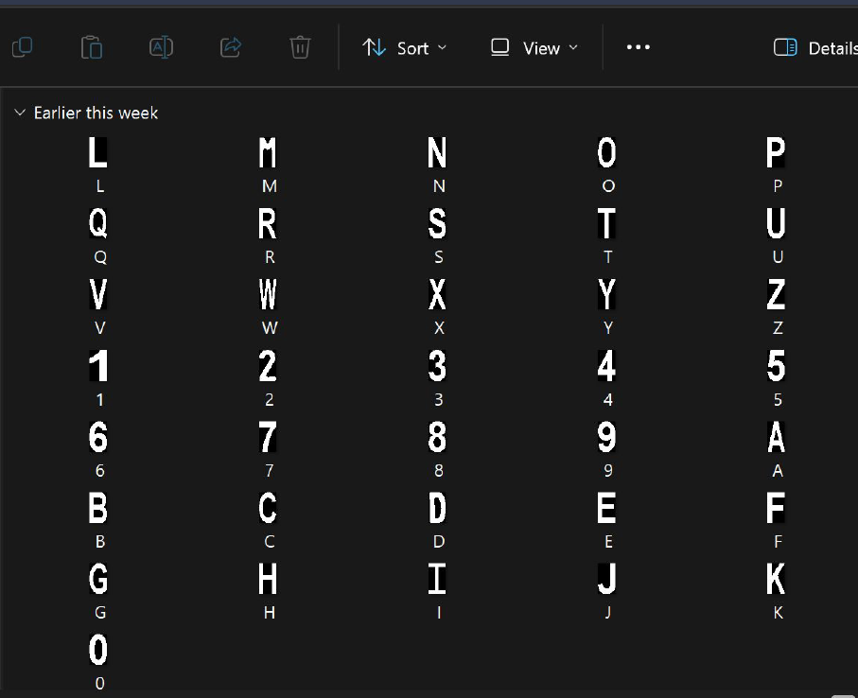

# RESULTS

1. After putting the code, it asks for the input image which is provided below:

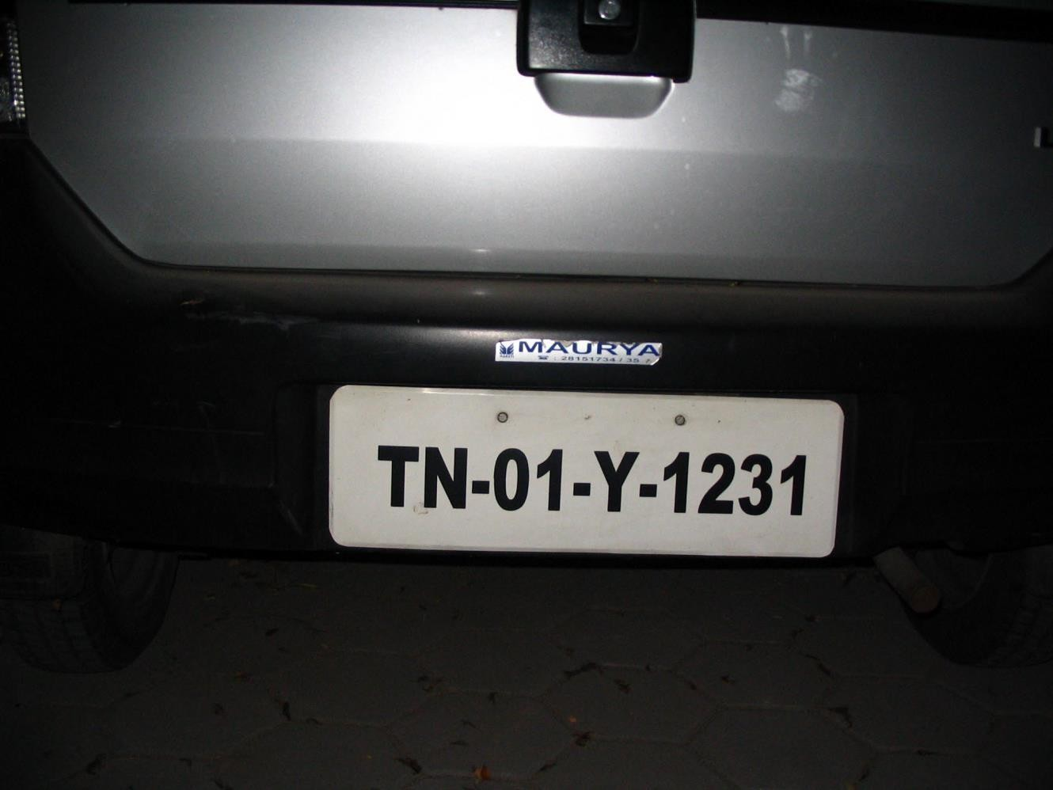

# Fig 5.1:Input Image

Number Plate

1. The next step would be the detection area after the input image is done;

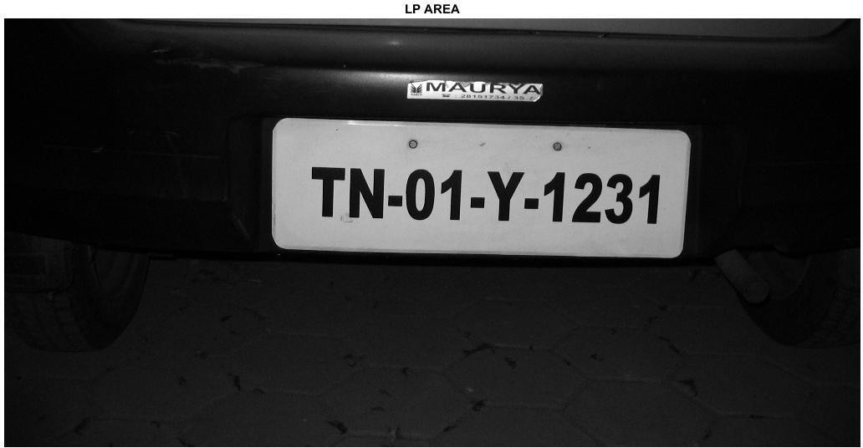

**5.1.** Selected text Area

1. The next step would be selecting the area where the text is done;

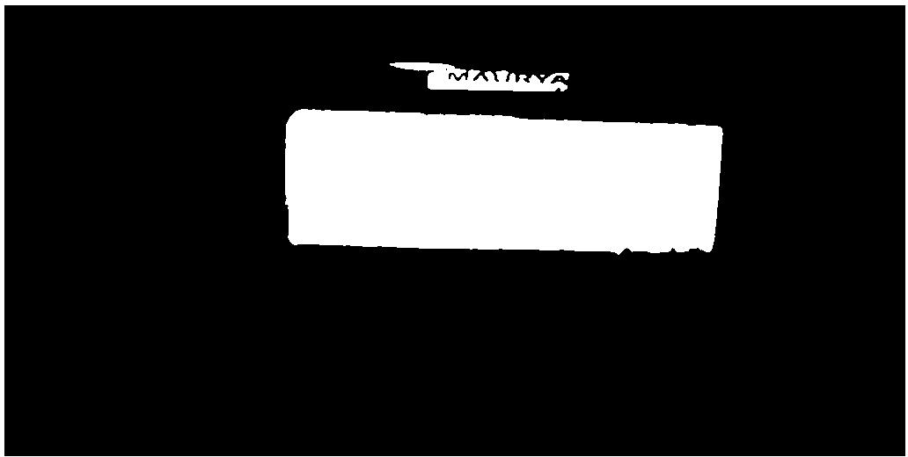

1. The number plate area is now selected;

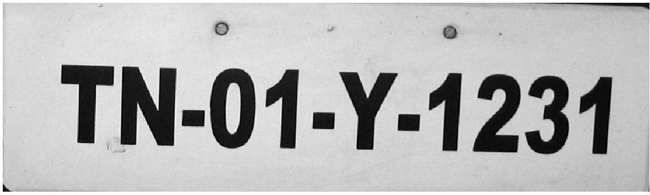

Output Image

1. The result is now displayed;

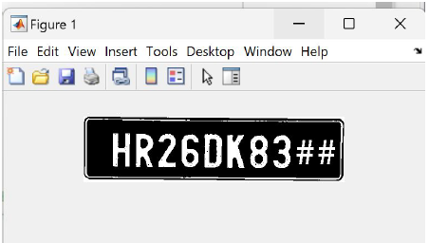

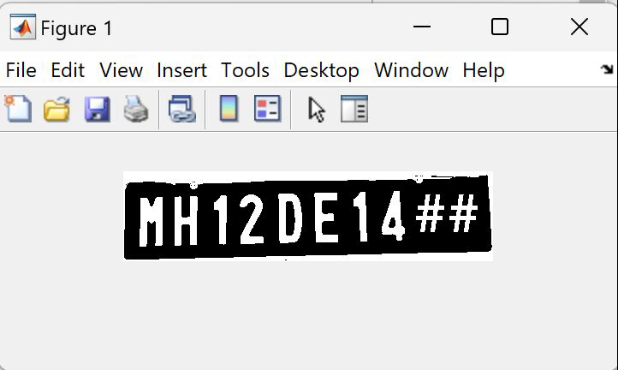

**4. CHALLENGES**

1. The challenge with mobile ANPR is that the processor needs clear images.
2. The equipment needs to be very efficient because the electrical power is car and the equipment needs to be small to reduce the space required.
3. Image quality is an issue that affects the camera's ability to actually read the license plate. Hence the algorithm.
4. Resolution is usually poor because the target is too far away, but sometimes it is due to using a bad a camera.
5. Photo blur, especially focus. Poor lighting and poor contrast due to overexposure, reflections or shadows.
6. An object covering (part of) a plate, usually a band or dirt on the plate.
7. Due to passenger transportation, please read the license plate from the front and back separately. While the driver's license is being read, the lane of the vehicle changes on the visual screen.transition process.

# Conclusion:

The purpose of this article is to examine and solve the algorithmic and mathematical aspects of automatic license plate identification, such as machine vision, pattern recognition, OCR and neural networks. questions are divided into sections according to the needs in the self-report steps

. Although many powerful algorithms are used in the analysis process, each section can be studied independently. The ANPR solution was tested on static images of vehicles grouped by complexity. The recognition rate of blurry and distorted snapshots is poorer than that of a series of clearly visible images. The goal of this test is not to find 100% identification of snapshots, but to test the consistency of the method for random snapshots that are systematically grouped into groups based on attributes.

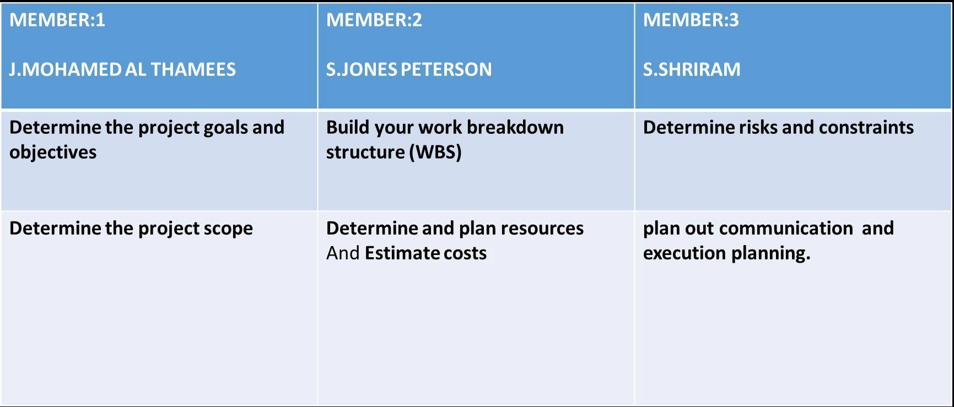

Signature of the Guide Student Reg. No :125004110

Name :ARUN.K Name : S.JONES PETERSON

Name : J.MOHAMED AL THAMEES Name : `S.SHRIRAM

Student reg no: 125004158 Student reg. No.: 125004274

**REFERENCES**

1. Feng Yang, Zheng Ma “Vehicle License Plate Location Based on Histogramming and Mathematical Morphology “, 2005.
2. Tran Duc Duan, Duong Anh Duc, Tran Le Hong Du “Combining Hough Transform and Contour Algorithm for detecting Vehicles. License-Plates”, October 2004.
3. Tran Duc Duan, Tran Le Hong Du, Tran Vinh Phuoc, Nguyen Viet Hoang “Building an Automatic Vehicle License-Plate Recognition System “, February 2005.
4. CheokMan, Kengchung “A High Accurate Macau License Plate Recognition System”, 2008.
5. R Thuy Tuong Nguyen, Xuan Dai Pham and Jae Wook Jeon “Rectangular Object Tracking Based on Standard Hough Transform “, February, 2009.
6. Yungang Zhang Changshui Zhang “A New Algorithm for Character Segmentation of License Plate”, June 2003.
7. Wenjing Jia, Huaifeng Zhang, and Xiangjian He Mean Shift for” Accurate Number Plate Detection”, July 2005.
8. S P Vijaya Vardan Reddy, B Sathyasri, A Balaji, S Vanaja, R Krishnan and Y Deepika, Automatic Number Plate Recognition system for Entry and exit Management, IEEE Access, ICCES, Vol 5, Issue 3, 2021, pp. 1-5.
9. Simon Mutua, Bernard Shibwabo, An Automatic Number Plate Recognition System for Car park Management, IEEE Access, Vol 175, Issue 7, 2017, pp. 36-42.
10. P Kulkarni, A Khatri, P Banga and K Shah, Automatic number plate recognition (anpr) system for Indian conditions, IEEE Access, Vol 11, Issue 2, 2009,