1. Select the language you want to translate.

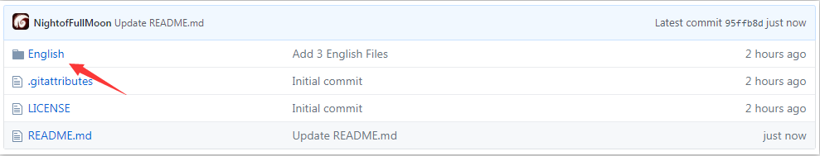

1. Select the text kind you want to translate

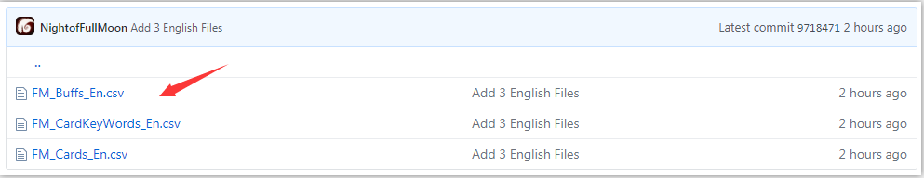

1. Select “Edit”

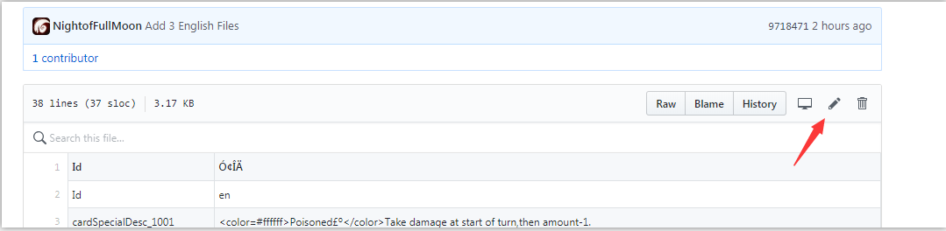

1. Hold“CTRL”then press “F” to find the text you want to modify.

(“freeze” in the example)

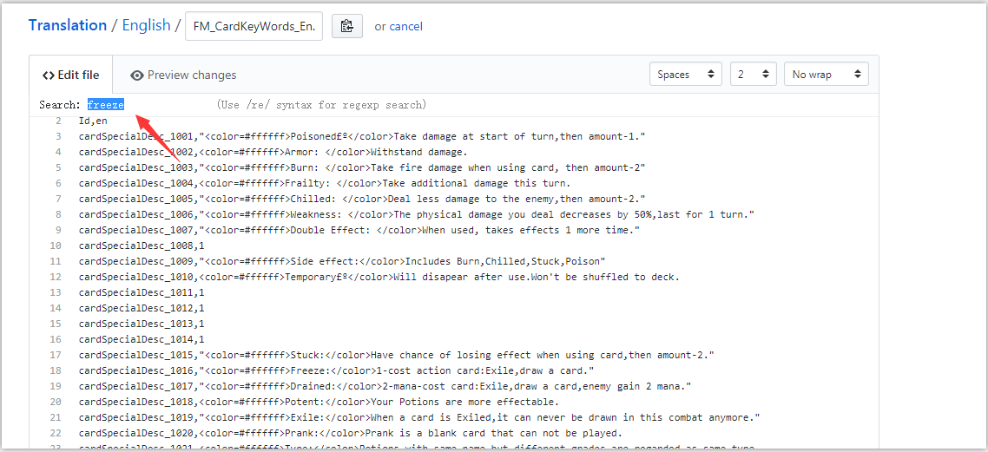

1. Then press “Enter” button to jump to the text.

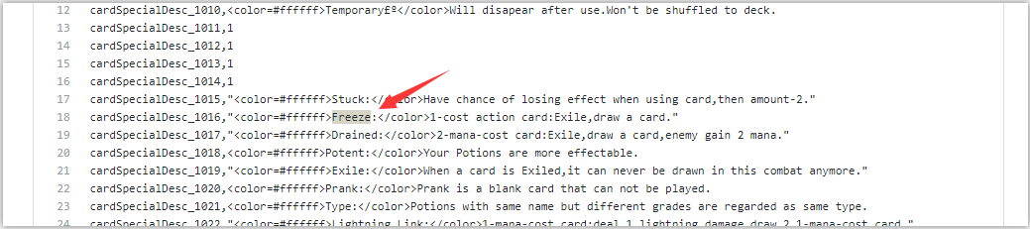

1. Then you can modify the text to anything you want. We will check it manually then merge it to official game.

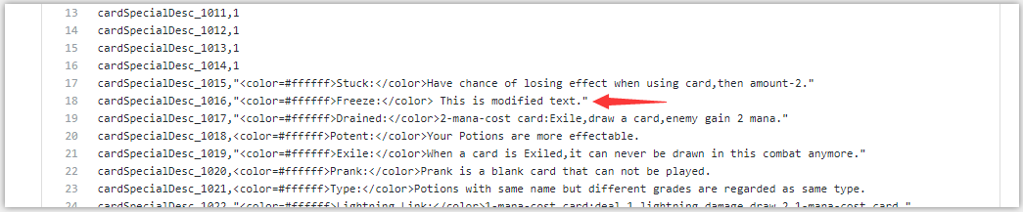

1. Finally fill in the reason you modify it. (Optional) Then click commit.

