Follow-up Creation Tool

# What is this application?

This application is used to:

* Create the “Follow-up” at the start of each Revision, based on the previous “Follow-up” and the “PseudoDataBase”.
* Update the existing “Follow-up” if updated MDLs are sent in middle of a revision.
* Create the “ALL_NCs_RXX” Excel file.

Limitations: The NC tab is currently created just by merging the NCs of the latest MDLs that are given.

# Create Follow-up

## Merge Latest Follow-up with existing PseudoDB

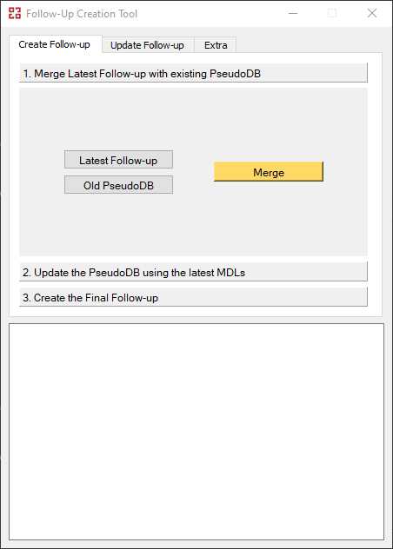

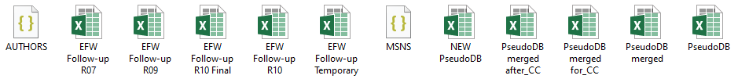

*Note: Before this step, make sure that the “Type” column inside the latest Follow-up is correct, so as not to input wrong information inside the PseudoDB.*

## Update the PseudoDB using the latest MDLs

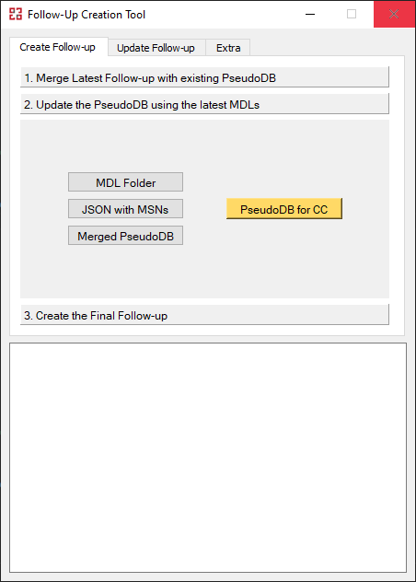

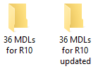

*Note 1: After this step, open the PseudoDB and sort the New Part Numbers as IPC and/or SRM. Use the file “Follow-up_Initial.xlsx” that was also created to assist you. If they are left as “TBD”, they application will interpeter them as “TRUE”, so as to not lose any potentially useful information.*

*Note 2: If something is “TRUE” only for “SRM A321” or only for “SRM A320” then both columns must be set to “TRUE”*

## Create the Final Follow-up

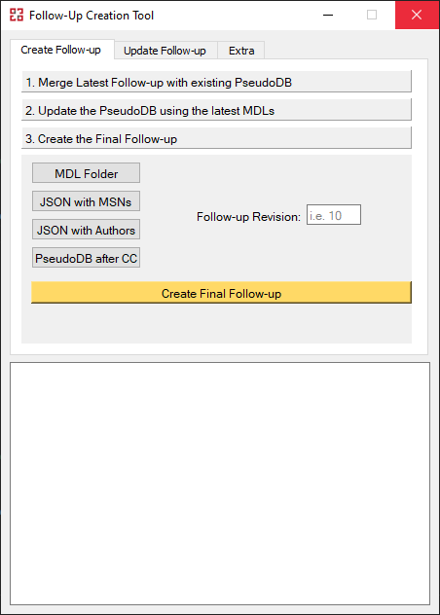



*Note: All columns that contain Dates have to be formatted manually!*

# Update Follow-up

## Update the PseudoDB using the latest MDLs

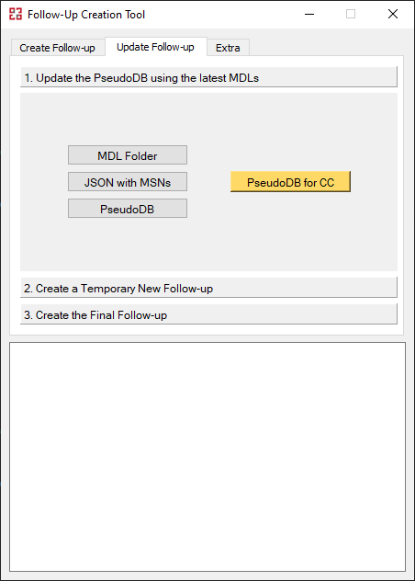



*Note 1: After this step, open the PseudoDB and sort the New Part Numbers as IPC and/or SRM. Use the file “Follow-up_Initial.xlsx” that was also created to assist you. If they are left as “TBD”, they application will interpeter them as “TRUE”, so as to not lose any potentially useful information.*

*Note 2: If something is “TRUE” only for “SRM A321” or only for “SRM A320” then both columns must be set to “TRUE”*

## Create a Temporary New Follow-up

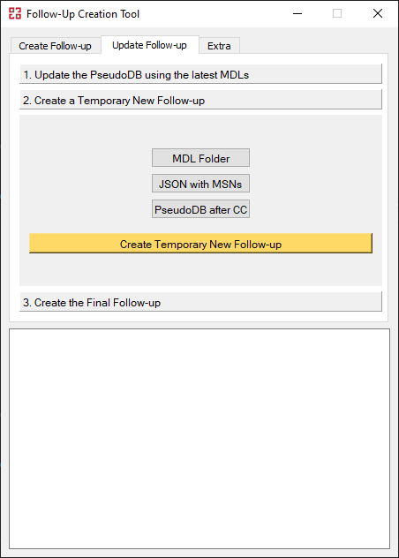



## Create the Final Follow-up

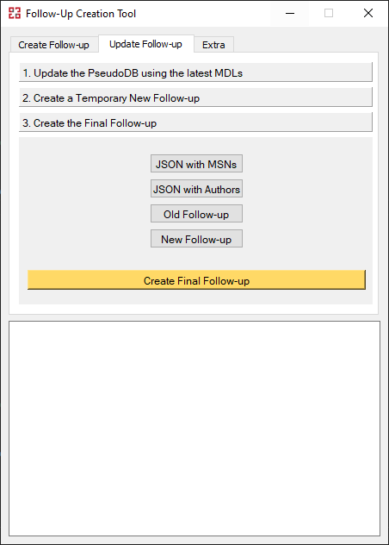



*Note: The Date columns have wrong formatting and need to be fixed manually.*

# Extra

## Generate JSON files

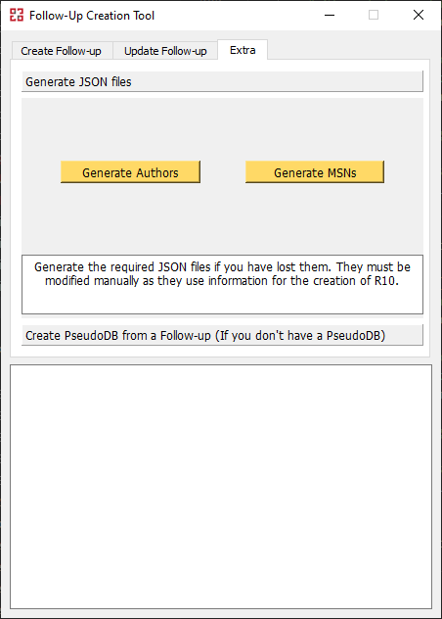



## Create PseudoDB from a Follow-up

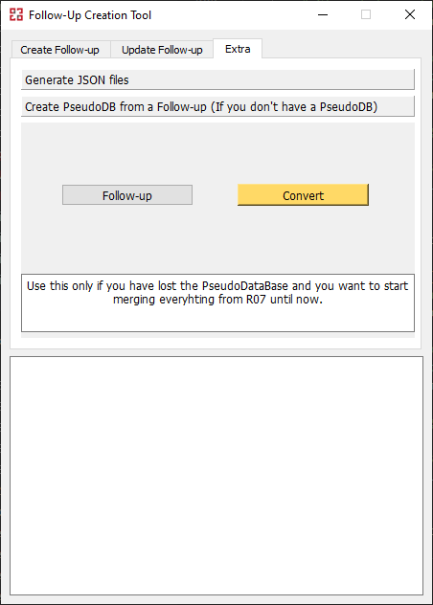



## Create ALL_NCs

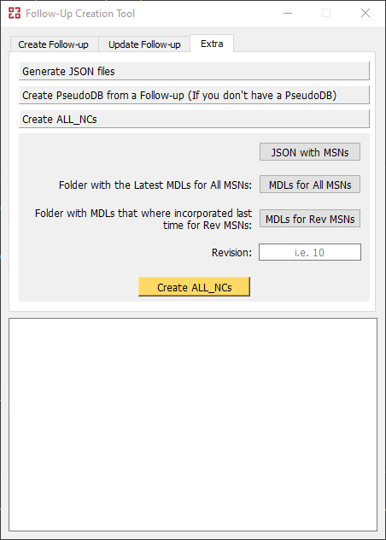

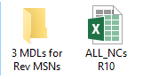

*Note 1: Provide the folder with the latest MDLs for all MSNs.*

*Note 2: Provide the folder with the MDLs that where incorporated last time for the revision MSNs.*

# PseudoDataBase

The PseudoDataBase that currently exists is a merge of:

* “EFW Follow-up R07”
* “EFW Follow-up R08”
* “EFW Follow-up R09”

It was checked and cleaned by V. Menegatos, and it was used as the basis for the creation of “EFW Follow-up R10”. The same PseudoDB should be used and updated for the following revisions.

*Note: If something is “TRUE” only for “SRM A321” or only for “SRM A320” then both columns must be set to “TRUE”*