FAA REMOTE PILOT TEST PREP
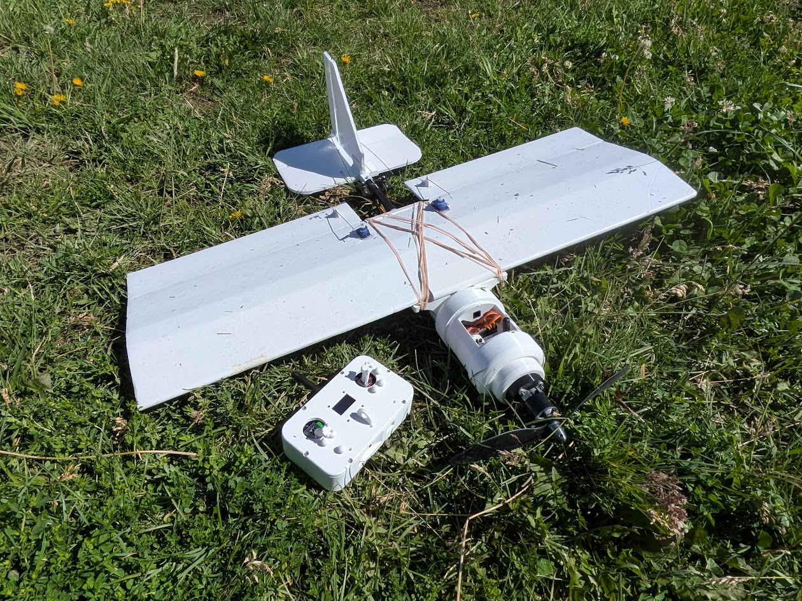
How to Use This Chapter 4
Learning Objectives 5
1.1 The Part 107 Regulatory Framework 5
1.2 Becoming a Certificated Remote Pilot 5
1.3 Remote PIC Authority and Responsibility 6
1.4 Supporting Crew Roles 6
1.5 Registration and Required Documents 7
1.6 Preflight Action and Airworthiness 7
1.7 Accident Reporting 7
1.8 Alcohol, Drugs, and Fitness for Flight 8
1.9 Visual Line of Sight 8
1.10 Right-of-Way and Operating Near Other Aircraft 8
1.11 Core Operating Limitations 9
1.12 Night Operations 9
1.13 Operations Over People and Moving Vehicles 10
1.14 Remote Identification 10
1.15 LAANC and Controlled Airspace Authorization 11
1.16 Waivers 11
1.17 Chapter Summary 11
1.18 Knowledge Check 12
Answer Key 12
Sources and Regulatory Update Notes 13
How to Use This Chapter 14
Learning Objectives 14
2.1 The National Airspace System 15
2.2 Controlled Airspace and Part 107 Authorization 15
2.3 Class A Airspace 15
2.4 Class B Airspace 16
2.5 Class C Airspace 16
2.6 Class D Airspace 16
2.7 Class E Airspace 17
2.8 Class G Airspace 17
2.9 Airspace at a Glance 17
2.10 Special-Use and Other Airspace 18
Prohibited Areas 18
Restricted Areas 18
Warning Areas 18
Military Operations Areas (MOAs) 18
Alert Areas 18
Controlled Firing Areas 18
Military Training Routes 19
2.11 NOTAMs: Time-Critical Information 19
FDC, Pointer, and Military Information 19
2.12 Temporary Flight Restrictions (TFRs) 19
2.13 FAA Airspace Resources 20
2.14 Reading a VFR Sectional Chart 20
2.15 Latitude, Longitude, and Topography 21
2.16 Airport Operations 22
2.17 Runway Numbers, Markings, and Signs 23
2.18 Security Identification Display Areas (SIDA) 24
2.19 Collision Avoidance 24
2.20 Inflight Hazards 25
2.21 Chapter Summary 25
2.22 Knowledge Check 26
Answer Key 27
Sources and Update Notes 28
How to Use This Chapter 29
Learning Objectives 29
3.1 Why Weather Matters to UAS Operations 29
3.2 Atmospheric Pressure, Altimeter Settings, and Temperature 30
3.3 Thermals and Convective Currents 30
3.4 Moisture: Evaporation, Condensation, Sublimation, and Dew Point 31
3.5 Wind and Wind Shear 31
3.6 Air Masses, Fronts, Ridges, and Troughs 32
3.7 Atmospheric Stability 33
3.8 Clouds and What They Tell a Pilot 34
3.9 Part 107 Visibility and Cloud Clearance 36
3.10 Thunderstorms 37
3.11 Icing and Frost 38
3.12 Fog 38
3.13 Density Altitude and UAS Performance 40
3.14 Obtaining a Weather Briefing 40
3.15 Surface Weather Observations: ASOS and AWOS 41
3.16 METAR: Aviation Routine Weather Report 42
3.17 Decoding a METAR 42
3.18 TAF: Terminal Aerodrome Forecast 43
3.19 SIGMETs, Convective SIGMETs, and Graphical Aviation Weather 44
3.20 Weather Decision Making for a Remote PIC 45
3.21 Chapter Summary 45
3.22 Knowledge Check 46
Answer Key 47
Sources and Update Notes 48
Chapter Objectives 48
4.1 The Remote PIC and Safe Operation 49
A Systematic Preflight Inspection 49
4.2 Communication and Crew Coordination 50
The ICAO Phonetic Alphabet 50
Understanding Airport Traffic Calls 51
Common Aviation Radio Terms 51
Initial Radio Contact 52
4.3 sUAS Radio Frequencies and Interference 52
4.4 Emergency and Abnormal Procedures 53
Lost Link 53
Flight Termination 53
Flyaways 53
Loss of GPS/GNSS 53
Lithium Battery Fires 53
4.5 Aeronautical Decision Making 54
The Five Hazardous Attitudes 54
4.6 Human Factors and Physiology 55
4.7 Maintenance and Inspection 55
4.8 Organizing a Safe Training Flight 56
Chapter 4 Summary 56
Chapter 4 Knowledge Check 57
Answer Key 58
Source Note 59
Chapter Objectives 60
5.1 Loading and Aircraft Control 60
Primary Fixed-Wing Flight Controls 60
5.2 Determining Speed, Course, and Altitude 61
Navigation Concepts 61
Altitude: AGL versus MSL 61
5.3 Aircraft Loading 61
5.4 Computing Weight and Balance 62
Worked Weight-and-Balance Example 62
5.5 Load Factor 63
5.6 Stalls and Angle of Attack 64
5.7 Aircraft Performance 64
Factors Affecting Launch and Flight Performance 64
Endurance versus Range 65
Chapter 5 Summary 65
Chapter 5 Knowledge Check 65
Answer Key 67
Source Note 68

FAA REMOTE PILOT TEST PREP
Chapter 1
Aviation Regulatory System

Study text for 14 CFR Part 107 Remote Pilot applicants

2026 EDITION Built from the course presentation and updated against current FAA Part 107 guidance. Where older slide language conflicts with current FAA rules, the current rule is identified in the text.

How to Use This Chapter
The FAA knowledge test does not reward memorizing isolated definitions. Many questions present an operating situation and ask what the remote pilot in command should do. As you study, focus on three things: who is responsible, what operating limitation applies, and what action keeps the operation compliant and safe.
· Learn the bold terms and numerical limits.
· Work through each scenario before reading the answer.
· Pay special attention to Exam Tip and Key Number boxes.
· Use the end-of-chapter questions without notes, then review weak areas.

Learning Objectives
· Explain when Part 107 applies to a small UAS operation.
· Describe Remote Pilot Certificate eligibility and recency requirements.
· Explain the authority and responsibilities of the remote PIC.
· Identify crew roles and limitations.
· Apply registration, documentation, inspection, accident-reporting, and preflight rules.
· Apply VLOS, right-of-way, speed, altitude, visibility, cloud-clearance, night, and moving-vehicle rules.
· Recognize requirements for operations over people and Remote ID.
· Explain the purpose of LAANC and Part 107 waivers.

1.1 The Part 107 Regulatory Framework
Small unmanned aircraft operations in the United States are governed primarily by Title 14 of the Code of Federal Regulations, Part 107. Part 107 establishes operating rules, pilot certification requirements, and limitations for civil small UAS operations.
A small unmanned aircraft is an aircraft operated without the possibility of direct human intervention from within or on the aircraft. Under Part 107, a small UAS must weigh less than 55 pounds at takeoff, including everything onboard or attached to the aircraft. Recreational operations may instead be conducted under the statutory recreational exception when all of its conditions are met; Part 107 is the normal framework for non-recreational work, business, research, education, and other civil operations that do not qualify for that exception.
The remote pilot should think of Part 107 as the baseline rule set. Some operations are permitted directly under the rule, some require airspace authorization, and some require an FAA waiver.
KEY NUMBER 55 lb is the upper weight boundary for a small unmanned aircraft operating under Part 107. The aircraft must be less than 55 lb at takeoff, including payload and attachments.

1.2 Becoming a Certificated Remote Pilot
A person acting as remote PIC under Part 107 must hold an FAA Remote Pilot Certificate with a small UAS rating. For a first-time applicant, the FAA currently requires the applicant to be at least 16 years old, be able to read, speak, write, and understand English, be in a physical and mental condition that allows safe operation, and pass the initial Unmanned Aircraft General – Small (UAG) aeronautical knowledge test.
Applicants who already hold an eligible Part 61 pilot certificate and have a current flight review have an alternate training path. The course slides also identify the FSDO, designated pilot examiner, airman certification representative, and certificated flight instructor as persons or offices that can process appropriate applications.
EXAM TIP The Remote Pilot Certificate itself does not expire. To exercise Part 107 privileges, however, the pilot must maintain aeronautical knowledge recency. Current FAA recurrent training is completed online within the preceding 24 calendar months.
KEY NUMBER 24 calendar months: recurrent aeronautical knowledge requirement.

1.3 Remote PIC Authority and Responsibility
Every Part 107 operation must have a remote pilot in command. The remote PIC is directly responsible for the operation and is the final authority as to the operation of the small UAS.
The remote PIC must be designated before or during the flight and must ensure that the operation complies with applicable regulations. The PIC must also ensure that the operation poses no undue hazard to people, aircraft, or property if control of the aircraft is lost.
This authority carries a practical consequence: automation does not transfer responsibility to the aircraft. Even when a mission is flown using an autopilot, the remote PIC remains responsible for the flight and must be able to respond to an unsafe condition.
SCENARIO A mapping aircraft is flying an automated grid when a helicopter appears near the operating area. The autopilot is functioning normally. The remote PIC is still responsible for avoiding the helicopter and must take whatever action is necessary to yield right-of-way.

1.4 Supporting Crew Roles
A person manipulating the flight controls does not necessarily have to hold a Remote Pilot Certificate. A non-certificated person may manipulate the controls when directly supervised by a certificated remote PIC who can immediately take direct control of the aircraft.
A visual observer (VO) is an optional crewmember under ordinary Part 107 operations. The VO helps maintain awareness of the aircraft, other aircraft, people, obstacles, and other hazards. When a VO is used, the remote PIC, person manipulating the controls, and VO must maintain effective communication.
A remote PIC or visual observer may not serve in that role for more than one small UAS operation at the same time.
EXAM TIP Do not confuse the person touching the controls with the remote PIC. The remote PIC is the person who carries regulatory responsibility for the operation.

1.5 Registration and Required Documents
Part 107 aircraft must be registered with the FAA and marked as required. The remote pilot should verify registration status before flight and ensure that required information is available for inspection.
The course presentation emphasizes that required documentation may be physical or digital. The remote pilot should have access to the Remote Pilot Certificate, aircraft registration, applicable waivers or exemptions, and other documents required for the operation.
The FAA may request inspection or testing of the small UAS. A professional operator should therefore treat documentation as part of preflight readiness rather than as an administrative afterthought.

1.6 Preflight Action and Airworthiness
Before flight, the remote PIC must become familiar with information relevant to the operation. This includes the local operating environment, weather, airspace, people and property on the surface, obstacles, and other factors that could affect safety.
The remote PIC must ensure that the small UAS is in a condition for safe operation. A practical preflight includes the airframe, propellers, motors, batteries, control links, navigation system, payload attachment, firmware or mission configuration, and any equipment required for the intended operation.
Part 107 places responsibility on the remote PIC to determine whether the aircraft is safe to fly. If a condition arises that makes continued flight unsafe, the operation should be discontinued.
SCENARIO During preflight you discover a propeller with a visible crack near the hub. Even if the aircraft powers up normally, it is not in a condition for safe operation. Replace the damaged component before flight.

1.7 Accident Reporting
Certain Part 107 accidents must be reported to the FAA. The course material emphasizes two reportable thresholds: serious injury to any person or any loss of consciousness, and damage to property other than the small unmanned aircraft when the repair or replacement cost exceeds the regulatory threshold.
The report must be made within 10 days of the operation. Students should distinguish FAA reporting requirements from any additional reporting that may be required by an employer, insurer, property owner, law-enforcement agency, or the NTSB.
KEY NUMBER 10 days: time allowed to submit a required Part 107 accident report to the FAA. $500: property-damage threshold identified in the course material, excluding damage to the sUAS itself.

1.8 Alcohol, Drugs, and Fitness for Flight
Part 107 prohibits a remote PIC, person manipulating the controls, visual observer, or other crewmember from participating when impaired by alcohol or drugs. The course presentation uses the same key alcohol limits familiar to manned aviation: no alcoholic beverage within the preceding 8 hours, no operation while under the influence, and no operation with a blood alcohol concentration of 0.04 percent or greater.
A crewmember also may not participate while using a drug that affects mental or physical capabilities in a way that makes the operation unsafe.
KEY NUMBER 8 hours bottle-to-throttle; 0.04% blood alcohol concentration.

1.9 Visual Line of Sight
Visual line of sight (VLOS) is a central Part 107 operating requirement. The aircraft must remain close enough to the remote PIC or visual observer for the aircraft's location, attitude, altitude, direction of flight, and hazards to be determined with unaided vision.
Corrective lenses are permitted because they are considered normal vision correction. Binoculars and similar devices may be used momentarily, but they are not a substitute for the required unaided visual capability.
First-person-view video can be a useful piloting aid, but a camera image by itself does not satisfy the VLOS requirement.
EXAM TIP The important concept is not simply 'I can see a dot.' The crew must be able to know the aircraft's position and movement and scan for hazards.

1.10 Right-of-Way and Operating Near Other Aircraft
Small UAS must yield the right-of-way to all other aircraft. The remote PIC may not pass over, under, or ahead of another aircraft unless well clear. Because a small drone can be difficult for a manned-aircraft pilot to see, the UAS crew should never assume that another pilot will maneuver around the drone.
Operations near airports require particular care. A remote PIC may not interfere with airport operations or traffic patterns. Controlled airspace may require FAA authorization, but authorization does not eliminate the requirement to see and avoid other aircraft.
SCENARIO You have a valid LAANC authorization and are flying at 150 ft AGL when a medical helicopter approaches below normal traffic-pattern altitude. The authorization does not give the drone priority. Yield immediately and remain well clear.

1.11 Core Operating Limitations
Several numerical limits appear repeatedly on the FAA knowledge test. Learn them as a group:
Limitation | Standard Part 107 value
Maximum groundspeed | 100 mph (87 knots)
Maximum altitude | 400 ft AGL, subject to the structure provision
Minimum flight visibility | 3 statute miles
Cloud clearance below clouds | 500 ft
Horizontal cloud clearance | 2,000 ft
Part 107 also contains a structure provision that can permit operation higher than 400 ft AGL when the aircraft remains within the allowed distance of a structure and does not exceed the permitted height above the structure's uppermost limit. Airspace restrictions still apply.
EXAM TIP When a test question gives several numbers, first identify whether it is asking about speed, altitude, visibility, or cloud clearance. Do not mix the 500-ft vertical cloud clearance with the 400-ft normal AGL ceiling.

1.12 Night Operations
Older Part 107 training materials stated that routine night operations required a waiver. That is no longer the general rule. Current Part 107 rules permit routine night operations when the remote PIC has completed the applicable updated knowledge test or recurrent training and the aircraft has qualifying anti-collision lighting.
The anti-collision lighting must be visible for at least 3 statute miles and have a flash rate sufficient to avoid a collision. The remote PIC may reduce the intensity when operating conditions make that action safer, but the lighting requirement remains part of the night-operation rule.
Night operations in controlled airspace still require the appropriate airspace authorization.
KEY NUMBER 3 statute miles: required visibility distance for the aircraft's anti-collision lighting during Part 107 night operations.

1.13 Operations Over People and Moving Vehicles
Part 107 now provides four categories that can allow qualifying small UAS operations over people. The categories are based on aircraft characteristics, injury risk, operating restrictions, and—in some cases—FAA declarations of compliance or airworthiness certification.
Category 1 applies to very small aircraft weighing 0.55 lb or less, including everything attached or carried, and the aircraft may not have exposed rotating parts that would cause lacerations. Categories 2 and 3 use performance-based requirements and require aircraft eligibility and an FAA-accepted declaration of compliance. Category 3 has more restrictive operating conditions. Category 4 applies to eligible aircraft with an airworthiness certificate and associated operating limitations.
Operations over moving vehicles are also allowed only when the applicable regulatory conditions are satisfied. A student should avoid the oversimplified rule that a drone can 'never' fly over a vehicle; the current regulation is conditional.
EXAM TIP For operations-over-people questions, identify the aircraft category first. Then ask whether the people are participants, whether the site is restricted-access, whether flight is sustained, and whether Remote ID requirements apply.

1.14 Remote Identification
Remote Identification (Remote ID) provides identification and location information about drones in flight. In general, drones that are required to be registered must comply with the Remote ID rule unless an exception applies.
A Standard Remote ID drone has compliant Remote ID capability built into the aircraft. An operator may also use an FAA-compliant broadcast module on an eligible aircraft. The course presentation emphasizes three practical responsibilities: the equipment must be functioning, it may not be intentionally disabled or tampered with, and if required Remote ID broadcasting fails, the pilot must land as soon as practicable.
Another compliance path is operation within an FAA-Recognized Identification Area (FRIA), subject to the conditions that apply to that type of operation.
EXAM TIP Remote ID is an aircraft-operation requirement, not a substitute for Part 107 certification, registration, airspace authorization, or VLOS.

1.15 LAANC and Controlled Airspace Authorization
The Low Altitude Authorization and Notification Capability (LAANC) is an FAA system that allows eligible drone pilots to request access to controlled airspace at low altitude through FAA-approved service suppliers. It provides pilots with information about where operations may be authorized and gives air traffic personnel visibility into planned drone activity.
LAANC is an authorization mechanism; it is not permission to disregard other Part 107 rules. The pilot remains responsible for weather, VLOS, right-of-way, operating limitations, local conditions, and any terms contained in the authorization.

1.16 Waivers
A Part 107 waiver allows the FAA to authorize certain operations that would otherwise not comply with a waivable provision of Part 107. The applicant must demonstrate that the proposed operation can be conducted safely under the terms of the waiver.
Not every Part 107 provision is waivable. Common waiver areas include certain VLOS, multiple-aircraft, operating-limitations, moving-vehicle, and operations-over-people provisions. Modern Part 107 rules mean that routine night operations meeting the standard night requirements generally do not need a waiver.
A waiver is not a blanket exemption from Part 107. The operator must comply with the waiver's specific conditions and all other regulations that remain applicable.

1.17 Chapter Summary
· Part 107 is the primary FAA rule set for civil small UAS operations that do not qualify for another operating framework.
· The remote PIC is the final authority and carries responsibility for regulatory compliance and operational safety.
· A non-certificated person may manipulate the controls under the direct supervision of a qualified remote PIC who can immediately take control.
· Aircraft registration, required documents, preflight inspection, and safe-condition determinations are operational responsibilities.
· Report qualifying accidents to the FAA within 10 days.
· Remember the core limits: 100 mph/87 kt, 400 ft AGL, 3 SM visibility, 500 ft below clouds, and 2,000 ft horizontally from clouds.
· Small UAS always yield right-of-way to other aircraft.
· Routine night operations are permitted when current training/knowledge and anti-collision-light requirements are met.
· Operations over people and moving vehicles depend on specific regulatory categories and conditions.
· Remote ID and airspace authorization are separate compliance requirements.
· LAANC can provide controlled-airspace authorization; a Part 107 waiver can permit certain otherwise prohibited operations when the FAA approves an equivalent level of safety.

1.18 Knowledge Check
1. What is the maximum takeoff weight for an aircraft to qualify as a small UAS under Part 107?
2. Does a Remote Pilot Certificate expire? What must a pilot do to maintain aeronautical knowledge recency?
3. Who is the final authority for a Part 107 operation?
4. May a person without a Remote Pilot Certificate manipulate the controls during a Part 107 flight?
5. Is a visual observer required for every Part 107 operation?
6. Within how many days must a qualifying Part 107 accident be reported to the FAA?
7. What is the standard maximum Part 107 groundspeed?
8. What is the standard maximum altitude above ground level?
9. What is the minimum flight visibility?
10. What are the vertical and horizontal cloud-clearance requirements?
11. Which aircraft has right-of-way in an encounter between a small UAS and a manned aircraft?
12. What two primary requirements allow routine Part 107 night operations?
13. What is the maximum weight of a Category 1 aircraft used for operations over people?
14. What should a pilot do if required Remote ID broadcasting fails during flight?
15. What does LAANC provide?
16. Does a LAANC authorization give the drone priority over other aircraft?
17. What is the alcohol 'bottle-to-throttle' period emphasized in the course?
18. What blood alcohol concentration is prohibited?
19. Can FPV video alone satisfy the Part 107 VLOS requirement?
20. What is the purpose of a Part 107 waiver?

Answer Key
1. Less than 55 lb at takeoff, including payload and attachments.
2. The certificate does not expire; the pilot must satisfy recurrent aeronautical knowledge requirements within the preceding 24 calendar months.
3. The designated remote pilot in command.
4. Yes, when directly supervised by a certificated remote PIC who can immediately take control.
5. No. A VO is optional unless needed to satisfy a particular authorization, waiver, or operating method.
6. 10 days.
7. 100 mph, or 87 knots groundspeed.
8. Normally 400 ft AGL, subject to the structure provision and airspace restrictions.
9. 3 statute miles.
10. 500 ft below clouds and 2,000 ft horizontally from clouds.
11. The other aircraft; the small UAS must yield.
12. Applicable updated pilot knowledge/training and anti-collision lighting visible for at least 3 statute miles.
13. 0.55 lb or less, including everything onboard or attached.
14. Land as soon as practicable.
15. A means for eligible pilots to request low-altitude controlled-airspace authorization through FAA-approved service suppliers.
16. No.
17. 8 hours.
18. 0.04 percent or greater.
19. No.
20. To obtain FAA approval for certain operations that would otherwise violate a waivable Part 107 provision, after demonstrating the operation can be conducted safely.

Sources and Regulatory Update Notes
Primary instructional source: Aviation Regulatory System-107 course presentation supplied for this textbook project.
Current-rule verification used for this draft: Federal Aviation Administration, Small Unmanned Aircraft Systems (UAS) Regulations (Part 107), updated July 6, 2026; FAA Become a Certificated Remote Pilot, updated June 9, 2026; FAA Operations Over People; FAA Remote Identification of Drones; FAA Part 107 Airspace Authorizations; FAA Part 107 Waivers.
This chapter is instructional material and is designed for FAA Remote Pilot knowledge-test preparation. Operators should consult current FAA regulations, authorizations, waivers, and official guidance before conducting an actual flight.

FAA REMOTE PILOT TEST PREP
Chapter 2
The National Airspace System

Airspace • Sectional Charts • NOTAMs • TFRs • Airport Operations • Collision Avoidance
2026 EDITION Built from the National Airspace System course presentation. Current FAA sources were used to verify airspace terminology, authorization requirements, NOTAM/TFR resources, and chart information.

How to Use This Chapter
Airspace questions are among the most visual questions on the FAA Remote Pilot knowledge test. You will often be given a sectional-chart excerpt and asked to determine the airspace, identify an airport or obstruction, interpret a symbol, or decide whether authorization is required. The goal is not to memorize a collection of colored lines. The goal is to look at a location and answer three questions: What airspace am I in? What restrictions or hazards affect it? What must I do before I fly?

Learning Objectives
· Describe the National Airspace System and distinguish controlled from uncontrolled airspace.
· Identify Classes B, C, D, E, and G airspace on a sectional chart and determine when Part 107 airspace authorization is required.
· Recognize prohibited, restricted, warning, military operations, alert, and other special-use airspace.
· Use sectional charts, the Chart Supplement, NOTAMs, and TFR information during preflight planning.
· Interpret latitude and longitude, airport symbols, runway information, obstacles, and common sectional-chart markings.
· Explain airport traffic patterns, runway numbering, SIDA concepts, and UAS responsibilities near airports.
· Apply collision-avoidance principles and recognize common inflight hazards.

2.1 The National Airspace System
The National Airspace System (NAS) is the network of airspace, airports, navigation systems, air traffic control facilities, procedures, and regulations that allows aviation to function safely in the United States. For a remote pilot, understanding the NAS means more than knowing whether a drone is below 400 feet. The pilot must understand what airspace exists at the aircraft's actual altitude, what nearby crewed aircraft may be doing, and whether temporary restrictions change the normal operating environment.
The course presentation divides airspace into regulatory and non-regulatory categories and also emphasizes the practical distinction between controlled and uncontrolled airspace. Controlled airspace includes Classes A, B, C, D, and E. Class G is uncontrolled. 'Uncontrolled' does not mean unregulated; Part 107 rules still apply in Class G.
EXAM STRATEGY For almost every airspace problem, ask: (1) What class of airspace exists at my planned altitude? (2) Does Part 107 require FAA authorization there? (3) Is there a NOTAM, TFR, special-use area, or other restriction that changes the answer?

2.2 Controlled Airspace and Part 107 Authorization
For Part 107 pilots, the most important authorization rule is straightforward: prior FAA authorization is required before operating in Class B, Class C, Class D, or within the lateral boundaries of the surface area of Class E airspace designated for an airport. Many routine authorizations can be obtained through LAANC. Class E that begins at 700 or 1,200 feet AGL is different: a drone operating below that floor may still be in Class G and therefore may not need an airspace authorization.
EXAM TIP Do not answer an airspace question based only on what class exists somewhere above the drone. Determine the class at the altitude where the UAS will actually operate.

2.3 Class A Airspace
Class A generally begins at 18,000 feet MSL and extends through Flight Level 600. Crewed aircraft in Class A normally operate under Instrument Flight Rules. Because Part 107 operations are ordinarily limited to low altitude, a remote pilot will not normally conduct a small UAS operation in Class A. Nevertheless, the lower boundary—18,000 feet MSL—is a common FAA knowledge-test fact.
KEY NUMBER Class A: 18,000 feet MSL through FL 600.

2.4 Class B Airspace
Class B surrounds the nation's busiest airports. Its dimensions are individually tailored and often resemble an upside-down wedding cake, with a surface area around the primary airport and shelves extending outward at higher altitudes. Class B generally extends from the surface to about 10,000 feet MSL, although the exact configuration must be read from the chart.
A Part 107 remote pilot must obtain FAA authorization before operating within Class B airspace. On sectional charts, Class B boundaries are shown with solid blue lines. Altitude numbers printed near the boundary identify the floor and ceiling of individual shelves.
EXAM TIP Solid blue = Class B. Do not assume the surface is Class B everywhere under a shelf; read the floor/ceiling figures.

2.5 Class C Airspace
Class C normally surrounds airports with an operating control tower and radar approach control. A typical Class C has a 5 NM surface core and a 10 NM shelf, with the upper limit about 4,000 feet above airport elevation. Actual dimensions vary and must be read from the chart.
Class C boundaries are shown by solid magenta lines. Part 107 operations within Class C require FAA airspace authorization.
KEY NUMBERS Typical Class C: 5 NM surface core, 10 NM outer shelf, top about 4,000 feet above airport elevation.

2.6 Class D Airspace
Class D generally surrounds airports with an operating control tower. It commonly extends from the surface to approximately 2,500 feet above airport elevation, but its lateral and vertical dimensions are tailored to the airport. The course presentation correctly cautions against assuming every Class D is exactly four nautical miles in radius.
Class D is depicted with a dashed blue boundary. Part 107 operations within Class D require FAA authorization.
EXAM TIP Dashed blue = Class D surface area. Look for the boxed ceiling number on the sectional rather than assuming a standard top.

2.7 Class E Airspace
Class E is controlled airspace that is not Class A, B, C, or D. It can begin at the surface, at 700 feet AGL, at 1,200 feet AGL, or at another designated altitude. This makes Class E one of the most frequently misunderstood classes for new remote pilots.
A faded magenta vignette on a sectional normally identifies an area where Class E begins at 700 feet AGL. In many other areas, Class E begins at 1,200 feet AGL. Dashed magenta identifies Class E airspace that begins at the surface around an airport. That surface Class E is the form most important to Part 107 authorization questions.
EXAM TIP Dashed magenta = Class E to the surface. Faded magenta = Class E begins at 700 feet AGL. For a UAS at 200 feet AGL beneath a 700-foot Class E floor, the aircraft is normally in Class G.

2.8 Class G Airspace
Class G is uncontrolled airspace. ATC does not provide the same control services there as in controlled airspace, but FAA regulations still apply. Remote pilots must still comply with Part 107, maintain VLOS, yield right-of-way, remain within operating limitations, and check for TFRs, special-use airspace, and other restrictions.
In many rural locations, Class G extends from the surface to either 700 or 1,200 feet AGL, with Class E above. Since many Part 107 flights occur below 400 feet AGL, Class G is a common operating environment.
MEMORY AID Class G = uncontrolled, not unregulated.

2.9 Airspace at a Glance
Class | Typical depiction / location | Part 107 relevance | Authorization?
B | Solid blue; busiest airports; layered shelves | Low-altitude shelves may reach surface | Yes
C | Solid magenta; tower + radar; core/shelf | Common near regional airports | Yes
D | Dashed blue; towered airport | Usually surface area | Yes
E surface | Dashed magenta | Controlled airspace begins at surface | Yes
E at 700/1200 AGL | Faded magenta / general transition | Often above normal UAS altitude | Not merely because E is above you
G | Surface below overlying controlled airspace | Common low-altitude UAS environment | Normally no airspace authorization

2.10 Special-Use and Other Airspace
A sectional chart may show areas created for security, military training, hazardous activity, or other special purposes. These areas require the remote pilot to look beyond the basic B-C-D-E-G classification.

Prohibited Areas
Aircraft operations are prohibited unless specifically authorized. These areas protect national security or other highly sensitive locations.

Restricted Areas
Contain unusual, often invisible hazards such as artillery firing or missile activity. Operations may be restricted when the area is active; pilots must determine status and controlling/using agency requirements.

Warning Areas
Similar in purpose to restricted areas but located over domestic or international waters where the United States does not have sole jurisdiction.

Military Operations Areas (MOAs)
Separate certain military training activities from IFR traffic. Military aircraft may maneuver rapidly and at high speeds. UAS pilots should exercise extreme caution and determine whether the MOA is active.

Alert Areas
Identify locations with a high volume of pilot training or unusual aeronautical activity. All pilots share responsibility for collision avoidance.

Controlled Firing Areas
Activities are suspended when a spotter or other means detects an aircraft approaching the area; CFAs are generally not charted.

Military Training Routes
Routes used by military aircraft for low-level, often high-speed training. A UAS operator near an MTR should expect the possibility of fast aircraft at relatively low altitude.
REAL-WORLD POINT A legal Class G operating site can still be a poor place to fly if it lies under an active military route, near a wildfire TFR, or in an area with frequent low-level aircraft.

2.11 NOTAMs: Time-Critical Information
NOTAMs—Notices to Air Missions—provide time-critical information that may not yet appear on normal charts or publications. The course material emphasizes checking NOTAMs before every flight because the operating environment can change after a sectional chart was published.
NOTAM information can include runway or taxiway closures, lighting or navigation-aid outages, construction, obstacles, parachute activity, airshows, military activity, and other temporary conditions. Older training materials often emphasize historical NOTAM categories such as NOTAM (D), FDC, Pointer, and Military NOTAMs. Those terms are useful for recognizing older exam-prep material, but the practical skill is finding and interpreting current NOTAM information that affects the planned operation.

FDC, Pointer, and Military Information
FDC NOTAMs contain regulatory information; TFRs are especially important to UAS pilots. Pointer NOTAMs direct the pilot to another NOTAM containing relevant information. Military NOTAM information can alert pilots to temporary changes or hazards associated with military facilities and operations.
EXAM TIP A sectional chart shows the normal airspace structure. A NOTAM can tell you that today's operating environment is different.

2.12 Temporary Flight Restrictions (TFRs)
A TFR temporarily restricts aircraft operations in a defined area for a specified purpose and time. TFRs may protect VIP or presidential movements, wildfire and disaster response, space operations, airshows, or qualifying sporting events. A normally legal UAS location can become unavailable when a TFR becomes active.
Wildfire TFRs deserve special attention. Firefighting aircraft may operate low, fast, and repeatedly over the incident. An unauthorized drone can force aerial firefighting operations to stop.
CRITICAL RULE An airspace authorization—including LAANC—does not override a TFR. Always check current restrictions before flight.

2.13 FAA Airspace Resources
No single source gives a remote pilot everything needed for preflight planning. The presentation identifies several complementary FAA resources:
· Sectional aeronautical charts: normal airspace structure, airports, obstacles, terrain, and charted hazards.
· Chart Supplement U.S.: detailed airport and facility information; formerly called the Airport/Facility Directory (A/FD).
· NOTAM and Flight Service resources: temporary changes and hazards.
· FAA TFR resources: current temporary flight restrictions.
· Aeronautical Information Manual (AIM): operational information about the NAS, airport procedures, ATC, communications, and safety.
· Advisory Circulars: FAA guidance explaining regulations and recommended procedures.

2.14 Reading a VFR Sectional Chart
The FAA knowledge test expects remote pilots to read sectional charts, not merely recognize their appearance. A chart question may ask you to identify airspace at a point, determine the floor or ceiling of controlled airspace, locate an airport from latitude and longitude, identify an obstruction, or recognize a special-use area.
CHART WORKFLOW Locate the point → determine the planned altitude → identify boundary colors/line styles → read nearby altitude labels → check special-use airspace and notes → determine whether authorization or another restriction applies.
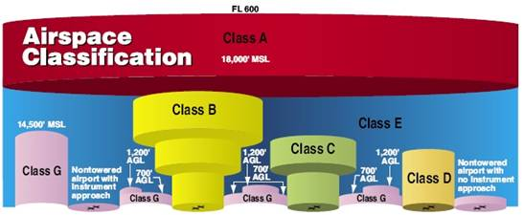
Course presentation figure: airspace classification example (source slide 56).

2.15 Latitude, Longitude, and Topography
A geographic grid of latitude and longitude allows any point on Earth to be described. Latitude lines run east-west and measure distance north or south of the Equator. Longitude lines run north-south and measure distance east or west of the Prime Meridian at Greenwich.
Coordinates may be expressed in degrees, minutes, and seconds. One degree contains 60 minutes and one minute contains 60 seconds. Sectional-chart questions may require you to estimate a location by reading this grid.
KEY NUMBERS 1 degree = 60 minutes. 1 minute = 60 seconds.
Topography matters operationally as well. Terrain can block line of sight and radio links, create local wind effects, and complicate the requirement to remain within the allowable height above the ground. Towers and other obstructions can also be difficult to see from a distance.
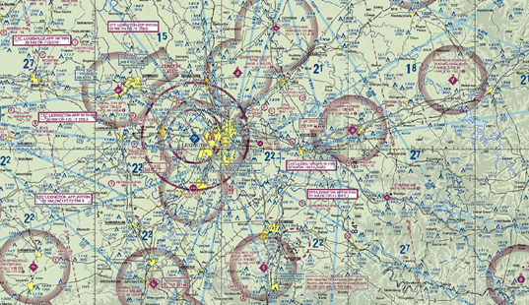
Course presentation topography/sectional-chart example (source slide 54).

2.16 Airport Operations
Remote pilots operating near airports must understand how crewed aircraft use the airport environment. Part 107 aircraft may not interfere with airport operations or traffic patterns, and small UAS must always yield right-of-way to other aircraft.
A standard traffic pattern normally uses left turns and consists of departure/upwind, crosswind, downwind, base, and final legs. Some airports use right traffic. Pattern altitude varies, but the course material notes that many traffic patterns are approximately 800 or 1,000 feet AGL.
REAL-WORLD POINT A crewed aircraft can be below normal pattern altitude while taking off, landing, practicing an approach, flying a helicopter route, conducting agricultural work, or responding to an emergency. Never treat pattern altitude as a protective floor for UAS operations.
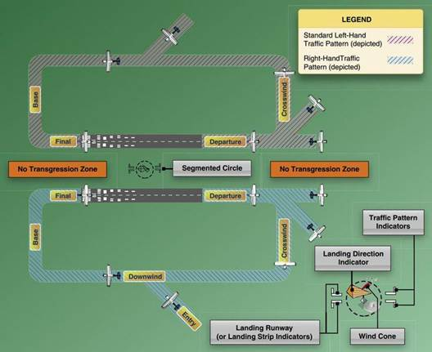
Course presentation airport traffic-pattern figure (source slide 57).

2.17 Runway Numbers, Markings, and Signs
Runway numbers are based on the runway's magnetic direction, rounded to the nearest ten degrees and with the final zero omitted. A runway aligned approximately 180 degrees magnetic is Runway 18; the opposite direction is approximately 360 degrees and is Runway 36. Parallel runways use L, C, or R for left, center, or right.
EXAM TIP Runway 18 points approximately south; Runway 36 points approximately north. Reciprocal runway numbers normally differ by 18.
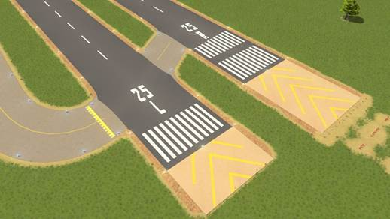
Course presentation runway-marking example (source slide 59).

2.18 Security Identification Display Areas (SIDA)
Some airport areas used for passenger or cargo functions are designated Security Identification Display Areas. Individuals in these areas must display airport-issued or other approved identification and comply with airport security requirements. For a UAS operator working on an airport, airspace authorization is only one part of the problem; physical access and airport security procedures may also apply.

2.19 Collision Avoidance
The course presentation emphasizes that many midair collisions occur in good visibility. Clear weather can increase traffic and can create a false sense of security. Effective scanning uses a series of short, regularly spaced eye movements rather than a continuous sweep.
A particularly important collision cue is relative motion. An aircraft on a collision course may appear nearly stationary in the field of view while growing larger. If another aircraft remains at the same relative bearing and its apparent size increases, treat the situation as a serious conflict.
When two crewed aircraft approach head-on, each normally alters course to the right. For UAS operations, however, the more fundamental Part 107 rule is simpler: the small UAS must yield to other aircraft and remain well clear.
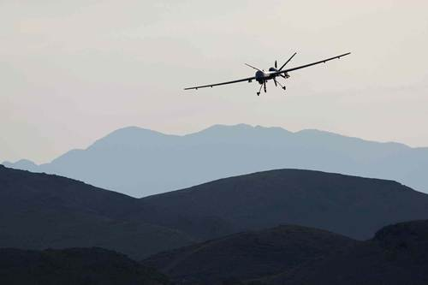
Course presentation collision-avoidance example (source slide 64).
MEMORY AID Little or no relative movement + increasing apparent size = possible collision course.

2.20 Inflight Hazards
Hazards around a UAS operating area include wildlife, towers, guy wires, terrain, low-flying aircraft, and temporary aviation activity. The course presentation notes that guy wires can extend a considerable horizontal distance from a tower and may be extremely difficult to see.
Wildlife strikes are not only a crewed-aircraft concern. Birds may attack or investigate UAS, and the remote PIC should avoid operating in a manner that creates a collision hazard or disturbs protected wildlife. The operating area should be continually reassessed rather than treated as safe simply because the preflight check was completed.

2.21 Chapter Summary
· The NAS includes the airspace, airports, facilities, procedures, and regulations that support U.S. aviation.
· Classes A, B, C, D, and E are controlled; Class G is uncontrolled.
· Part 107 requires prior FAA authorization for Class B, C, D, and Class E surface areas designated for an airport.
· Determine airspace at the UAS's actual altitude; controlled airspace above the aircraft does not automatically mean the aircraft is in it.
· Solid blue identifies Class B; solid magenta Class C; dashed blue Class D; dashed magenta Class E surface areas; faded magenta commonly indicates Class E beginning at 700 feet AGL.
· Special-use airspace and military activity can create hazards even when the basic airspace class would otherwise allow a flight.
· NOTAMs and TFRs can temporarily change the operating environment. LAANC does not override a TFR.
· Sectional charts, the Chart Supplement, AIM, Advisory Circulars, and current FAA/Flight Service information work together during preflight planning.
· Remote pilots should understand airport traffic patterns, runway numbering, markings, and security restrictions.
· UAS must yield to other aircraft. A target with little relative motion that grows larger may be on a collision course.

2.22 Knowledge Check
1. Which classes of airspace are considered controlled airspace?
2. What is the only uncontrolled airspace class used in the United States?
3. Which controlled airspace classes normally require prior FAA authorization for Part 107 operations?
4. Does Class E beginning at 700 feet AGL automatically require authorization for a UAS operating at 200 feet AGL?
5. What sectional-chart color and line style normally identifies Class B?
6. What identifies Class C?
7. What identifies Class D?
8. What does a dashed magenta boundary normally indicate?
9. What does a faded magenta vignette normally indicate?
10. What is the lower boundary of Class A airspace?
11. What is the typical radius of the Class C surface core?
12. What is the difference between uncontrolled and unregulated airspace?
13. What is the primary purpose of a NOTAM?
14. Can a LAANC authorization override an active TFR?
15. Name three situations that may result in a TFR.
16. What is the purpose of a Pointer NOTAM?
17. What FAA publication contains detailed airport and facility information and was formerly called the A/FD?
18. How many minutes are in one degree of latitude or longitude?
19. What are the five principal legs of a standard airport traffic pattern?
20. What direction are turns in a standard traffic pattern?
21. What approximate magnetic heading is represented by Runway 27?
22. What do L, C, and R mean when used with parallel runway numbers?
23. What should a remote pilot do when another aircraft approaches the operating area?
24. Why can an aircraft with little apparent relative movement be dangerous?
25. Why should a remote pilot check current NOTAMs even when using a current sectional chart?

Answer Key
1. A, B, C, D, and E.
2. Class G.
3. Class B, C, D, and the surface area of Class E designated for an airport.
4. No. At 200 feet AGL the UAS may still be in Class G; determine the actual airspace at the operating altitude.
5. Solid blue.
6. Solid magenta.
7. Dashed blue.
8. Class E beginning at the surface.
9. An area where Class E commonly begins at 700 feet AGL.
10. 18,000 feet MSL.
11. Typically 5 NM.
12. Class G is uncontrolled by ATC, but FAA regulations still apply.
13. To provide time-critical aeronautical information not necessarily shown in normal publications.
14. No.
15. Examples: VIP/presidential movement, wildfire/disaster response, major sporting event, space operation, airshow.
16. It directs the pilot to another NOTAM containing relevant information.
17. Chart Supplement U.S.
18. 60.
19. Upwind/departure, crosswind, downwind, base, and final.
20. Left, unless right traffic is specified.
21. Approximately 270 degrees magnetic.
22. Left, Center, and Right.
23. Yield right-of-way and remain well clear.
24. Constant relative bearing with increasing size can indicate a collision course.
25. NOTAMs and TFRs can change the operating environment after the chart was published.

Sources and Update Notes
Primary instructional source: National Airspace System-107 course presentation supplied for this textbook project, including its speaker notes.
Current-rule verification: Federal Aviation Administration Remote Pilot - Small Unmanned Aircraft Systems Study Guide; FAA Aeronautical Information Manual, Chapter 3; FAA Part 107 Airspace Authorizations; FAA NOTAM/TFR resources; and current FAA VFR chart resources. The presentation's instructional organization and terminology were preserved where practical, while outdated items were identified and modernized for this 2026 edition.
This chapter is intended for FAA Remote Pilot knowledge-test preparation. Pilots should consult current charts, NOTAMs, TFRs, airspace authorizations, and FAA regulations before an actual operation.
FAA REMOTE PILOT TEST PREP
Chapter 3
Weather

Weather Theory • Wind • Stability • Clouds • Thunderstorms • Icing • Fog • Density Altitude • METARs • TAFs
2026 EDITION Built from the Weather course presentation and expanded for textbook study. The chapter preserves the presentation's instructional sequence while clarifying several older terms and using current FAA/Aviation Weather Center resources where appropriate.

How to Use This Chapter
Weather questions on the FAA Remote Pilot knowledge test are usually practical. You may be asked to identify a hazardous condition, interpret a METAR or TAF, determine whether visibility and cloud clearance meet Part 107 requirements, or explain how temperature, pressure, wind, and humidity affect aircraft performance. The best way to study weather is to connect each weather concept to a flight decision.

Learning Objectives
· Explain how unequal heating of Earth's surface drives weather and pressure differences.
· Describe thermals, wind, wind shear, air masses, fronts, and atmospheric stability.
· Compare stable and unstable air and identify common cloud and precipitation patterns.
· Apply Part 107 visibility and cloud-clearance requirements.
· Describe thunderstorm development and the hazards associated with thunderstorms, icing, fog, and turbulence.
· Explain density altitude and how high density altitude affects UAS performance.
· Identify common aviation weather sources, including ASOS, AWOS, METARs, TAFs, SIGMETs, and graphical aviation-weather products.
· Decode basic METAR and TAF information used on the FAA knowledge test.

3.1 Why Weather Matters to UAS Operations
Weather affects both the legal limits and the physical performance of a small UAS. Wind can exceed the aircraft's ability to return to the launch point, precipitation can damage electronics, low clouds can violate cloud-clearance requirements, high density altitude can reduce lift and thrust, and unstable air can create turbulence that exceeds the capability of a small aircraft.
The presentation begins with a fundamental idea: most weather processes are driven by unequal heating of Earth's surface. Land, water, vegetation, pavement, snow, and terrain absorb and release heat at different rates. Those temperature differences create differences in pressure and density, which in turn drive wind, convection, cloud formation, and many of the weather patterns pilots observe.
FLIGHT DECISION Weather is not only a forecast problem. A remote PIC should compare forecast conditions with the actual conditions at the operating site and be prepared to delay, shorten, or terminate a flight when conditions deteriorate.

3.2 Atmospheric Pressure, Altimeter Settings, and Temperature
Atmospheric pressure is the force exerted by the weight of the atmosphere. Pressure decreases with altitude, which is why barometric altimeters can estimate height. Aviation altimeter settings are adjusted to a sea-level reference so aircraft using the same local setting can compare altitudes consistently.
Standard sea-level pressure is 29.92 inches of mercury, and standard sea-level temperature is 15°C (59°F). These standard values are important because departures from standard pressure and temperature change air density and therefore aircraft performance.
KEY NUMBERS Standard sea-level pressure: 29.92 inHg. Standard sea-level temperature: 15°C (59°F).
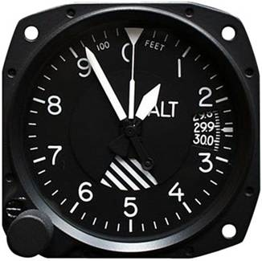
The presentation uses a conventional aircraft altimeter to introduce pressure-based altitude measurement (source slide 5).

3.3 Thermals and Convective Currents
A thermal is a rising column of warmer air produced by uneven surface heating. Dark, dry ground, plowed fields, pavement, and rocky terrain can heat rapidly and become strong thermal sources. Moist areas, marshes, and heavily vegetated surfaces tend to heat more slowly and usually produce weaker thermals.
For small UAS, thermals can create vertical gusts, turbulence, and unexpected altitude changes. They can be especially noticeable on sunny afternoons over uneven terrain. A temperature inversion, by contrast, suppresses vertical mixing and produces more stable air.
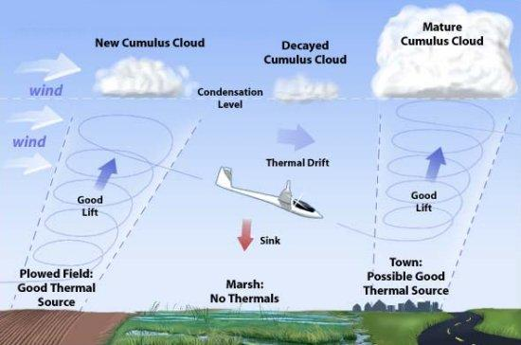
Thermals form over stronger heat sources and drift with the wind; moist terrain is generally a weaker thermal source (source slide 6).

3.4 Moisture: Evaporation, Condensation, Sublimation, and Dew Point
Water continuously changes phase in the atmosphere. Evaporation is the change from liquid water to water vapor. Condensation is the change from vapor to liquid droplets. Sublimation is a direct change between solid ice and water vapor without passing through the liquid phase.
Clouds, fog, dew, frost, precipitation, and icing all depend on atmospheric moisture. The dew point is the temperature to which air must cool for saturation to occur. When air temperature and dew point move close together, the likelihood of fog or low cloud formation increases.
EXAM TIP A small temperature-dew point spread means the air is close to saturation. Expect an increased possibility of fog, clouds, dew, or frost when sufficient cooling occurs.

3.5 Wind and Wind Shear
Wind is one of the most important weather factors for small UAS. Terrain, buildings, trees, ridgelines, surface roughness, and local heating can change both wind speed and direction close to the ground. A weather station several miles away may therefore report conditions that differ substantially from conditions at the launch site.
Strong winds can reduce groundspeed on an upwind leg, increase battery consumption, complicate landing, and make it difficult or impossible to return to the launch point. Gusts can exceed the steady wind value and may be more important than the average wind when evaluating whether a small UAS can safely operate.
Wind shear is a rapid change in wind speed, wind direction, or both over a relatively small distance. It can occur at any altitude, but wind shear close to the surface is especially hazardous because the aircraft has little altitude or time to recover.
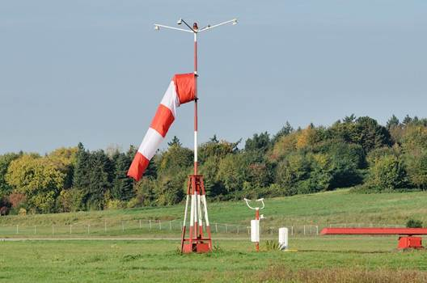
A windsock provides a quick visual indication of surface wind direction and approximate speed (source slide 8).
REAL-WORLD UAS TIP Plan the first part of the flight into the wind when possible. Returning with a tailwind preserves energy margin if winds increase during the mission.

3.6 Air Masses, Fronts, Ridges, and Troughs
An air mass is a large body of air with relatively uniform temperature and moisture characteristics. A front is the boundary between two different air masses. Temperature change, pressure change, and a shift in wind direction or speed are common signs of frontal passage.
A ridge is an elongated area of relatively high pressure. A trough is an elongated area of relatively low pressure. Fronts and troughs are important because they often organize clouds, precipitation, wind shifts, and thunderstorms over large areas.
Cold fronts generally move faster than warm fronts. Cold fronts may be associated with strong showers, thunderstorms, gusty winds, and rapid weather changes. Warm fronts often produce more widespread low ceilings, precipitation, and reduced visibility ahead of the surface boundary.
EXAM TIP A frontal passage is commonly associated with a temperature change, a pressure trend that changes as the front passes, and a shift in wind direction and/or speed.

3.7 Atmospheric Stability
Atmospheric stability describes the atmosphere's tendency to resist or encourage vertical motion. Stable air resists vertical displacement. Unstable air encourages rising and sinking motion and therefore tends to produce more turbulence and convective cloud development.
Unstable Air | Stable Air
Cumuliform clouds | Stratiform clouds and fog
Showery precipitation | Steady or continuous precipitation
Rough air / turbulence | Generally smoother air
Often good visibility between showers | Fair to poor visibility in haze, smoke, or fog
The lapse rate is the rate at which air temperature changes with increasing altitude. Adiabatic cooling occurs when rising air expands as pressure decreases and cools without exchanging heat with its surroundings. The relationship between the environmental lapse rate and the cooling rate of a rising parcel helps determine whether the atmosphere is stable or unstable.
A temperature inversion occurs when temperature increases with altitude rather than decreasing. The warmer air aloft acts like a lid that suppresses vertical mixing. Smoke, haze, fog, and pollutants can become trapped beneath the inversion and reduce visibility.

A temperature inversion can trap fog and pollutants in valleys and other low terrain (source slide 21).

3.8 Clouds and What They Tell a Pilot
Cloud shape provides clues about atmospheric stability. Cumuliform clouds are associated with rising unstable air. Stratiform clouds are associated with more stable air and widespread layered cloud cover. Lenticular clouds form in strong airflow over mountains and are a warning of mountain-wave activity and potentially severe turbulence.
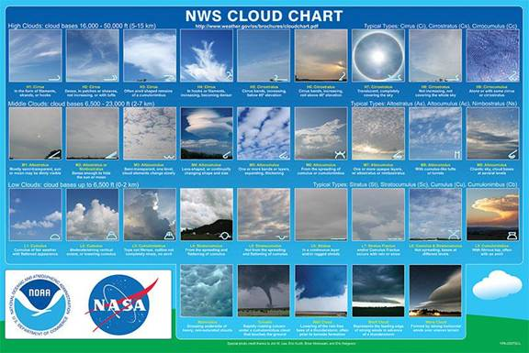
The NWS cloud chart in the presentation groups high, middle, and low cloud types and shows common cloud forms (source slide 14).
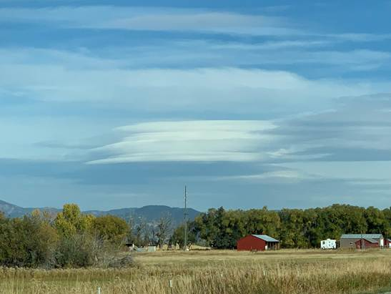
Lenticular clouds are commonly associated with strong winds and mountain-wave conditions (source slide 16).
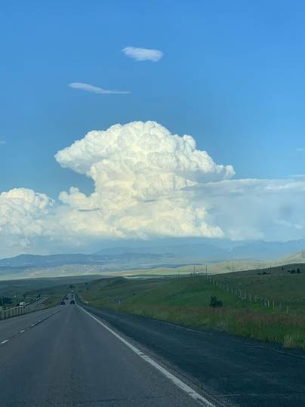
Strong vertical development in a cumuliform cloud is a warning that convective activity is increasing (source slide 18).

3.9 Part 107 Visibility and Cloud Clearance
Part 107 establishes minimum visibility and cloud-separation requirements. Flight visibility must be at least 3 statute miles as observed from the location of the control station. The small UAS must remain at least 500 feet below a cloud and at least 2,000 feet horizontally from a cloud.
Requirement | Part 107 Minimum
Flight visibility | 3 statute miles
Below clouds | 500 feet
Horizontal distance from clouds | 2,000 feet
KEY NUMBERS 3 SM visibility • 500 ft below clouds • 2,000 ft horizontally from clouds.
These limits matter even for very low UAS operations. A low cloud deck can make a planned 400-foot flight illegal or unsafe, and reduced visibility can make it difficult to maintain visual line of sight or detect nearby aircraft.

3.10 Thunderstorms
Thunderstorms are among the most hazardous weather phenomena for aviation. They can produce severe turbulence, strong updrafts and downdrafts, lightning, hail, heavy precipitation, gust fronts, microbursts, and wind shear. Small UAS operations in or near thunderstorms should be avoided.
Three ingredients are needed for thunderstorm development: sufficient moisture, an unstable atmosphere, and a lifting mechanism. The thunderstorm life cycle is commonly described in three stages.
Stage | Dominant Motion | Key Characteristics
Cumulus | Updrafts | Cloud grows vertically; little or no precipitation reaches the ground.
Mature | Updrafts and downdrafts | Greatest intensity; precipitation, turbulence, lightning, hail, and gust fronts may occur.
Dissipating | Downdrafts | Updraft weakens; precipitation and downdrafts dominate as the cell decays.
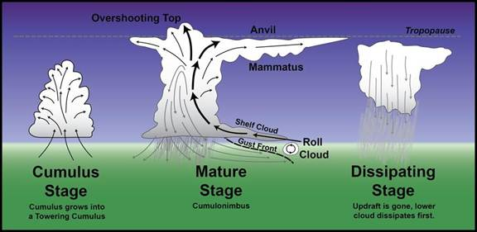
Thunderstorm life cycle: cumulus, mature, and dissipating stages (source slide 23).
Squall lines are particularly dangerous because they can contain long lines of intense thunderstorms with little or no safe path between cells. Wind shear associated with convection may extend well beyond the visible cloud and can occur at any altitude.
EXAM TIP The mature stage is generally the most hazardous stage because strong updrafts and downdrafts coexist. Precipitation beginning to fall from a growing cell signals that downdrafts have developed and the storm is entering the mature stage.

3.11 Icing and Frost
Ice changes the aerodynamic shape of wings, propellers, and rotors. It increases weight and drag while reducing lift and thrust. On small UAS, even a small amount of ice can be significant because the aircraft has limited excess power and small lifting surfaces.
The presentation identifies two conditions required for structural icing in flight: visible liquid moisture such as cloud droplets or rain, and a surface temperature at or below freezing. Freezing rain is especially dangerous because supercooled droplets can form clear ice rapidly.
· Lift decreases.
· Drag increases.
· Weight increases.
· Stall speed can increase on fixed-wing aircraft.
· Propeller or rotor efficiency can decrease.
· Available thrust and control margin decrease.
Frost can form on cool, clear, calm nights when a surface cools below the dew point and below freezing. Frost should be removed before flight; a thin layer can disturb airflow and reduce performance.
REAL-WORLD UAS TIP Do not assume a drone is safe merely because precipitation is light. Cold mist, cloud droplets, freezing fog, or freezing rain can create ice quickly on small propellers and exposed sensors.

3.12 Fog
Fog forms when air near the surface becomes saturated. When air temperature and dew point are close, only a small amount of additional cooling may be needed for fog to develop.
Fog Type | How It Forms | Typical Clue
Radiation fog | Ground cools on a clear, calm night and cools adjacent moist air to the dew point. | Light wind, clear night, low terrain.
Advection fog | Warm moist air moves over a colder surface. | Wind is required; common near coasts.
Upslope fog | Moist stable air is forced uphill and cools as it rises. | Wind flowing toward rising terrain.
Steam fog | Cold dry air moves over warmer water. | Cold-season lakes or rivers.
Precipitation-induced fog | Rain falls into cooler air, increasing moisture and saturation. | Warm rain falling through cooler air.

The presentation compares radiation, advection, and upslope fog (source slide 30).
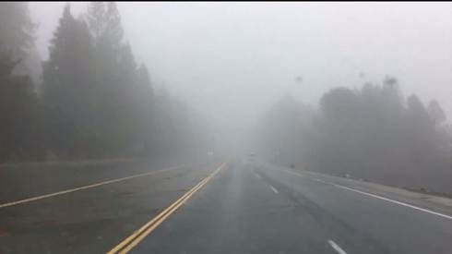
Steam fog can form when cold air moves over relatively warm water (source slide 31).
EXAM TIP Radiation fog favors clear skies, moist air, and light or calm wind. Advection fog requires wind because moist air must move over a colder surface.

3.13 Density Altitude and UAS Performance
Density altitude is pressure altitude corrected for nonstandard temperature. In practical terms, it describes how dense the air 'feels' to the aircraft. High density altitude means thin air and reduced aircraft performance.
The conditions that increase density altitude include higher elevation, lower atmospheric pressure, higher temperature, and higher humidity. Humidity normally has a smaller effect than pressure and temperature but still reduces air density because water vapor is lighter than dry air.
Condition | Effect on Density Altitude | Effect on Performance
Higher elevation | Increases | Decreases
Lower pressure | Increases | Decreases
Higher temperature | Increases | Decreases
Higher humidity | Increases slightly | Decreases slightly
For a fixed-wing UAS, reduced air density means less lift at a given true airspeed and reduced propeller thrust. For a multirotor, the rotors must work harder to produce the required lift. A battery-powered UAS may therefore experience reduced climb performance and shorter useful endurance under hot, high conditions.
MEMORY AID High + Hot + Low Pressure + Humid = High Density Altitude = Lower Performance.

3.14 Obtaining a Weather Briefing
The presentation directs pilots to obtain a weather briefing before flight and identifies AviationWeather.gov and Flight Service as important sources. Modern aviation weather planning is increasingly graphical, but the fundamental task is unchanged: build a complete picture of current conditions, forecasts, hazards, and trends that could affect the operation.
For a short UAS mission, useful weather information includes surface wind and gusts, visibility, ceiling, temperature, dew point, precipitation, thunderstorms, nearby fronts, smoke or haze, and any expected change during the planned operating window.
PRE-FLIGHT WEATHER CHECK Current conditions → Forecast trend → Wind/gust margin → Visibility/ceiling → Thunderstorms/precipitation → Temperature/dew point → Density altitude/performance → Local terrain effects.

3.15 Surface Weather Observations: ASOS and AWOS
ASOS (Automated Surface Observing System) and AWOS (Automated Weather Observing System) provide automated observations at many airports. These systems can report wind, visibility, temperature, dew point, altimeter setting, cloud information, and other weather elements depending on the installation.
Airport observations are valuable, but the remote PIC must remember that a station describes conditions at the station. Hills, valleys, buildings, vegetation, and distance can produce different conditions at the actual UAS site.
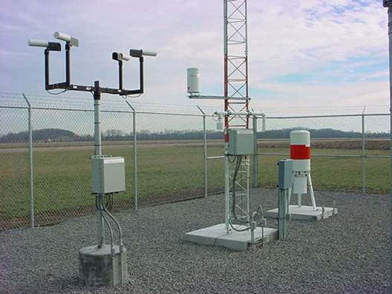
An automated airport weather observation station such as ASOS/AWOS provides measured surface conditions (source slide 35).

3.16 METAR: Aviation Routine Weather Report
A METAR is a coded aviation weather observation. It reports what has been observed at or near an airport weather station. The presentation labels METAR as an international weather-reporting code; importantly, a METAR is an observation, not a forecast.
A typical METAR contains the station identifier, observation time in UTC (Zulu), wind, visibility, present weather, sky condition, temperature/dew point, altimeter setting, and remarks.
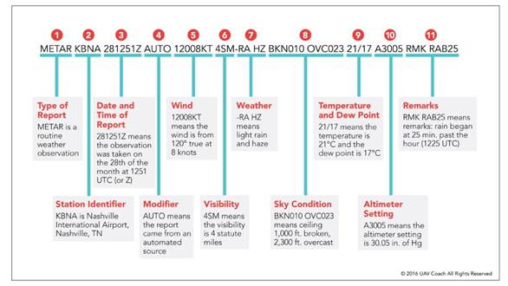
Annotated METAR example from the presentation showing the order of common report elements (source slide 36).

3.17 Decoding a METAR
METAR KBNA 281251Z AUTO 12008KT 4SM -RA HZ BKN010 OVC023 21/17 A3005 RMK RAB25
Group | Meaning
METAR | Routine aviation weather observation.
KBNA | Station identifier: Nashville International Airport.
281251Z | Observed on the 28th at 1251 UTC.
AUTO | Automated report.
12008KT | Wind from 120° true at 8 knots.
4SM | Visibility 4 statute miles.
-RA HZ | Light rain and haze.
BKN010 OVC023 | Broken clouds at 1,000 ft; overcast at 2,300 ft.
21/17 | Temperature 21°C; dew point 17°C.
A3005 | Altimeter 30.05 inHg.
RMK ... | Remarks follow.
EXAM TIP Cloud heights in METARs and TAFs are reported in hundreds of feet AGL. BKN010 means a broken layer at 1,000 feet AGL.

3.18 TAF: Terminal Aerodrome Forecast
A TAF is a coded forecast for conditions expected in the vicinity of a terminal area during a specified valid period. It uses many of the same abbreviations as a METAR, but it includes forecast-change groups such as FM (from), TEMPO (temporary), and BECMG (becoming).
TAFs are useful for determining whether conditions are expected to improve or deteriorate during a mission window. As with all airport-based products, the remote PIC must consider whether local terrain and distance make the forecast representative of the actual UAS operating site.
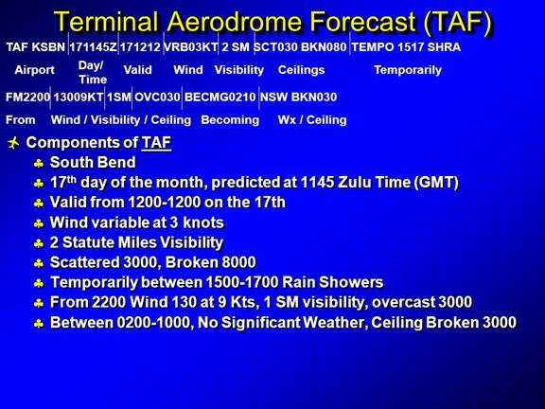
TAF example from the presentation, annotated to show issue time, validity, wind, visibility, ceilings, and change groups (source slide 38).

3.19 SIGMETs, Convective SIGMETs, and Graphical Aviation Weather
SIGMETs identify significant weather hazards that can affect aircraft. Convective SIGMETs are associated with hazardous convective weather such as severe thunderstorms, embedded thunderstorms, lines of thunderstorms, and other organized convection meeting issuance criteria. A small UAS should not be operated in an area affected by severe convective weather.
Current Aviation Weather Center products also include Graphical Forecasts for Aviation (GFA), G-AIRMETs, radar, satellite imagery, METAR/TAF displays, SIGMETs, icing, turbulence, wind, ceiling, visibility, and other layers. These graphical products make it easier to see how hazards relate spatially to a planned operating area.
2026 UPDATE The Aviation Weather Center discontinued CONUS text AIRMETs in January 2025; G-AIRMETs are now the primary CONUS AIRMET-format advisory product. Students may still encounter older references in legacy study material.

3.20 Weather Decision Making for a Remote PIC
Weather information is useful only if it changes decisions. A remote PIC should establish personal and aircraft-specific limits before arriving at the field. Those limits may be more conservative than the regulatory minimums.
· Know the manufacturer's wind and precipitation limitations.
· Consider gusts, not just sustained wind.
· Evaluate whether the aircraft can return upwind with adequate battery reserve.
· Watch temperature-dew point spread for fog and low-cloud potential.
· Avoid thunderstorms and rapidly developing convection.
· Consider density altitude when operating hot, high, or heavily loaded.
· Recheck conditions during the flight; weather can change during even a short mission.
· Land early when conditions approach the limit instead of waiting until the operation becomes an emergency.
SCENARIO A mission begins with wind at 8 knots and gusts to 12. Twenty minutes later gusts reach 20 knots and the aircraft is returning slowly against the wind. The correct decision is not to 'use the remaining battery.' Terminate the mission and recover while adequate energy and control margin remain.

3.21 Chapter Summary
· Unequal heating of Earth's surface drives pressure differences, convection, and many weather processes.
· Thermals form over stronger heat sources and can create vertical currents and turbulence.
· Wind and wind shear can reduce UAS control margin and endurance; local terrain may make site conditions differ from airport reports.
· Fronts separate different air masses. Frontal passage commonly brings temperature, pressure, and wind changes.
· Unstable air favors turbulence, cumuliform clouds, and showery precipitation; stable air favors stratiform clouds, fog, haze, and smoother conditions.
· Part 107 requires at least 3 statute miles of flight visibility, 500 feet below clouds, and 2,000 feet horizontally from clouds.
· Thunderstorms require moisture, instability, and lift. The mature stage is usually the most intense.
· Icing increases drag and weight while reducing lift and thrust. Frost should be removed before flight.
· Fog commonly forms when temperature and dew point converge.
· High density altitude means thin air and reduced aircraft performance.
· METARs report observed weather; TAFs forecast terminal weather.
· Use current FAA/Aviation Weather Center tools to evaluate hazards and trends before and during UAS operations.

3.22 Knowledge Check
1. What fundamental process drives most weather on Earth?
2. What is a thermal?
3. Which generally produces stronger thermals: dry plowed ground or a moist marsh?
4. Define wind shear.
5. Name three common indications of frontal passage.
6. Which generally moves faster, a cold front or a warm front?
7. What type of clouds are commonly associated with unstable air?
8. What type of clouds are commonly associated with stable air?
9. What is a temperature inversion?
10. What is the Part 107 minimum flight visibility?
11. What are the Part 107 cloud-clearance requirements?
12. What three ingredients are required for thunderstorm development?
13. During which thunderstorm stage are updrafts and downdrafts both present?
14. What change signals that a growing thunderstorm cell is entering the mature stage?
15. What two basic conditions are necessary for structural icing?
16. What happens to lift and drag when ice accumulates on an aircraft?
17. What weather relationship indicates that fog may soon form?
18. What conditions favor radiation fog?
19. What is required for advection fog to form?
20. What conditions increase density altitude?
21. How does high density altitude affect aircraft performance?
22. Is a METAR an observation or a forecast?
23. What does 12008KT mean in a METAR?
24. What does BKN010 mean?
25. What does A3005 mean?
26. What is a TAF?
27. What does TEMPO indicate in a TAF?
28. What kind of weather is associated with a Convective SIGMET?
29. Why might the weather at an airport differ from the weather at a UAS operating site several miles away?
30. Why should a remote PIC establish weather limits more conservative than the legal minimums?

Answer Key
1. Unequal heating of Earth's surface.
2. A rising column of warmer air produced by convective heating.
3. Dry plowed ground.
4. A rapid change in wind speed, direction, or both over a small distance.
5. Temperature change, pressure trend change, and a shift in wind direction and/or speed.
6. A cold front.
7. Cumuliform clouds.
8. Stratiform clouds and fog.
9. A layer in which temperature increases with altitude; it tends to suppress vertical mixing.
10. 3 statute miles.
11. At least 500 feet below and 2,000 feet horizontally from clouds.
12. Moisture, instability, and a lifting mechanism.
13. The mature stage.
14. Precipitation beginning to fall from the cloud base, indicating downdraft development.
15. Visible liquid moisture and a surface temperature at or below freezing.
16. Lift decreases and drag increases; weight also increases and thrust/control margin may decrease.
17. Air temperature and dew point becoming equal or very close.
18. Clear sky, moist air, light/calm wind, and nighttime surface cooling.
19. Wind carrying warm moist air over a colder surface.
20. High elevation, low pressure, high temperature, and high humidity.
21. It reduces lift, thrust, climb performance, and overall performance margin.
22. An observation.
23. Wind from 120 degrees true at 8 knots.
24. Broken cloud layer at 1,000 feet AGL.
25. Altimeter setting 30.05 inches of mercury.
26. A Terminal Aerodrome Forecast for expected weather in the terminal area during a defined valid period.
27. Temporary conditions are forecast during the stated time period.
28. Significant convective weather such as severe, embedded, or organized thunderstorms.
29. Terrain, surface heating, buildings, vegetation, elevation, and distance can produce local weather differences.
30. Legal minimums do not account for the performance limits of every aircraft, mission, pilot, or operating site.

Sources and Update Notes
Primary instructional source: Weather-107 course presentation supplied for this textbook project, including its figures and instructional sequence.
Current-rule and product verification for this draft: Federal Aviation Administration Remote Pilot - Small Unmanned Aircraft Systems Study Guide and current NOAA/NWS Aviation Weather Center resources. The chapter preserves the source presentation's core concepts while clarifying that METAR is an observation rather than a forecast and noting the 2025 transition from CONUS text AIRMETs to G-AIRMETs.
This chapter is instructional material for FAA Remote Pilot knowledge-test preparation. Pilots should use current aviation weather observations, forecasts, advisories, aircraft limitations, and FAA regulations before conducting an actual operation.
Chapter 4
Operations
FAA Remote Pilot Part 107 Exam Study Guide
This chapter develops the operational knowledge needed to safely plan, conduct, and manage small unmanned aircraft system (sUAS) flights. It follows the Operations lesson material and emphasizes practical application, crew coordination, emergency planning, aeronautical decision making, human factors, and maintenance.

Chapter Objectives
· Explain the remote pilot in command’s responsibility for determining that an sUAS is in a condition for safe operation.
· Use a systematic preflight process to inspect the aircraft, control station, payload, batteries, communications links, and supporting equipment.
· Interpret common airport traffic-pattern calls and basic aviation radio phraseology.
· Explain how radio-frequency interference can affect UAS command, telemetry, and video links.
· Describe appropriate planning and responses for lost link, flyaways, loss of GPS/GNSS, flight termination, and lithium-battery hazards.
· Apply aeronautical decision making (ADM), crew resource management (CRM), and situational awareness to UAS operations.
· Recognize hazardous attitudes and common physiological factors that can degrade pilot performance.
· Explain basic maintenance and inspection practices and organize a safe training flight.

4.1 The Remote PIC and Safe Operation
The remote pilot in command (remote PIC) is responsible for determining whether the aircraft is in a condition for safe flight. A successful flight on the previous mission is not proof that the system is safe for the next one. Transportation, a hard landing, a payload change, a repair, a firmware update, or a battery change can introduce new hazards.
Preflight inspection should therefore be thorough, systematic, and performed before each operation. A checklist helps the pilot perform the same critical checks every time and reduces the chance that familiarity or time pressure will cause a step to be skipped.
When a component is damaged or questionable, the conservative response is to remove the aircraft from service until the problem is corrected. Repairs and replacement of components should follow the manufacturer’s recommendations whenever they are available.
KEY POINT: The remote PIC makes the final determination that the entire UAS—not merely the airframe—is ready for safe operation.

A Systematic Preflight Inspection
· Visually inspect the airframe and system components for cracks, looseness, bending, damage, or anything out of place.
· For fixed-wing aircraft, inspect wings, fuselage, hinges, control linkages, control surfaces, propeller, motor, and attachment points.
· Verify the correct battery or energy source, adequate charge for the mission and reserve, secure installation, and no swelling or physical damage.
· Secure cameras, sensors, and other payload equipment. Payload movement can change center of gravity or allow equipment to separate in flight.
· Check required registration markings and identification.
· Inspect avionics, wiring, antennas, the controller/ground station, and communications links.
· Perform sensor or compass calibration when required by the manufacturer or operating conditions.
· Perform functional checks. For fixed-wing UAS, verify that ailerons, elevator, and rudder move freely and in the correct direction.
· Confirm propulsion, GPS/GNSS, telemetry, and other mission-critical systems operate as expected.
EXAM TIP: Think of the preflight as an inspection of the complete system: aircraft, power source, payload, controller, communications, navigation systems, crew, and operating environment.

4.2 Communication and Crew Coordination
Good communication is a core element of crew resource management. The remote PIC, visual observer (VO), and other crew members should understand their roles before flight and should have a clear method for communicating hazards, traffic, aircraft status, and changes to the mission.
Crew members should continuously maintain situational awareness by scanning for crewed aircraft, people, obstacles, and other collision hazards. A visual observer can assist the remote PIC, but useful communication must be specific. A call such as “Traffic, two o’clock, low, moving left to right” provides far more information than simply shouting “airplane.”
Before flight, the crew should agree on important words such as abort, land, hold, traffic, lost link, and the phrases used to transfer control. Clear terminology reduces ambiguity during high-workload situations.

The ICAO Phonetic Alphabet
Letter | Word | Letter | Word
A | Alpha | N | November
B | Bravo | O | Oscar
C | Charlie | P | Papa
D | Delta | Q | Quebec
E | Echo | R | Romeo
F | Foxtrot | S | Sierra
G | Golf | T | Tango
H | Hotel | U | Uniform
I | India | V | Victor
J | Juliett | W | Whiskey
K | Kilo | X | X-ray
L | Lima | Y | Yankee
M | Mike | Z | Zulu
Aircraft identification is commonly spoken using the phonetic alphabet, and numbers are generally spoken individually. For example, N123AB is spoken as “November One Two Three Alpha Bravo.”

Understanding Airport Traffic Calls
When operating near an airport, a remote pilot should understand how crewed aircraft move through the traffic pattern. A standard pattern includes departure/upwind, crosswind, downwind, base, and final. Most standard patterns use left turns, although right-hand patterns are used at some runways.
“Entering left downwind Runway 18” — The aircraft is parallel to Runway 18 on the downwind leg in a left-hand pattern.
“Turning left base Runway 36” — The aircraft is approaching the runway environment and will soon turn final.
“Short final Runway 36” — The aircraft is very close to the runway and about to land.
“Upwind Runway 36, departing the area northwest” — The aircraft is climbing away from the runway and intends to leave the airport area toward the northwest.
“Departing Runway 18, remaining in the pattern” — The aircraft will continue flying the airport traffic pattern rather than leaving the area.
Distance from an airport alone does not define the collision risk. The remote PIC should consider runway orientation, the active traffic pattern, and where aircraft are likely to climb, descend, or turn. Monitoring the CTAF can improve situational awareness when appropriate, but radio monitoring never replaces visual scanning because some aircraft may not transmit or may not have a radio.

Common Aviation Radio Terms
Term | Meaning
Affirmative | Yes.
Negative | No, or permission not granted.
Roger | I have received your transmission; it does not necessarily mean yes or that the speaker will comply.
Wilco | I understand your message and will comply.
Say again | Repeat the last transmission.
Stand by | Wait; I will get back to you.
Unable | I cannot comply with the instruction or request.
Verify | Confirm specified information.
Read back | Repeat the instruction or information so it can be checked.

Initial Radio Contact
An initial callup is the first transmission to a particular ATC facility or the first call after being transferred to another controller or Flight Service specialist. A useful memory aid is:
WHO you are calling → WHO you are → WHAT you want
For example: “Bozeman Tower, November One Two Three Alpha Bravo, request transition through Class Delta airspace.” The word “over” is generally unnecessary in routine VHF aviation communication.
A longer ATC exchange may include a request, an assigned transponder code (“squawk”), an instruction to IDENT, confirmation of radar contact, altitude instructions, and an altimeter setting. Even if a remote pilot does not routinely talk to ATC, understanding this language helps the pilot interpret nearby crewed-aircraft activity.

4.3 sUAS Radio Frequencies and Interference
UAS commonly depend on radio-frequency links for command and control, telemetry, and video/data transmission. In the United States, the radio-frequency spectrum is regulated by the Federal Communications Commission (FCC). Two bands commonly used by consumer and commercial UAS are 2.4 GHz and 5.8 GHz.
These bands are also used by Wi-Fi and many other devices. In dense RF environments, interference may reduce range, degrade video, increase latency, or cause a command-and-control link to be lost. Buildings, terrain, trees, vehicles, and antenna orientation can also reduce signal quality.
Modern systems may use either 2.4 GHz or 5.8 GHz—or switch between them—for control, telemetry, and video. Pilots should therefore know the behavior of the specific UAS rather than memorizing a fixed rule that one band is always control and the other is always video.
KEY POINT: Know what your aircraft will do if the radio link is lost. Lost-link behavior should be configured and understood before takeoff.

4.4 Emergency and Abnormal Procedures
Emergency planning is most effective when it occurs before the emergency. The remote PIC should know how the aircraft is configured to respond to failures and should decide in advance what actions the crew will take.

Lost Link
Lost link is the loss of the command-and-control communications link between the control station and the aircraft. Depending on the system, the aircraft may return to home, hold or loiter, continue a programmed route, or land. The pilot should know the programmed behavior, return-home altitude, home point, expected endurance, and any hazards along the automated route. If the event could affect controlled airspace or create a hazard to other aircraft, appropriate ATC notification may be necessary.

Flight Termination
Flight termination means intentionally ending the flight when continuing would create a greater hazard. Depending on the aircraft, this could mean an immediate landing or use of a dedicated termination function. Protecting people and other aircraft takes priority over saving the UAS.

Flyaways
A flyaway occurs when the crew loses the ability to control the UAS and it continues in an unintended manner. Lost link may contribute, but navigation failures, incorrect programming, sensor faults, and other malfunctions can also be involved. If a flyaway threatens controlled airspace or other aircraft, the crew should provide useful information as quickly as practical, such as last known position, altitude, direction of flight, and estimated remaining endurance.

Loss of GPS/GNSS
Loss of GPS/GNSS does not automatically mean loss of aircraft control. Many UAS can still be manually controlled, but position hold, autonomous navigation, geospatial functions, and return-to-home may be degraded or unavailable. The remote PIC should understand the aircraft’s non-GPS flight mode and have a plan for safely recovering or landing the aircraft.

Lithium Battery Fires
Lithium-ion and lithium-polymer batteries can enter thermal runaway when damaged, overheated, overcharged, or otherwise compromised. Affected cells can become extremely hot and may ignite neighboring cells. Batteries that are swollen, punctured, physically damaged, unusually hot, or otherwise questionable should be removed from service.
SCENARIO: Your UAS loses GPS but still responds normally to manual control. Do not assume a flyaway is inevitable. Stabilize the aircraft, determine which automated functions are unavailable, and use the predetermined recovery plan for that aircraft.

4.5 Aeronautical Decision Making
Aeronautical Decision Making (ADM) is a systematic approach to the mental process pilots use to determine the best course of action for a given set of circumstances. Good ADM is based on recognizing hazards, evaluating risk, and deliberately reducing risk before it develops into an accident.
Concept | Operational Meaning
Situational Awareness | Understanding what is happening around the operation and anticipating what may happen next. Airspace, weather, terrain, obstacles, people, nearby aircraft, privacy concerns, and regulatory requirements all contribute.
Aeronautical Decision Making (ADM) | A systematic process for identifying hazards, assessing risk, comparing alternatives, and choosing a safe course of action.
Crew Resource Management (CRM) | Effective use of available people, equipment, information, checklists, and other resources before and during flight.
Safety Management System (SMS) | An organizational approach to managing safety through defined responsibilities, policies, procedures, risk-management processes, and continuous improvement.
These ideas reinforce one another: situational awareness asks what is happening; ADM asks what should be done; CRM asks how people and resources can be used effectively; and SMS asks how safety can be built into the organization.

The Five Hazardous Attitudes
Hazardous attitude | Typical thought | Antidote
Anti-authority | “Don’t tell me.” | Follow the rules; they are usually right.
Impulsivity | “Do it quickly.” | Not so fast—think first.
Invulnerability | “It won’t happen to me.” | It could happen to me.
Macho | “I can do it.” | Taking chances is foolish.
Resignation | “What’s the use?” | I’m not helpless; I can make a difference.
Hazardous attitudes can affect pilots at any experience level. Repeated success can even make an experienced pilot more willing to normalize risk. A useful self-check is: Am I making this decision because it is the safest option, or because I want the flight to happen?

4.6 Human Factors and Physiology
A remote pilot operates from the ground, but the same human limitations that affect crewed-aircraft pilots can degrade UAS performance. Judgment, situational awareness, reaction time, and decision making can all be affected by physical and mental condition.
Hyperventilation: Rapid or deep breathing associated with stress, anxiety, or fear can reduce carbon dioxide in the blood and cause dizziness, tingling, lightheadedness, confusion, or fainting.
Dehydration: Loss of body water can contribute to headaches, fatigue, cramps, sleepiness, dizziness, and reduced concentration.
Heatstroke: Failure of the body’s temperature-regulation system. Confusion, altered behavior, collapse, or loss of consciousness are serious warning signs.
Hypothermia: Excessively low body temperature. Symptoms may include shivering, clumsiness, slurred speech, confusion, low energy, skin discoloration, and loss of consciousness.
Stress: Can result from weather, equipment problems, inexperienced crew, spectators, time pressure, or mission demands. Excessive stress can narrow attention and impair decisions.
Fatigue: May be acute or chronic. Lack of sleep, long missions, repetitive tasks, stress, heat, cold, and sustained concentration can slow reactions and increase errors.
Chronic stress: Long-term unresolved stress can degrade sleep, concentration, judgment, and overall performance.
KEY POINT: Preflight the pilot and crew as deliberately as you preflight the aircraft. Being present is not the same as being fit to fly.

4.7 Maintenance and Inspection
Proper maintenance extends the service life of an sUAS and helps ensure that it remains safe to operate. Manufacturer inspection intervals, maintenance instructions, component limitations, and replacement schedules should be followed when available.
For custom-built or experimental systems without a complete manufacturer maintenance program, the operator should develop documented procedures appropriate to the aircraft. Useful records may include flight hours, number of flights, battery cycles, motor hours, propeller condition, servo operation, control linkages, structural inspections, repairs, firmware changes, and payload changes.
When different components have different inspection or replacement intervals, using the most restrictive applicable limitation provides a conservative margin. After repairs or maintenance, perform appropriate functional checks before returning the aircraft to normal operation.
For a fixed-wing UAS, post-maintenance checks should include structural integrity, propulsion, communications, navigation, and correct control-surface movement and direction.

4.8 Organizing a Safe Training Flight
A training flight should be a structured learning environment rather than an improvised flight. The objective is to give the student room to learn while controlling risk.
1. Check weather and use conservative limits appropriate to the student’s skill level.
2. Establish a clearly defined flight zone.
3. Establish an observer/spectator area and a pilot/instructor area.
4. Preflight the aircraft and supporting equipment.
5. Verify controls are free and correct.
6. Verify the battery is secure and has adequate charge.
7. If using a buddy-box or dual-control system, test transfer and instructor override before launch.
8. Visually inspect the aircraft and check the surrounding airspace.
9. Preflight the student: alert, focused, distractions controlled, and aware of the plan.
10. Brief the sequence of the flight and what the student should do if orientation or control is lost.
11. Use positive transfer-of-control language: “You have control.” / “I have control.”
12. Debrief after the flight.
A useful sequence is: Brief → Preflight → Launch → Establish a safe flight condition → Transfer control → Practice → Recover → Debrief.

Chapter 4 Summary
· The remote PIC is responsible for determining that the UAS is in a condition for safe operation.
· Preflight inspections should be systematic and include the entire UAS, not just the aircraft.
· Clear crew communication and situational awareness are essential to safe operations.
· Understanding airport traffic patterns and common radio phraseology helps remote pilots anticipate crewed-aircraft activity.
· 2.4 GHz and 5.8 GHz are common UAS frequency bands, but their exact use depends on the system.
· Lost link, flyaways, loss of GPS/GNSS, flight termination, and lithium-battery hazards should be planned for before launch.
· ADM, CRM, situational awareness, and SMS provide complementary approaches to managing aviation risk.
· The five hazardous attitudes are anti-authority, impulsivity, invulnerability, macho, and resignation.
· Physiology, stress, fatigue, dehydration, heat, and cold can degrade remote-pilot performance.
· Maintenance, records, functional checks, and structured training procedures help create repeatable safe operations.

Chapter 4 Knowledge Check
1. What is the remote PIC’s responsibility regarding the condition of an sUAS before flight?
2. Why should a preflight inspection be systematic rather than informal?
3. Name four items or systems that should be checked during an sUAS preflight.
4. What does the radio call “short final Runway 36” tell you about the position of a crewed aircraft?
5. What is the purpose of the ICAO phonetic alphabet?
6. What is the difference between “Roger” and “Wilco”?
7. What three pieces of information form a useful initial ATC callup?
8. Why can 2.4 GHz and 5.8 GHz UAS links experience interference?
9. What is lost link, and why should its aircraft response be configured before flight?
10. How is a flyaway different from a simple loss of GPS/GNSS?
11. When might flight termination be the safest decision?
12. What is thermal runaway?
13. Define aeronautical decision making (ADM).
14. What is crew resource management (CRM)?
15. List the five hazardous attitudes.
16. What is the antidote to impulsivity?
17. How can fatigue affect UAS operations?
18. Why should a remote PIC consider the condition of the pilot as part of preflight planning?
19. What should an operator do when no manufacturer maintenance program exists for a custom UAS?
20. What phrases can be used to positively transfer control between an instructor and student?

Answer Key
1. The remote PIC must determine that the aircraft and complete UAS are in a condition for safe operation before flight.
2. A repeatable checklist reduces omissions and helps prevent familiarity, distraction, or time pressure from causing critical steps to be skipped.
3. Examples include airframe/structure, control surfaces and linkages, propeller/motor, battery, payload, registration markings, avionics, antennas, controller, communications link, GPS/GNSS, and telemetry.
4. The aircraft is very close to Runway 36 and is about to land.
5. It substitutes standardized words for letters so transmissions are less likely to be misunderstood.
6. Roger means the transmission was received. Wilco means the message is understood and the speaker will comply.
7. Who you are calling, who you are, and what you want.
8. Those bands are shared with Wi-Fi and many other devices; obstacles and antenna orientation can also reduce signal quality.
9. Lost link is loss of the command-and-control link. Its predetermined behavior must be known so the crew can predict where the aircraft will go and manage the resulting risk.
10. A flyaway is an unintended loss of control in which the aircraft continues flying unpredictably. Loss of GPS may only remove navigation/position-hold functions while manual control remains available.
11. When continuing flight presents a greater hazard to people or other aircraft than intentionally ending the flight.
12. A self-heating battery reaction that can cause a cell to overheat, ignite, and spread heat to neighboring cells.
13. A systematic process for identifying hazards, evaluating risk, considering alternatives, and selecting a safe course of action.
14. The effective use of people, equipment, information, checklists, and other available resources before and during flight.
15. Anti-authority, impulsivity, invulnerability, macho, and resignation.
16. Not so fast—think first.
17. It can slow reaction time, reduce concentration and situational awareness, and increase errors and poor decisions.
18. A safe aircraft is not enough; an impaired, fatigued, stressed, dehydrated, or otherwise unfit pilot can make the operation unsafe.
19. Develop and document an appropriate maintenance and inspection procedure for the aircraft and track relevant component life and maintenance history.
20. “You have control.” and “I have control,” with acknowledgement so both people know who is flying.

Source Note
This chapter was developed from the Operations FAA Remote Pilot Part 107 Exam Prep presentation supplied for the course, including its slide content and speaker notes. The source presentation cites Marshall, Barnhart, Shappee, and Most (2016), Introduction to Unmanned Aircraft Systems, CRC Press.
Chapter 5
Loading and Performance
FAA Remote Pilot Part 107 Exam Study Guide
This chapter explains how aircraft loading, center of gravity, aerodynamic load factor, stalls, altitude, wind, and environmental conditions affect small unmanned aircraft system (sUAS) performance and safe operation.

Chapter Objectives
· Explain how payloads and loading can affect aircraft controllability and performance.
· Identify the primary fixed-wing flight controls and the aircraft motions and axes they control.
· Distinguish dead reckoning, pilotage, and the wind-triangle concept.
· Distinguish altitude above ground level (AGL) from mean sea level (MSL) altitude and describe practical ways to determine sUAS altitude.
· Define empty weight, useful load, launch weight, and landing weight.
· Calculate moment and center of gravity (CG) using weight-and-balance data.
· Explain how CG location affects aircraft stability and controllability.
· Explain load factor and how bank angle affects aerodynamic loads.
· Explain stalls in terms of critical angle of attack and relate load factor to stall speed.
· Describe how weight, altitude, temperature, wind, and launch-surface slope affect aircraft performance and endurance.

5.1 Loading and Aircraft Control
Before each flight, the remote PIC must ensure that objects attached to or carried by the small unmanned aircraft are secure and do not adversely affect the aircraft’s flight characteristics or controllability. A battery, camera, sensor, or other payload can change both total weight and center of gravity.
A flight should begin with a control check. Flight-control surfaces should move freely and in the correct direction, and added equipment should not obstruct control movement. The pilot should know the correct CG location for the aircraft and understand how to check it before flight.
KEY POINT: Payload placement can matter just as much as payload weight. A secure payload can still make an aircraft unsafe if it moves the CG outside allowable limits.

Primary Fixed-Wing Flight Controls
Control surface | Aircraft movement | Axis of rotation | Type of stability
Aileron | Roll | Longitudinal | Lateral
Elevator/Stabilator | Pitch | Lateral | Longitudinal
Rudder | Yaw | Vertical | Directional
Ailerons roll the aircraft around its longitudinal axis. The elevator controls pitch around the lateral axis. The rudder controls yaw around the vertical axis. On a typical Mode 2 RC transmitter, the right stick controls pitch and roll, while the left stick controls throttle and yaw.
MEMORY AID: Right stick = pitch and roll; left stick = throttle and yaw.

5.2 Determining Speed, Course, and Altitude

Navigation Concepts
Dead reckoning: Navigation based on computations involving time, airspeed, distance, and direction. Wind direction and speed are used to determine heading and ground speed.
Pilotage: Navigation by reference to recognizable landmarks or checkpoints such as roads, rivers, towns, mountains, or towers.
Wind triangle: A vector relationship among aircraft heading and true airspeed, wind direction and velocity, and the resulting ground track and ground speed.
The important wind-triangle idea is that where an aircraft points is not necessarily where it travels over the ground. A crosswind can push the aircraft sideways, requiring the pilot or autopilot to point into the wind to maintain the desired course.

Altitude: AGL versus MSL
Part 107 operations generally keep a small UAS at or below 400 feet above ground level (AGL). AGL is the aircraft’s height above the surface below it. Mean sea level (MSL) altitude is referenced to sea level and therefore is not the same measurement.
If an aircraft reports 5,400 feet MSL and the terrain directly below it is 5,000 feet MSL, its approximate height is 400 feet AGL. Pilots must understand what altitude reference their particular UAS or control station displays.
· Use a calibrated barometric altimeter and convert MSL altitude to AGL using terrain elevation when necessary.
· Use GPS/GNSS altitude while understanding the reference used by the system.
· Use the control station’s displayed altitude or height when its reference is understood.
· Use known terrain, structures, or other objects as supporting visual references.
· A visual observer may use a measured ground distance to develop a rough visual sense of 400 feet, but this is only an approximation.
EXAM TIP: 400 feet above the takeoff point is not necessarily 400 feet AGL. Rising or falling terrain changes the aircraft’s actual height above the ground.

5.3 Aircraft Loading
Term | Meaning
Empty weight | The aircraft’s basic weight, including the airframe, fixed equipment, and—under the lesson definition—the power source/unusable fuel as applicable.
Useful load | Items added for the mission, such as usable fuel or battery and payload equipment.
Launch weight | Empty weight plus useful load; the aircraft’s weight at the beginning of flight.
Landing weight | Launch weight minus fuel consumed or any load released or jettisoned during the flight.
Increasing launch weight generally increases the lift and power required to fly. It can affect launch distance, climb performance, stall speed, maneuverability, and endurance. A battery-powered aircraft normally returns at nearly the same mass at which it launched, while a fuel-powered aircraft becomes lighter as fuel is consumed.

5.4 Computing Weight and Balance
Datum line: A manufacturer-established reference point along the aircraft’s longitudinal axis from which arms are measured.
Arm: The horizontal distance from the datum to the location of an item.
Moment: The rotational effect of a weight at a distance from the datum.
Center of gravity (CG): The aircraft’s balance point, expressed as a distance from the datum.
Moment = Weight × Arm
CG = Total Moment ÷ Total Weight
A CG that is too far forward generally increases longitudinal stability but may make it difficult to pitch the nose up. A CG that is too far aft reduces longitudinal stability and can make the aircraft difficult or unsafe to control. Lateral balance also matters: mounting a heavy battery or sensor off-center can create a left-right imbalance.

Worked Weight-and-Balance Example
Item | Weight (lb) | Arm (in) | Moment ÷ 1000
Aircraft empty weight | 1,639 | 39.29 | 64.4
Pilot & front passenger | 340 | 37 | 12.58
Fuel: 53 gal | 318 | 48 | 15.26
Rear passenger | 80 | 72 | 5.76
Baggage | 30 | 76 | 2.28
TOTAL | 2,407 |  | 100.28
Because the moments in the table are expressed in thousands of pound-inches, multiply the total moment by 1,000 when computing CG:
CG = (100.28 × 1,000) ÷ 2,407 = 41.66 inches from the datum
The calculation alone does not establish that the loading is safe. The resulting CG must be compared with the manufacturer’s allowable CG range. The same process applies to a UAS: determine weights and arms, calculate moments, find total weight and total moment, calculate CG, and verify that the CG is within limits.
KEY POINT: The remote PIC should use current weight-and-balance data. Changing a battery, camera, sensor, or payload can change both total weight and CG.

5.5 Load Factor
In aerodynamics, load is the force or stress the aircraft structure must support in flight. Load factor describes the aerodynamic load on the aircraft compared with its weight and is commonly expressed in G units.
In straight-and-level, unaccelerated flight, an aircraft experiences approximately 1 G. During maneuvering, the load factor can increase or decrease. In a level turn, part of the lift vector acts horizontally to turn the aircraft. To maintain altitude, the wings must generate additional total lift, increasing load factor.
Bank angle | Approximate load factor
0° | 1.000 G
10° | 1.015 G
30° | 1.154 G
45° | 1.414 G
60° | 2.000 G
70° | 2.923 G
80° | 5.747 G
85° | 11.473 G
90° | Approaches infinity for a theoretical level turn
The increase is modest at shallow bank angles but becomes very rapid beyond about 45 degrees. At 60 degrees of bank, a level coordinated turn produces approximately 2 G, meaning the wings must generate roughly twice the aircraft’s weight in lift.
More bank → more required lift → higher load factor → higher stall speed

5.6 Stalls and Angle of Attack
Airfoil: A structure or body shaped to produce a useful aerodynamic reaction to airflow.
Chord line: An imaginary straight line from the leading edge to the trailing edge of an airfoil.
Relative wind: The airflow experienced by the airfoil, acting opposite the aircraft’s flight path.
Angle of attack (AOA): The angle between the airfoil’s chord line and the relative wind.
As angle of attack increases, lift generally increases until the wing reaches its critical angle of attack. Beyond that point, airflow separates significantly from the upper surface, lift decreases sharply, and the wing stalls.
The lesson identifies a typical critical angle in the neighborhood of 18–20 degrees for many airfoils, while noting that the actual value depends on the airfoil and aircraft design. The essential concept is not a particular number: a stall occurs when the critical angle of attack is exceeded.
EXAM TIP: An aircraft does not stall merely because it is flying slowly. A wing stalls when it exceeds its critical angle of attack. It can therefore stall at any airspeed, altitude, weight, or attitude if that critical angle is exceeded.
Load factor and stall speed are connected. In a steep level turn, the wing must generate more lift. The higher load factor causes the aircraft to reach its critical angle of attack at a higher airspeed. Therefore, increasing load factor increases stall speed.

5.7 Aircraft Performance
The remote PIC is responsible for determining whether the planned flight can be accomplished safely without creating an undue hazard or increasing the likelihood of losing positive control. Aircraft configuration, payload, launch area, and environmental conditions must all be considered before launch.

Factors Affecting Launch and Flight Performance
Weight: A heavier aircraft requires more lift and generally more power and launch speed. Increased weight can degrade climb, maneuverability, and endurance.
Altitude: Higher altitude contributes to higher density altitude and reduced air density, which can reduce aerodynamic and propeller performance.
Temperature: Higher temperature reduces air density and can degrade aircraft performance, especially when combined with high elevation.
Wind: A headwind generally improves fixed-wing launch performance by reducing the ground speed needed to obtain the required airspeed. A tailwind increases required ground speed and launch distance.
Runway or launch-surface slope: For a rolling fixed-wing takeoff, an upslope adds a retarding component and increases the distance required to accelerate; a downslope assists acceleration.

Endurance versus Range
Maximum endurance means remaining airborne for the greatest amount of time. For a fixed-wing aircraft, maximum endurance occurs near the condition of minimum power required to maintain flight. For an electric UAS, this corresponds to a flight condition requiring the least battery power necessary to remain airborne.
Endurance and range are different. Endurance asks, “How long can I stay airborne?” Range asks, “How far can I travel?” The airspeed that maximizes endurance is not necessarily the same airspeed that maximizes range.

Chapter 5 Summary
· The remote PIC must ensure that payloads are secure and do not adversely affect flight characteristics or controllability.
· Ailerons control roll, the elevator controls pitch, and the rudder controls yaw.
· Dead reckoning uses calculations; pilotage uses visual landmarks; the wind triangle relates heading, airspeed, wind, track, and ground speed.
· AGL is height above the ground below the aircraft; MSL is altitude referenced to sea level.
· Aircraft loading affects performance, stability, and controllability.
· Moment equals weight times arm; CG equals total moment divided by total weight.
· A CG outside approved limits can make an aircraft difficult or impossible to control.
· Load factor increases rapidly as bank angle becomes steep; a 60-degree level turn produces about 2 G.
· A stall occurs when the critical angle of attack is exceeded, not simply because the aircraft is slow.
· Higher load factor increases stall speed.
· Weight, altitude, temperature, wind, and launch-surface slope can affect launch and flight performance.
· Maximum endurance occurs near minimum power required, and maximum endurance is not the same as maximum range.

Chapter 5 Knowledge Check
1. What must the remote PIC determine about an attached or carried payload before flight?
2. Which control surface controls roll, and around which axis does the aircraft roll?
3. Which control surface controls pitch?
4. Which control surface controls yaw?
5. What is the difference between dead reckoning and pilotage?
6. What three vector relationships are represented by a wind triangle?
7. What is the difference between AGL and MSL altitude?
8. If a UAS is at 5,400 feet MSL over terrain at 5,000 feet MSL, approximately how high is it AGL?
9. Define empty weight, useful load, launch weight, and landing weight.
10. What is an arm in a weight-and-balance calculation?
11. How is moment calculated?
12. How is center of gravity calculated?
13. Why must a calculated CG be compared with manufacturer limits?
14. How can an aft CG affect a fixed-wing aircraft?
15. What load factor does an aircraft experience in straight-and-level unaccelerated flight?
16. Approximately what load factor occurs in a 60-degree banked level turn?
17. What happens to load factor as a level turn approaches 90 degrees of bank?
18. Define angle of attack.
19. What actually causes an aerodynamic stall?
20. How does increasing load factor affect stall speed?
21. How does increased aircraft weight generally affect launch and climb performance?
22. How do high altitude and high temperature affect aircraft performance?
23. How does a headwind generally affect a fixed-wing launch?
24. What is the difference between maximum endurance and maximum range?

Answer Key
1. The payload must be secure and must not adversely affect flight characteristics or controllability.
2. The ailerons control roll around the longitudinal axis.
3. The elevator or stabilator controls pitch.
4. The rudder controls yaw.
5. Dead reckoning uses computations based on time, airspeed, distance, direction, and wind; pilotage uses visual landmarks or checkpoints.
6. Aircraft heading and true airspeed; wind direction and velocity; and resulting ground track and ground speed.
7. AGL is height above the ground below the aircraft; MSL is altitude referenced to mean sea level.
8. Approximately 400 feet AGL.
9. Empty weight is the basic aircraft weight under the lesson definition; useful load is mission-added battery/fuel and payload; launch weight is empty weight plus useful load; landing weight is launch weight minus fuel used or load released.
10. The horizontal distance from the datum to an item.
11. Moment = weight × arm.
12. CG = total moment ÷ total weight.
13. Because the numerical CG is only acceptable if it falls within the aircraft’s approved CG range.
14. It reduces longitudinal stability and can make the aircraft difficult or unsafe to control.
15. Approximately 1 G.
16. Approximately 2 G.
17. The required load factor theoretically approaches infinity for a constant-altitude level turn.
18. The angle between the airfoil chord line and the relative wind.
19. Exceeding the wing’s critical angle of attack.
20. It increases stall speed.
21. It increases required lift and power and generally degrades launch and climb performance.
22. They reduce air density and can reduce aerodynamic and propeller performance.
23. It generally improves launch performance by reducing the ground speed required to reach the needed airspeed.
24. Endurance is how long the aircraft can remain airborne; range is how far it can travel.

Source Note
This chapter was developed from the Loading and Performance FAA Remote Pilot Part 107 Exam Prep presentation supplied for the course, including its slide content, tables, diagrams, and speaker notes. The source presentation cites Marshall, Barnhart, Shappee, and Most (2016), Introduction to Unmanned Aircraft Systems, CRC Press.

