Loading and Performance Activity
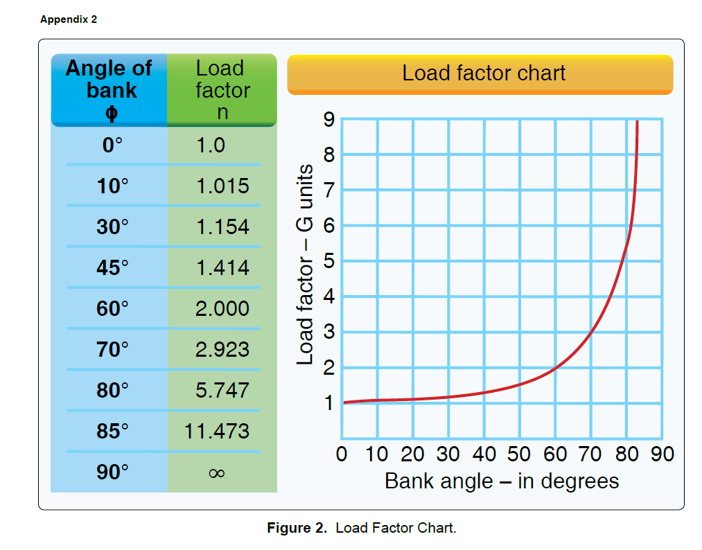
- You normally fly your sUAS with a 1.5lbs. battery but you have just upgraded it to a 2lbs. battery. What was the load factor at 1lbs. in a 60 degree bank compared to the load factor with your new battery in a 60 degree bank?
Load factor at 1.5lbs:______________________
Load factor at 2 lbs:______________________
- What happens to the load factor on an aircraft as you bank past 60 degrees?
- Which control surface controls Yaw? Pitch? Roll?
- What are the purpose of flaps?
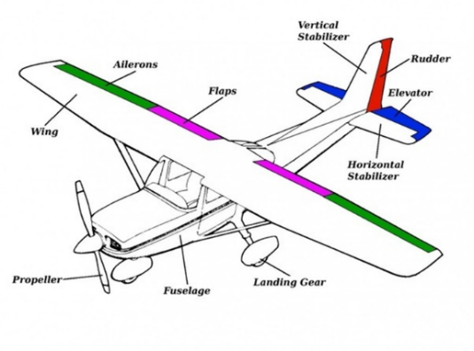
- As you increase your angle of bank in a turn, does your stall speed increase or decrease?
- What are some methods for determining altitude of a sUAS if you don’t have an altimeter installed?
- The runway you are launching from has an uphill slope. How will this affect your take-off? How will it affect landing?
- How much weight would a structure on your drone need to withstand if it weights 20lbs and you are in a 45 degree banked turn?
- What is a stall? Define it in terms your grandmother would understand.
- What is a spin? What is the procedure for recovering from a spin?

