Operations Activity
Questions 1-2: The tail number of an airplane is N19GWJ. Given this tail number, what is the correct phraseology for proper radio communications given each scenario below?
- Bozeman ATC (Big Sky Approach) asks you for your current altitude. Your altimeter reads 4,800 feet MSL.
- You are making a cold call to Big Sky Approach.
- You are operating near Three Forks airport. You have a handheld air-band radio to monitor for air traffic. What frequency should you monitor?
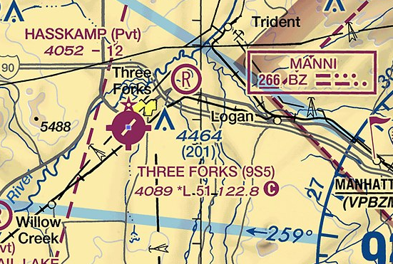
- At what distance from an uncontrolled airport should you monitor the traffic advisory frequency or multicom frequency?
- What is the field elevation at Three Forks airport?
- What are each of the following? ATIS, CTAF, FSS?
- Describe what to do if you have a fly away or a lost link situation with your drone?
- Give an example of someone exhibiting each of the following hazardous attitudes:
Anti-authority, Impulsivity, Invulnerability, Machoism, Resignation
- Sketch an airport that has a runway configuration of 21/3. Assume the top of your paper is north. Sketch the runway in the correct orientation.
- Using the sketch above, if ATC tells you to stay clear of the approach path for runway 3, which direction from your location do you need to avoid assuming you are north of the airport?
- Using the tail number from question 1, when is it OK to abbreviate your tail number to “Whiskey Juliet” when speaking to ATC?

