Regulations and Airspace
The job: You have been hired by Verizon to take aerial imagery of four of their cell towers. The towers are marked on the sectional below in green with a white number marking each tower. All of the towers are 200 (AGL) feet tall. As part of the survey, they have asked you to examine the obstructions in the area, so they have asked that you take a max altitude image directly above each tower in addition to a 360 survey of each tower.
Materials: This worksheet, AutoPylot for Drones app.
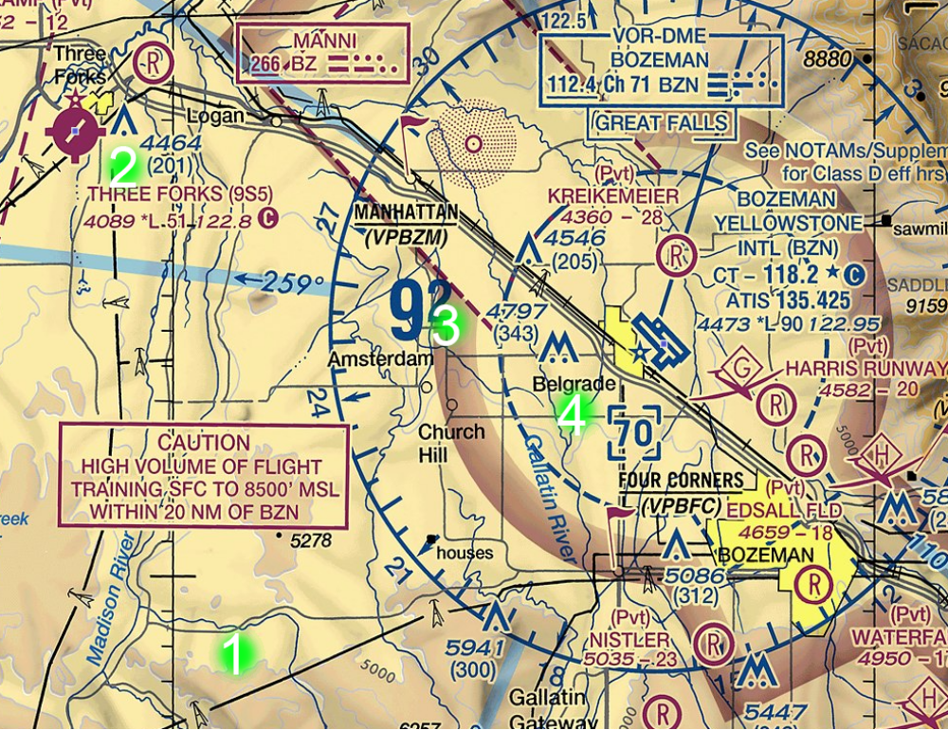
Task: Examine each of the locations that you need to image. Determine if:
- Can you legally fly this mission under part 107 for each tower in question?
- If you can’t fly the mission for a particular tower, what are the issues?
- If there are towers that need approvals from the FAA, what is the process for gaining approval?

