**Economic feasibility of resilient energy transition projects on global islands still remains challenging**

**全球岛屿韧性能源转型项目经济可行性仍具挑战**

**Abstract**

全球岛屿正面临一个深刻的能源三元悖论，其根源在于对动荡的化-石燃料价格和不断升级的气候灾害的双重脆弱性。尽管向具有韧性的低碳能源系统转型是一条关键路径，但其在全球范围内的经济可行性仍缺乏量化，这阻碍了有效的政策制定和国际融资。在此，我们构建了一个综合评估框架，**利用覆盖全球1898个岛屿、包含近5000万条关于能源需求和可再生潜力逐时记录的时空数据库，系统性地量化了全球岛屿能源转型的成本差异。**我们揭示了巨大的地理成本差异，其驱动因素不仅包括高纬度地区的“气候惩罚”，也涵盖了东南亚等热带地区高昂的系统平衡需求。然而，在考虑能源可负担能力后，大量岛屿的转型项目因成本超出而在经济上不可行，形成了巨大的“可行性缺口”。至关重要的是，纳入气候韧性设计会产生一种“韧性惩罚”，进一步扩大了这一缺口，并对气候脆弱的岛屿造成了巨大的影响。我们发现，尽管未来的技术进步会降低成本，但这不足以弥合根本性的经济与公平鸿沟。我们的研究结果表明，仅靠市场驱动的技术进步是不够的，并呼吁向针对性的金融机制进行范式转变，以解决结构性不平等问题，确保所有岛屿都能实现公正的能源转型。

**Introduction**

全球岛屿正面临一个尤为尖锐的**能源三元悖论（energy trilemma）**，其根源在于一种深刻的**双重脆弱性（dual vulnerability）**。首先，在经济上，岛屿能源系统的物理孤立性导致了对进口化石燃料的深度依赖，这种依赖长期吞噬外汇储备、削弱财政韧性（fiscal resilience）——例如，马尔代夫曾将超过10%的GDP用于进口柴油，而太平洋岛国的燃料进口在2019年占其GDP的13%。其次，在物理上，岛屿的能源基础设施直接暴露于日益频发和强化的极端气象灾害威胁之下。这种高度的脆弱性直接转化为一项沉重的经济负担，即任何能源发展规划都必须**超越传统的韧性标准**，构建具有**气候韧性的能源基础设施（climate-resilient infrastructure）**。这种经济与物理上相互交织的脆弱性，不仅限制了发展，更使岛屿国家陷入了一个几乎不可调和的僵局，寻找新路径成为不可回避的战略抉择。

在这一背景下，能源转型——特别是向低碳、**具有气候韧性**的能源系统过渡——被广泛视为岛屿突破结构性发展僵局的关键路径。然而，转型的明确目标与现有投资范式的商业逻辑之间存在着深刻矛盾：许多岛屿能源转型项目因可再生能源系统的资本密集型特性和更高的气候韧性设计需求，导致其初期成本十分高昂，再结合有限的市场规模和较高的风险认知，使得转型项目往往无法满足传统的投资回报标准。这一困境使得任何转型方案都必须经过严格的**成本效益分析（cost-benefit analysis）**，以证明其**经济可行性（economic feasibility）**。尽管经济可行性是所有后续政策设计与融资安排的基石，但现有研究大多局限于零散的案例分析或单纯的技术成本评估，严重缺乏一个能够系统性、大规模评估岛屿能源转型经济可行性的分析框架。这一认知上的缺口，使得全球岛屿转型的真实成本与可行性边界始终模糊不清，从而制约了有效的国际援助与**金融工具（financing instruments）**的设计。

为填补这一空白，本研究构建了一个**全球岛屿能源系统的经济可行性评估框架**，首次在全球尺度上系统性地量化了不同岛屿在结构性障碍下的**转型成本差异（cost differentials）与可行性缺口（viability gaps）**。首先，我们创建了一个覆盖**全球1898个岛屿**的多源异构时空数据库，利用**近5000万条**刻画能源需求和可再生能源潜力（光伏、风能）的逐时记录数据，量化了各岛屿在当前技术与投资标准下的基准转型成本与经济可行性。接下来，通过整合CMIP6等**全球尺度的高分辨率气候模型**数据，我们进一步模拟了**纳入气候韧性设计**后，对转型项目可行性缺口产生的增量影响。最后，我们探讨了不同技术进步情景的有效性，测算了未来的成本下降在多大程度上能够弥合我们所识别出的可行性鸿沟。通过这一系统性分析，本研究旨在为全球岛屿能源转型提供一个清晰的经济路线图，为国际社会设计更精准、更有效的金融支持机制提供坚实的科学依据。

**Results**

**Result1: Substantial cost differentials in island low-carbon energy transition projects**

**岛屿的低碳能源转型项目存在着巨大的成本差异**

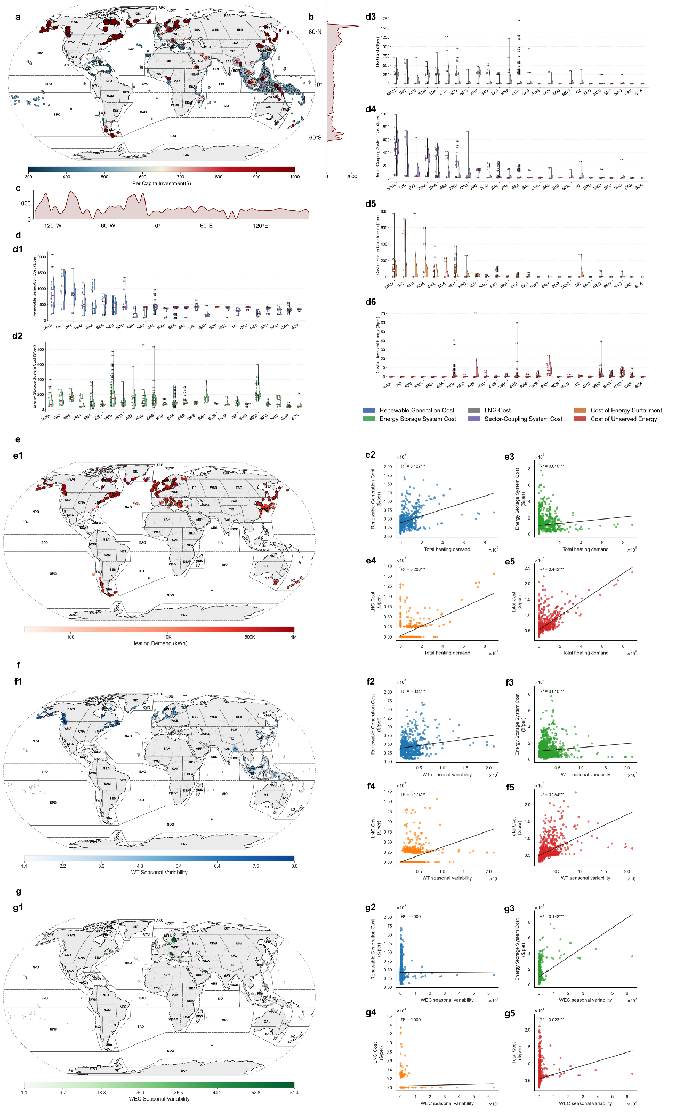

**Fig. 2 | Global-scale cost differentials of island low-carbon energy transition projects.** **a**, World map showing the per capita investment ($) required for each island's energy transition project. The color scale indicates the cost magnitude, from lower (blue) to higher (red). **b**, Latitudinal distribution of per capita investment costs, highlighting higher costs at high latitudes. **c**, Longitudinal distribution of per capita investment costs, showing regional cost clusters. **d**, Violin plots showing the distribution of the six primary cost components across different oceanic and climatic regions; the red line within each violin indicates the median value. The components are: **d1**, Renewable generation cost; **d2**, Energy storage cost; **d3**, LNG backup system cost; **d4**, Other equipment cost; **d5**, Energy discard cost; and **d6**, Load shedding cost. The x-axis acronyms represent different geographical regions (we adopted the IPCC AR6 Working Group I (WGI) reference regions (v4) as the spatial framework, see Supplementary Information 1 for full definitions).

我们的分析表明，全球岛屿在韧性能源转型所需的人均投资方面存在显著差异（图2a）。全球范围内的投资水平差异超过三倍，从一些太平洋小岛屿的低于350美元/人，到东亚与北欧岛屿的超过1000美元/人。高成本区域主要集中在日本北部、北欧及加拿大等高纬度地区，这些地区的中位投资水平普遍高于850美元/人。相比之下，太平洋、加勒比海及印度洋的热带岛屿普遍低于500美元/人，其中许多岛屿的中位值接近400美元。沿纬度轴呈现的显著U形趋势（图2b）和沿经度轴呈现的清晰区域集群（图2c），进一步证实了这种空间差异性。为了解这种异质性的构成，我们将总投资分解为六个主要的成本部分（图2d）。该分析表明，高纬度地区几乎在所有成本类别上都系统性地表现出更高的成本。除了负荷削减成本外，这些北方地区在可再生能源发电、储能、LNG基础设施及其他能源转换设施上的投资均持续高于低纬度地区。例如，高纬度区域的人均可再生能源投资经常超过1200美元（图2d1），其LNG成本也显著高于其他区域（图2d3），这也带动了相关能源转换设施的成本（图2d4）。尽管高纬度地区呈现出全面的成本上涨，但在其他地区也存在显著的成本驱动因素。具体而言，储能成本是东亚和东南亚部分地区高投资的关键因素，其投资峰值超过800美元/人（图2d2）；同时，部分亚洲岛屿的液化天然气成本也额外增加了超过600美元/人的负担（图2d3）。相比之下，弃能和负荷削减成本在大多数区域中均属边缘性因素，通常不超过100美元/人（图2d5–d6）。总而言之，全球岛屿能源转型的巨大经济差异主要体现在可再生能源发电和储能的成本之中。

在确定了转型成本存在显著的地理异质性之后，我们接着探究其根本驱动因素。我们的分析表明，气候环境因素，尤其是在高纬度地区，是导致成本升高的主要原因。我们识别出两个关键机制：高昂的供暖能源需求和可再生能源的季节性波动（图3）。首先，我们使用总供暖需求作为寒冷气候所带来的额外能源负担的代理变量。供暖需求的空间分布与我们先前识别出的高成本区域高度重合，其中最巨大的需求集中在北半球的高纬度岛屿（图3a）。回归分析证实了这一关系，揭示了岛屿的总供暖需求与其人均总能源系统成本之间存在强烈的正相关性（R2=0.442，图3b4）。这种总成本的增加，部分源于供暖需求与可再生能源发电成本（R2=0.127，图3b1）以及LNG备用系统成本（R2=0.203，图3b3）的正相关。这表明，更寒冷的气候本身就意味着需要一个规模更大、因而更昂贵的能源系统来满足基本需求。其次，我们研究了能源供给和需求之间季节性错配的影响，其中，我们将风力涡轮机（WT）的季节性可变性——定义为产量最高月份与最低月份的比率——作为一个关键指标。风力涡轮机季节性可变性的空间分布，在很大程度上反映了高成本的格局，其最显著的波动性集中在高纬度地区（图3c）。值得注意的是，在部分热带地区，特别是印度尼西亚群岛，也清晰可见一个季节性可变性较高的次级集群。我们发现，在全球尺度上，这种可变性是财务支出的一个重要预测因子。风机的季节性可变性与总能源系统成本呈现出统计上显著的正相关（R2=0.224，图3d4）。这一点进一步体现在它与可再生能源发电成本（$R^2=0.054，图3d1）和LNG系统成本（R2=0.174，图3d3）的正相关关系上。因此，可再生能源资源的更大季节性波动，直接转化为更高的总系统投资。总而言之，这些结果将特定区域观察到的高昂转型成本与基本的气候因素进行了因果关联。由寒冷温度驱动的高能源需求，以及可再生能源供应的显著季节性变化，这两个双重挑战系统性地推高了所需的投资，构成了对全球成本差异的主要解释。

**Result2: Given energy expenditure burdens, many island transition projects are economically infeasible  
考虑到能源支出负担scenario,许多岛屿的能源转型项目在经济上不可行**

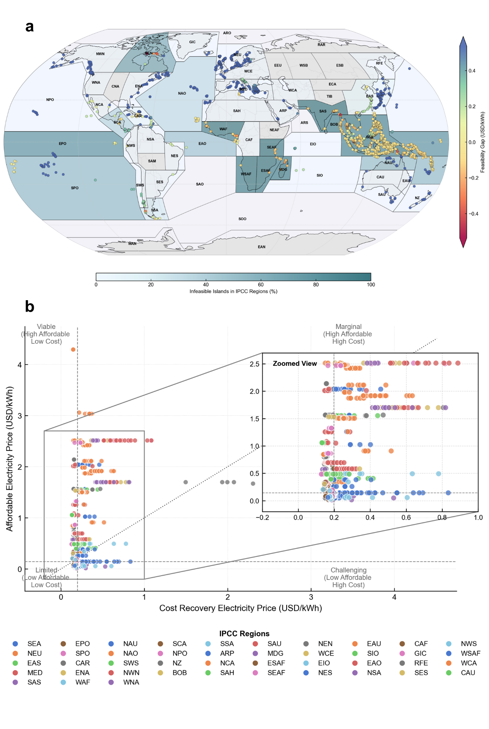

**Fig. 3 | Economic infeasibility of resilient energy transition projects on global islands.a**, Global distribution of the economic viability gap for resilient energy transition projects on individual islands. The viability gap (USD/kWh) is the difference between the project's cost-recovery tariff and a social affordability threshold. Positive values (red) signify infeasibility, where the required cost exceeds the affordable level, while negative values (green) indicate economic feasibility. **b**, A cartogram illustrating the regional concentration of infeasible islands. Each region is colored according to the percentage of islands within it that are classified as economically infeasible. The analysis underscores that the economic barriers to a resilient energy transition are most pronounced in developing regions, particularly Southeast Asia.

为了评估这些转型项目的经济可行性，我们为每个岛屿计算了一个经济上的“可行性缺口”。该缺口衡量了项目真实的成本回收电价与一个既定的社会可负担阈值之间的差异。当缺口为正值时，意味着项目成本超出了当地社会的可负担水平，在没有外部资金支持的情况下，项目在经济上是不可行的（详细计算方法见“方法”部分）。

我们的全球分析显示，相当数量的岛屿能源转型项目在经济上面临挑战（图4a）。许多岛屿的可行性缺口为正值，特别是在东南亚、太平洋地区和加勒比海部分地区等发展中区域，表明其成本回收电价超出了可负担水平。这些岛屿面临着能源系统成本高昂（如结果1所述）和当地经济吸收这些支出的能力较低的双重挑战。相比之下，欧洲和北美的许多岛屿则呈现出负值的可行性差距，表明其转型项目在既定的可负担性阈值内是经济上可行的。图4b中的面积示意图进一步强调了这种差异，显示了在印度尼西亚和菲律宾等地区，能源转型在经济上不可行的岛屿比例非常高。这突出表明，韧性能源转型的财政负担不成比例地集中在发展中岛屿国家，对它们实现其气候和能源目标构成了重大障碍。

为了进一步剖析导致经济可行性缺口的驱动因素，我们根据成本回收电价和可负担电价，将全球岛屿分为四个不同类别（图5）。这种分类揭示了项目特定成本和当地经济能力所带来的双重挑战。

1. **可行型 (高支付能力, 低成本):** 位于左上象限。这些岛屿同时受益于高社会可负担性和低能源转型成本。它们的散点位置远高于可行性对角线（y=x），表明其能源转型在经济上是自我维持的。这些案例主要分布在发达地区，如欧洲（例如，NEU, MED IPCC区域）。
2. **挑战型 (低支付能力, 高成本):** 位于右下象限。这些岛屿面临最严峻的障碍，它们同时承受着高昂的项目成本和非常有限的当地支付能力。大量来自发展中地区（如东南亚-SEA和南亚-SAS）的岛屿属于这一类别，它们最迫切地需要国际支持和金融创新。
3. **受限型 (低支付能力, 低成本):** 位于左下象限。这些岛屿的项目成本相对较低，理论上应使其转型更加容易。然而，它们的经济可行性被极低的可负担阈值严重制约。对于这些岛屿而言，主要障碍并非技术成本本身，而是当地的社会经济条件。
4. **边缘型 (高支付能力, 高成本):** 位于右上象限。这些岛屿拥有强大的地方经济，能够承受较高的能源价格。尽管如此，它们的转型项目却因异常高昂的成本而受阻，常常导致其落入可行性对角线以下。这突出表明，即使是富裕岛屿，不利的地理或后勤条件也可能使转型项目在经济上不可行。

**Result3: Integrating climate resilience design further exacerbates this economic infeasibility**

**纳入气候韧性设计进一步加剧了经济不可行性**

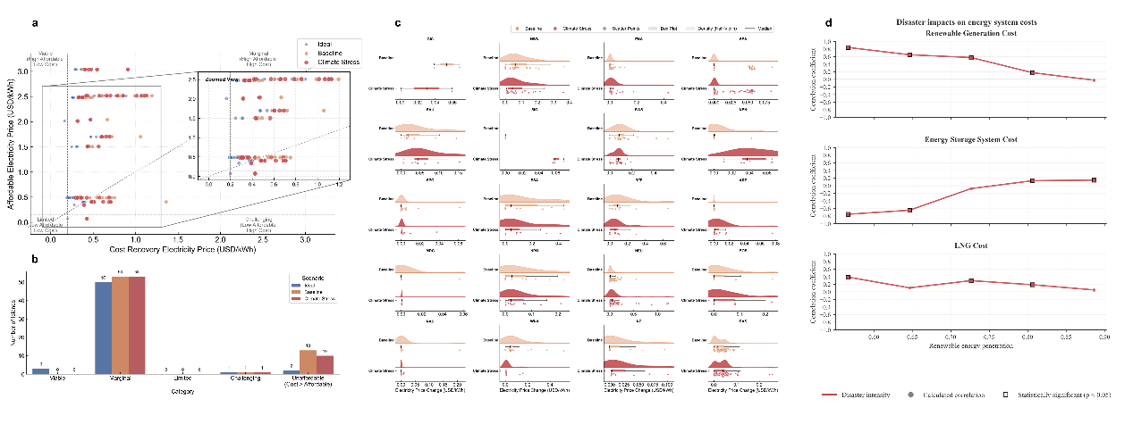

**Fig. 4 | Worsening economic infeasibility after integrating climate resilience design. a**, Global distribution of the economic viability gap for *resilient* energy transition projects. Compared to the baseline scenario (Fig. 4a), a larger number of islands, particularly in climate-vulnerable regions like Southeast Asia and Southwestern South America, shift towards positive (red) values, indicating heightened economic infeasibility. **b**, Scatter plot classifying the islands after resilience costs are included. The general rightward shift of points compared to the baseline (Fig. 5) illustrates the increase in cost-recovery prices, pushing more islands into the "Challenging" and "Marginal" categories and further below the economic viability line.

岛屿能源项目的一个关键维度是其应对气候变化的韧性，这需要在系统加固和适应性方面进行额外投资。然而，我们的分析表明，纳入这些气候韧性设计会显著加剧能源转型的经济不可行性，对最脆弱的岛屿尤其如此。

对比纳入韧性措施前后的经济可行性缺口（比较图4a和图6a），可以发现一个明显的负面趋势。大多数岛屿的可行性缺口都在扩大，将许多先前处于可行性边缘的岛屿推向了明确的不可行状态。这种影响在全球范围内并非均等分布，在高度暴露于气候灾害风险的地区，情况恶化最为显著。例如，面临极端天气事件等风险的南美洲西南部（SWS IPCC区域）的岛屿，其可行性缺口出现了明显增大。同样，在东南亚，特别是菲律宾（隶属SEA IPCC区域），以及在日本东北部（隶属EAS IPCC区域），为保护能源基础设施以抵御台风灾害威胁所需的额外成本，使得转型项目的价格大幅上涨，可负担性也随之降低。

这一发现揭示了一个严峻的权衡困境：那些最迫切需要韧性能源系统以确保在气候变化面前电力供应稳定的岛屿，恰恰最无力承担相关的成本。散点图（图6b）证实了这一点，因为众多数据点向右移动（成本更高），而可负担性却没有相应提高，从而扩大了可行性对角线下方的差距。这凸显了一个关键的政策挑战，即如果没有针对性的国际气候融资或创新的风险降低机制，在岛屿上建设真正具有韧性的可持续能源系统将仍然是一个遥不可及的目标。

为了理解气候韧性系统成本增加的驱动机理，我们进行了一项回归分析，旨在检验在不同可再生能源渗透率水平下，灾害强度如何影响可再生能源、储能和LNG等关键能源系统组件的成本（图7）。该分析揭示了随着岛屿向更高可再生能源份额转型，其韧性策略发生了根本性转变。

在较低的可再生能源渗透率水平（约60-75%），以“功率耗散指数”（PDI）和“最大故障持续时间”衡量的灾害强度，与可再生能源基础设施自身的成本呈现出强烈的、统计上显著的正相关关系。这表明，在对可再生能源依赖程度较低的系统中，实现韧性的主要策略是增加可再生能源的装机容量。这种超额配置（overprovisioning）确保了即使部分机组因灾害停运，剩余的容量也足以满足需求。因此，在灾害风险更严重的地区，所需的总装机容量及其成本会显著更高。

然而，当可再生能源渗透率超过75%时，这种相关性急剧减弱，并失去统计显著性。与此同时，灾害强度与总储能投资之间的相关性则从负向或中性转变为强烈的正相关且统计上显著。这种“交叉”是该机理的核心：在高渗透率系统中，保障韧性不再主要依赖于超额配置可再生能源发电容量，而是通过大规模的储能提供系统级的备用支持。这些储能必须足以应对由恶劣天气事件引发的持续数天的电力中断。因此，在高风险地区，要实现一个高渗透率的韧性系统，就必须大规模建设储能容量，使其成本与气候威胁的严重程度成正比。

作为备用燃料来源，LNG的成本与灾害强度呈现出较弱但总体为正的相关性，并在中等渗透率水平达到峰值。这表明，在过渡的中间阶段，LNG作为韧性缓冲的角色最为关键，之后在极高渗透率情景中，其作用在很大程度上被储能所取代。

总而言之，该分析表明**，随着能源转型的推进，气候韧性的财务负担从用于超额配置可再生能源的资本支出，转移到了对储能的巨额投资上。**正是在气候脆弱地区，这种对昂贵储能解决方案的不断升级的需求，主要解释了为何纳入韧性设计会进一步加剧岛屿能源转型的经济不可行性。

**Result4: Technological progress alone cannot solve the current economic infeasibility**

**仅依靠技术进步并不能解决经济不可行现状**

**Fig. 5 | Impact of technological progress on project costs and economic viability. a**, Breakdown of total system costs across different IPCC regions under various scenarios: Baseline (current technology), TP2030 (projected technology for 2030), and TP2050 (projected for 2050). The bars show the contribution of different components, illustrating a general reduction in total costs, primarily driven by lower renewable investment costs in future scenarios. **b**, Distribution of the economic viability gap for each IPCC region across five scenarios: Ideal (no climate risk), Baseline, Climate Stress (resilient design), TP2030, and TP2050. The markers represent the median viability gap, while the horizontal bars show the uncertainty range. The rightward shift of markers from Baseline to TP2050 indicates a universal improvement in economic viability. However, many of the initially most disadvantaged regions (left side of the plot) remain deep in the infeasible range (negative gap) even in the TP2050 scenario, highlighting the limitations of technology alone in bridging the feasibility and equity gap.

技术进步被普遍认为是推动能源转型的核心驱动力。我们的情景分析证实，预期的可再生能源和储能技术成本下降（分别对应TP2030和TP2050情景）确实能为全球几乎所有岛屿地区带来显著的经济效益。从总成本构成来看（图8a），与基准情景（Baseline）相比，TP2030和TP2050情景下的系统总成本普遍降低，这主要得益于可再生能源投资成本的大幅削减。相应地，经济可行性缺口也得到了普遍改善（图8b）。几乎所有IPCC区域的可行性缺口中位数都随着时间的推移向右移动，逐渐靠近甚至超过零点（即可行点），这表明技术进步在降低项目成本、提升经济吸引力方面扮演了至关重要的积极角色。

然而，尽管技术进步带来了普遍的正面效应，我们的分析也揭示了其局限性，并指出了一个关键问题：技术进步的收益并未能有效解决区域间的公平性问题。如图8b所示，虽然可行性缺口的整体分布向好的方向移动，但不同区域间的差距依然巨大。那些在基准情景下经济可行性最差的地区（如SWS, EIO, SPO等，位于图8b最左侧），即便在最乐观的TP2050情景下，其可行性缺口虽然有所改善，但中位数仍然深陷于负值区域，远未达到经济可行的水平。

这种现象揭示了技术与公平在一定程度上的“脱钩”（decoupling）。技术成本的下降是一种普惠性的、全局性的变化，它系统性地降低了所有地区的成本基线，但它并不能改变由地理位置、资源禀赋和气候风险等固有因素决定的相对劣势。换言之，技术进步让“富裕”地区（可行性好的地区）变得更富裕，但并未能给予“贫困”地区（可行性差的地区）足够的支持来克服其根本性的结构障碍。因此，研究结论明确指出，仅依靠对未来技术进步的乐观预期，不足以解决全球岛屿能源转型中的深层次经济可行性与公平性挑战。若要确保所有岛屿，特别是那些最脆弱的岛屿，都能从能源转型中受益，就必须超越技术范畴，引入针对性的金融支持、创新的商业模式和公平导向的国际合作机制。

**Discussion**

本研究首次在全球尺度上对岛屿韧性能源转型的经济可行性进行了量化评估，揭示了一个充满深刻结构性挑战和深层不公平的现实格局。我们的分析系统性地打破了一种乐观的叙事，即仅靠能源技术成本的下降就能为全球最脆弱的岛屿社区普遍开启一个可持续的未来。相反，我们揭示了一个根本性的悖论：那些在物理和财政上最易受气候变化影响、因而最需要进行韧性能源转型的岛屿，恰恰是面临着最难以逾越的经济障碍的群体。这一发现将相关的讨论从一个纯粹的技术挑战，转移到了一个关乎气候经济学、发展金融和全球公平性的议题

我们发现，转型成本中存在的显著地理差异，这种差异并非随机分布，而是系统性地由我们称之为“气候惩罚”（climatic penalty）的因素所决定。高纬度岛屿承受着双重挑战：更高的供暖能源需求，以及可再生能源供给与需求之间显著的季节性错配（图3）。东南亚和南亚的部分岛屿也存在较高的转型成本。这实质上构成了一种技术本身无法消除的结构性成本劣势。这一发现对当前主流的“一刀切”式能源政策和国际援助提出了挑战，这些政策往往忽略了基本的气候和地理条件如何从根本上改变脱碳的经济方程式。我们的研究结果主张采用一种更精细化、更具地理洞察的战略，即根据每个岛屿地区的内在环境背景来量身定制其转型路径和金融支持。

此外，我们的分析揭示了一个“脆弱性陷阱”（vulnerability trap）：建立气候韧性的迫切需求，反而加剧了经济上的不可行性，对发展中岛国尤其如此。通过纳入气候韧性成本，我们发现成本回收曲线出现了系统性的右移（图6b），将更多岛屿——特别是那些位于东南亚和太平洋等气候脆弱地区的岛屿——推入了“挑战型”和“受限型”的象限（图5, 6b）。这背后的关键机理在于韧性策略的转变：随着可再生能源渗透率的提高，实现韧性的财务负担从超额配置发电容量，转移到了对长时储能的巨额投资上（图7）。这种“韧性惩罚”（resilience penalty）形成了一种残酷的悖论：那些最需要建立强大防御以抵御气候冲击的群体，却被要求支付最高的溢价，而这恰恰是其经济最无法承受的。这种动态从根本上重新定义了岛屿的能源基础设施——它不仅是一项技术资产，更是一个关键的气候适应节点，理应获得专门的国际气候融资，而非传统的开发援助。

本研究也为技术乐观主义的局限性提供了一个冷静的视角。虽然我们的情景预测证实了技术进步确实会降低全球的成本，但它们也揭示了技术进步与公平性结果之间的关键“脱钩”（decoupling）现象（图8）。更便宜的光伏和电池所带来的益处是普惠的，但它们并不会优先惠及那些处于最不利地位的群体。因此，全球北方与南方国家之间在经济可行性上的巨大鸿沟依然存在，甚至在某些情况下相对差距可能还会扩大。这表明，依赖市场驱动的技术扩散是一种不充分、甚至可能不公平的策略。它强调了国际社会迫切需要采取主动干预措施，这种干预必须超越单纯的技术转让，致力于创造能够主动纠正其内在结构性劣势的金融工具。

发展中岛国所承受的超乎比例的负担，是分配正义（distributional justice）的重大缺失。我们的四象限分类（图5）本质上是一幅全球能源不公平的地图，它清晰地标示出那些同时遭受高成本和低支付能力双重困境的“挑战型”岛屿集群。当前金融模型未能为这些岛屿的韧性溢价进行充分定价和融资，则反映了程序正义（procedural justice）的缺陷，因为现有机制并不适用。因此，要实现全球岛屿的公正转型，就需要一场范式转变。国际气候与发展金融必须从被动的、逐个项目审批的模式，演变为一种主动的、系统性的框架，该框架应明确承认并补偿本研究中所识别出的气候和地理惩罚。具体形式可以包括设立专门的“韧性与公平基金”、为能源基础设施提供参数保险等风险缓释工具，或者提供与国家脆弱性指数而非其信用评级挂钩的优惠融资。

尽管我们的分析框架具有前所未有的全球尺度，但我们也承认其局限性。我们的模型简化了复杂的电网动态，并且未能捕捉所有潜在的收入来源或社会政治障碍（如土地使用冲突或政治不稳定），这些因素都可能进一步影响项目的可行性；气候模型的模拟精度限制也影响了对气候韧性溢价的计算，然而，这些局限性并未削弱我们研究的核心结论，反而为未来的研究指明了方向，包括整合更精细的社会经济变量和更广泛的技术组合。

总而言之，我们的研究提供了一个严峻的警示：全球岛屿韧性能源转型的经济可行性并非一个必然的结果，而是一个远未被解决的重大挑战。未来的道路不能仅靠技术来铺就。它需要一份新的全球能源公平契约，利用精准融资来抚平一个因自然禀赋而本不平坦的竞争环境。本研究开发的框架不仅为问题提供了诊断，也为设计这些精准的干预措施提供了潜在工具，以确保在向可持续能源的未来转型中，不让任何一个岛屿掉队。

**Method**

**Island Integrated Energy System Model**

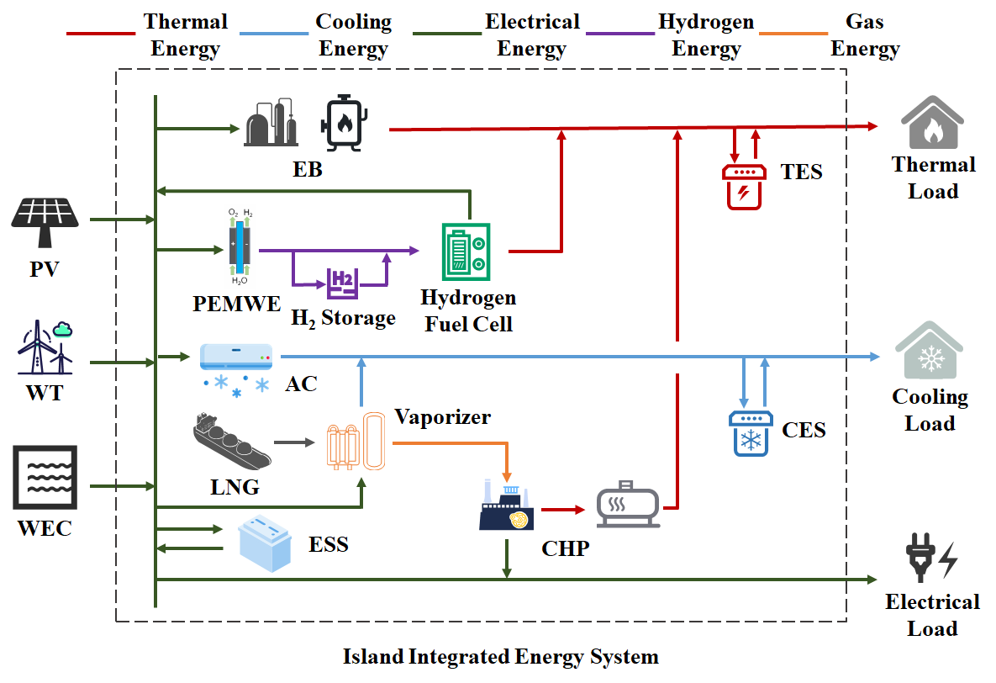

**Fig.9 | Island Integrated Energy System.**

We developed an island integrated energy system (IES) (Fig. 9) that incorporates external energy inputs from wind, solar, wave, and liquefied natural gas (LNG). LNG is procured from the nearest base station and transported to the island. Energy conversion and storage facilities couple these resources to meet electricity, heating, and cooling demands. The model's cost and operational parameters are derived from the U.S. National Renewable Energy Laboratory's (NREL) Annual Technology Baseline (ATB) medium-cost scenario and relevant literature, with detailed parameters provided in Supplementary Note 1.

The system is scaled for a 500-person community, which represents an optimal scale for demonstrating renewable energy integration in an island context. Based on the International Renewable Energy Agency's (IRENA) analysis of off-grid systems (Case 7), this scale is particularly suitable for comprehensive hybrid renewable solutions, as it allows for meaningful capacity deployment (typically 0.5–2 MW) while remaining manageable in terms of system complexity and investment requirements. For islands with smaller populations, we scale the system proportionally to their actual population size to maintain per capita energy adequacy.

**Renewable Potential and Demand Assessment**

Hourly solar photovoltaic (PV) and wind generation profiles were simulated using the Renewables.ninja platform, leveraging historical meteorological data (ERA5, MERRA-2) and performance models. The simulations used data from 2020, with each island represented by its centroid coordinates.

PV systems were modeled as fixed-tilt installations with tilt angles optimized for maximum annual yield. The azimuth was set to south-facing (Northern Hemisphere) or north-facing (Southern Hemisphere). To avoid artificial capacity constraints during optimization, the maximum AC power input was scaled proportionally to the population (2.0 kW/person), with system losses set at 10%. Wind simulations used Vestas V90 2000 turbines at an 80m hub height, with the maximum AC power input similarly set to 2.0 kW/person.

Wave energy density (kW/m) and significant wave height (m) data under the SSP585 scenario were sourced from a global wave model dataset. To fully explore the configuration potential of wave energy facilities in the optimization model, the maximum length for such facilities was set to 1 km per island.

Hourly heating and cooling demands were simulated using the Renewables.ninja methodology. Heating demand is initiated when the ambient temperature falls below region-specific heating thresholds, while cooling demand is activated when the temperature exceeds cooling thresholds. The calculations incorporate regional parameters as defined in Table 1.

**Table 1 Cooling and heating load parameters**

|  |  |  |  |  |  |  |  |  |
| --- | --- | --- | --- | --- | --- | --- | --- | --- |
| **regions** | **Heating  threshold [°C]** | **Cooling  threshold [°C]** | **Heating  power [W/(°C · p)]** | **Cooling  power [W/(°C · p)]** | **Smooth  coef. [day-1]** | **Solar coef. [°C/(Wm-2)]** | **Wind coef. [°C/(ms-1)]** | **Humidity  coef. [°C/(gkg-1)]** |
| APAC | 11.9 | 20.4 | 127 | 52 | 0.73 | 0.014 | -0.12 | 0.036 |
| Europe | 12.7 | 20.4 | 116 | 16 | 0.62 | 0.019 | -0.13 | 0.032 |
| US | 9.7 | 18.8 | 129 | 59 | 0.35 | 0.011 | -0.1 | 0.022 |
| Others | 11.9 | 20.4 | 127 | 52 | 0.73 | 0.014 | -0.12 | 0.036 |

*APAC parameters were adopted as defaults for the "Others" region given their broad applicability and intermediate characteristics.*

The electrical load typically comprises heating/cooling-related demand and a base electricity demand (e.g., for lighting and appliances) that is independent of thermal needs. Given the availability of heating/cooling demand data for the islands, only the base electricity demand was modeled. For modeling simplicity, this base demand was decomposed into an illumination-dependent lighting load and a time-varying, activity-dependent load. Detailed modeling procedures are described in Supplementary Note 2.

**Island Selection Criteria**

We selected 2,015 global islands that met the following criteria in 2015: 1) inhabited (ensuring socioeconomic relevance); 2) minimum area ≥10 km² (to enable renewable infrastructure); 3) geographical isolation ≥10 km from the mainland (to minimize continental influence); and 4) population <3.5 million (to exclude mainland-like energy systems). Population data were sourced from LandScan; island area and mainland distance data were obtained from relevant geographical databases.

**Climate Data for Hazard Modeling**

Typhoon hazards were modeled using 3-hourly near-surface wind speed data from the MRI-AGCM3-2-S_highresSST model (CMIP6, SSP585 scenario), accessed via the Earth System Grid Federation (ESGF). This high-resolution model has demonstrated enhanced capabilities in simulating tropical cyclones.

**Economic Viability Gap Assessment**

To evaluate the economic feasibility of the island energy transition, we introduce the "viability gap" as a core metric. The calculation of this metric involves the following steps:

1. Cost-Recovery Tariff

For each island's energy transition plan, we utilize the optimization model described below to calculate the minimum electricity tariff required for the project to break even over its entire lifecycle (i.e., achieve a net present value, NPV, of 0). This tariff reflects the true price level of the project under the condition that it must cover all its costs (including initial investment, operation and maintenance, fuel, etc.) solely through electricity sales, without any external subsidies or policy support.

2. Affordable Tariff

To measure the electricity payment capacity of local residents, this study assumes that household energy expenditure should not exceed 10% of per capita income. This assumption is based on commonly used thresholds in international energy poverty literature (typically ranging from 6% to 10%) and provides a comparable upper limit for social affordability in a global-scale analysis. Based on per capita income data for each island, we derive the corresponding affordable tariff level.

3. Viability Gap Calculation

The viability gap is defined as the difference between the affordable tariff and the cost-recovery tariff:

Viability Gap ($/kWh)=Affordable Tariff−Cost-Recovery Tariff

A positive value (Affordable Tariff > Cost-Recovery Tariff) indicates that the project is economically viable within the residents' ability to pay. Conversely, a negative value signifies that the project's costs exceed the society's payment capacity, rendering it economically infeasible under the current investment logic and requiring interventions such as external subsidies, concessional financing, or other policy instruments.

It should be noted that using a uniform 10% income threshold as the basis for the affordable tariff, while consistent with international research practices, does not fully capture the income distribution disparities among different islands or the actual burden on low-income groups. Therefore, we consider this a conservative approximation. Future research could enhance the granularity and equity of the analysis by incorporating distributed socioeconomic data, such as median income or income quintiles.

**Energy System Optimization Model**

To determine the optimal energy system configuration and operational strategy for each island under various scenarios, we developed a comprehensive Mixed-Integer Linear Programming (MILP) model. This single-level optimization model is designed to co-optimize long-term investment decisions (i.e., the capacity of generation and storage assets) and short-term operational scheduling (i.e., the hourly dispatch of energy) to minimize the total annualized cost of the system.

The model's objective function is to minimize the total annualized system cost (Ctotal​), which is the sum of the equivalent annualized investment cost (Cinvest​) and the annualized operational cost (Cop​).

The annualized investment cost is calculated as follows:

where l is the total number of equipment types; ai​ is the configured capacity of equipment i (a decision variable); ci​ is the unit installation price of equipment i; r is the annual discount rate; and y is the equipment lifespan.

The annualized operational cost (Cop​) includes LNG procurement costs, equipment maintenance costs, penalties for renewable energy curtailment, and penalties for load shedding:

Detailed cost components and formulations are provided in Supplementary Note 3.

The model's main constraints include the supply-demand balance for each energy carrier (electricity, heat, cool) at each time step, the operational limits of each technology component, and the system reliability constraint described below.

**Climate Resilience and System Reliability**

To assess system reliability under climate change, we incorporate the failure dynamics of renewable energy equipment into the model. The failure probability of a component is determined by combining wind speed data from climate models with vulnerability curves. These curves define the failure probability (Pfail,i​) as a function of wind speed (Vt​) or wave height (Ht​)

Specific vulnerability functions are detailed in Supplementary Note 3.

We use Monte Carlo simulations to generate component failure state sequences. To ensure computational tractability, the elbow method is used to cluster the large number of failure states and identify the most representative scenarios for optimization. This approach effectively captures climate-induced failures and their systemic impacts.

Component failure events are simulated using a Monte Carlo approach. Once a component fails, it remains inoperable until repairs are completed. The repair process is contingent upon favorable weather conditions (e.g., wind speeds below 20 m/s), reflecting operational constraints during extreme weather. Furthermore, an operational shutdown rule is enforced where key components (e.g., wind turbines, PV, and LNG facilities) cease operation when wind speeds exceed 20 m/s, irrespective of their failure status.

To manage the computational complexity arising from numerous potential failure timelines, we employ a scenario reduction technique. A large number (1,000) of annual failure scenarios are generated. For each scenario, we extract key features, such as total downtime, maximum consecutive downtime, and the frequency of simultaneous multi-component failures. These feature sets are then grouped using K-Means clustering, with the optimal number of clusters determined by the silhouette score. The medoid—the most representative scenario from each cluster—is then selected and incorporated into the optimization model.

System reliability is enforced through a constraint on the Normalized Expected Energy Not Served (NEENS). The Expected Energy Not Served (EENS) is calculated as the probability-weighted sum of energy shortfalls across all representative failure scenarios. The NEENS is then constrained to be less than 0.1% of the total annual demand for each energy type, ensuring a high level of supply security even under climate stress.

where m represents each energy type (electricity, heat, cooling), Nc​ is the number of representative scenarios (clusters), pk​ is the probability of scenario k, and Shortfallm,k​ is the total energy not served for energy type m in scenario k. This constraint ensures the system is designed to meet minimum supply requirements under a diverse set of disaster scenarios. Detailed model formulations are provided in Supplementary Note 3.

**Data Availability**

The wind and solar photovoltaic generation profiles, as well as heating and cooling demand data, were obtained from the Renewables.ninja model, available at https://www.renewables.ninja/. Wave energy and wave height data were sourced from the Science Data Bank repository at https://www.scidb.cn/en/detail?dataSetId=700894282ab745d0b420fe0844c924ae&version=V2. Population distribution data were derived from the LandScan database, hosted by Oak Ridge National Laboratory and accessible at https://landscan.ornl.gov/. Climate model data were downloaded from the Earth System Grid Federation (ESGF) portal at https://esgf-ui.ceda.ac.uk/cog/search/cmip6-ceda/.

**Code availability**

The code used in this study is available in the GitHub repository at https://github.com/Alto-R/island_optimization.git.The code was developed and tested using Python 3.11.13 and Gurobi 11.0.3.

**Reference**