## Climate Change Exacerbates Inequities in Island Energy System Investments

## Authors

## Abstract

This study analyzes how climate change amplifies global inequities in per capita energy investments across islands. High-latitude islands face elevated investment pressures due to seasonal mismatches between heating demand and renewable resources; disaster-prone regions require substantial additional investments in energy storage and LNG infrastructure. Economically vulnerable islands suffer disproportionately from climate risks, with RCP8.5 scenarios projecting significantly increased energy investment burdens for low-GDP nations. Even with declining technology costs, small island developing states (SIDS) will endure energy investment burdens far exceeding those of developed economies. This demonstrates that geographic and socioeconomic factors create structural inequities that cannot be addressed by technology alone, necessitating international financing mechanisms and global cooperative frameworks.

## Introduction

Island energy systems face a critical triple challenge: high costs, carbon-intensive operations, and climate vulnerability. Fossil fuel-dominated supply models elevate marginal generation costs and amplify carbon lock-in risks due to isolated grid architectures1–3；Concurrently, extreme climate events increasingly disrupt energy infrastructure, exposing systemic imbalances in security, sustainability, and equity4–7。This complex crisis disproportionately affects SIDS8, where generation costs can be 10-fold higher than continental averages. In 2021, island nations faced the world’s highest electricity price9. Addressing these challenges to meet island energy demands safely, sustainably, and affordably is imperative.

Three interconnected constraints characterize this energy dilemma: Spatial isolation elevates energy costs and climate exposure. Maritime supply chains increase logistics costs (contributing significantly to end-user tariffs) and heighten disruption risks10；Resource limitations intensify reliance on carbon-intensive facilities and storage, preventing economies of scale and inter-regional power exchanges. Path dependency impedes transition efforts, maintaining renewable penetration below global averages11；Climate vulnerability complicates structural transitions. These constraints create a self-reinforcing cycle of " increasing marginal costs – carbon lock-in – reduced climate resilience", positioning island regions as persistent stragglers in the global energy transition landscape.

While islands possess abundant renewable resources and potential as clean energy innovation hubs9, the deployment of distributed renewable systems introduces new spatial inequities. Islands with favorable geographies achieve lower unit costs for renewable systems, whereas peripheral islands face higher costs and disaster risk premiums, impeding their transition12. This growing divergence undermines coordinated climate action and challenges the equity principles established in UN Sustainable Development Goal 7 (SDG7).

Current research exhibits several critical gaps: (i) oversimplified technical focus neglecting multi-energy synergies; (ii) fragmented spatial analyses lacking global comparability13；(iii) inadequate resilience integration, treating climate risks as static cost parameters; and (iv) neglect of investment justice in energy planning. Crucially, no study simultaneously combines climate risk assessment, economic feasibility, and system optimization for global islands under climate scenarios.

This study addresses the identified research gap by developing an integrated island energy system incorporating diversified renewable energy sources. Focusing on islands across multiple global regions, we investigate the dynamic evolution patterns of investment costs and system configurations, while analyzing emerging energy investment inequities. Two design scenarios are contrasted: (i) a current risk-based design considering present typhoon hazards, and (ii) a future risk-based design accounting for projected future typhoon hazards. In this study, we first analyze the spatial coupling patterns between per capita investment costs in island energy systems and geographic-climatic risk gradients globally, identifying transmission pathways of energy investment inequity. We then systematically evaluate the divergent impacts of two investment design paradigms (current risk-based vs. future risk-based) on social equity. Finally, we construct equity-optimization pathways under projected cost reductions in energy storage and hydrogen production scenarios. This work provides novel perspectives and critical references for designing cost-effective, disaster-resilient, and equitable island energy systems under climate change and deep uncertainty.

**Fig.1 | Framework.**

## Results

**Spatial Heterogeneity in Per Capita Energy Investment for Current Risk-Based Design**

**Fig.2 | Geographic disparities in energy investment patterns under current risk-based scenario.**

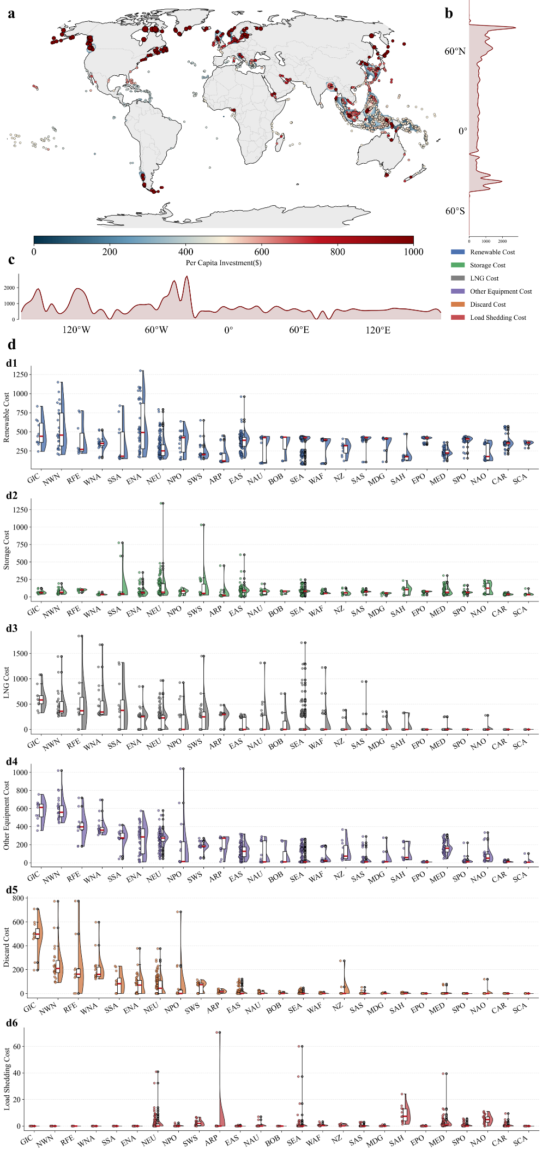

**a,** Spatial distribution of per capita energy investment costs undercurrent risk-based scenario. Dot colors represent investment intensity with darker colors indicating higher costs. **b, c,** Latitudinal (b) and longitudinal (c) variations in average investment per capita. **d,** Cost breakdown of renewable energy systems across different island locations and oceanic regions. The stacked bar charts illustrate the total system costs across island locations, while the corresponding donut charts represent the proportional distribution of average cost components across oceanic regions. All costs are disaggregated into six categories: Renewable Cost (blue), Storage Cost (green), LNG Cost (gray), Other Equipment Cost (purple), Discard Cost (orange), and Load Shedding Cost (red).

Our optimization analysis of global island energy systems under current disaster risk reveals significant spatial inequality in investment. This inequality manifests as pronounced latitudinal and regional disparities in per capita investment costs.

Under the current risk scenario, a distinct pattern of spatial heterogeneity emerges in per capita energy system investment costs across global islands (Fig. 2a). Islands with the highest per capita investment are predominantly concentrated in the North Atlantic, the Northwest Pacific, and the Central Pacific. These include islands in high-latitude or extremely remote offshore regions, such as Greenland, the United Kingdom, parts of Alaska (USA), and Fiji. Notably, this latitudinal effect is substantial: islands situated above 60° latitude require per capita energy investment costs approximately two to three times higher than those below this threshold (Fig. 2b), underscoring the profound influence of latitude on investment requirements.

Islands with moderate investment levels are concentrated in the Northwest Atlantic, the Western Pacific, and the Southwest Indian Ocean, encompassing regions like southeastern China, southern Japan, Indonesia, and the southeastern United States. On average, their per capita investment costs are 1.5 times those of the lowest-cost islands. These low-cost islands, in turn, are more broadly distributed, with significant clusters in the Central Atlantic, the Southwestern United States, and the Mediterranean region (Fig. 2c, d).

To understand the drivers of these disparities, we decomposed the total investment into six technology categories (Fig. 2d). This analysis shows that latitudinal and regional factors predominantly influence the costs of energy storage and Liquefied Natural Gas (LNG) infrastructure. Specifically, both energy storage and LNG costs are substantially elevated for islands above 60° latitude compared to their lower-latitude counterparts. In contrast, islands in the South Pacific Ocean (SPO) region exhibit high energy storage costs but exceptionally low LNG-related investment, highlighting a distinct regional cost structure that contributes to the overall global inequality.

**Fig.3 | Global island energy demand patterns and renewable resource characteristics.**

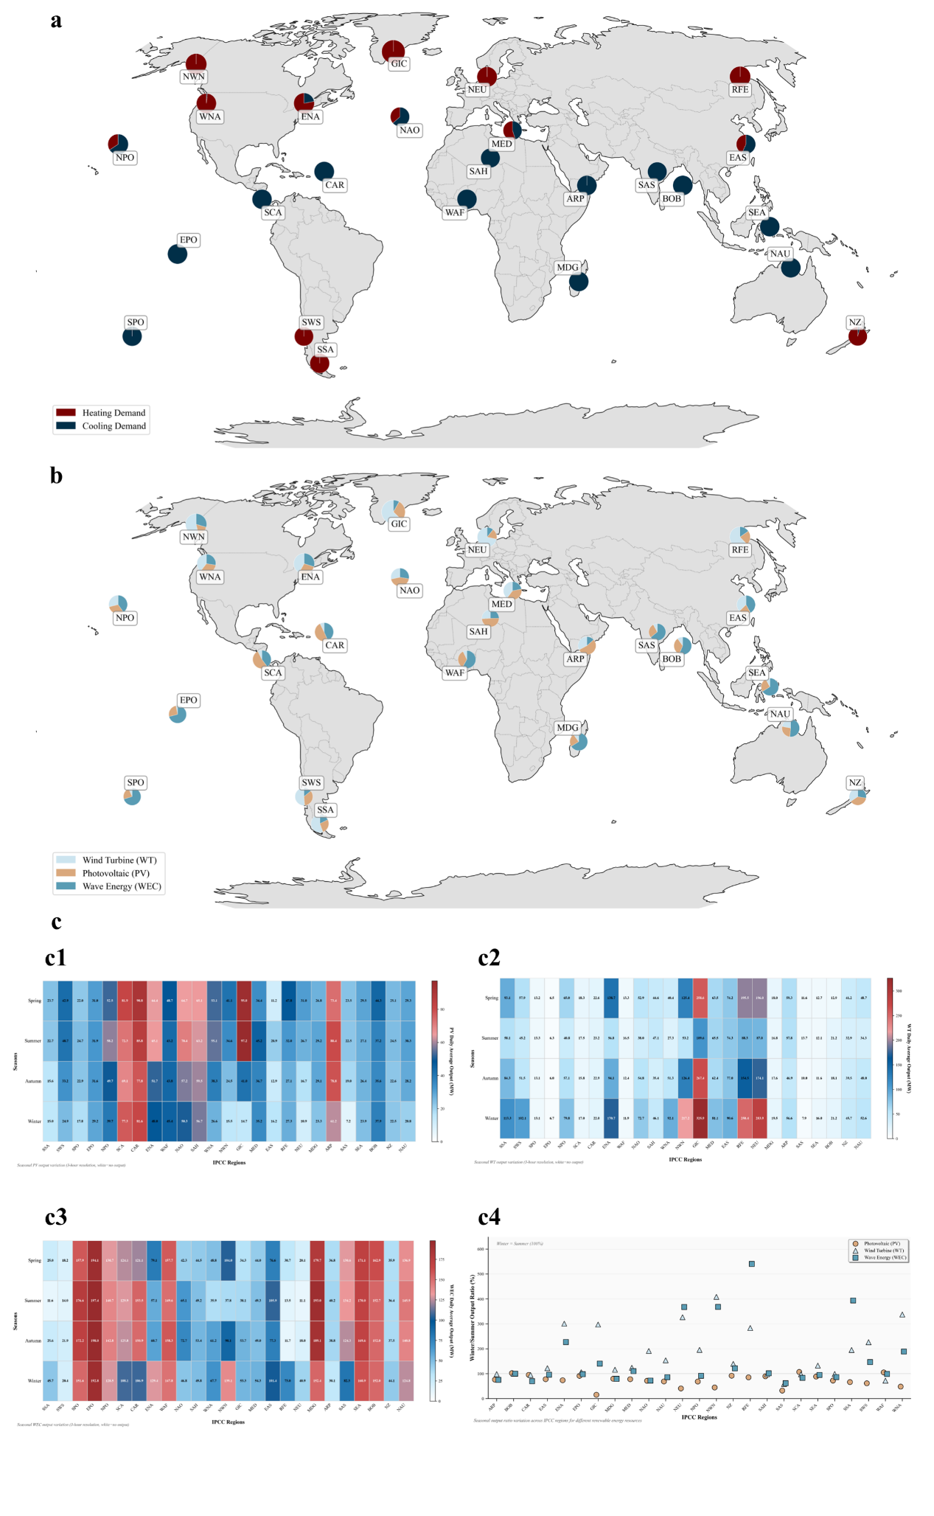

**a,** Geographic distribution of dominant energy demand types across global islands in 2020. Blue dots represent islands with primarily cooling demand, while red dots indicate islands with primarily heating demand. The size of dots corresponds to the per capita energy demand intensity. **b,** Cumulative installation of renewable energy resources across global islands under current risk-based scenario. Pie charts show the proportional mix of different energy technologies: wind turbines (WT, light blue), solar photovoltaics (PV, yellow) and wave energy (WAVE, blue). The size of each pie chart represents the total energy capacity. **c,** Seasonal variations in wind energy potential across diverse geographical locations. The figure presents violin and box plots depicting the distribution of wind energy resources across spring (green), summer (yellow), autumn (orange), and winter (blue-gray). The Winter/Summer ratio (%) indicated below each panel quantifies the seasonal variability by comparing winter to summer wind energy potential.

Our systematic analysis identifies the core drivers underpinning this spatial heterogeneity in island energy system investment costs, collectively forming the structural mechanisms shaping the global pattern.

Firstly，differences in climate and consequent energy demand structure constitute fundamental drivers. Islands at higher latitudes face harsher low-temperature conditions, leading to a significantly higher proportion of heating demand in their energy consumption mix (Fig. 3a). In our case islands, heating constitutes 100% of total energy demand for those above 40° latitude, while only islands in southeastern China and the eastern US below 40° latitude exhibit minor heating needs. This demand structure necessitates larger-capacity energy supply systems and reliance on purchasing LNG (liquefied natural gas) for heating in high-latitude islands, thereby increasing unit investment costs. Under the baseline scenario, LNG-related costs for islands above 40° latitude are significantly higher—averaging six times those of low-latitude islands (Fig. 2d).

**Fig.4 | Energy supply-demand patterns and global infrastructure for island energy systems.**

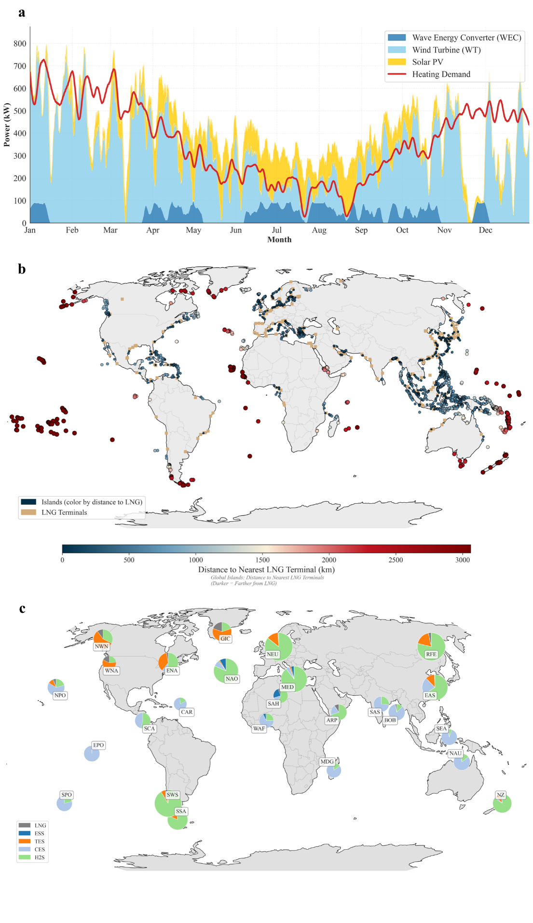

**a,** Annual energy profile of a case study island showing heating demand (red line) plotted against renewable energy generation from wind turbines (WT, light blue), photovoltaics (PV, yellow), and wave energy converters (WAVE, blue). The x-axis represents months (1-12), and the y-axis shows output/demand in kilowatts (kW). **b,** Global distribution of islands (blue dots) and LNG terminals (red dots) demonstrating the geographical relationship between potential energy consumers and existing LNG supply infrastructure. **c,** Geographic distribution of energy facilities on islands worldwide, categorized as LNG (Liquefied Natural Gas, gray), ES (Energy Storage, blue), HS (Heating Storage, orange), CS (Cooling Storage, light blue), and H2S (Hydrogen Storage, green). Left and right panels show different scenarios of the relative distribution of these technologies across global island communities.

The uneven spatiotemporal distribution of renewable resources is a key variable driving investment disparities. During winter, solar energy utilization rates decrease significantly for high-latitude islands, coinciding precisely with peak heating demand, creating a critical spatiotemporal mismatch between resource availability and load (Fig. 4a). For instance, a high-latitude case island in the North Atlantic (-45.27849, 60.15269) experiences an average winter solar utilization rate of only 21.03% of its summer rate, while heating loads remain persistently high. This mismatch compels high-latitude islands to deploy significantly more energy storage capacity and LNG infrastructure to offset the seasonal variability and instability of renewable supply. Model results demonstrate that investments in storage systems for high-latitude islands average 254% higher than for low-latitude islands, while LNG investments are 335% higher, directly contributing to substantially higher overall system investment costs.

Variations in renewable resource endowments also drive differences among lower-latitude islands, as illustrated by comparing islands in Indonesia (124.01352, -1.85265) and Cuba (-114.724312, 18.356756). Despite similar per capita cooling demands, their per capita energy investment costs differ markedly. Renewable energy facility investment is significantly higher for the Indonesian island. Analysis reveals that while both islands possess abundant solar resources, wind resources differ substantially. The Indonesian island suffers from scarce and seasonally uneven wind resources, significantly lower than Cuba's. Consequently, the Indonesian island requires greater investment in more expensive wave energy resources to meet its electricity demand, resulting in higher per capita energy costs (Fig. 3b, c).

Geographic remoteness significantly impacts investment costs through supply chain complexity. Case studies show that islands near Greenland (-45.27849, 60.15269) face LNG procurement costs averaging twice those of nearshore islands like the UK case (-7.466944, 56.986007), primarily due to their greater distance from the nearest LNG ports. Combined with the high LNG demand for heating in these high-latitude locations, this results in much higher per capita energy investment compared to UK islands (Fig. 4b). Further contrasting the Indonesian island (124.01352, -1.85265) with Fiji in the South Pacific (-178.580599, -19.141772)—both with comparable per capita cooling demands—reveals that Fiji's lower solar, wind, and wave energy resources, coupled with extreme remoteness from LNG ports (making LNG prohibitively expensive), necessitate larger investments in renewables and significantly increased storage capacity to ensure supply reliability. This strategy leads to Fiji's higher per capita investment (Fig. 3a,b; Fig. 4b,c).

**Climate Risk Gradients Intensify Spatial Heterogeneity in Per Capita Energy Investment for Future Risk-Based Design**

Climate change is projected to significantly increase future typhoon risks. In our second scenario, we adopt a more conservative design approach to assess global island energy system investments under projected 2050 disaster risks. Comparative analysis between the 2020 baseline and 2050 scenarios reveals that climate change amplifies per capita energy investments in specific regions, intensifying preexisting spatial disparities (Fig. 5a). Under RCP8.5, islands in the northwestern Pacific and southwestern Indian Ocean experience a 16.3% average increase in per capita energy investment—markedly higher than the 3% average increase in other regions—leading to more pronounced heterogeneity. This divergence is particularly acute within the Pacific Northwest’s "typhoon corridor" (Fig.5a). Case studies in this high-risk zone (e.g., southeastern China, southern Japan, and northern Philippines) demonstrate significantly higher cost escalations than elsewhere. Our simulations indicate that typhoon corridor islands require substantial additional investments in energy storage and LNG infrastructure to withstand extreme climate events under RCP8.5. For instance, islands in southeastern China exhibit a 60% increase in per capita storage investment costs—far exceeding other regions (Fig.5b).

**Fig.5 | Transformation of global island energy system configurations under current and future risk-based scenarios.**

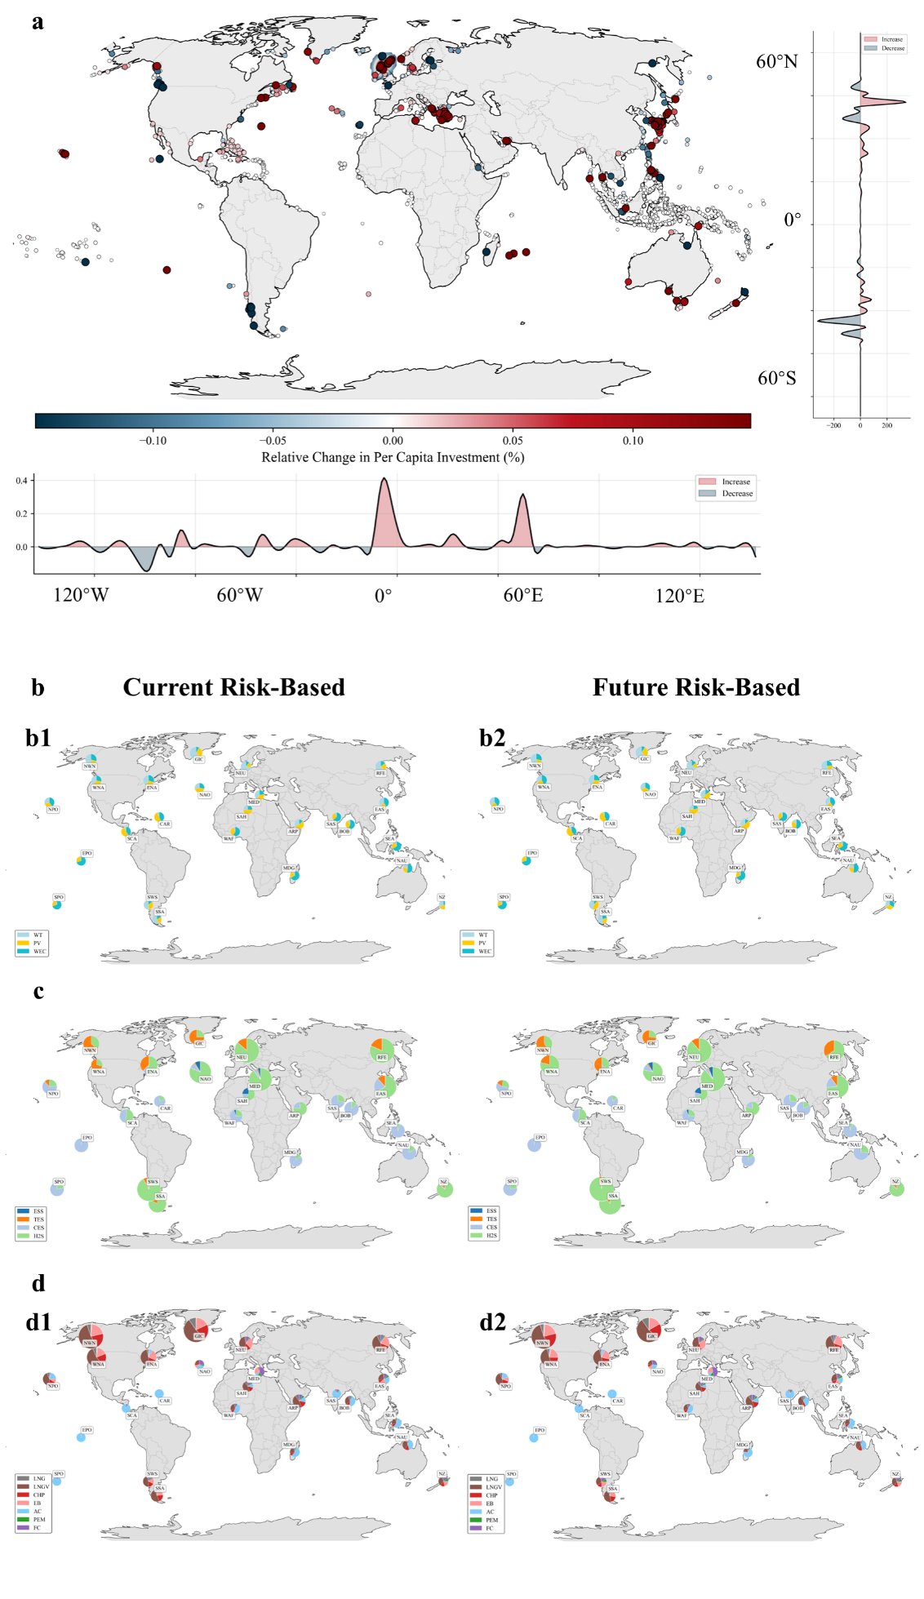

**a,** Geographic distribution of energy generation capacities on global islands showing the proportional mix of Wind Turbines (WT, light blue), Photovoltaics (PV, yellow), Liquefied Natural Gas (LNG, gray), and Wave energy converters (WEC, blue) under current(left) and future(right) risk-based scenarios. **b,** Evolution of energy storage capacity allocations across global islands between current(left) and future(right) risk-based scenarios, categorized as Energy Storage (ES, blue), Heating Storage (HS, orange), Cooling Storage (CS, light blue), and Hydrogen Storage (HYS, green). **c,** Distribution of energy conversion facilities on islands worldwide under current(left) and future(right) risk-based scenarios, including Combined Heat and Power (CHP, red), Electric Boilers (EB, pink), Air Conditioning (AC, light blue), Electrolyzer (ELEC, green), Fuel Cell (BAT, purple), and Gas Vaporizer (GAS, brown).

Extreme typhoon events exacerbate differential infrastructure vulnerability in high-risk areas of the Pacific Northwest, compelling affected islands to augment storage or LNG capacity. For China’s case island (121.195504, 27.987457), heightened disaster intensity under the 2050 scenario reduces renewable penetration versus 2020, necessitating significant capacity expansions in thermal, electrical, cooling, and hydrogen storage systems alongside increased LNG-related facilities (CHP, GAS), substantially elevating costs. Conversely, Japan’s case island (26.49370, 127.959792) shows no marked change in renewable share despite rising disaster intensity; only hydrogen storage capacity increases significantly, with other components remaining stable.

Regression analysis quantitatively reveals the mechanisms driving divergent energy investment pathways among island nations under climate stress. First, heightened typhoon intensity directly and significantly increases dependence on conventional Liquefied Natural Gas (LNG) as a primary security measure (LNG_Usage: β = 0.565, p < 0.001). Crucially, our multivariate model predicting investment in climate-resilient energy storage (Energy_Storage_Capacity) uncovers a pronounced negative interaction effect between typhoon intensity and pre-existing LNG dependency (Typhoon_Intensity:LNG_Usage β = -0.0977, p < 0.001). This interaction signifies a profound structural inequity: **islands with initially lower LNG usage are disproportionately forced to undertake significantly higher marginal investments in both LNG reserves and, critically, energy storage capacity when facing increased disaster risk.**As visually confirmed in Fig. 1b, the slope representing the required increase in storage investment per unit rise in typhoon intensity is markedly steeper for these smaller, less fossil-fuel-dependent systems (blue line) compared to larger, incumbent systems (green line). This steep slope translates to punishingly high adaptation costs per unit of additional climate risk. The three-dimensional response surface (Fig. 6c) further illustrates that the investment burden for achieving resilience is heavily conditioned by an island's developmental path, imposing the steepest financial climb on those nations historically least responsible for emissions and with the most limited existing infrastructure.

Spatial heterogeneity in island energy investments thus stems from interconnected climatic, resource, geographic, and socioeconomic drivers, forming systemic inequities reflective of structural energy transition challenges. Climate change—through altered frequency and intensity of extreme events—further escalates investment demands in vulnerable regions, deepening global spatial disparities in energy system financing.

**Fig.6 | Multivariate multiple regression analysis on the impact of disaster intensity on LNG and energy storage capacity**

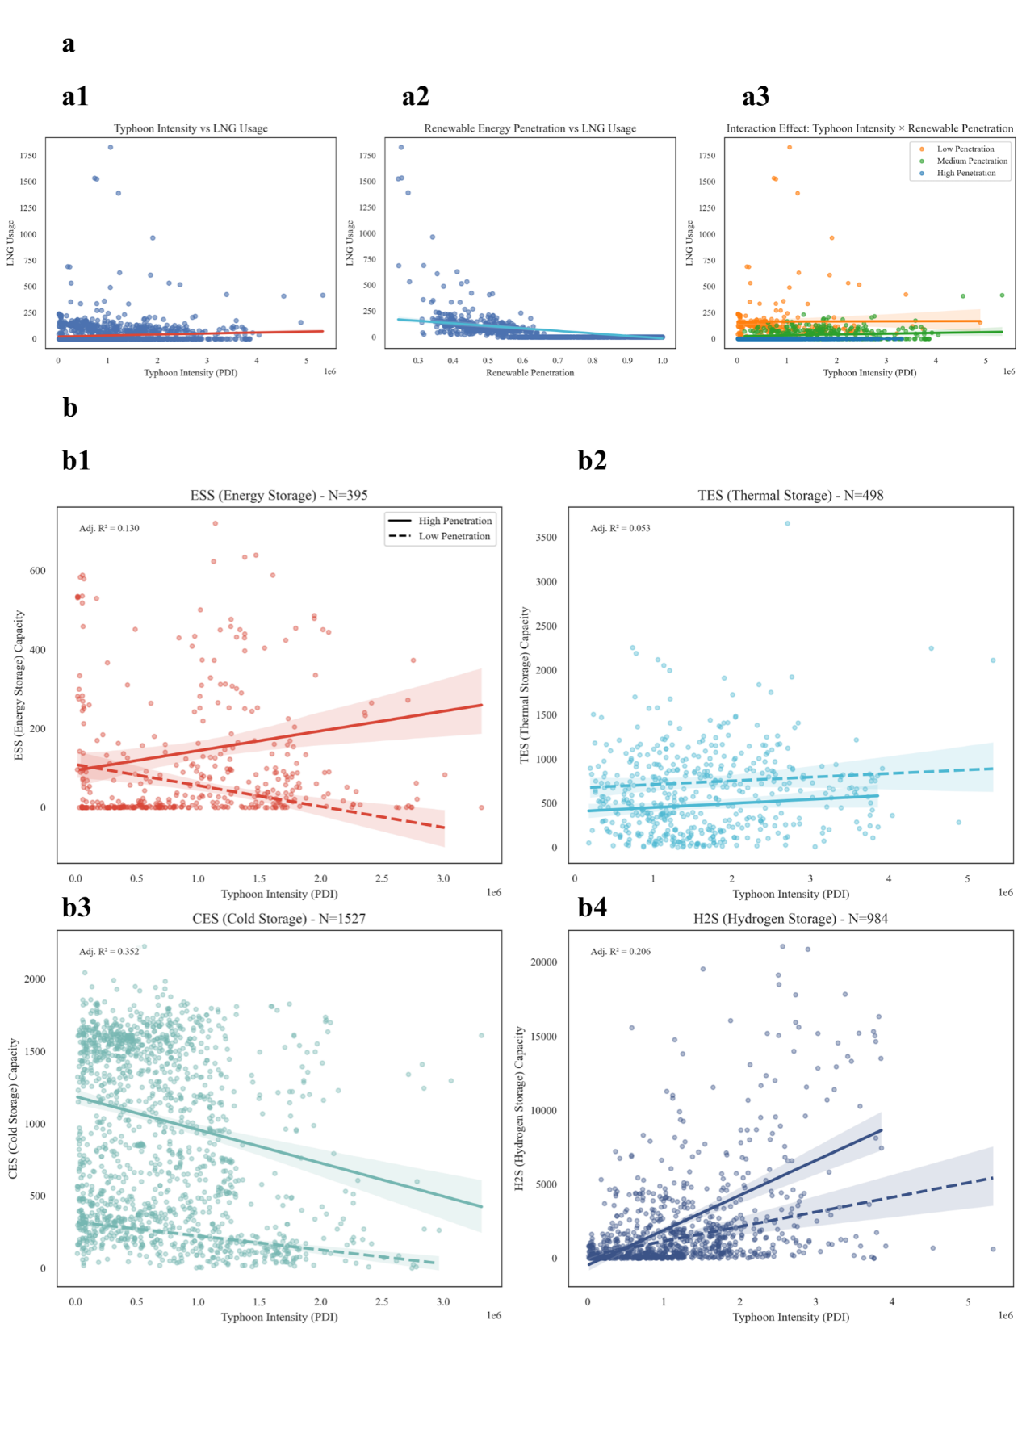

**Spatial Inequity in Energy Investment Burden Coefficients Across Scenarios**

**Fig.7 | Spatiotemporal evolution of energy investment burdens under climate change scenarios.**

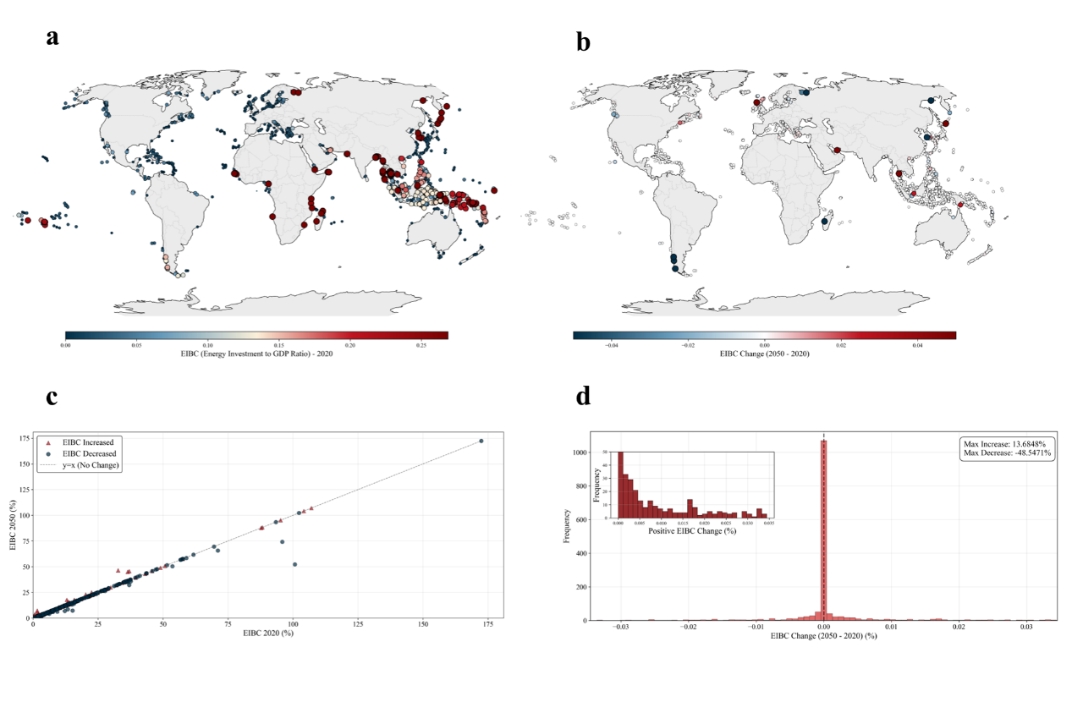

**a,** Global distribution of Energy Investment Burden Coefficient (EIBC) under current(left) and future(right) risk-based scenarios. Red dots indicate higher EIBC values, representing greater investment burdens relative to local GDP, while blue dots represent moderate investment-to-GDP ratios.

The Energy Investment Burden Coefficient (EIBC), defined as the ratio of energy system investment costs to per capita GDP, exhibits a spatial pattern distinct from absolute investment costs. Regions with high EIBC concentrate in low-income island nations of Southeast and South Asia, alongside geographically isolated central Pacific islands. Despite lower absolute investments than developed islands, these areas face disproportionate fiscal pressure due to constrained economic capacity, with EIBC consistently exceeding 20% (Fig. 6, left). Within the Northwest Pacific’s "typhoon corridor," EIBC variations reflect stark economic disparities: Japan’s southern islands exhibit a 1.6% burden, southeastern Chinese islands 6.5%, and economically vulnerable northern Philippine islands 22%. Globally, Small Island Developing States (SIDS) demonstrate higher relative burdens despite modest absolute investments, revealing a structural mismatch between investment needs and economic resilience that constitutes foundational energy transition inequality.

Comparative analysis of 2020 and 2050 scenarios indicates climate change intensifies EIBC spatial heterogeneity (Fig. 6, right). The EIBC ratio between high-burden and low-burden islands expands from 4-fold (2020) to 5-fold (2050), primarily driven by additional climate adaptation investments in vulnerable regions. Climate change particularly exacerbates intra-regional inequity in the West Pacific, where northern Philippines and Fiji experience EIBC surges from approximately 18% to 22–25% (a 4–7 percentage-point increase). In contrast, southern Japanese islands show only a marginal rise from 1.6% to 1.8% (+0.2 points), while southeastern Chinese islands increase from 6.5% to 8.1% (+1.6 points).

This diverging trajectory demonstrates that climate change disproportionately escalates fiscal pressure on economically vulnerable islands, irrespective of absolute cost variations. The amplification of burden disparities underscores intricate climate-inequality interactions, presenting critical equity challenges for global energy transition governance and international climate cooperation frameworks.

**Limited Equity Gains from Technological Progress in Energy Systems**

**Fig.8 | Equity implications of projected cost reductions from technological progress for global islands.**

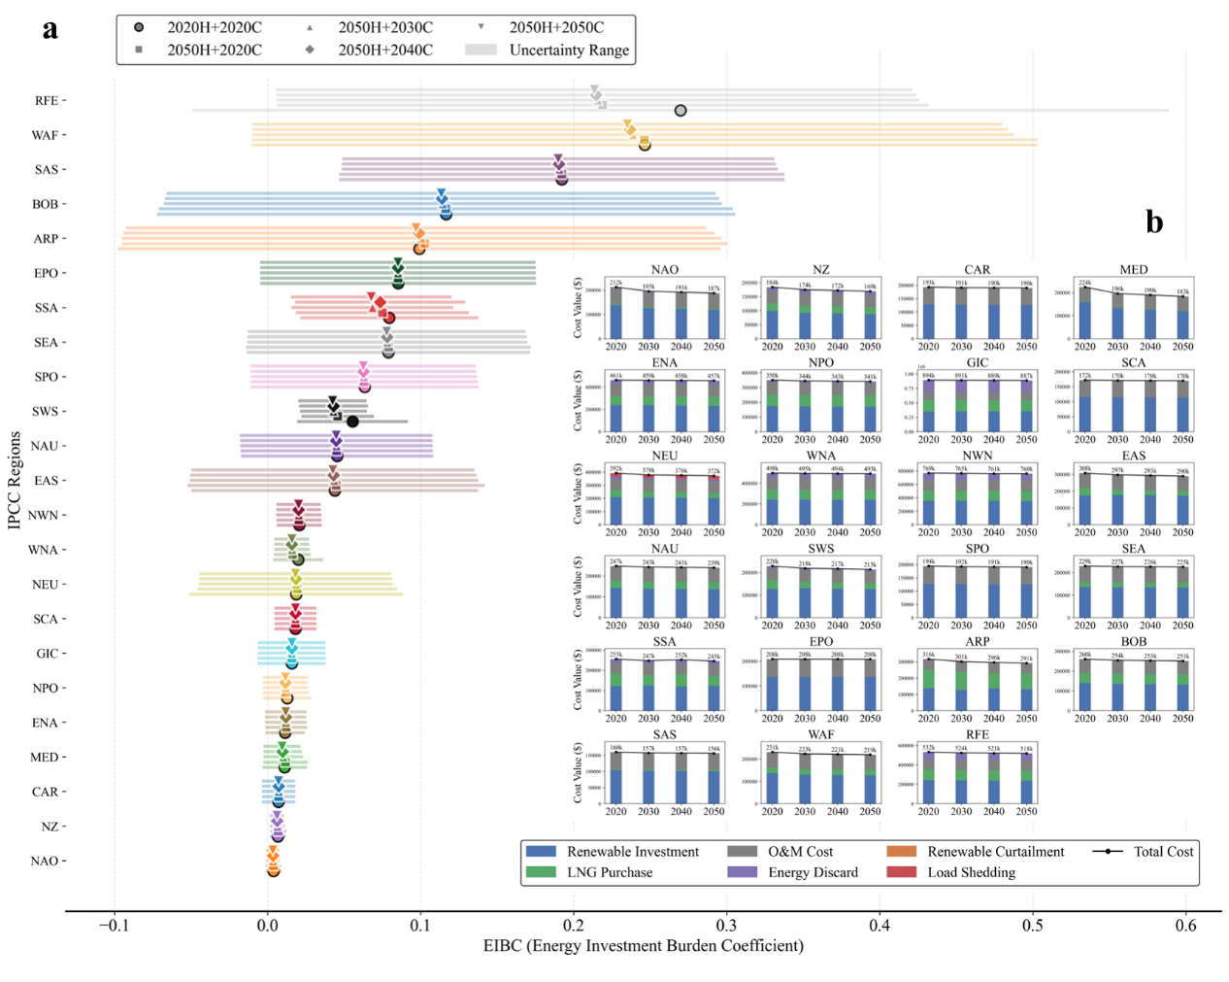

**a,** Temporal trends of the Energy Investment Burden Coefficient (EIBC) from 2020 to 2050 for selected regions, showing declining investment burdens across all regions with geographic coordinates indicated. **b,** Stacked bar charts illustrating the composition of total investment costs across different regions, categorized into Renewable Cost (blue), Storage Cost (green), LNG Cost (gray), Other Equipment Cost (purple), Discard Cost (orange), and Load Shedding Cost (red), with total cost indicated by the black line. **c,** Geographic distribution of energy system component capacities on global islands represented by pie charts, designed for future risk-based scenario with 2020 (left) and 2050(right) technology costs. The charts depict the relative capacities of different technologies.

Technological progress is often regarded as a critical pathway to addressing global energy inequity, with cost reductions in energy storage and hydrogen production serving as illustrative examples. These two technologies are particularly relevant as they represent key scenarios of technological advancement analyzed in this study. Our analysis confirms these technological advances exert a universal cost-reduction effect across global islands. Simulations indicate that when storage and hydrogen costs decrease by ∼50% from 2020 to 2050 (following current projections), average per capita energy investments under 2050 disaster risk decline by 12% globally. Most islands exhibit reduced Energy Investment Burden Coefficients (EIBC), demonstrating broad-based benefits (Fig. 7a). Specifically: Vanuatu’s EIBC decreases from ∼0.22 (2020) to 0.18 (2050; −18%); Fiji from 0.21 to 0.16 (−24%); southeastern China from 0.08 to 0.06 (−25%); southeastern US islands show fluctuating but overall decline; while southwestern Japanese islands remain stable. This widespread reduction confirms technological progress alleviates energy investment burdens globally.

Cost composition analysis reveals underlying mechanisms. The proportion of storage costs (green segments) decreases over time, directly reflecting technological economies (Fig. 7b). Concurrently, renewable energy costs (blue segments) demonstrate systemic effects: lower storage/hydrogen costs enable more economical integration of intermittent renewables, facilitating higher renewable deployment and structural optimization. This synergy enhances system flexibility and clean energy competitiveness.

Declining reliance on LNG (gray segments) and gasification infrastructure (GAS) emerges as storage/hydrogen costs fall (Fig. 7b,c). Technological advances thus reconfigure optimal energy systems—increasing clean energy deployment, reducing fossil fuel imports, enhancing energy self-sufficiency, lowering security risks, and generating significant carbon mitigation co-benefits.

Despite universal gains, cost-reduction benefits vary regionally. Vanuatu exhibits steeper declines than disaster-vulnerable southeastern China or Fiji—a divergence attributable to Pacific islands’ geographic isolation. These islands require larger storage capacities for weather resilience and supply security, heightening sensitivity to storage cost reductions. Consequently, Pacific cases show more pronounced EIBC decreases and higher storage cost shares, amplifying total cost impacts.

Critically, EIBC disparities persist despite technological gains. In 2020, Vanuatu and Fiji (EIBC 0.21–0.22) faced burdens 10–20× higher than the US/Japan (0.01–0.02). By 2050, Pacific EIBCs (0.16–0.18) remain 8–15× higher than developed economies’ levels. Notably, Pacific nations’ 2050 burdens still exceed developed islands’ 2020 baselines, confirming technology alleviates but does not resolve structural inequity (Fig. 7a). This gap may exacerbate economic inequality by constraining investments in education, healthcare, and development.

Thus, while storage/hydrogen cost reductions deliver broad-based benefits, their spatially uneven impact—and failure to eliminate fundamental disparities—underscores that technology alone cannot achieve equitable energy transitions. A 50% cost reduction only lowers high-burden EIBCs by 18–25%, insufficient to bridge 10–20× gaps. Targeted international cooperation and support mechanisms for Small Island Developing States remain imperative.

**Discussion**

This study reveals the spatial heterogeneity of global island energy system investments and the evolution of inequity under climate change. We demonstrate that climate risk gradients exacerbate pre-existing disparities in energy investment burdens, creating systemic regional divergence. Intensifying meteorological hazards may perpetuate and amplify inequities in the global energy transition. While anticipated cost reductions in energy storage and hydrogen production technologies offer broad benefits, their spatially uneven impact and limited scale are insufficient to intrinsically resolve this structural inequality.

Fundamental spatial disparities in energy investment costs arise from differential climate conditions, supply chain complexity, and renewable resource endowments. High-latitude islands face elevated investment pressure due to greater heating demands and seasonal renewable resource mismatches. Islands with remote offshore locations incur higher fossil fuel transportation costs, necessitating greater energy storage deployment. Globally uneven renewable resource distribution further drives interregional investment differences. These inherent inequities are aggravated by climate change: Islands in high-risk zones (e.g., the Northwest Pacific "typhoon corridor") require up to 56% greater investment in storage and LNG infrastructure for climate resilience—far exceeding the global average.

Island energy systems exhibit self-reinforcing inequity mechanisms due to divergent climate risks and development levels. Climate change not only increases absolute investment needs in vulnerable islands but also widens the per capita investment gap between high- and low-risk regions. Analysis of the Energy Investment Burden Coefficient (EIBC) shows that for economically vulnerable islands (e.g., the Philippines), EIBC surges from 20% at baseline to 25–30% by 2050, whereas developed regions (e.g., Japan) see merely a 0.2-percentage-point increase. This divergence portends worsening inequity in the global energy transition.

Although projected cost declines in storage and hydrogen technologies provide universal benefits, their impact remains spatially heterogeneous and insufficient to eliminate structural inequities. Disaster-prone, isolated islands exhibit higher sensitivity to storage costs, experiencing greater per capita investment reductions. Yet even under rapid technological advancement, Pacific Island nations’ 2050 EIBC will remain 8–15 times higher than that of developed economies. This "equity-technology disconnect" underscores that innovation alone cannot resolve transition inequities.

Our findings elucidate how geographic constraints and socioeconomic vulnerability synergistically drive self-reinforcing inequity. Achieving energy justice requires solutions beyond market-driven techno-fixes.

Conventional energy justice frameworks focus on access, affordability, and participation, often neglecting geographically determined vulnerabilities to climate risks. Our analysis reveals significant disparities driven by location: high-latitude islands face inherently higher structural energy investment needs due to climate-driven demand patterns. Similarly, islands in typhoon-prone regions incur substantial additional costs for disaster-resilient infrastructure capacity. This geographically imposed burden necessitates moving beyond egalitarian principles towards discussions of equitable compensation and differentiated responsibilities.

Island energy systems exhibit distinct vulnerabilities arising from a triple constraint: geographical isolation, limited resource endowments, and heightened climate sensitivity. This fundamentally differentiates them from mainland systems in terms of investment needs and resilience building. Firstly, geographical isolation extends supply chains, imposing a significant "geographical tax" – particularly for transporting fuels like LNG to high-latitude or remote islands – elevating baseline energy costs. Secondly, limited resource endowments constrain viable renewable options, as evidenced by case studies (e.g., Indonesia vs. Cuba) demonstrating how spatial heterogeneity in resources (e.g., wind potential) drives substantial investment disparities. Thirdly, heightened climate sensitivity requires disproportionately higher investment in adaptation and resilient infrastructure due to elevated risks from extreme weather events (e.g., typhoon damage).

Current international climate finance mechanisms inadequately address these unique island constraints. Allocation based primarily on population, mitigation potential, or absolute vulnerability overlooks the critical mismatch between high investment burdens and limited economic capacity. Our results underscore the need for finance metrics that better capture the compound effects of climate risk and economic vulnerability specific to islands. Moreover, this "decoupling of technological progress from equity" demands a strategic shift in R&D priorities towards fair energy transitions. This entails prioritizing technologies with the highest cost-reduction potential in high Energy Investment Burden Coefficient (EIBC) regions; developing modular, climate-resilient solutions with flexible investment scales; and creating integrated systems aligned with local resources and technical capacity. Crucially, technological innovation must be coupled with financial innovation – such as climate-risk insurance and low-cost financing mechanisms for highly vulnerable areas – to bridge investment gaps that technology alone cannot solve. Only this dual-track approach can mitigate structural inequalities in the energy transition.

Achieving a just global energy transition requires systematically reconceptualizing energy justice to incorporate geographical vulnerability, developing targeted policies for islands, and directing innovation towards equitable outcomes. These insights are critical for building a more resilient, fair, and sustainable energy future.

**Method**

**Island Integrated Energy System Model**

**Fig.9 | Island Integrated Energy System.**

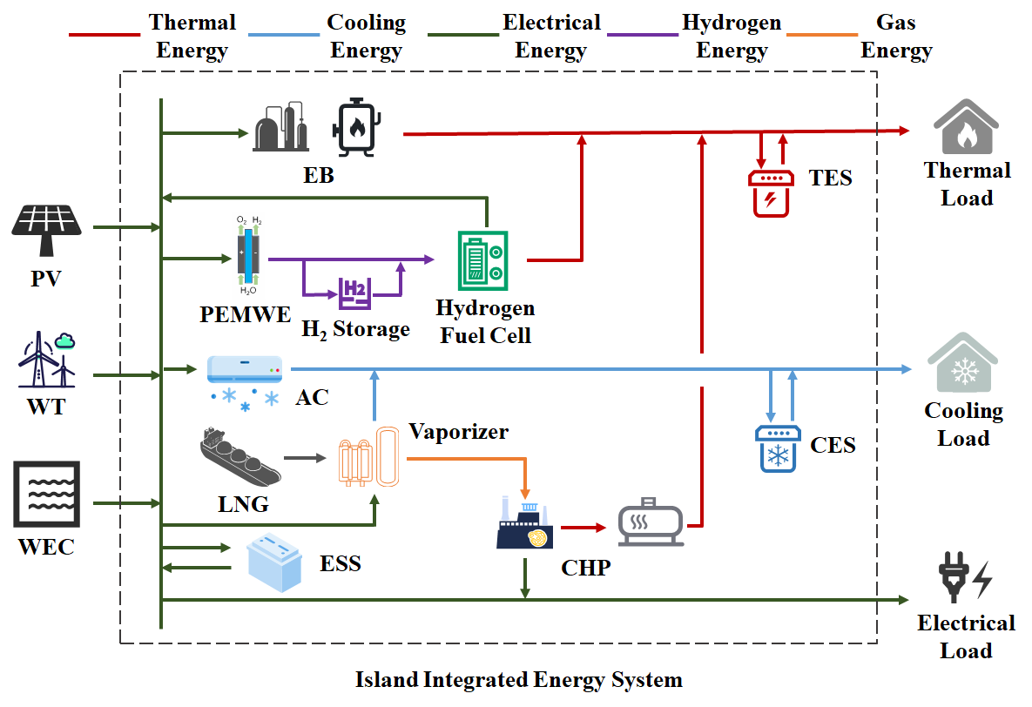

We propose an island integrated energy system (Fig.7), incorporating external energy inputs from wind, solar, wave, and liquefied natural gas (LNG). LNG is procured from the nearest base station and transported to the island (data source14). Energy conversion and storage facilities couple these sources to meet electricity, heating, and cooling demands. Model cost and operational parameters derive from the U.S. NREL's Annual Technology Baseline (ATB) medium-cost scenario15 and relevant literature, with detailed parameters provided in Supplementary Note 1. The system is scaled for a 500-person community, which represents an optimal scale for demonstrating renewable energy integration in an island context. Based on IRENA's analysis of off-grid systems (Case 7)16, this scale is particularly suitable for comprehensive hybrid renewable solutions, as it allows for meaningful capacity deployment (typically 0.5-2 MW) while remaining manageable in terms of system complexity and investment requirements. For islands with smaller populations, we scale the system accordingly using their actual population size to maintain per capita energy adequacy.

**Renewable Potential and Demand Assessment**

Hourly solar photovoltaic (PV) and wind generation profiles were simulated using the *Renewables.ninja* platform17,18 , leveraging historical meteorological data (ERA5, MERRA-2) and performance models. Simulations used 2020 data with each island represented by its centroid coordinates.

PV systems were modeled as fixed-tilt installations with tilt angles optimized for maximum annual yield. Azimuth was set southward (Northern Hemisphere) or northward (Southern Hemisphere). To avoid artificial capacity constraints during optimization, maximum AC power input was scaled proportionally to population (2.0 kW/person), with system losses set at 10%. Wind simulations used Vestas V90 2000 turbines at 80m hub height, with maximum AC power input similarly set to 2.0 kW/person.

Wave energy density (kW/m) and significant wave height (m) under SSP585 scenario were sourced from a global wave model data19, and to fully explore the configuration potential of wave energy facilities in the optimization model, the maximum wave energy facility length per island was set to 1 km.

Hourly heating and cooling demands were simulated using *Renewables.ninja* methodology20 . Heating demand initiates when ambient temperature falls below region-specific heating thresholds, while cooling demand activates when temperature exceeds cooling thresholds. Calculations incorporate regional parameters as defined in Table 1 20：

**Table 1 Cooling and heating load parameters**

|  |  |  |  |  |  |  |  |  |
| --- | --- | --- | --- | --- | --- | --- | --- | --- |
| **regions** | **Heating  threshold [°C]** | **Cooling  threshold [°C]** | **Heating  power [W/(°C · p)]** | **Cooling  power [W/(°C · p)]** | **Smooth  coef. [day-1]** | **Solar coef. [°C/(Wm-2)]** | **Wind coef. [°C/(ms-1)]** | **Humidity  coef. [°C/(gkg-1)]** |
| APAC | 11.9 | 20.4 | 127 | 52 | 0.73 | 0.014 | -0.12 | 0.036 |
| Europe | 12.7 | 20.4 | 116 | 16 | 0.62 | 0.019 | -0.13 | 0.032 |
| US | 9.7 | 18.8 | 129 | 59 | 0.35 | 0.011 | -0.1 | 0.022 |
| Others | 11.9 | 20.4 | 127 | 52 | 0.73 | 0.014 | -0.12 | 0.036 |

*APAC parameters were adopted as defaults for the "Others" region given their broad applicability and intermediate characteristics.*

The electrical load typically comprises heating/cooling-related demand and base electricity demand (e.g., lighting, appliances) independent of thermal needs. Given available heating/cooling demand data for islands, only base electricity demand was modeled. For modeling simplicity, this base demand was decomposed into illumination-dependent lighting load and time-varying activity-dependent load21 . Detailed modeling procedures are described in Supplementary Note 2.

**Island Selection Criteria**

We selected 2015 global islands meeting these criteria: 1) Inhabited (ensuring socioeconomic relevance); 2) Minimum area ≥10 km² (enabling renewable infrastructure); 3) Geographical isolation ≥10 km from mainland (minimizing continental influence); 4) Population <3.5 million (excluding mainland-like energy systems) 22. Population data came from23; island area and mainland distance from 24.

**Climate Data for Hazard Modeling**

Typhoon hazards were modeled using 3-hourly near-surface wind speed data from MRI-AGCM3-2-S_highresSST (CMIP6, SSP585 scenario) 25, accessed via Earth System Grid Federation (ESGF). This high-resolution model demonstrates enhanced tropical cyclone simulation capability.

**Bi-level Optimization Model**

A bi-level optimization framework was adopted to determine the minimum annualized cost for island energy system planning. This structure effectively balances long-term investment decisions with short-term operational scheduling.

The objective of the upper-level model is to minimize the total annual cost of the energy system. This level determines the optimal configuration capacity of energy components for each island (e.g., PV, wind, wave, storage devices, and other conventional equipment). The decision variables are the installation capacities of all devices within the system. The objective function minimizes total cost, including equivalent annual investment cost and annual operational cost. The equivalent annual equipment investment cost is:

Where is the annual equipment investment cost; is the total number of devices; is the configuration capacity of device ; is the unit installation price of device ;  is the annual discount rate; is the equipment lifespan. The annual operational cost is defined in the lower-level model.

The upper-level model must satisfy the load demand constraint:

where represents electricity, heating, and cooling systems; is the total load demand; is the total configured capacity.

The objective of lower-level model is to minimize the total annual operational cost of the energy system. Decision variables are the real-time output of system components. Annual operational cost includes LNG purchase cost, equipment maintenance cost, renewable curtailment penalty, and load shedding penalty:

Where is the annual total operating cost, is the LNG procurement cost, is the equipment operation and maintenance cost, is the renewable energy curtailment penalty cost， is the load curtailment penalty cost; *h* is the total simulation time steps, is the LNG procurement quantity (m3), is the LNG purchase price per cubic meter, is the transportation cost per m3-km of LNG, is the LNG transportation distance (assumed as 1.2×straight-line distance【】), is the Fixed cost per procurement order, is the number of procurement orders; *l* is the total number of equipment types, is the fixed O&M cost coefficient for equipment , is the installed capacity of equipment ; is the Penalty coefficient for renewable curtailment, is the curtailed renewable power; is the penalty coefficient for load curtailment, is the curtailed load amount.

To evaluate system reliability under climate change, renewable equipment failure dynamics are incorporated. Component failure probabilities are determined by combining climate model wind data with vulnerability curves. Monte Carlo simulation generates component failure states. For computational tractability, failure states are clustered using the elbow method to identify representative states for optimization. This captures climate-induced failures and system impacts.

Vulnerability curves 7,26–33 define failure probability () as functions of wind speed () or wave height ():

To simulate component failure events, at each time step , a random number  ∈ [0,1] is generated for each component . Failure is triggered if < . Affected components remain inoperable until repairs are completed. The repair duration is determined based on assumptions accounting for the island’s geographical constraints34,35, with maintenance restricted to periods of wind speeds below 20 m/s due to extreme weather limitations. During repairs, failed components are considered unavailable, reducing system capacity and impacting overall energy supply reliability:

Where is the actual output of component at time ， denotes its rated capacity, and is a binary state variable (: operational，: failed).

The Average Service Availability Index (*ASAI*) quantifies the energy system’s sustained supply capability for each load type:

Where is the average service availability index of system , is the total simulation time steps, denotes the duration of supply deficit for system at time .

This reliability constraint ( ≥ 99%) is embedded in the lower-level optimization model, ensuring the island’s energy system meets minimum supply requirements under disaster scenarios. Detailed model formulations are provided in Supplementary Note 3.

**Data availability**

The wind and photovoltaic power generation profiles, as well as heating/cooling demand data, were obtained from the *Renewables.ninja* model and are available at <https://www.renewables.ninja/>. Wave energy and wave height data were sourced from the *Science Data Bank* repository at <https://www.scidb.cn/en/detail?dataSetId=700894282ab745d0b420fe0844c924ae&version=V2>. Population distribution data were derived from the *LandScan* database hosted by Oak Ridge National Laboratory and are accessible at <https://landscan.ornl.gov/>. Climate model data were downloaded from the *Earth System Grid Federation (ESGF)* portal (<https://esgf-ui.ceda.ac.uk/cog/search/cmip6-ceda/>).

**Code availability**

The code used in this study is available in the GitHub repository at <https://github.com/LeventRRR/Island-energy-optimization.git>.The code was developed and tested using Python 3.11.7 and Gurobi 11.0.3.

**Reference**

1. Renewable Energy Country Profiles - Special edition on islands. https://www.irena.org/publications/2012/Sep/Renewable-Energy-Country-Profiles---Special-edition-on-islands (2012).

2. Bertheau, P. Assessing the impact of renewable energy on local development and the Sustainable Development Goals: Insights from a small Philippine island. *Technological Forecasting and Social Change* **153**, 119919 (2020).

3. Katsaprakakis, D. Al. Hybrid power plants in non-interconnected insular systems. *Applied Energy* **164**, 268–283 (2016).

4. Østergaard, P. A., Duic, N., Noorollahi, Y. & Kalogirou, S. Latest progress in Sustainable Development using renewable energy technology. *Renewable Energy* **162**, 1554–1562 (2020).

5. WorldRiskReport 2020 - Focus: Forced Displacement and Migration - World | ReliefWeb. https://reliefweb.int/report/world/worldriskreport-2020-focus-forced-displacement-and-migration (2020).

6. To, L. S. *et al.* A research and innovation agenda for energy resilience in Pacific Island Countries and Territories. *Nat Energy* **6**, 1098–1103 (2021).

7. Bennett, J. A. *et al.* Extending energy system modelling to include extreme weather risks and application to hurricane events in Puerto Rico. *Nat Energy* **6**, 240–249 (2021).

8. Prasad, R. D., Bansal, R. C. & Raturi, A. A review of Fiji’s energy situation: Challenges and strategies as a small island developing state. *Renewable and Sustainable Energy Reviews* **75**, 278–292 (2017).

9. Islands need resilient power systems more than ever. Clean energy can deliver – Analysis. *IEA* https://www.iea.org/commentaries/islands-need-resilient-power-systems-more-than-ever-clean-energy-can-deliver (2024).

10. Hybrid renewable mini-grids on non-interconnected small islands: Review of case studies. *Renewable and Sustainable Energy Reviews* **116**, 109417 (2019).

11. Villarroel, N., Lazo, J. & Watts, D. High energy costs in insular energy systems and the potential for integrating innovative renewable solutions: The case of Chile. *Renewable Energy* **246**, 122967 (2025).

12. Cross, S., Padfield, D., Ant-Wuorinen, R., King, P. & Syri, S. Benchmarking island power systems: Results, challenges, and solutions for long term sustainability. *Renewable and Sustainable Energy Reviews* **80**, 1269–1291 (2017).

13. Meschede, H., Bertheau, P., Khalili, S. & Breyer, C. A review of 100% renewable energy scenarios on islands. *WIREs Energy & Environment* **11**, e450 (2022).

14. Global Energy Monitor. Global Gas Infrastructure Tracker. (2024).

15. Vimmerstedt, Laura and Akar, et al. 2021 Annual Technology Baseline (ATB) Cost and Performance Data for Electricity Generation Technologies. https://doi.org/10.25984/1807473 (2021).

16. Electricity Storage Valuation Framework 2020. https://www.irena.org/publications/2020/Mar/Electricity-Storage-Valuation-Framework-2020 (2020).

17. Pfenninger, S. & Staffell, I. Long-term patterns of European PV output using 30 years of validated hourly reanalysis and satellite data. *Energy* **114**, 1251–1265 (2016).

18. Staffell, I. & Pfenninger, S. Using bias-corrected reanalysis to simulate current and future wind power output. *Energy* **114**, 1224–1239 (2016).

19. Jiang, X., Xie, B., Bao, Y. & Song, Z. Global 3-hourly wind-wave and swell data for wave climate and wave energy resource research from 1950 to 2100. *Sci Data* **10**, 225 (2023).

20. Staffell, I., Pfenninger, S. & Johnson, N. A global model of hourly space heating and cooling demand at multiple spatial scales. *Nat Energy* **8**, 1328–1344 (2023).

21. Muratori, M., Roberts, M. C., Sioshansi, R., Marano, V. & Rizzoni, G. A highly resolved modeling technique to simulate residential power demand. *Applied Energy* **107**, 465–473 (2013).

22. Meschede, H., Holzapfel, P., Kadelbach, F. & Hesselbach, J. Classification of global island regarding the opportunity of using RES. *Applied Energy* **175**, 251–258 (2016).

23. Rose, A., McKee, J., Sims, K., Bright, E., Reith, A., & Urban, M. LandScan Global 2020 [Data set]. Oak Ridge National Laboratory. https://doi.org/10.48690/1523378 (2021).

24. Weigelt, P., Jetz, W. & Kreft, H. Bioclimatic and physical characterization of the world’s islands. *Proc. Natl. Acad. Sci. U.S.A.* **110**, 15307–15312 (2013).

25. Mizuta, Ryo; Yoshimura, Hiromasa; Ose, Tomoaki; Hosaka, Masahiro; Yukimoto, Seiji. MRI MRI-AGCM3-2-H model output prepared for CMIP6 HighResMIP. World Data Center for Climate (WDCC) at DKRZ (2023).

26. Zuo, H. *et al.* Fragility analyses of offshore wind turbines subjected to aerodynamic and sea wave loadings. *Renewable Energy* **160**, 1269–1282 (2020).

27. Cheng, Y. *et al.* Fragility and vulnerability development of offshore wind turbines under aero-hydro loadings. *Engineering Structures* **293**, 116625 (2023).

28. Watson, E. B. & Etemadi, A. H. Modeling Electrical Grid Resilience Under Hurricane Wind Conditions With Increased Solar and Wind Power Generation. *IEEE Trans. Power Syst.* **35**, 929–937 (2020).

29. Martín Del Campo, J. O. & Pozos-Estrada, A. Multi-hazard fragility analysis for a wind turbine support structure: An application to the Southwest of Mexico. *Engineering Structures* **209**, 109929 (2020).

30. Seo, J., Pokhrel, J. & Hu, J. W. Multi-Hazard Fragility Analysis of Offshore Wind Turbine Portfolios using Surrogate Models. *Renewable and Sustainable Energy Reviews* **165**, 112552 (2022).

31. Jaimes, M. A., García‐Soto, A. D., Martín Del Campo, J. O. & Pozos‐Estrada, A. Probabilistic risk assessment on wind turbine towers subjected to cyclone‐induced wind loads. *Wind Energy* **23**, 528–546 (2020).

32. Göteman, M., Shahroozi, Z., Stavropoulou, C., Katsidoniotaki, E. & Engström, J. Resilience of wave energy farms using metocean dependent failure rates and repair operations. *Ocean Engineering* **280**, 114678 (2023).

33. Pokhrel, J. & Seo, J. Statistical model for fragility estimates of offshore wind turbines subjected to aero-hydro dynamic loads. *Renewable Energy* **163**, 1495–1507 (2021).

34. Carroll, J., McDonald, A. & McMillan, D. Failure rate, repair time and unscheduled O&M cost analysis of offshore wind turbines. *Wind Energy* **19**, 1107–1119 (2016).

35. Oprea, S.-V., Bara, A., Preotescu, D. & Elefterescu, L. Photovoltaic Power Plants (PV-PP) Reliability Indicators for Improving Operation and Maintenance Activities. A Case Study of PV-PP Agigea Located in Romania. *IEEE Access* **7**, 39142–39157 (2019).